Stats Range Explanation

1. Melee Damage
   1. The base damage for melee is 3, it increases by 1 for every point in the stat.
   2. Damage can go beyond 10, but it isn’t shown on stat ui.
2. Gun Damage +1
   1. The base damage for Gun is 1, it increases by 1 for every point in the stat.
   2. Damage can go beyond 10, but it isn’t shown on stat ui.
3. Bullet Range
   1. 
4. Bullet Speed
   1. Base bullet speed is
   2. Bullet max speed will not go beyond 10.
5. Firing Rate
   1. Rate of 1 means a single bullet is shot once ever second….10 means a single bullet can be fired once every .10 of a second
   2. Firing speed will not go beyond 10.
6. Accuracy
   1. 
7. Movement Speed
   1. Speed can’t go beyond 10
8. Jump Height
   1. Jump can’t go beyond 10

Platforms

1. Nonsolid platforms
   1. Players can hold down while pressing jump. This will allow them to drop below the platform.
   2. There will be various of these types.
   3. 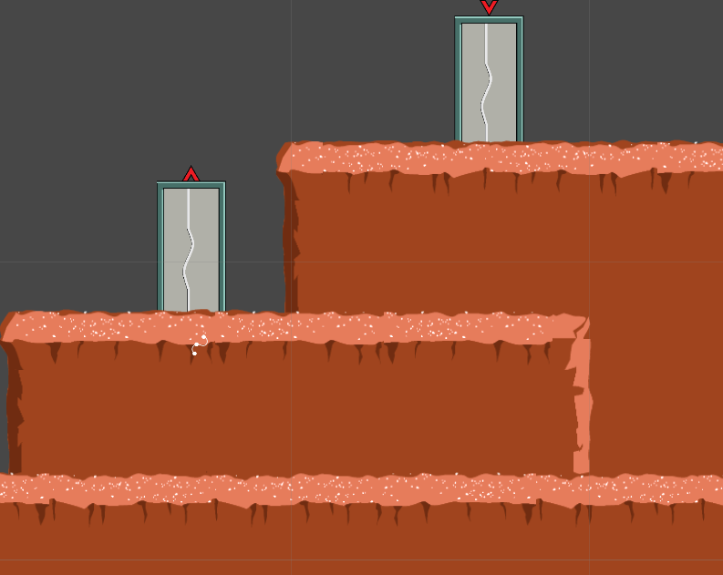
2. Solid platforms
   1. Players can do what ever they want on these…they will never pass under unless there is an opening.
   2. 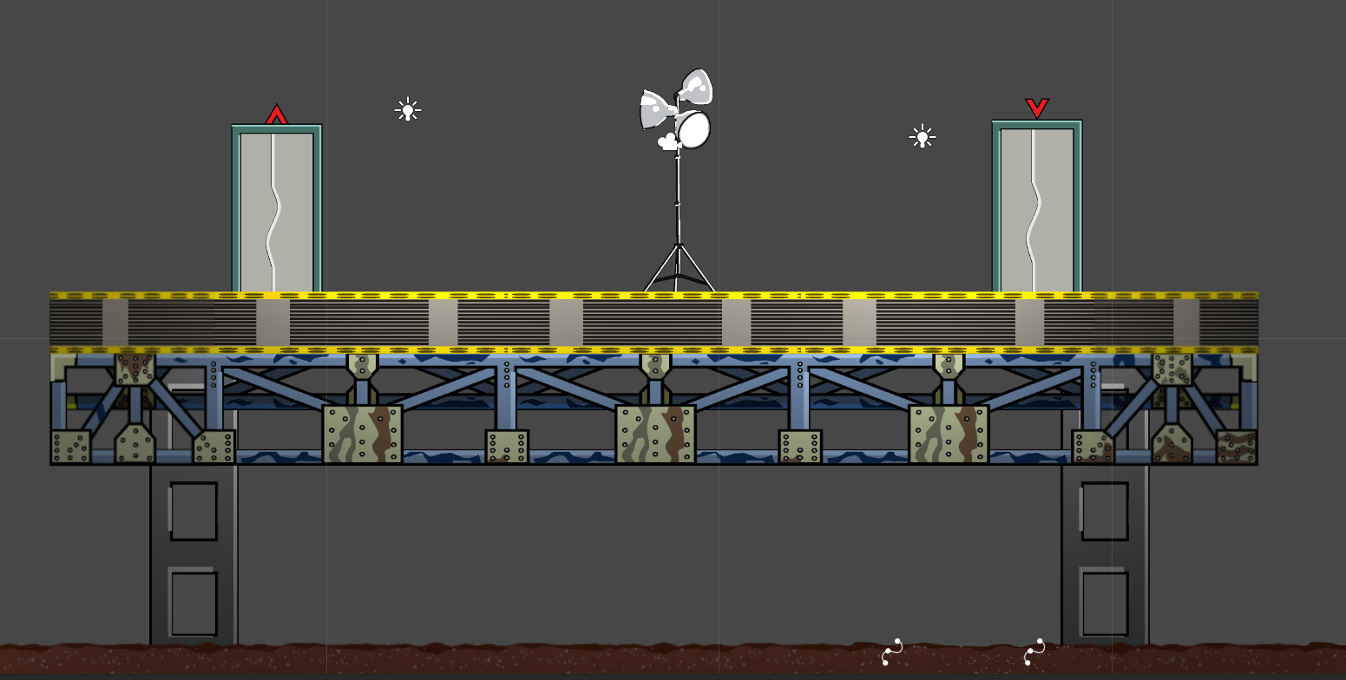
3. Ladders
   1. If a player touches collides with the ladder they will enter a ladder_climb animation.
   2. Players can jump off of it to be released
   3. 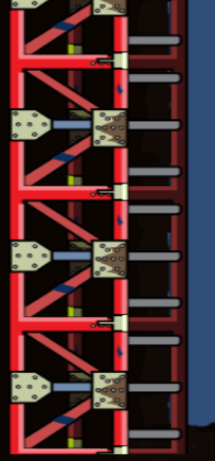
4. Ceiling Ladder
   1. 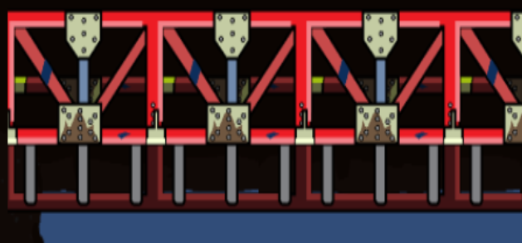
   2. A over hanging ladder if touched by a player will put them in a ceiling climb animation.
   3. Players can jump down to get off of animation.