**Lab # 07: Fourier Transform**

**Objective:**

The objective of this session is to perform Discrete Time Fourier Transform (DTFT) in MATLAB.

**Description:**

Each representation has some advantages and some disadvantages depending upon the type of system under consideration. However, when the system is linear and time invariant, only one representation stands out as the most useful. It is based on the complex exponential signal set emu and is called the discrete-time Fourier transform. fx[n] is absolutely summable, that is

$$\sum_{-∞}^{+∞}{x\left[n\right]<∞}$$

then its Discrete time Fourier Transform is given by,

$$X(e^{jw})=\sum_{-∞}^{+∞}{x\left[n\right]*e^{-jωn}}$$

**Task 1: Understanding the Fourier Transform**

**Objective**: Visualize the Fourier Transform of simple signals

**Steps**:

* 1. Generate a simple sinusoidal signal (e.g., x(t)=sin(2πft)
  2. Compute its Fourier Transform using the FFT algorithm.
  3. Plot the magnitude spectrum and phase spectrum.

**Task 2: Analyzing Signal Component**

**Objective:** Analyze a composite signal using the Fourier Transform.

**Steps**:

1. Create a composite signal by adding multiple sinusoids of different frequencies.
2. Compute the FFT of the composite signal.
3. Identify the frequency components from the magnitude spectrum.

**Task 3: Filtering out noise**

**Objective:** Filter a noisy signal using Lowpass band filter.

**Steps**:

1. Generate cosine signal in such a way that first value should be 0 with frequency 5Hz, Amplitude 5 and Fs=5000.
2. Compute Fourier Transform of respective signal using MATLAB command fft() or user defined function. Plot the signal in **frequency domain**
3. Add Gaussian noise in input signal using (Y =awgn(x,10,'measured')) command. Here x is input signal. Plot the resultant signal in **time domain**.
4. Pass **DTFT** of input signal from LTI system (Lowpass band) analyze the results.
5. Plot the resultant signal in **time domain**.

**Task 4:**

Consider an LTI system with an even unit sample response.

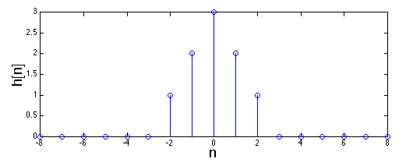

1. Plot the Frequency response of this filter
2. Plot the phase response of this filter
3. Plot the magnitude response of this filter

### ****Task 5: Real-World Signal Analysis****

**Objective**: Apply the Fourier Transform to a real-world signal (e.g., audio, ECG).

**Steps**:

* 1. Load a real-world signal (e.g., an audio file or ECG data).
  2. Compute the FFT and analyze the frequency components.
  3. Identify dominant frequencies and their significance.

**Task 6:** You have to design the ideal low pass filter with fixed length approximation of IIR Filter, by using different values of M. Sample output is given below. Find h[n] for each, make it causal and plot the frequency, phase, and magnitude response of the system.

