**Nama: Wahda Adella Putri Febriana**

**Kelas: 1B / 244107020156**

**Absen: 24**

**Persiapan**

1. Buat file book.java

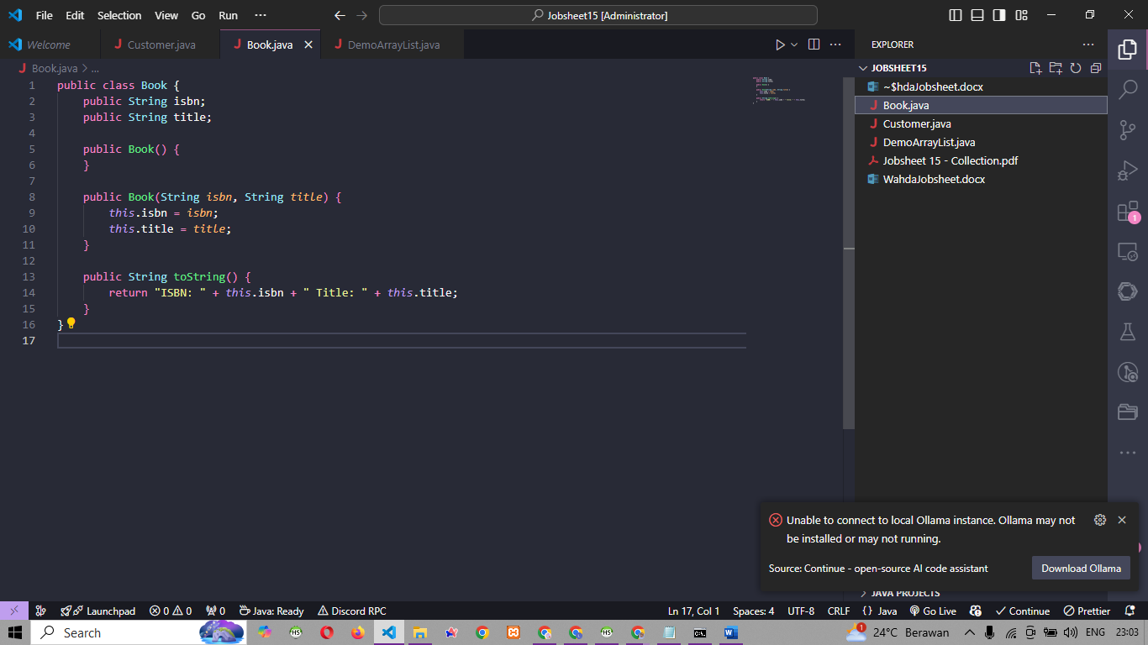

1. Buat file Customer.java

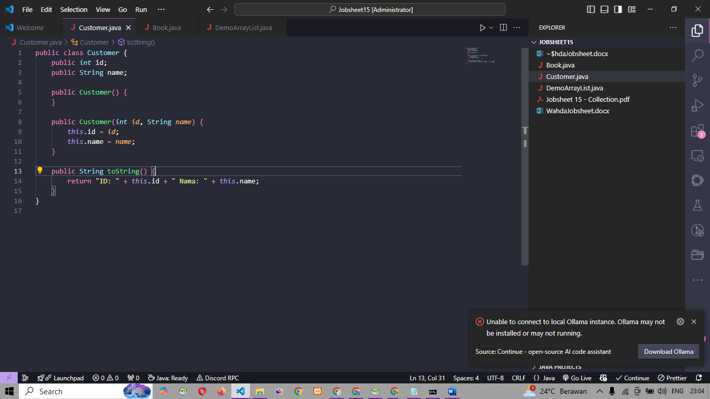

**Praktikum**

1. Buat file DemoArrayList.java

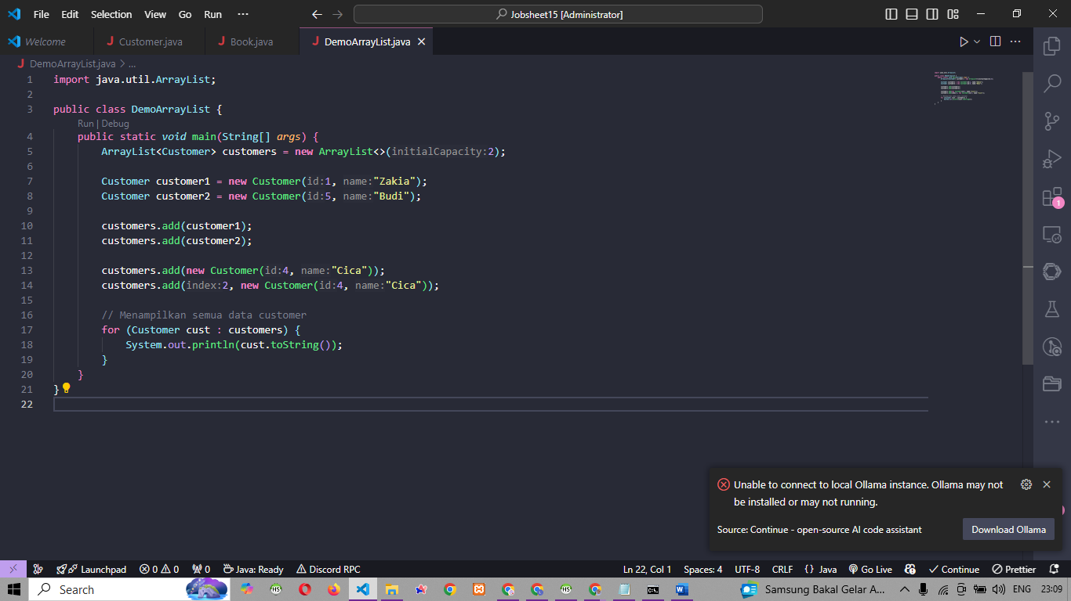

1. Hasil Run

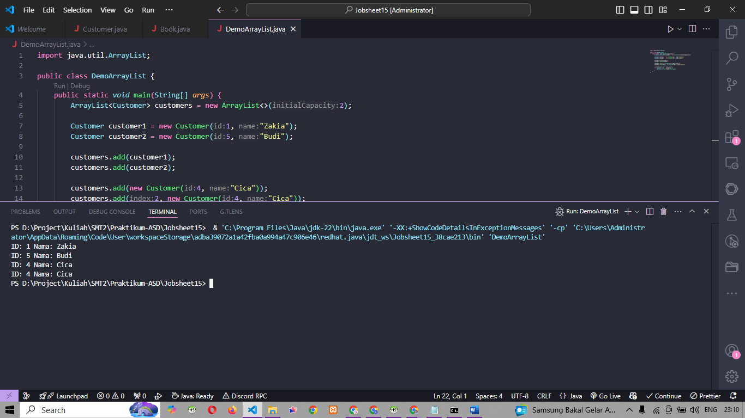

1. Update code

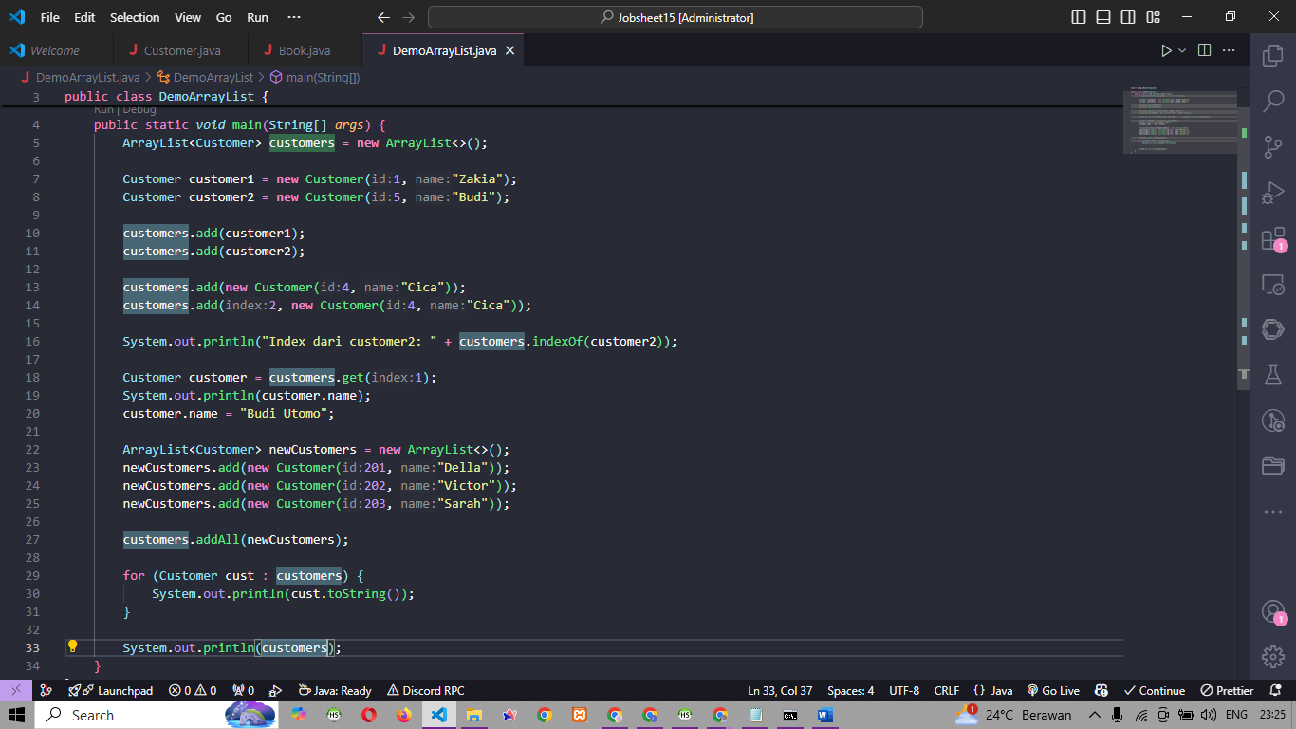

1. Hasil run

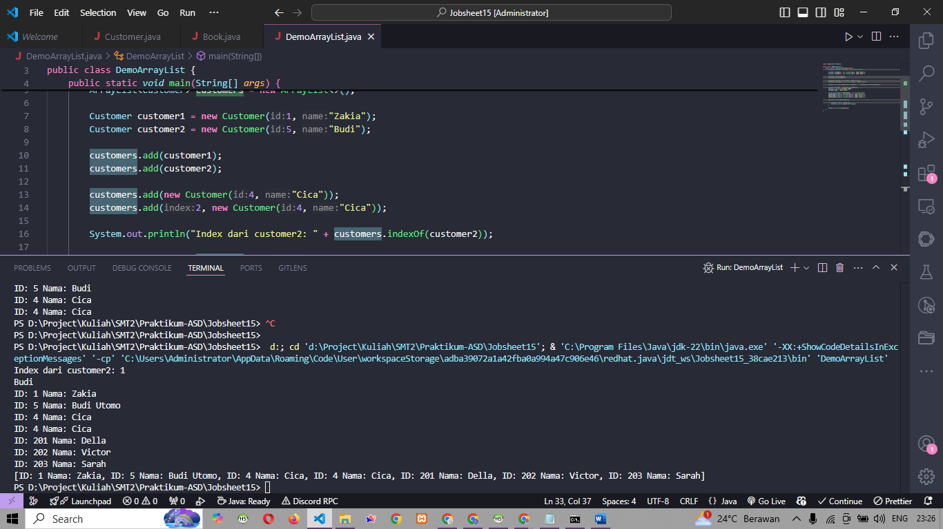

**Praktikum**

1. Buat file stackdemo.java

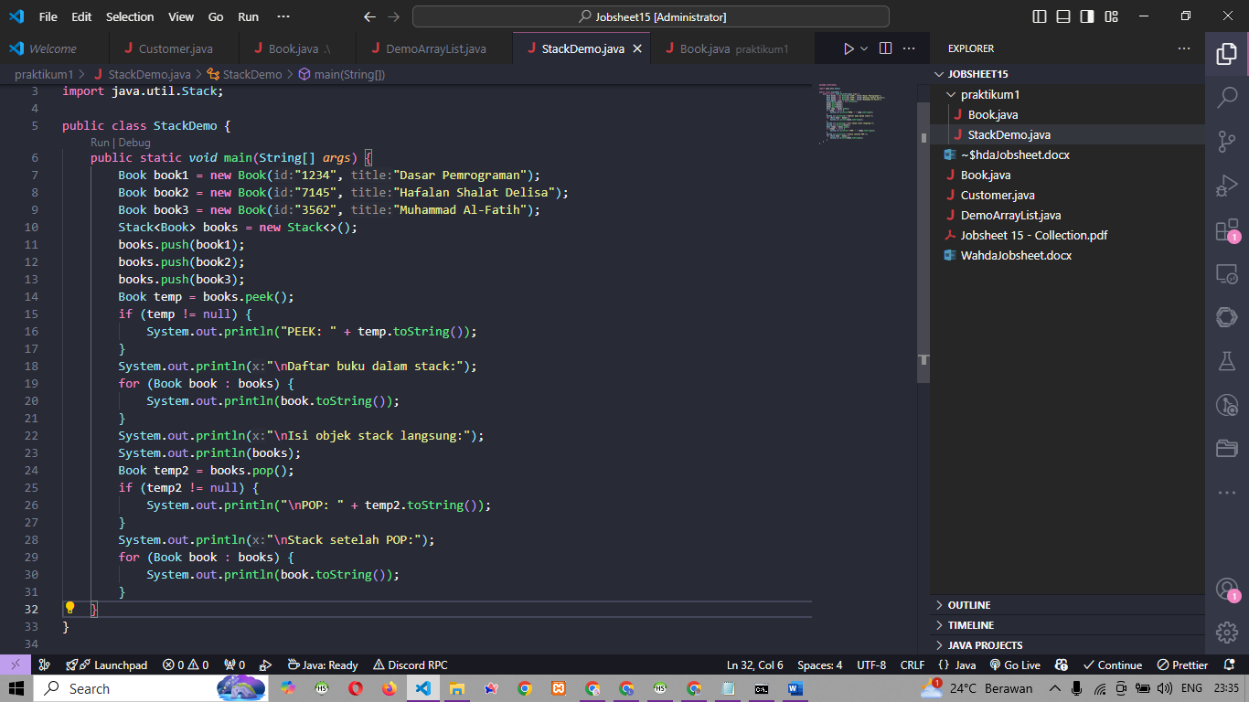

1. Buat file book.java

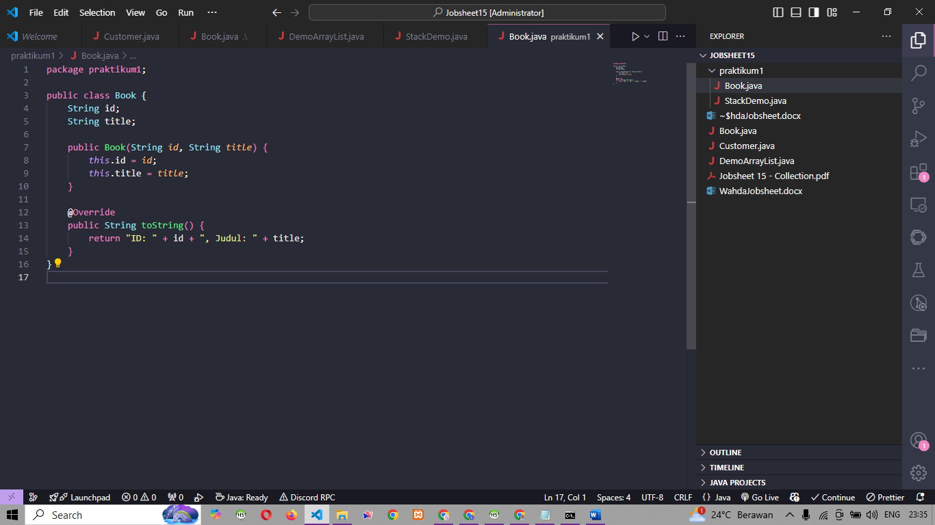

1. Hasil Run

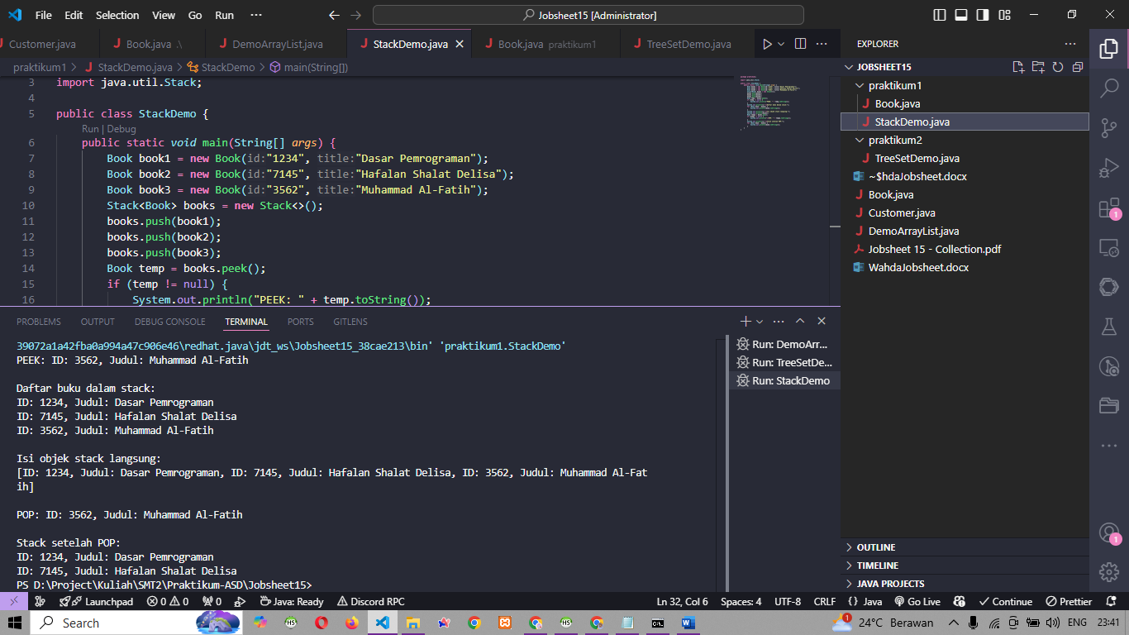

**Praktikum**

1. Buat file test set demo

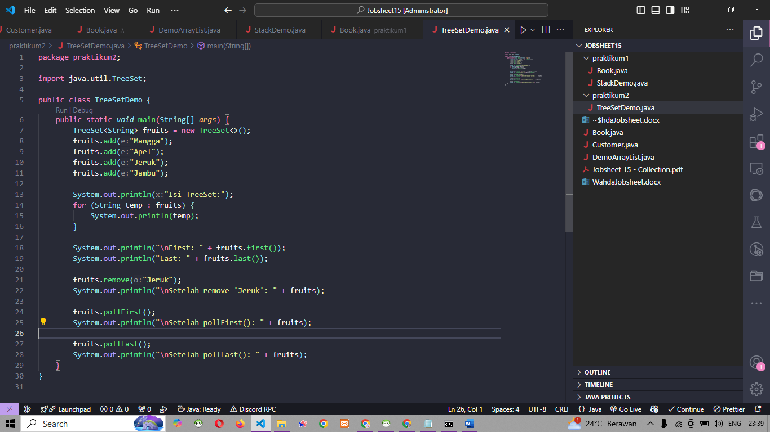

1. Hasil run

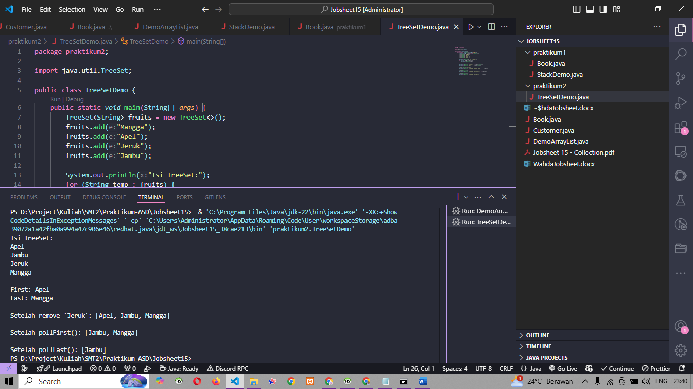

**Praktikum**

1. Main

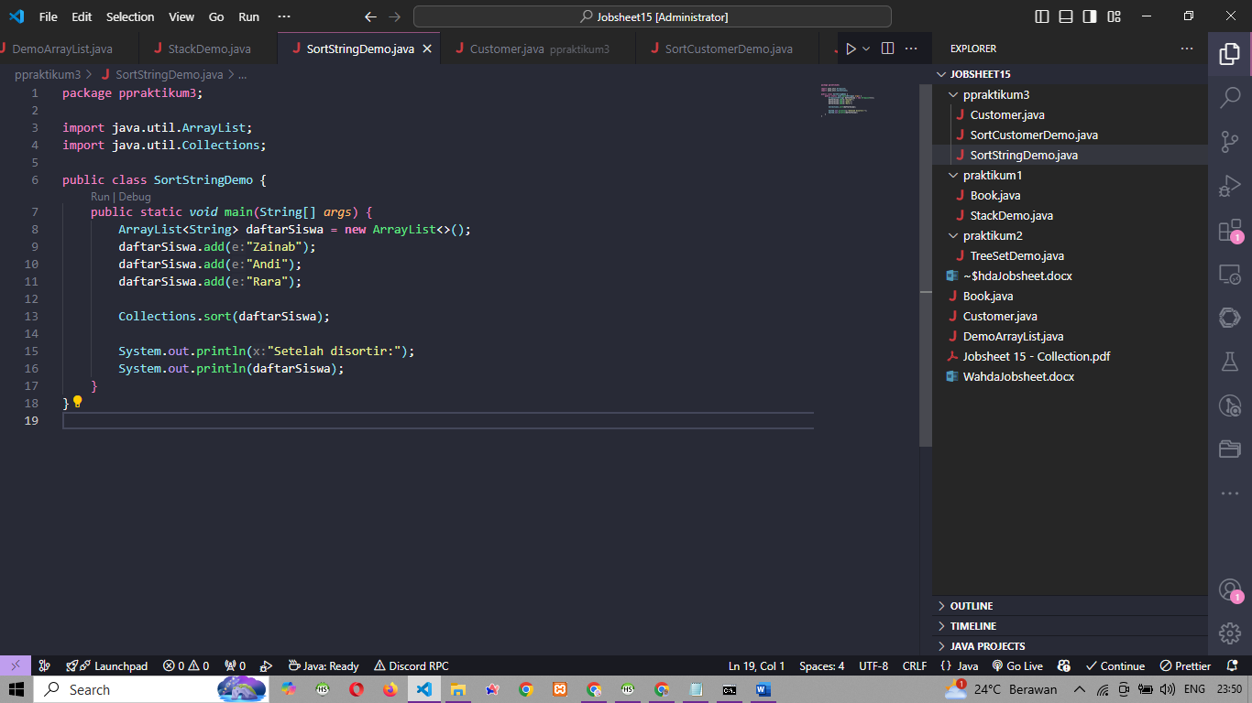

1. SortCustomerDemo.java

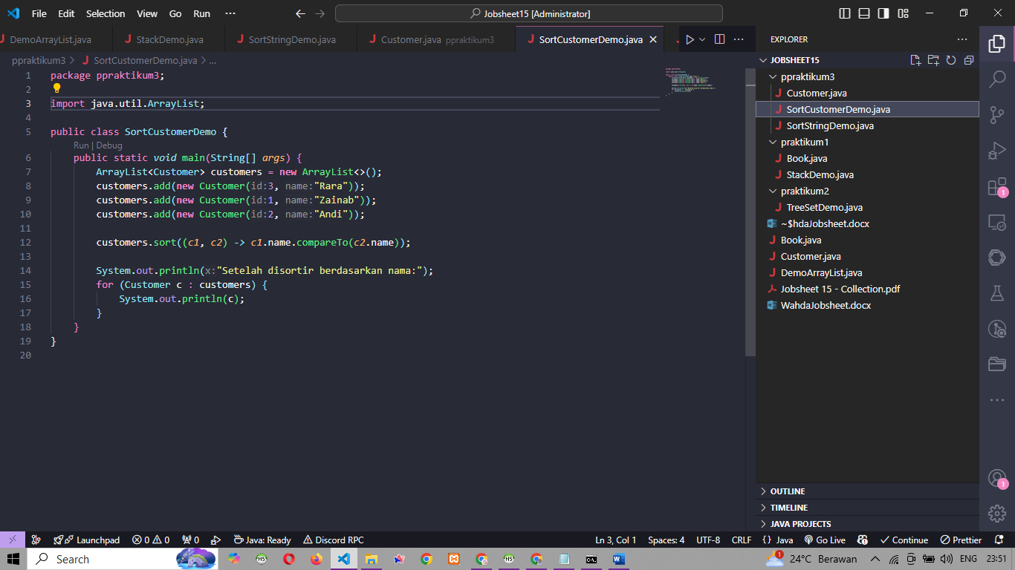

1. Customer.java

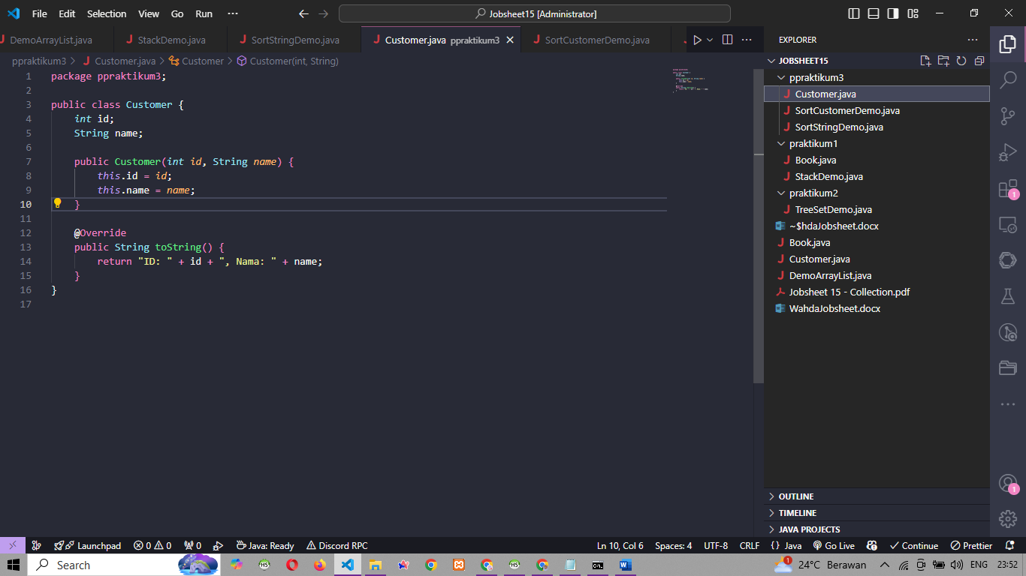

1. Hasil run

