Recognition of Sign Language Digits using ConvNets
Waheed Gulzar

Abstract—This Document tells how the recognition of the sign language digit using ConvNets.
Keywords—convolutional neural network, digit recognition, image classification (key words)

Introduction
Understanding a Sign language is a tough task and hard to interpret. The convolutional network helps to recognize the digit using sign language.

Data Set of Sign Language
The dataset includes 64 x 64 greyscale images of sign digits from 0-9. The dataset is downloaded from Kaggle.
Images were split into 85 % training and 15 % validation subsets while maintaining class balance.

methodlogy

Preprocessing of data
- Images loaded via tf.keras.utils.image_dataset_from_directory.
- Pixel intensities normalized to [0, 1].
- Optional augmentation: horizontal flip, ±8 % rotation, ±5 % zoom.
- Labels were integers 0–9 (used with sparse_categorical_crossentropy).

Model Architecture
Layers | Details
Input | 64 x 64 x 1
Conv2D | 32 Filters 3 x 3
MaxPooling2D | 2 x 2
Dropout | 0.25
Conv2D | 64 x 64 x 3
MaxPooling2D | 2 x 2
Dropout | 0.25
Dense | 128 units, RELU, (L2=0.001)
Dropout | 0.5
Dense | 10 Units

Training
- Optimizer= Adam
- Initial training rate: 0.001
- Batch Size: 32
- Epochs Up to 40
- Early stopping where the learning rate is reduced to 0.5 to avoid overfitting.

HyperParameters Experiment

HyperParameters:
Hyperparameters | Value
Batch Size | 32
Learning rate | 0.001
Drop Ratio | 0.25-0.5
L2 | 0.001

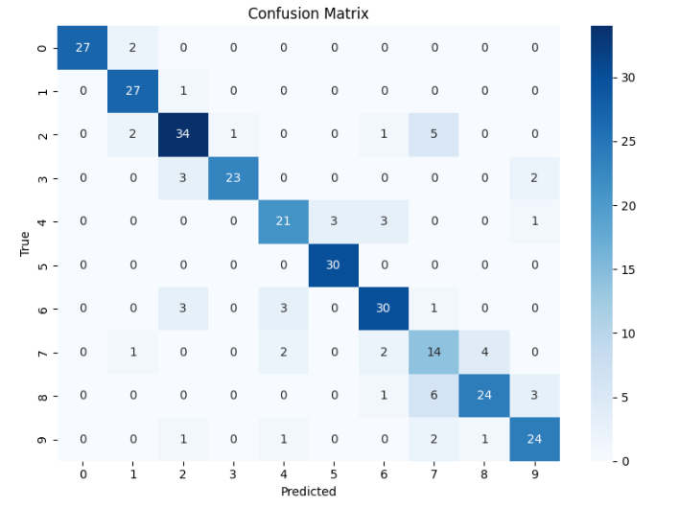
Results:
Figure 1: Confusion matrix
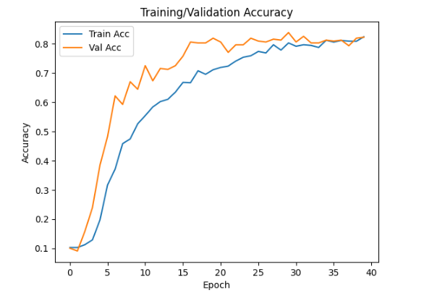
Figure 2: Training and validation comparison

Hyperparameters:
Hyperparameters | Value
Batch Size | 64
Learning rate | 0.0005
Drop Ratio | 0.25-0.5
L2 | 0.0001

Results:
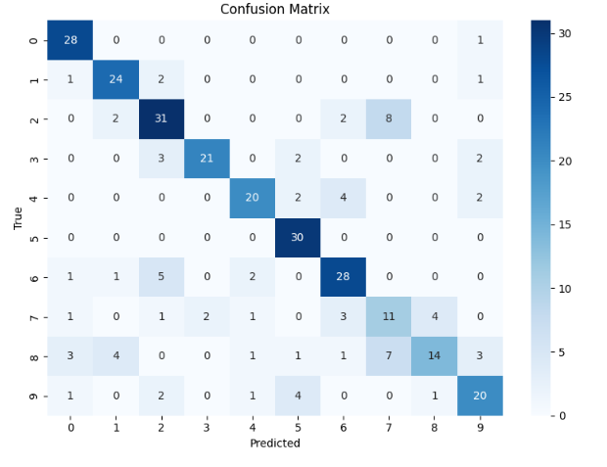
Figure 3: Confusion matrix for batch size 64
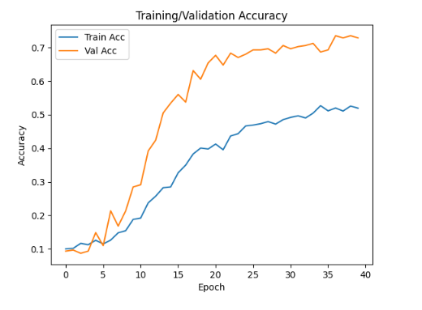
Figure 4: Validation and Accuracy Graph with batch Size 64

Hyperparameters:
Hyperparameters | Value
Batch Size | 32
Learning rate | 0.0005
Drop Ratio | 0.25-0.5
L2 | 0.0001

Results:
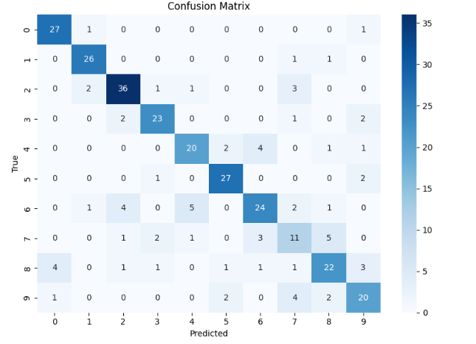
Figure 5: Confusion Matrix
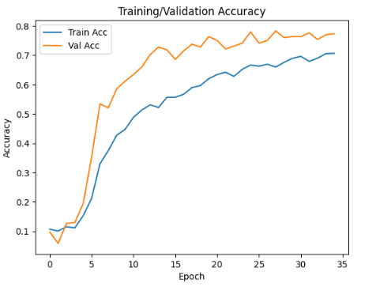
Figure 6: Training and Accuracy Plot

Results
The best performance was with batch size 32, learning rate 0.001, dropout 0.25/0.5, and L2=0.001.
Where the validation accuracy rate is 0.8026
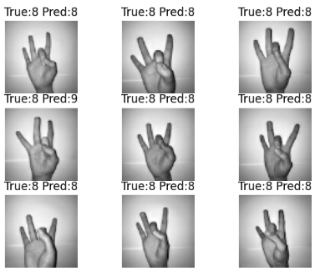
Figure 7: Results from the best model

Conclusion
We have implemented CNN and achieved 80% of accuracy.
The use of Convolutional Neural Network can help in the sign gestures recognitions.

References:
[1] A. Mavi, “Sign Language Digits Dataset,” Kaggle, 2017. [Online]. Available: https://www.kaggle.com/ardamavi/sign-language-digits-dataset
[2] F. Chollet, Deep Learning with Python, 2nd ed. Manning, 2021.
[3] TensorFlow/Keras Documentation, https://www.tensorflow.org/
[4] Project Sign language recognition, https://github.com/imRishabhGupta/Indian-Sign-Language-Recognition.git

