**SQL**

**SELECT * FROM vrinda_store.sales_data limit 5;**

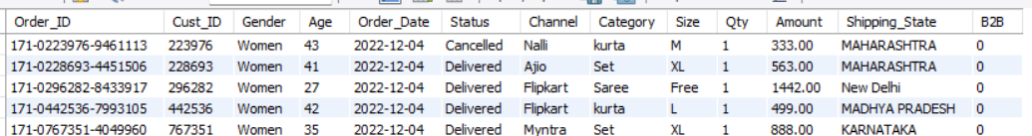

**select sum(amount) as Total_Revenue from vrinda_store.sales_data;**

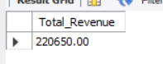

**select Channel, sum(Amount) as Total_Revenue_per_channel**

**from vrinda_store.sales_data**

**group by Channel**

**order by Total_Revenue_per_channel desc;**

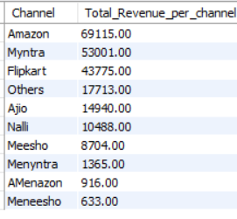

**select Category, sum(Amount) as Total_Revenue_per_category**

**from vrinda_store.sales_data**

**group by Category**

**order by Total_Revenue_per_categorys desc;**

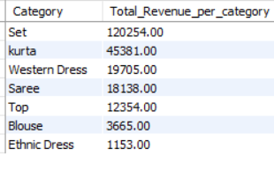

**select Shipping_State, sum(Amount) as Top_5_States_by_Revenue**

**from vrinda_store.sales_data**

**group by Shipping_State**

**order by Top_5_States_by_Revenue desc**

**limit 5;**

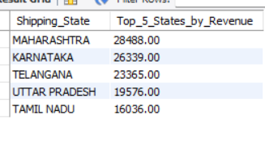

**select sum(Amount)/count(Order_ID) as Avg_Order_Value**

**from vrinda_store.sales_data ;**

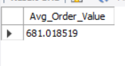

**select Channel ,Category**

**from (**

**select Channel ,Category , sum(Amount) as amt,**

**Dense_Rank() over(partition by Category order by amt desc) as rnk**

**from vrinda_store.sales_data**

**group by Channel , Category**

**) as t**

**where rnk<=1;**

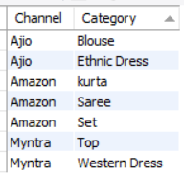

**SELECT Gender,**

**(SUM(Amount) * 100.0 / SUM(SUM(Amount)) OVER ()) AS Revenue_Percentage**

**FROM vrinda_store.sales_data**

**GROUP BY Gender**

**ORDER BY Revenue_Percentage DESC;**

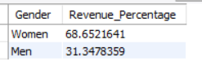

**select count(Order_ID) as cnt , Status**

**from vrinda_store.sales_data**

**group by Status**

**order by cnt desc;**

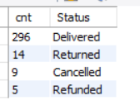

**select Category , Size**

**from (**

**select Category, Size , count(Order_ID) as cnt,**

**dense_rank() over (partition by Category order by cnt desc) as rnk**

**from vrinda_store.sales_data**

**group by Category ,Size**

**) as t**

**where rnk=1;**

