Fraud analytics uses big data analysis to find patterns from massive amounts of transactions. Insights collected can help organizations catch and prevent suspicious activity by identifying essential trends. It combines artificial intelligence (AI), machine learning, and predictive analytics.
By combining tech analytics with human expertise, fraud experts can spot fraud more easily, find patterns that humans might miss, and prepare for new threats. Most importantly, businesses can react swiftly to potential risks in real time.

Insurance companies are increasingly using AI-driven analytics, machine learning, and, in 2026, advanced simulation models to detect fraud, reducing billions in losses and lowering premiums. These systems analyze vast datasets for anomalies, such as staged accidents or falsified medical records, while tools like computer vision and natural language processing (NLP) verify documents.
Key Components of Modern Insurance Fraud Detection
- AI and Machine Learning: Algorithms identify hidden patterns in claim data, flagging suspicious activity faster and more accurately than manual reviews.
- Predictive Analytics: Models are trained on historical data to assign risk scores to new claims, predicting the likelihood of fraud.
- Network Analysis: These tools uncover links between claimants, medical providers, and repair shops to identify organized fraud rings.
- Image/Video Analytics: Computer vision validates accident scenes and damages, detecting photo manipulation or staged accidents.
- Special Investigative Units (SIUs): Human investigators review AI-flagged high-risk claims to confirm fraud.
Deloitte +6
Fraud Detection Techniques
- Supervised Learning: Models trained on historical fraudulent claims to detect similar patterns in new data.
- Unsupervised Learning: Algorithms identify anomalies and outliers that do not fit standard, legitimate claim profiles.
- Text Mining & NLP: Analyzes unstructured data, such as claims adjusters' notes, for inconsistencies.
- Rules-Based Systems: Automated triggers for specific red flags, such as high-value claims occurring shortly after policy inception
Fraud detection is the process of identifying suspicious activity that indicates criminal theft of money, data or resources might be underway.
From credit card theft to investment scams, account takeovers and money laundering, fraud is a widespread problem. The Association of Certified Fraud Examiners (ACFE) estimates that US businesses lose an average of 5% of their gross annual revenues to fraud.1 The Federal Trade Commission (FTC) found that US consumers lost more than USD 10 billion to fraudsters in 2023.2

Because of fraud’s significant impact on individuals and the economy, fraud detection is considered an essential capability in transaction-intensive industries such as e-commerce, banking, insurance, government and healthcare.

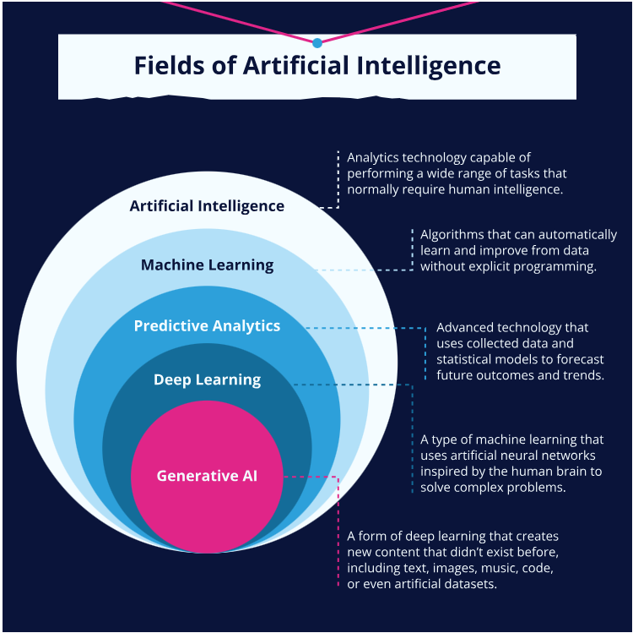

Key Benefits of Fraud Analytics

Predict Future Fraud Risk
Fraud analytics helps banks get ahead by predicting future risks with risk scoring. Machine learning models use past data to get better at catching new fraud patterns early. This forward-thinking approach helps banks stay one step ahead of fraudsters and move from detecting fraud to preventing it.

Detect and Prevent Fraud in Real Time to Reduce Revenue Losses
A critical advantage of fraud analytics is its real-time detection capabilities. The system uses pattern recognition and data analytics techniques to identify potential fraud rapidly. Real-time monitoring immediately flags anomalies, reducing the impact of fraud. Earlier detection also empowers banks to prevent potential losses for the bank and customers.

Improved Customer Satisfaction and Trust
Proactive fraud prevention measures powered by advanced fraud analytics create a protective shield around customer assets. Banks reassure customers that their funds and sensitive information are safe, improving customer satisfaction and trust in their bank.

Resource Optimization
With fraud analytics, financial institutions can focus on the riskiest cases using data insights. This means less time spent on manual investigations, so teams can prioritize what matters most. This boosts efficiency and saves money by stopping the most significant fraud threats.

Uncover More Fraudulent Activities
Fraud analytics proactively detect and prevent a wide range of suspicious activities, including:

Credit Card Fraud
A fraudster steals a credit card and makes small online purchases to avoid suspicion. They eventually move on to bigger purchases.
- Stopping Credit Card Fraud. Fraud analytics can flag unusual spending patterns, location changes, and transactions with unknown merchants. Machine learning algorithms can also review historical data and user behavior to flag anomalies.
- Benefit. Early detection protects both the customer and the bank from financial losses.

Debit Card Fraud
Fraudsters use skimming technology to steal debit card information at ATMs or gas station card readers. When a customer swipes their debit card, the skimmer reads and steals the card’s info.
- Stopping Debit Card Fraud. Fraud analytics can detect potentially fraudulent activity based on location, time, and amount compared to the customer’s usual spending habits. Meanwhile, geo-location tracking can identify attempted ATM withdrawals from unfamiliar places.
- Benefit. Banks can protect their customers’ funds and businesses from potential chargebacks.

Account Takeover
A fraudster uses phishing tactics to steal a customer’s login info, change their password, and transfer their money to an account they control.
- Stopping Account Takeover Fraud. Fraud analytics can use behavioral biometrics technology to detect login attempts from unrecognized devices or locations. Using multi-factor authentication and anomaly detection enables banks to prevent unauthorized access and transfers.
- Benefit. Banks protect customer data and prevent unauthorized transfers, building strong customer trust.

ACH Fraud
Criminals breach a company’s payroll system to initiate fraudulent ACH transfers, diverting employee salaries to the criminal’s accounts.
- Stopping ACH Fraud. Fraud analytics spots strange payment activity, mismatched names, and account info that doesn’t match payroll data.
- Benefit. Banks prevent losses for businesses and protect employee payments, which keeps clients happy and the economy stable.

Synthetic Identity Fraud
Criminals create fake identities using stolen information from various sources and apply for credit cards and loans.
- Stopping Synthetic ID Fraud. Link analysis can identify suspicious connections between seemingly unrelated accounts and transactions. Additionally, fraud analytics can detect unusual patterns that are red flags for synthetic identities.
- Benefit. Fraudulent accounts and loan applications threaten the entire financial system. By implementing fraud analytics, banks take an active role in protecting the system, protecting banks themselves and legitimate borrowers.

Account Opening Fraud
Fraudsters use stolen personal information to open new bank accounts online, potentially for money laundering or other illegal activities.
- Stopping Account Opening Fraud. Fraud analytics can cross-reference applicant information with databases of known fraudulent activities and verify information with external sources to identify suspicious applications.
- Benefit. Banks can block the opening of fraudulent accounts and protect themselves from financial losses and potential involvement in illegal activities.
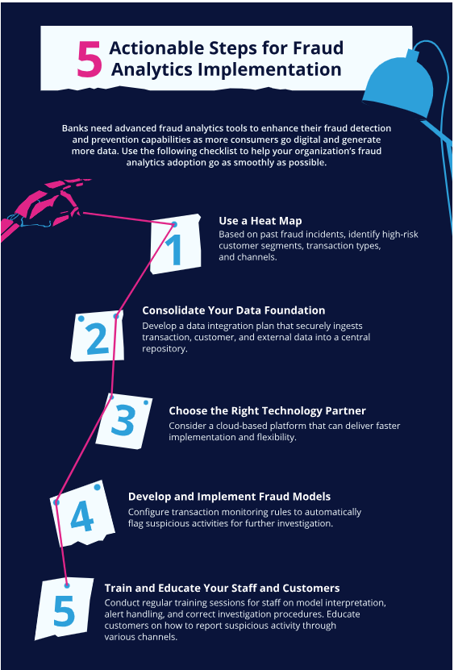

Scams
Fraudsters deceive people into making payments for goods and services that don’t exist, impersonate family, friends, or coworkers, or play with human emotions to lead victims into making money transfers, sometimes draining entire lives.
- Stopping Scams. Fraud analytics can help differentiate between different types of scams (e.g., CEO fraud and romance scams have very different modus operandi, and that’s reflected in the data)
- Benefit. Banks can tune their risk strategy to better fit the situation at hand. E.g., by having different user journeys depending on the flagged risk or by having different scripts for Fraud operators to communicate with the customer

Using AI & Machine Learning for Fraud Analytics
Traditional rule-based systems have limitations in detecting new and complex fraud patterns. By analyzing extensive datasets, artificial intelligence and machine learning algorithms can detect minute irregularities that human analysis might miss.
Here’s how integrating AI and machine learning has revolutionized fraud analytics and delivered powerful tools to combat evolving fraud tactics.

AI and Machine Learning: Key Fraud Analytics Capabilities
AI and machine learning offer several key capabilities for fraud analytics. These include:
- Pattern recognition: AI algorithms can recognize complex patterns and relationships in data to detect fraudulent activities.
- Anomaly detection: Machine learning models identify potential fraud by detecting anomalies in behavior.
- Predictive analytics: AI can predict future fraud risks by analyzing historical data and trends.
- Real-time analysis: Real-time analysis enables immediate fraud detection and prevention without delay.
- Automation: Automatically streamlines fraud detection processes, reducing the need for manual review.

AI and Machine Learning Techniques Used in Fraud Analytics
Various AI and machine learning techniques are employed in fraud analytics. These include:
- Supervised learning: Supervised learning algorithms are trained using labeled data to classify transactions as either fraudulent or legitimate.
- Unsupervised learning: Unsupervised learning algorithms identify patterns and anomalies in unlabeled data.
- Deep learning: Using neural networks, deep learning can analyze complex data to detect sophisticated fraud schemes.
- Natural language processing (NLP): NLP can analyze text data, such as customer communications, to detect fraud indicators.

Key Benefits of Fraud Analytics
The benefits for businesses that use AI and machine learning in fraud analytics include:
- Improved accuracy: Using AI and machine learning models, fraud analytics platforms can detect fraud with greater accuracy than traditional methods
- Increased efficiency: Automated fraud detection enhances efficiency by decreasing the time and resources needed.
- Enhanced real-time detection: Real-time detection enables the immediate prevention of fraudulent activities.
- Adaptability: Machine learning models can detect evolving patterns and quickly adapt to new fraud tactics.
- Scalability: AI solutions make scalability more achievable to reviewing large volumes of data and transactions.

