System Design Document (SDD)

Project Name: TechBoard Prepared by: Sajib Jahan Date: March 16, 2025

Date | version | Prepared by | Checked by
20/03/2025 | 1.0.0 | Sajib Jahan | Masihur Maruf

1. System Overview

1.1 Core Features
- Job Listings: Local, remote, freelance positions with filters for tech stack, location, salary, and experience.
- Recruiter Platform: Tools for posting, managing, and analyzing job listings.
- Job Seeker Platform: Profiles, resume building, job recommendations, and skill suggestions.
- AI-Powered Features: Resume grading, job recommendations, career path predictions.
- Contract Hiring System: Freelance project-based system with milestone tracking, chat, and file sharing.
- Subscription System: Access to features based on free, pro, or enterprise plans for both job seekers and recruiters.
- Admin Panel: Platform moderation, user management, and billing controls.

1.2 Stakeholders
- Job Seekers
- Employers/Recruiters
- Platform Administrators

2. Architecture Diagram
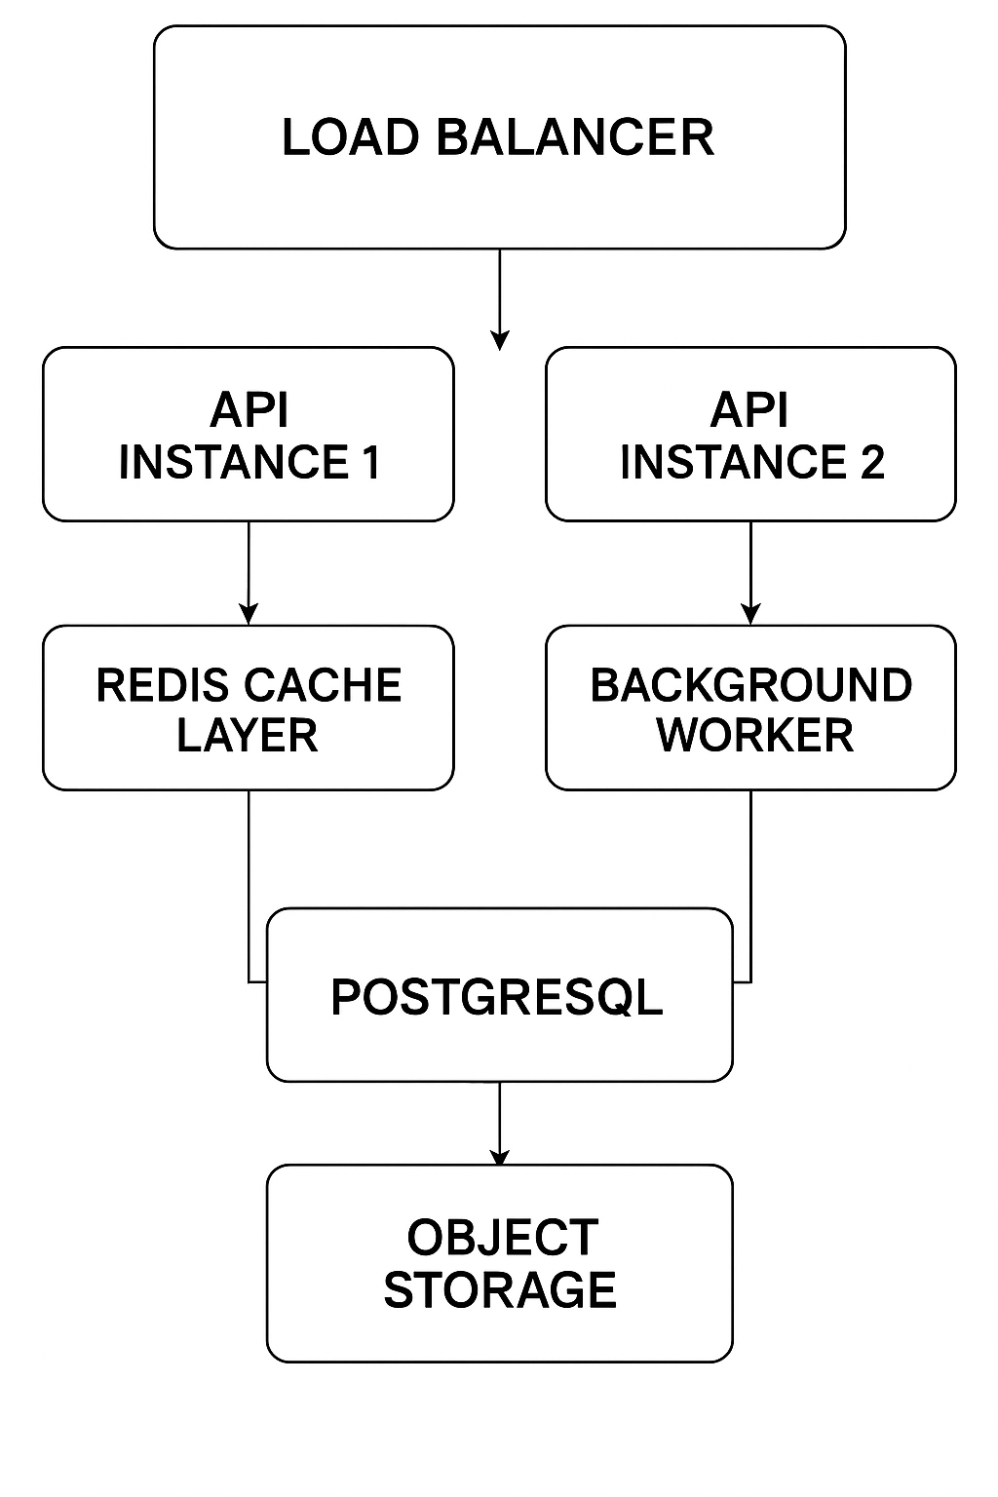

3. Component Breakdown
3.1 Rest API Service
- Handles all external and internal communications via RESTful endpoints
- Provides endpoints for job listings, job applications, user profile management, bookmarks, categories, resumes, and admin functions
- Applies versioning for backward compatibility.

3.2 Admin Dashboard
- Internal UI for platform administrators. API versioning
- Interfaces with internal APIs for real-time data.
3.3 User & Role Management
- Handles registration, login, role assignment (Seeker, Recruiter, Admin).
- Implements password hashing, reset workflows, email verification.
3.4 Storage & File Management Service
- Abstracts upload, retrieval, and deletion of resume files

3.5 Caching & Rate Limiting Service
- Implements API throttling/rate-limiting to prevent abuse
- Reduces DB load for read-heavy endpoints
- Redis-backed caching layer for common queries
3.6 Notification & Email Service
- Sends emails for registration, password reset, job alerts, application status
- Integrated with SMTP or external providers
4. API Design Overview
This section provides an overview of the RESTful APIs that serve as the communication interface between the frontend and backend of the JobBoard system. These APIs will support key functionalities for job seekers and recruiters.
4.1 User Management
- POST /auth/register – Register a new user (seeker or recruiter)
- POST /auth/login – Authenticate user and return JWT
- GET /users/me – Get current authenticated user profile
- PUT /users/me – Update profile
  - Job Postings
  - GET /jobs – Retrieve job listings with filters (search, location, tags, remote, etc.)
  - GET /jobs/{id} – Retrieve a specific job posting
  - POST /jobs – (Recruiters only) Create a new job post
  - PUT /jobs/{id} – (Recruiters only) Update job post
  - DELETE /jobs/{id} – (Recruiters only) Remove job post
  - Job Applications
  - POST /jobs/{id}/apply – (Seekers only) Apply to a job
  - GET /applications/me – (Seekers only) Get list of applied jobs
  - GET /jobs/{id}/applications – (Recruiters only) Get applicants for a job
  - Saved Jobs & Bookmarks
- POST /bookmarks – Save a job
- GET /bookmarks – List saved jobs
- DELETE /bookmarks/{id} – Remove bookmark
5. Database Design
5.1 Tables
- Users: Id, Name, Email, PasswordHash, CreatedAt
- Jobs: Id, Title, Description, CompanyId, Location, IsRemote, SalaryRange, PostedAt
- JobApplications: Id, JobId, ApplicationId, ResumeUrl, CoverLetter, AppliedAt, Status
- Companies: Id, Name, CompanyType, CompanySize
- Resumes: Id, UserId, ResumeUrl, OptimizedText, CreatedAt
- Skills: Id, Name
- JobSkills: JobId, SkillId
- Categories: Id, Name
- JobCategories: JobId, CategoryId
- Bookmarks: Id, UserId, JobId, CreatedAt

6. Security
- Authentication: OAuth2 with JWT tokens for secure user sessions.
- Access Control: Role-based access control (RBAC) for job seekers, recruiters, and admins.
- Input Validation: Prevent SQL injection, XSS, and other security threats.
- Protection: Rate limiting, CSRF protection, and optional two-factor authentication.

