**Chapter 4**

**Feasibility Analysis**

**4.1 Introduction**

For understanding the structure and the work process of Bangladesh Telecommunications Company Limited structured analysis tools can be used. These tools like dataflow diagram, decision trees etc. are mainly graphical representation. In this section we also do feasibility analysis. The existing system is working manually and need human interruption. But we can improve this system if we can implement an artificial Intelligence computerized system in this section. This part is on such candidate system and proves that our system is performing better than the existing system. In feasibility study phase we had undergone through various steps which are describe as under:

* Identify the starting point of the data at various level 
* Identify the desire for workers and the result from AI modernized framework. 
* Analyze the disadvantage of existing framework (manual) framework 
* Comparing execution between the current and the proposed framework 

**4.2 Working of present manual system**

* Engineers have to control the network using the tower control frequency manually. 
* Engineers have to maintain between two computer or/and terminals. 
* There is Wireless communication to support man and machine mobility. 
* Intelligent capability of switching system to support complex and huge switching the world over with a universal code or number. 

The existing system does not have any online database for accounts section. 

**4.3 Potential candidate systems**

1. Introducing one extra generator to constant force age.

2. Introducing AI support framework in control room.

3. Introducing data base the board framework to store the records data

4. Complete infrastructure details / Network plan including schematic diagrams with full equipment details.

The qualities of every applicant frameworks are talked about quickly in the accompanying area to assess the best up-and-comer frameworks. The Customer will be obliged to submit a filled up application along with the following information. Under this agreement BTCL will provide the International Private Leased Circuit (IPLC) connection to the customer in order to establish a dedicated secure digital point-to-point private connection between two locations-one location at Bangladesh and other at overseas country.

**4.4 Identification of characteristics of each candidate system**

Identification of the characteristics of potential candidate systems depends on the performance and developing cost of that system. In contrast with the existing system two potential candidate systems has been enumerated.

The first characteristics is proposed to network. In Bangladesh Telecommunications Company Limited. In traditional telephone communication the call set-up is actually made between the end terminals (telephone handsets/machines). Similarly, in conventional data communication the same is done between two computer or/and terminals

The second characteristic is for the control room. The control room is maintained manually by technical stuffs. If there is a failure, the alarm rings and the staffs have to manually stop the generation. So, we introduce an Artificial intelligence maintenance system to control the system virtually.

The third characteristics is a database management system to store the information so that no information is lost. For keeping track on accounts, the existing system uses a ledger book and write the information on it. So, we introduce a form to write the information and save it in a DBMS system.

**4.5 Advantages of Proposed System**

The AI system is developed to cope up with the current environment and problems of the BTCL. The system can automatically and make decisions itself whenever problem is occurred. 

 

* **Save cost**: After computerized system is implemented less human force will be required to maintain the control room thus reducing the overall cost. 

 

* **Save time**: Specialists have closed down the plant physically or if issues happened, they need to manage them physically. New modernized AI framework takes control naturally. In this way it spares significant time*.* 

 

* **User Friendly**: Control room engineers can shutdown generator or transformers with a single click and able to keep track on engine conditions and issues.
* **Data loss:** We introduce a DBMS system to store the ledger book information so that no data is lost or destroyed.

**4.5.1 Registration and Installation Charges**

The Registration and Installation charges will be included in the Demand Note along with advance rental charges as approved by the concerned authority. For restorable capacity, charges will be 1.25 times higher. Restorable capacity will be 25% of the main capacity, which is minimum 64 Kbps. Upon approval by the board, Overseas Telecommunication Region (OTR) will issue Demand Note (Invoice) for the IPLC. The voice-based application through IPLC will depend on the following conditions:

• needs prior approval from BTCL

• Should be application specific.

• Point to point and limited within close user groups.

• Cannot be terminated to any Public Telecommunication Network.

When BTCL pays the other half charge on customer’s behalf, BTCL will add its markup to the other end price. The charges will be collected in advance. This mark up will cover BTCL overhead expenses and any variation in foreign currency rate.

**4.5.2 Customer’s Liability**

• Sharing of IPLC bandwidth wholly or partly is not allowed.

• IPLCs may be terminated on Customer's private leased line network. Customer will

inform the details of terminations.

• IPLC must not be used for any illegal, fraudulent, immoral or improper purpose.

• IPLC must not be used for sending any communication, which is of offensive, abusive,

indecent, obscene, defamatory or threatening in nature.

• Re-filing traffic from one country to another is not permitted.

• Call centers can transmit voice for its functioning subject to the conditions described in

the guidelines for facility provisioning by BTCL to Call Centers.

**4.6 Feasibility Study**

The feasibility study performs mainly in following ways-

1. Economic Feasibility

2. Technical Feasibility

3. Behavioral Feasibility

**4.6.1 Economic Feasibility**

The economic system of BTCL is highly efficient. The organization don’t need to spend much money for the development of the system because it’s already exist. Upon approval by the board, Overseas Telecommunication Region (OTR) will issue Demand Note (Invoice) for the IPLC. The Registration and Installation charges will be included in the Demand Note along with advance rental charges as approved by the concerned authority. For price calculation of higher bandwidth, multiplication factor will be applied after adding this charge. Registration & Installation charges for the domestic portion will not be charged except the case of submarine cable to the Customer’s premise. When BTCL pays the other half charge on customer’s behalf, BTCL will add its markup to the other end price. The charges will be collected in advance. This mark up will cover BTCL overhead expenses and any variation in foreign currency rate.

**4.6.2 Technical Feasibility**

BTCL provides co-location service including building, cooling, power, bandwidth and physical security. This facility is provided considering the type of equipment, power consumption, floor loading and such other technical feasibility. Our clients are IGW, ICX, IIG, ITC, DDCSP, NTTN IPTSP, ISP, Mobile Operators, Telephone E1 etc. The technical feasibility divided into three configuration. They are -

1. Hardware configuration.
2. Software configuration.
3. Satellites.

**1.Hardware** **configuration:**

BTCL provides the International Private Leased Circuit (IPLC) connection to the customer in order to establish a dedicated secure digital point-to-point private connection between two locations-one location at Bangladesh and other at overseas country. BTCL allocates bandwidth from 64 Kbps to 2 Mbps depending on the requirement and justification of the customer and higher bandwidth up to 45 Mbps will be allocated after scrutiny by BTCL. The customer will request for up-gradation of the bandwidth of the IPLC to BTCL with detail reasoning.

Server –

Bandwidth : 64 Kbps - 2 Mbps

Server : Cloud [ADSL2+](https://en.wikipedia.org/wiki/ADSL2%2B) technology

Cable : 5mm. broadband fiber cable

**2.Software configuration:**

Operating System : windows 10

Language : Java and HTML

Database : SAP and DB2

Website : www.btcl.com.bd

E-mail:  btclit@gmail.com

**3.Satellites:**

Bangladesh's first satellite on earth's orbit will have 40 transponders to provide telecommunications and broadcast services. US-based Space Partnership International (SPI) has already started designing the satellite and will also help launch it under a contract signed with the government. The two ground stations that will control the satellite will be built at Gazipur's Joydebpur and Rangamati's Betbunia on the land owned by Bangladesh Telecommunications Company Limited (BTCL). The government plans to have the satellite, named after the Father of the Nation Bangabandhu Sheikh Mujibur Rahman, sent to space by June 2017.

**4.6.3 Behavioral Feasibility**

The feasibility of the organization is good. The administrative authority is fully co-operative to employers. BTCL pays the other half charge on customer’s behalf, BTCL will add its markup to the other end price. The charges will be collected in advance. This mark up will cover BTCL overhead expenses and any variation in foreign currency rate. The annual charges of the approved tariff schedule will be applicable for connections having minimum commitment time of 1 (one) year and the charges shall be payable in advance on quarterly basis. The customer will not be refunded the registration and installation charges if the order is cancelled in whole or in part prior to the complete installation or service commencement date.

**4.7 Charge & Rate of Services**

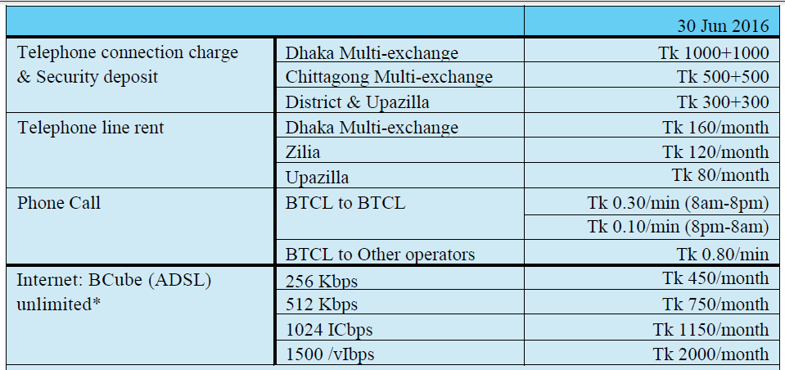

Table 4.1: Charge & Rate of Services

*Registration charge: Tk 100, Setup + Configuration charge at BTCL Tk 300, Downgrade charge Tk 150, Upgrade Charge: Nil, Shifting: Tk 150, Modem/Router: Customers will purchase .

**4.8 BTCL Telephone (PSTN) & BCube (ADSL Internet) Status**

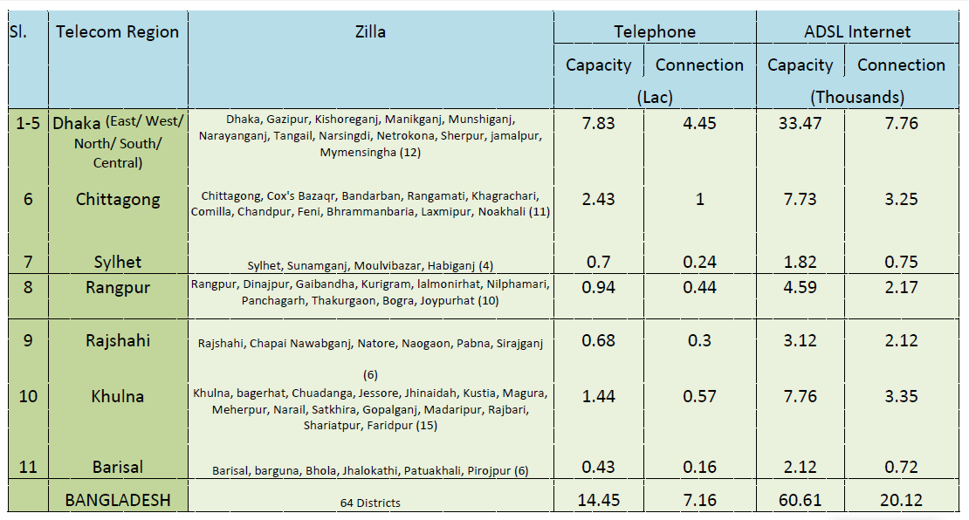

Table 4.1: BTCL Telephone Status

**4.9 Service cost of the organization:**



Figure: 4.1.1 cost of services of BTCL

**5.1 Determine performance and cost effectiveness using Evaluation matrix**

|  |  |  |  |  |
| --- | --- | --- | --- | --- |
| **Criteria of BTCL** | **Present method** | **Attribute 1** | **Attribute 2** | **Attribute 3** |
| Performance **:**  System accuracy  Network efficiency  Payment process  User-friendly  Reliability  Connection imbalance | Good  Very Good    Good  Excellent  Very Good  Fair | Very Good  Very Good    Good  Excellent  Very Good  Good | Very Good  Excellent    Very Good  Very Good  Excellent  Good | Excellent  Excellent  Very Good  Excellent  Excellent  Very Good |
| Costs **:**  System operation  Operating criteria  User device  Connection inquire | Very Good  Very Good  Good  Very Good | Very good  Excellent  Very Good  Very Good | Excellent  Excellent  Very Good  Excellent | Excellent  Very Good  Excellent  Excellent |

Table 4.2: Candidate System Evaluation Matrix

**5.2 Existing System VS Proposed System**

* The existing system of BTCL under ICT ministry but it was propused to observe under postal administration.
* Now the service of BTCL widely used all over the country but it was propused to use only for Government services.
* Existing system has an operating system installed in their computers for maintenance but there was no specific operating system in proposed system.
* Existing system of BTCL controlled by a server but the propused system was under human resource.
* Existing system give broadband connection but propused system was by fiber wire.
* In existing system subscriber can pay the bill through online but propused system was official.
* In existing system if any problem occurs subscriber can get rid from this in few minutes but in propused system it was complicated.
* The customer will request for up-gradation of the bandwidth of the IPLC to BTCL with detail reasoning.
* The requirement and justification of the customer and higher bandwidth up to 45 Mbps will be allocated after scrutiny by BTCL.

**5.3 Disconnection and Termination**

Minimum 3 months prior notice is necessary for Discontinuation of the IPLC within Initial Commitment.

1. If at any time during the Initial Commitment Period, the customer wishes to reduce the contractual

period or serves notice for termination, then

2. Month-to-month rate will be applicable for the serviced period if the commitment period is one year.

3. Month-to-month rate will be applicable for the remaining serviced period after counting the whole year

if the commitment period is more than two years.

4.The customer may terminate the IPLC by giving one month’s notice to BTCL at any time after the

Initial Commitment Period is expired.

**5.4 Change of ownership**

Change of Name of the owner due to merger, acquisition and or company name change shall incur charges as per tariff schedule.

**5.5 Conclusion**

The Company also acknowledges its responsibilities towards the stakeholders and subscribers by providing quality services thereby adopting the norms of transparent corporate governance. The Board of Directors of the Company would like to put on record the appreciation of the cooperation and support that were received from the Ministry of Post & Telecommunications. Teletalk Bangladesh Ltd, Bangladesh Submarine Cable Co.Ltd (BSCCL), Telephone Shilpa Shangstha Ltd. (TSS), Bangladesh Cable Shilpa Ltd. (BCS), other government organizations and private telecom operators & entities.