Aegis Flow Functional Setup Guide
Audience: Salesforce admins, implementation leads, support managers, and customer success teams
Last updated: 2026-08-01

1. What Aegis Flow Does
Aegis Flow helps Salesforce users and admins understand why an automation or custom process failed. When a supported failure happens, Aegis records the issue, groups it with similar issues, creates a user-safe explanation, and can notify the affected user through the Lightning utility bar.
The product is designed for:
- Users who need a clear next step instead of a confusing platform error.
- Admins who need to know which automation failed.
- Developers who need sanitized technical evidence.
- Support teams who need escalation packages without manually gathering logs.

2. What Users See
When Aegis has active alerts, the utility item is highlighted in the Lightning footer:
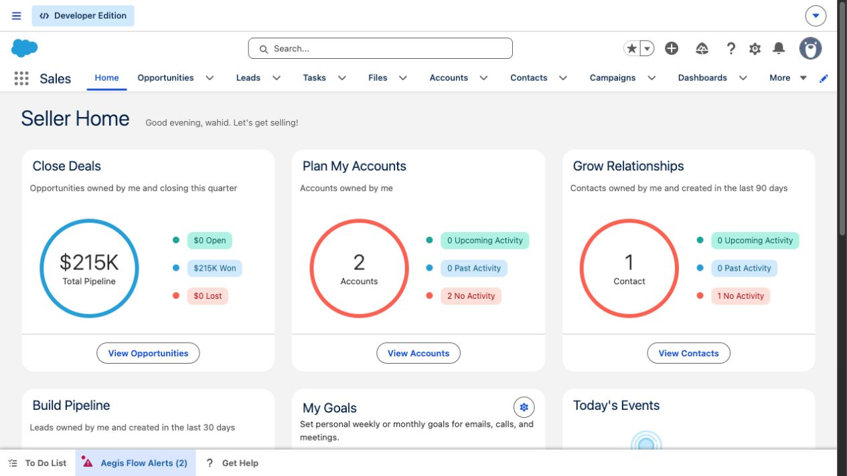
Aegis Flow highlighted utility alerts
When auto-open is enabled and the alert meets the policy threshold, the utility can open automatically:
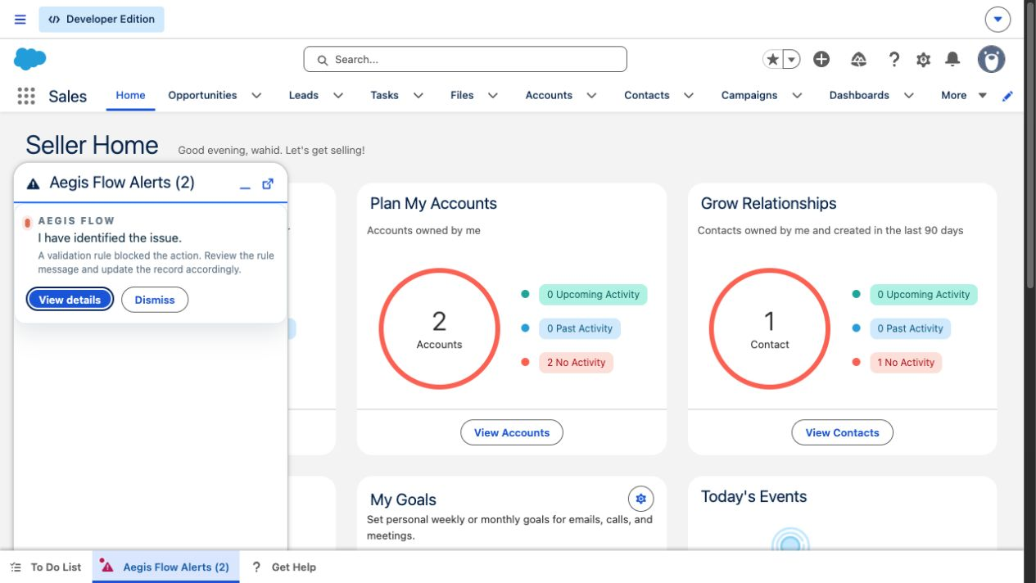
Aegis Flow auto-open alert panel
Users and admins can open the details panel to see the diagnosis and escalation options:
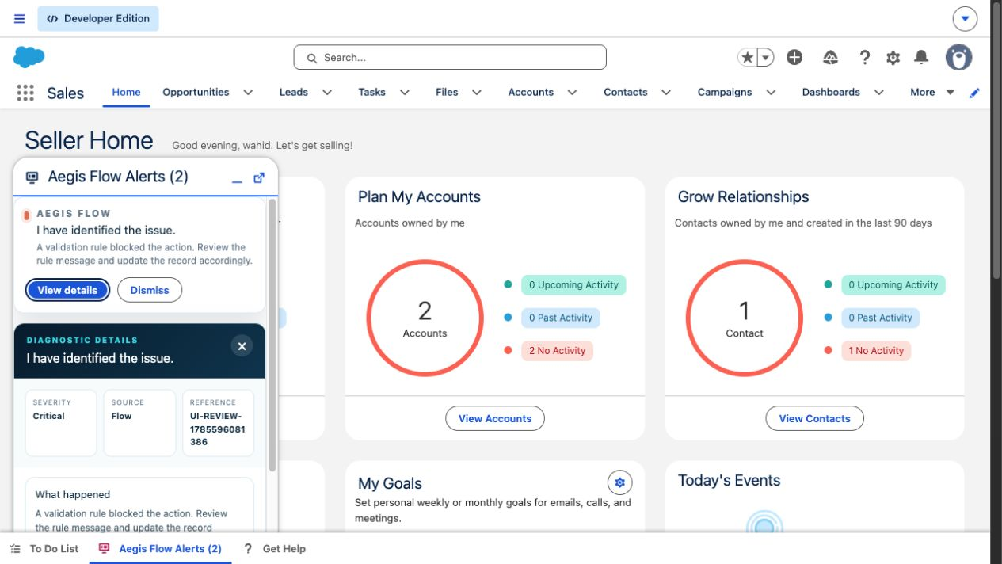
Aegis Flow diagnostic details

3. Setup Checklist
Before testing with business users:
- Deploy the Aegis Flow metadata to the target Salesforce org.
- Assign the correct permission sets.
- Open the Aegis Flow Setup tab and save routing details.
- Add Aegis Flow Alerts to every Lightning app utility bar where users work.
- Add Get Help to the same utility bars when users should be able to start a manual diagnostic session.
- Run the Aegis setup health check.
- Test one automation failure scenario before pilot rollout.

4. Permission Sets
Permission set | Assign to | Purpose
AEIR_Product_Admin | Implementation owner or Salesforce admin | Configure Aegis Flow and review all diagnostic records.
AEIR_End_User | Pilot and production users | Use the utility bar alerts and manual Get Help flow.
AEIR_Support_Analyst | Support/admin triage team | Review logs, sessions, incidents, and escalations.
AEIR_Developer_Viewer | Developers or technical support | Read sanitized diagnostic packages.
AEIR_Integration_User | Integration user only | Publish or create diagnostics through the API/integration path.
AEIR_Sample_Account_Remediation | Test users only | Enables the sample remediation scenario. Do not assign broadly.

5. Configure Aegis Flow Setup
Open the Aegis Flow Setup tab in Salesforce.
Use this page to:
- Save the company or org-level routing details.
- Enter the admin/support team email address.
- Enter the developer escalation email address.
- Decide whether sanitized summaries can be shared with the Aegis Flow support address.
- Run the health check.
- Scan Flows for missing failure coverage.
The setup tab is backed by the Aegis_Flow_Setup custom tab and the aegisSetupWizard component.

6. Add Aegis Flow To A Lightning Utility Bar
Repeat these steps for every Lightning app where users should see proactive Aegis alerts.
1. Go to Salesforce Setup.
2. Open App Manager.
3. Find the target Lightning app, such as Sales, Service, Sales Console, or a customer app.
4. Click Edit.
5. Open Utility Items.
6. Click Add Utility Item.
7. Choose the custom Lightning component Aegis Flow Headless Monitor.
8. Configure it with these values:
Property | Recommended value
Label | Aegis Flow Alerts
Icon | screen
Width | 340
Height | 480
Start automatically | Enabled
Scrollable | Enabled

Then add the manual help utility:
1. Click Add Utility Item.
2. Choose helpMeAgentUtility.
3. Configure it with these values:
Property | Recommended value
Label | Get Help
Icon | question
Width | 380
Height | 520
Start automatically | Disabled
Scrollable | Enabled

Save and activate the app. Users may need to refresh the browser before the new utility items appear.

7. Notification Policy Defaults
The current default policy is Notification_Policy.DEFAULT.
Setting | Current value | What it means
Active | true | The policy is enabled.
Notify affected user | true | The user involved in the failure can receive the alert.
Notify admin | true | Admin/support recipients can also be notified.
Auto open utility | true | The utility may open automatically when an eligible alert is created.
Minimum severity | Medium | Low-severity items are not auto-opened by the default policy.
Critical mode | Notify Both | Critical issues can notify both user and admin paths.
Cooldown | 15 minutes | Reduces repeated alerts for the same user/incident.
Max alerts per hour | 3 | Prevents alert spam.
Minimum confidence | 60 | Filters out low-confidence diagnosis results.

8. Scenarios Covered

Flow Fails Because A Validation Rule Blocks The Transaction
This is the key scenario tested in the utility bar. Example: a Flow runs on an Order, Opportunity, Lead, or Contact path and tries to save data, but a validation rule blocks the save. Aegis can capture this when the failure happens through supported automation paths.
Expected user experience:
- The utility bar highlights as Aegis Flow Alerts.
- If policy allows, it opens automatically.
- The user sees a clear message such as: "A validation rule blocked the action. Review the rule message and update the record accordingly."
- The details panel shows severity, source type, diagnosis, and escalation controls.

Flow With A Fault Path
Best practice for important customer Flows is to connect the Flow fault path to the Aegis capture action.
Expected result:
- Aegis logs the error in seconds.
- Record context is preserved.
- The transaction can still roll back safely because the capture path uses a platform event.

Flow Without A Fault Path
Aegis also has a monitor for failed Flow interviews.
Expected result:
- Aegis can detect the failed Flow after the scheduled monitor runs.
- This is useful for background coverage.
- Record context may be missing because Salesforce does not expose it in the same way as an explicit fault path.

Browser-Based Real-Time Flow Alert
When a Lightning app has the Aegis utility bar open or loaded, Aegis can listen for Salesforce Flow failure events in the browser.
Expected result:
- The user sees the alert quickly.
- This is browser-dependent. If no user has the Aegis utility loaded, the scheduled/publish-based paths are still needed for durable monitoring.

Apex Exception
Developers can wrap important Apex operations with the Aegis guard/capture pattern.
Expected result:
- Aegis records the failure.
- The error can be grouped into an incident.
- The user/admin notification policy can route alerts.

Batch Apex Failure
Batch classes that opt in to Salesforce batch error events can be captured.
Expected result:
- Aegis records failed batch chunks.
- Support and developer teams can review the technical failure.

Failed Async Job
Aegis includes a scheduled monitor for failed async jobs.
Expected result:
- Failed jobs are found by the monitor.
- A diagnostic record is created.
- Record context may not be available.

Custom LWC Error
Custom LWCs can use the Aegis error boundary wrapper.
Expected result:
- Client-side errors are captured.
- Page and component context can be included.
- This is the best option for custom user-facing forms.

Integration Or API Failure
An authenticated integration can submit diagnostic information to Aegis.
Expected result:
- Aegis creates a diagnostic record from the integration payload.
- The caller should use a scoped integration user, not a broad admin account.

User Needs Help But There Is No Error
Users can open the Get Help utility.
Expected result:
- A diagnostic session is created.
- The user can describe what they were trying to do.
- Support receives structured context instead of a vague help request.

9. Scenarios Not Captured Automatically
Some Salesforce errors happen before Aegis can receive a platform automation failure.
Scenario | Expected behavior
User directly edits a record and a validation rule blocks Save | Not automatically captured. This is a standard platform save failure.
User directly hits a duplicate rule | Not automatically captured unless handled by a custom form or automation wrapper.
Lead Convert fails because of a validation rule | Not automatically captured by the current package.
Page layout or field-level security prevents an edit | Not automatically captured as an Aegis automation failure.

For these scenarios, use the Get Help utility, a custom LWC form with the Aegis wrapper, or an automation/Apex path that explicitly calls Aegis.

10. Where To Verify Results
After running a test, check these areas:
- The Lightning utility bar label and alert panel.
- Error Logs.
- User Notifications.
- Incidents.
- AI Diagnoses.
- Diagnostic Sessions.
- Developer Escalations.
- Delivery Audits.
- Aegis Flow Setup health check.

11. Troubleshooting
Issue | What to check
Utility does not appear | Confirm the component was added to the correct Lightning app utility bar and the user refreshed the app.
Utility appears but does not auto-open | Confirm Auto_Open_Utility__c is enabled, the alert severity meets the policy threshold, and the alert is not inside the cooldown window.
No alert appears for a Flow failure | Confirm the Flow has a fault path to Aegis, or keep the Aegis utility loaded for browser-based Flow event capture, or wait for the scheduled monitor.
Direct validation rule error is not captured | This is expected for direct record saves. Use manual Get Help or a custom instrumented form if capture is required.
Details are missing record id | This can happen for scheduled/polling paths where Salesforce does not expose the record id. Use a Flow fault path for reliable record context.
Too many alerts | Adjust cooldown, max alerts per hour, severity threshold, or grouping policy.
Users cannot see records | Review the assigned Aegis permission set and standard Salesforce object permissions.

12. Current Versus Future
Current release focus:
- Salesforce-native error logging.
- Flow, Apex, batch, async, LWC, REST, and manual help capture paths.
- Utility bar notifications and auto-open behavior.
- Incident grouping.
- Deterministic diagnosis.
- Sanitized developer escalation.
- Retention and security controls.
Future headless focus:
- A formal headless diagnostic API.
- MCP tools for support and developer copilots.
- Real Agentforce action execution.
- Optional external operations channels.
- Managed package namespace readiness.

13. Customer Acceptance Checklist
Use this before pilot sign-off:
- Aegis Flow Alerts appears in the target Lightning app utility bar.
- Get Help appears where manual diagnostics are required.
- A test Flow failure creates an Aegis error log.
- A Flow fault path test preserves record context.
- The utility highlights or opens for an eligible alert.
- Details show a clear user-safe diagnosis.
- Escalation creates a sanitized package.
- Admin/support users can find the record in Aegis list views.
- Direct validation-rule saves are understood as out of automatic capture scope.
- The customer knows how to route future high-value Flows through the Aegis capture action.

