Aegis Flow Headless Technical Document
Version: Sprint 2 working draft
Last updated: 2026-08-01
Primary org used for validation: Aegis Flow_WA_Dev

1. Purpose
Aegis Flow is a Salesforce-native diagnostic and response layer for automation failures, user-facing Flow failures, Apex failures, async failures, batch failures, custom LWC errors, and explicit integration diagnostics. The current utility bar experience is one delivery surface. The product direction is broader: Aegis Flow should behave as a headless diagnostic platform that can serve Lightning utility bars, Agentforce actions, MCP tools, APIs, admin consoles, and external operations surfaces from the same governed incident model.

2. Screenshots
The current org validation shows the Aegis utility bar highlighted when open alerts exist:
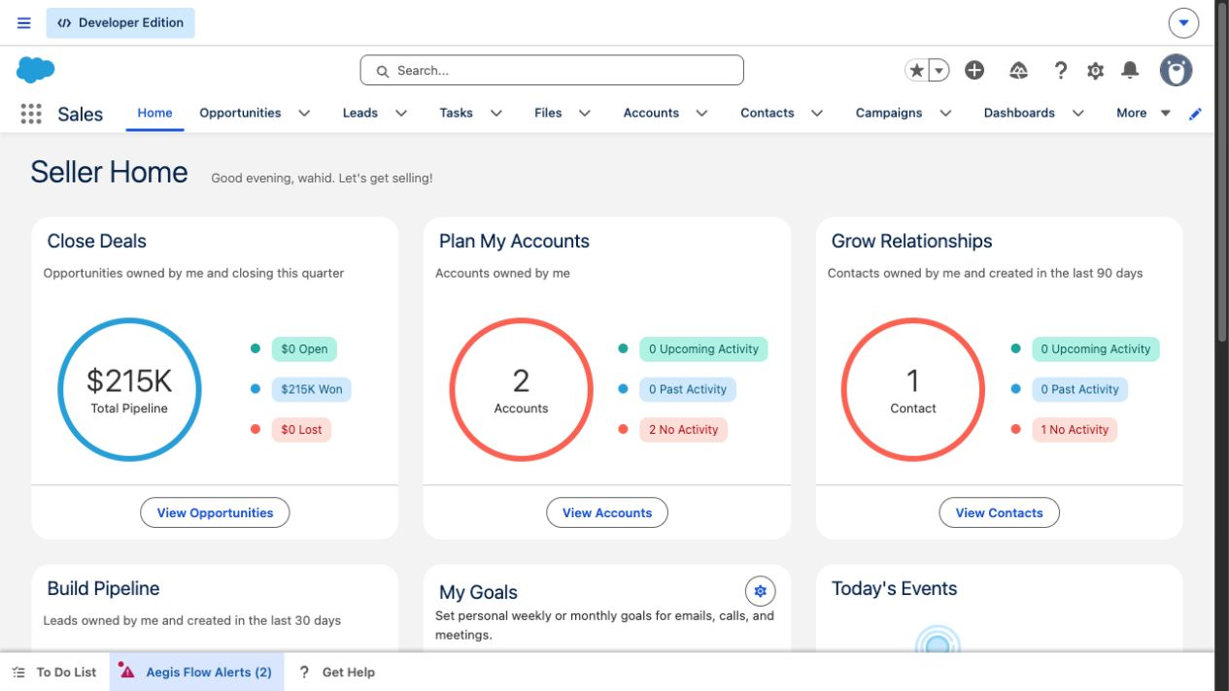
Aegis Flow highlighted utility alerts
The proactive utility panel opens with a plain-language diagnosis for the affected user:
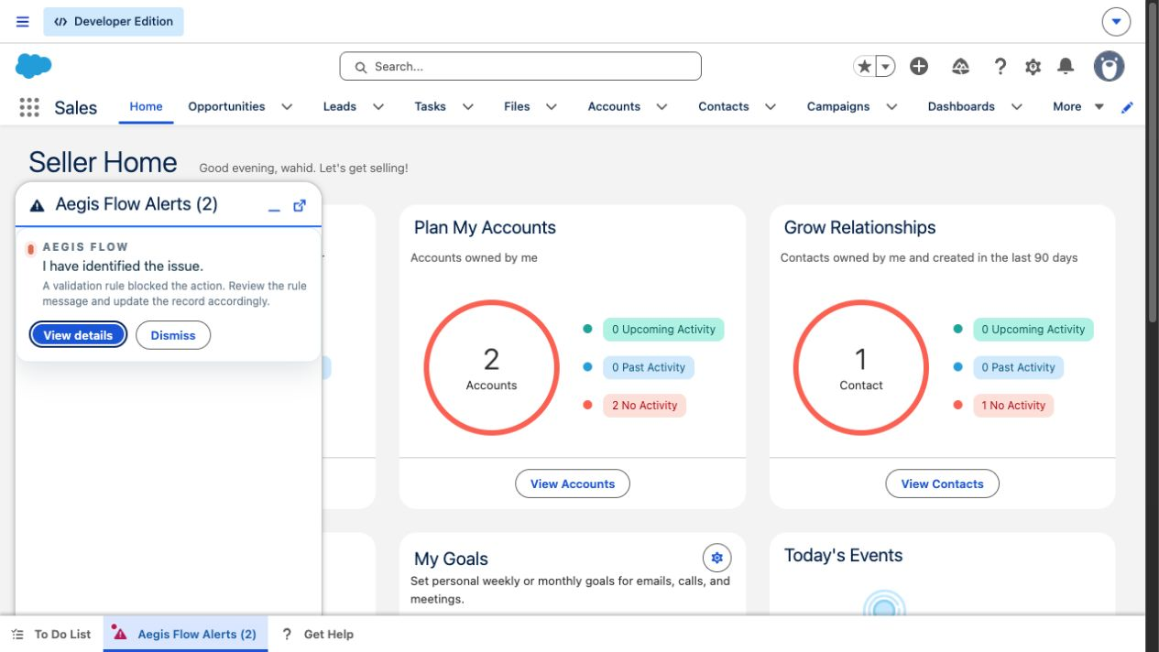
Aegis Flow auto-open alert panel
The detail panel exposes the diagnostic metadata and escalation controls:
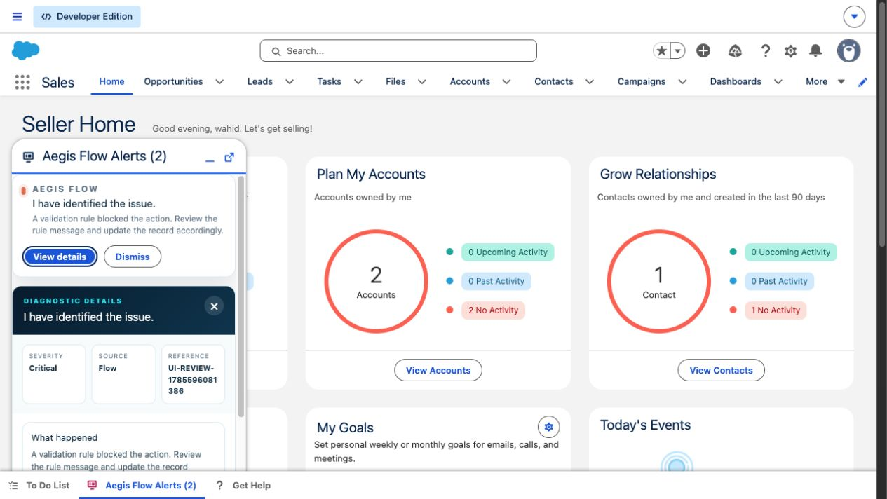
Aegis Flow diagnostic details

3. Technical Summary
Aegis Flow captures platform and application failures, normalizes them into Error_Log__c, groups repeated failures into incidents, applies a notification policy, and exposes diagnostic actions through Salesforce UI and automation entry points.
The most important design decision is rollback-safe capture. When a Flow or Apex transaction fails and rolls back, direct DML cannot be trusted to persist diagnostics. Aegis uses platform events for rollback-safe paths, then downstream subscribers create durable logs, notifications, incident records, escalation records, and optional remediation/retry records.

4. Headless Architecture
Code block: mermaid
flowchart LR
A["Flow/Apex/LWC/Batch/Async/REST sources"] --> B["Rollback-safe capture"]
B --> C["AEIR_ErrorCaptureService"]
C --> D["Normalization and classification"]
D --> E["Error_Log__c"]
E --> F["Incident aggregation"]
E --> G["Notification policy"]
E --> H["Diagnosis and remediation services"]
G --> I["Aegis_User_Alert__e"]
I --> J["Utility bar monitor"]
E --> K["Admin console and list views"]
H --> L["Agentforce actions"]
H --> M["Future headless APIs and MCP tools"]
E --> N["Escalation and audit records"]
The utility bar should be treated as a subscriber to Aegis Flow, not as the product boundary. The same normalized diagnostic contract can be called by an LWC, Agentforce, an MCP server, an external support console, or a customer-owned integration.

5. Capture Sources
Source | Current implementation | Speed | Record context | Notes
Record-triggered Flow fault, browser open | FlowExecutionErrorEvent streamed to aegisHeadlessMonitor, then AEIR_AegisHeadlessMonitorController.captureFlowError() | Seconds | Yes, when provided by event | Browser-dependent because this Salesforce event is not triggerable in Apex.
Flow fault path | AEIR_CaptureFlowFaultAction publishes Error_Captured__e | Seconds | Yes | Best pattern for business-critical customer Flows.
Failed Flow interview polling | AEIR_FlowInterviewMonitor reconciles failed interviews | Testing cadence: up to 5 minutes. Normal cadence: up to 15 minutes. | No | Works without browser session, but the platform does not expose full record context.
Apex exception | AEIR_Guard.capture() or AEIR_ErrorCaptureService.capture() | Seconds | Yes, when caller passes it | Use publish-based capture when the caller will rethrow.
Batch Apex | BatchApexErrorEvent trigger and handler | Seconds | Usually no | Batch classes must implement Database.RaisesPlatformEvents.
Failed async job | AEIR_AsyncJobMonitorScheduler | Scheduled | No | Polling path for failed async jobs where no event is available.
Custom LWC error | errorBoundaryWrapper and AEIR_ClientErrorController | Seconds | Page/client context | Best for custom forms and user-facing component failures.
Integration/API diagnostic | AEIR_InboundDiagnosticRestService | Seconds | Caller-provided | Requires authenticated caller and scoped permission.
Manual "Get Help" | helpMeAgentUtility and AEIR_HelpMeController | User initiated | Page context | For user confusion or cases where no platform exception is emitted.

6. Core Services And Methods
Area | Main classes | Responsibility
Capture | AEIR_ErrorCaptureService, AEIR_CaptureFlowFaultAction, AEIR_Guard, AEIR_ClientErrorController, AEIR_InboundDiagnosticRestService | Convert source-specific failures into normalized capture requests.
Flow monitoring | AEIR_AegisHeadlessMonitorController.captureFlowError, AEIR_FlowInterviewMonitor, AEIR_FlowCoverageService | Capture real-time Flow events, reconcile failed interviews, and detect Flows that lack fault coverage.
Notification | AEIR_UserNotificationService, AEIR_NotificationPolicyService, aegisHeadlessMonitor | Create user notifications, apply policy thresholds, update utility labels/highlights, and open the utility when policy allows.
Diagnosis | AEIR_ErrorNormalizationService, AEIR_AgentforceGatewayService, AEIR_InvokeDiagnosisAction | Classify known failure patterns and store deterministic or agent-generated diagnosis records.
Incidents | AEIR_IncidentAggregationService | Group repeated failures by incident key and time bucket.
Escalation | AEIR_EscalationService, AEIR_CreateEscalationAction, developerEscalationViewer | Create sanitized developer packages and delivery audit records.
Remediation | AEIR_RemediationOrchestrator, AEIR_ExecuteRemediationAction, Remediation_Action_Setting__mdt | Execute approved, metadata-whitelisted remediation actions.
Retry | AEIR_RetryOrchestrationService, AEIR_RetryHandler, Retry_Handler__mdt, Retry_Attempt__c | Queue and execute approved retry patterns.
Setup and health | aegisSetupWizard, AEIR_OrgSetupService, AEIR_SetupHealthCheckService | Configure routing, run health checks, and report Flow coverage gaps.
Retention | AEIR_RetentionScheduler, AEIR_RetentionPurgeBatch, Retention_Policy__mdt | Delete or redact old diagnostic data based on policy.

7. Data Model
Object or metadata type | Purpose
Error_Log__c | Primary durable failure record.
Error_Context__c | Structured technical context attached to an error.
Incident__c | Grouped incident for repeated failures.
User_Notification__c | Alert state for affected users/admins.
AI_Diagnosis__c | Stored diagnosis, confidence, recommended action, and summary.
Diagnostic_Session__c | Manual help session or user-requested diagnostic workflow.
Developer_Escalation__c | Sanitized escalation package.
Delivery_Audit__c | Delivery and escalation audit trail.
Remediation_Action__c | Execution record for approved remediation.
Retry_Attempt__c | Retry request and execution status.
Error_Feedback__c | User/admin feedback on a diagnosis or outcome.
Error_Attachment__c | Optional attachment metadata for diagnostic evidence.
Notification_Policy__mdt | Governs alert eligibility, auto-open, cooldown, grouping, and admin/user routing.
Error_Rule__mdt | Deterministic classification rules.
Retention_Policy__mdt | Diagnostic retention and purge policy.
Sensitive_Field__mdt | Fields that must be masked or excluded from outbound payloads.
Remediation_Action_Setting__mdt | Whitelisted remediation actions and object/field boundaries.
Retry_Handler__mdt | Retry handler routing and enabled status.

8. Platform Events
Event | Role
Error_Captured__e | Rollback-safe custom capture event. Published by Flow fault paths and Apex guard flows.
Aegis_User_Alert__e | User/admin alert event consumed by the utility bar.
Agent_Diagnosis_Requested__e | Requests asynchronous diagnosis processing.
Diagnostic_Session_Requested__e | Starts manual or guided diagnostic sessions.
Escalation_Requested__e | Requests developer escalation processing.
BatchApexErrorEvent | Salesforce standard event for failed batch chunks when the batch opts in.
FlowExecutionErrorEvent | Salesforce standard streaming-only event consumed by the browser-side utility monitor.

Important platform constraint: FlowExecutionErrorEvent is not Apex-triggerable and is not used as a durable server-side trigger source. Aegis captures it through the utility bar while a user is in a Lightning app that includes the monitor.

9. Notification And Utility Behavior
The deployed default notification policy is Notification_Policy.DEFAULT.
Setting | Current value
Active | true
Notify affected user | true
Notify admin | true
Auto open utility | true
Minimum severity | Medium
Critical mode | Notify Both
Cooldown | 15 minutes
Max alerts per hour | 3
Minimum confidence | 60
Grouping key | IncidentKey

The aegisHeadlessMonitor LWC is hosted in Lightning utility bars with label Aegis Flow Alerts, icon screen, width 340, height 480, eager loading enabled, and scrolling enabled. It uses lightning/platformUtilityBarApi to update the utility label, highlight the utility item, and open the panel when Auto_Open_Utility__c allows it.

10. Security Model
Aegis Flow is designed around least-privilege diagnostics:
- Permission sets separate end-user, product admin, support analyst, developer viewer, integration user, and sample remediation access.
- Raw platform event payloads and browser context are treated as untrusted input.
- Sensitive data is masked through AEIR_SecuritySanitizerService and Sensitive_Field__mdt.
- Remediation is metadata-whitelisted and rechecks CRUD/FLS before writing records.
- Escalation packages are sanitized before they are sent to developer/support recipients.
- The REST diagnostic endpoint requires an authenticated caller and should be assigned only to an integration user or other explicit technical identity.
- Alert events carry user-safe summaries. Detailed diagnostic data remains in governed Salesforce records.

11. Covered Scenarios
Scenario | Covered now | Expected result
Flow trips a validation rule and faults while utility is open | Yes | Utility highlights/opens and shows validation-rule diagnosis.
Flow fault path calls Aegis capture action | Yes | Durable error log is created in seconds with record context.
Flow fails without a fault path and no browser is open | Yes, delayed | Poller detects failed interview; record context may be missing.
Apex DML exception wrapped with Aegis guard | Yes | Durable error log, incident grouping, and alert routing.
Batch Apex failure with platform event opt-in | Yes | Batch failure is logged through standard batch error event handling.
Failed async job | Yes | Scheduled monitor creates the diagnostic record.
Custom LWC component exception | Yes | Client error is captured through the wrapper/controller.
Integration or external diagnostic post | Yes | REST service records caller-provided diagnostic context.
User confusion without a platform exception | Yes | User can open Get Help and create a diagnostic session.
Direct standard page validation-rule save | No | Salesforce blocks the save before Aegis receives a platform automation failure.
Direct duplicate-rule save | No | Expected platform boundary; not captured unless wrapped by automation/custom code.
Lead Convert validation failure | No | Expected platform boundary; use custom instrumentation if required.
Real Agentforce callout | Deferred | Current product stores deterministic/contract-ready diagnosis; live Agentforce integration remains Phase 2.
Namespace and second-generation managed package readiness | Deferred | Tracked separately in namespace readiness work.

12. Phase 2: Aegis Flow Headless Line Items
Phase 2 should make the headless model explicit. The Lightning utility should remain a polished surface, but not the only way to consume Aegis.
Line item | Goal | Notes
Headless product contract | Define Aegis Flow as a diagnostic service layer with UI, agent, and API clients. | Use stable logical keys, not namespaced API names, in external payloads.
Diagnostic API facade | Add Apex service methods that return current errors, incident summaries, notification state, and recommended next actions. | Keep payloads sanitized and permission-checked.
MCP server toolset | Expose tools such as find_recent_errors, get_error_context, list_incidents, dismiss_notification, create_escalation, run_health_check, and scan_flow_coverage. | This makes Aegis usable by Codex, Claude Code, internal agents, and support copilots.
Agentforce action package | Package the current invocable actions as governed agent actions once real Agentforce callout configuration is enabled. | Preserve deterministic fallback when the model/action is unavailable.
External operations channels | Add optional Slack, Teams, webhook, or customer support console subscribers. | These should subscribe through governed server-side services, not raw event payloads.
Headless auth model | Define Connected App, integration permission set, IP/session rules, and per-tool scopes. | Avoid broad admin tokens for diagnostic clients.
API observability | Add delivery audits, request ids, usage counts, and failure logs for headless consumers. | Required before customer-facing headless rollout.
Packaging boundary | Complete namespace and 2GP review before managed package creation. | Keep namespace readiness deferred until the package org path is chosen.
Demo scenario | Build a demo where an agent asks, "Why did this Order Flow fail?" and Aegis returns the incident, rule cause, affected record, and safe next step. | Utility bar remains optional; headless response is the product proof.

13. Validation Evidence
Current validation evidence for this working branch:
- LWC unit tests: npm run test:unit passed 18 of 18 tests.
- Local audit: python3 scripts/local_audit.py passed after current sprint fixes.
- Focused Apex regression during the sprint passed 15 of 15 specified tests.
- Utility bar metadata deploy succeeded in the target org.
- Notification_Policy.DEFAULT.Auto_Open_Utility__c is deployed as true.
- Browser validation confirmed the utility highlighted as Aegis Flow Alerts (2), opened with the proactive validation-rule diagnosis, and exposed diagnostic details and escalation controls.

14. Known Deferred Work
- Namespace readiness and second-generation managed package creation.
- Live Agentforce callout configuration and real action execution.
- Marketplace/AppExchange collateral and go-to-market packaging.
- Direct standard page validation-rule and duplicate-rule capture, which remains a Salesforce platform boundary unless the customer uses custom forms, Flow fault paths, Apex wrappers, or browser-assisted manual diagnostics.

