**Project report template**

**1.INTRODUCTION**

**1.1 OVERVIEW**

**PLUGGING INTO THE FUTURE:AN EXPLORATION OF ELECTRICITY CONSUMPTON PATTERNS**

The energy efficieny and conervatioin hane numerous benefits for the both environment and human health. The include reduction in air,water,and soil pollution ,acide rain and global warming ,oil spills and waer pollutions, loss of widerness areas and biodiversity, construction and new power plants .Saveing electicity may look like a difficult task due to the nature of electricity,which remains invisisible right,. his approach will allow us to assess the relationship between

4 electricity consumption and structural explanatory variables, such as dwelling characteristics and occupants’ profiles. This sample size was still reduced to 230 households, since, where at least 5% of the data over the 3-year period average was missing from a particular meter, that meter was excluded from the study (i.e. 20 meters). An exploratory data analysis was made for the final sample of 230 households focused on electricity data clustering from smart meters data. The cluster analysis is based on daily means (per household), i.e., averaged over 2011-2013 for a given day.

**1.2 purose**

Electricity consumption is an essential component of the modern life. It not only provides clean and safe light throughout the day, but also in many countries refreshes homes on hot summer days, and in others warms them in winter. In all countries, it allows the use of electrical and electronic equipment in which the use of electricity is essential to ensure their proper functioning. Although hundreds of millions of Americans and Canadians connect to the power grid every day, most of them do not think about how they get the electricity consumed, and how much it costs to produce it. Keeping the North America region energized is actually an amazing feat, a daily miracle.**.**

**2.PROBLEM DEFINITION& DESIGN THINKING**

**2.1empathy map**

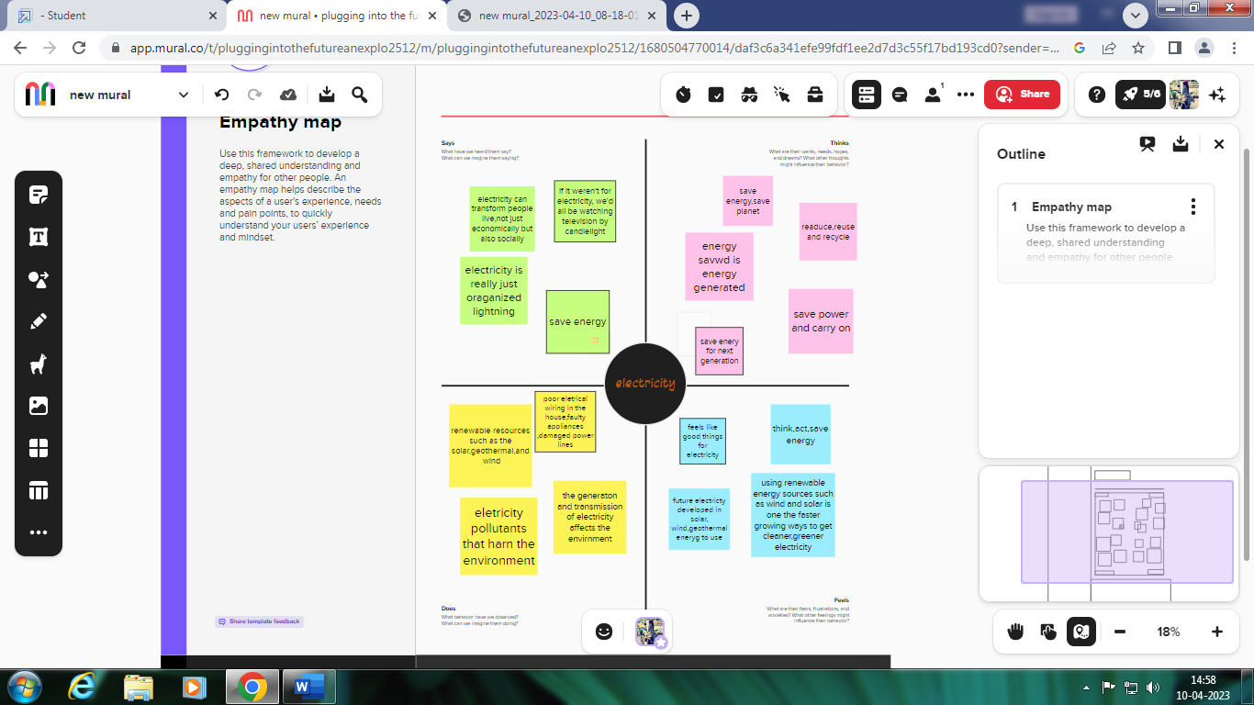

**2.2 ideation&brainstorming map**

……

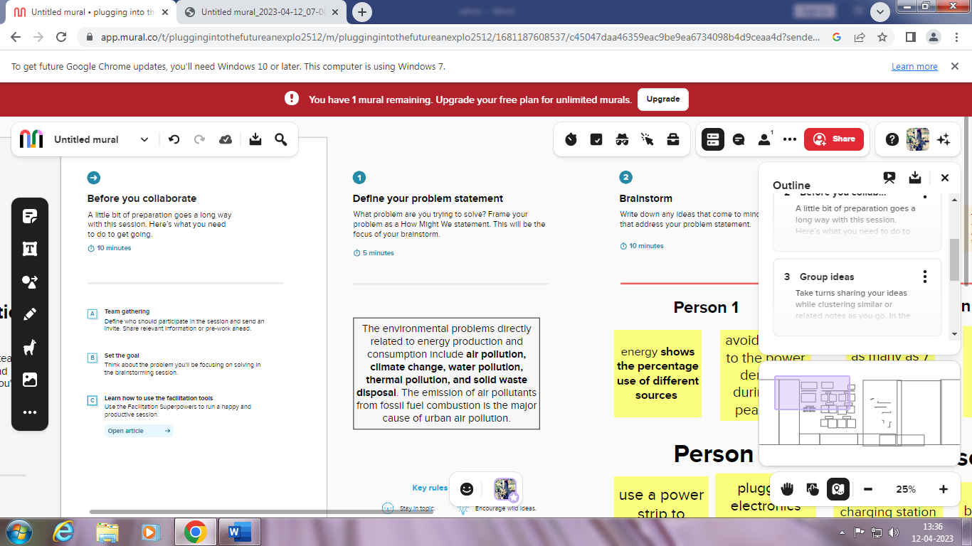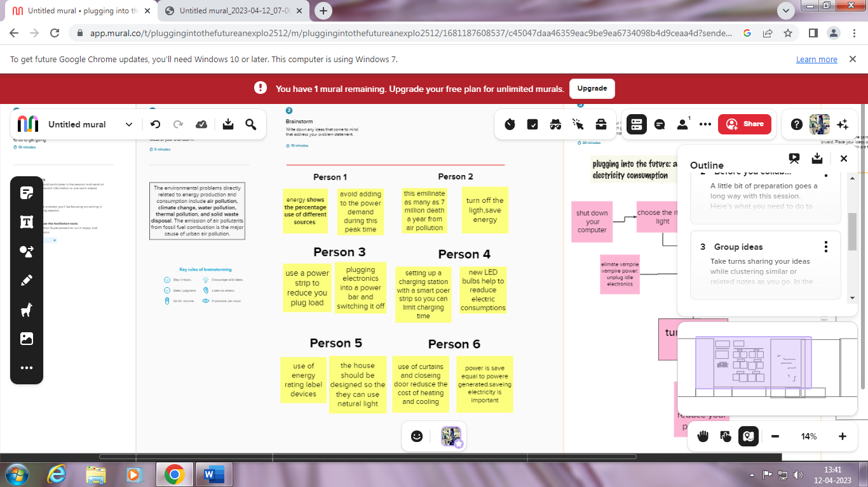

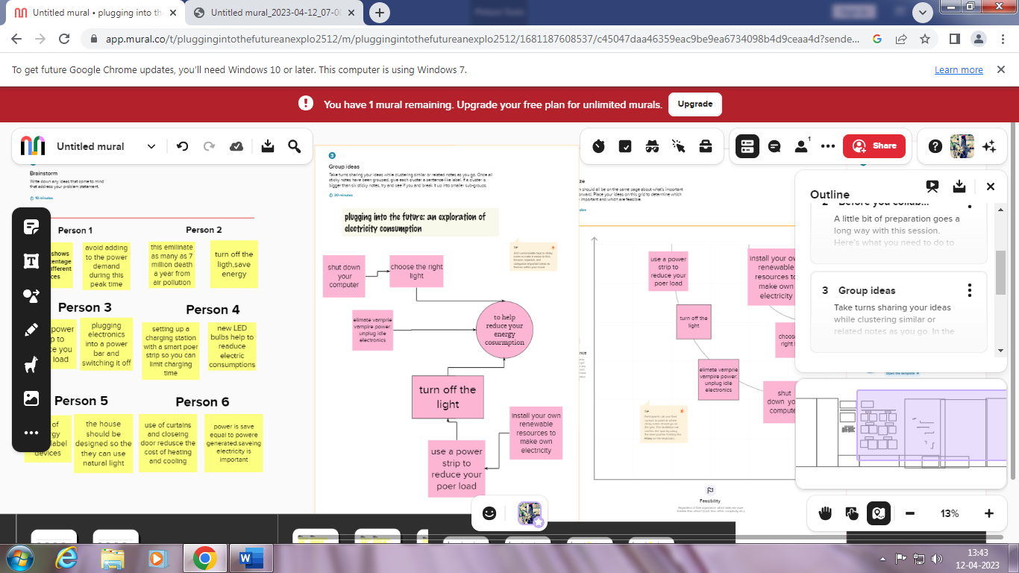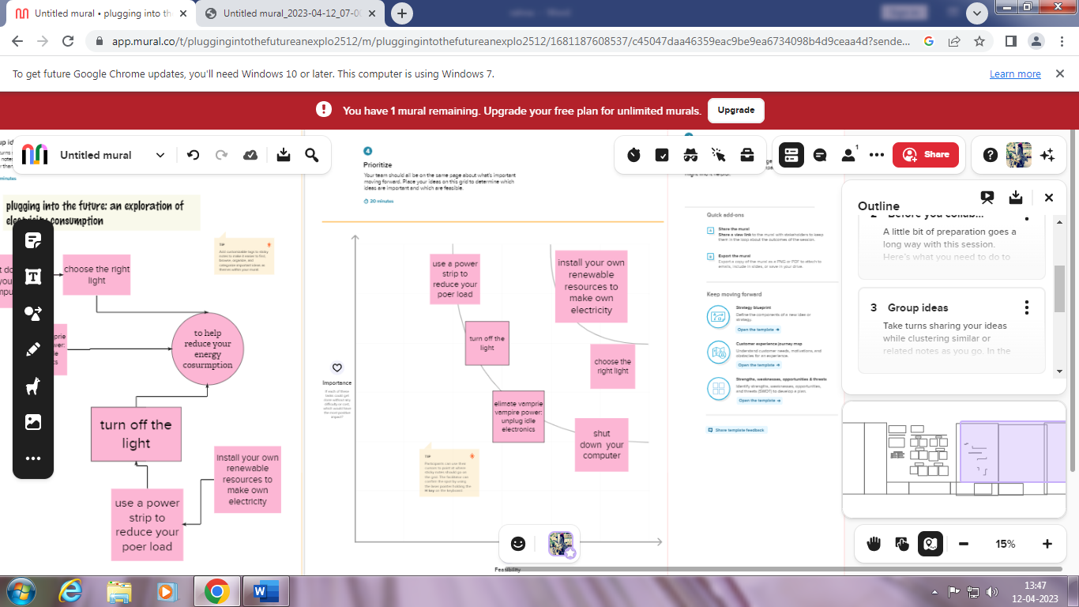

3.**RESULT**

Create the empathy map in my own idea framework.

We are smaller group ideas for our team;

***plugging into the future: an exploration of electricity consumption***

To help reduce your energy cosurmptiom in BRAINSTORM AND IDEA PRIORITIZATION template.

Make some ideas and then priotization abouts the topic with our ideas

**4.ADVANTAGES AND DISADVANTAGES**

plugging into the future: an exploration of electricity consumption

the electric vehicle is becoming more prevalent throughout the world. The popularity of electric vehicles will likely skyrocket, given the rapid developments in the auto industry. Electric cars are also being developed at a rapid rate in India. However, there are other hurdles for e-vehicles in India. However, automobile manufacturers are moving quickly in this direction. Many electric vehicles will be released in India in the coming months. As a result, in this article, we will discuss electric vehicles' benefits and drawbacks. So, let's look at the advantages and disadvantages of electric cars

**Advantages**

1. Low Noise Pollution

No one loves the harsh noise made by cars running on petrol. Using electric vehicles can help to minimize noise pollution. The advantage of electric vehicles is that they produce no noise.

2. Secure Environment

Every human being's primary priority is to protect the environment. Cars create toxic pollutants that have a direct impact on the environment. Every fuel-powered automobile causes environmental damage, as we are all aware.

The best feature of electric vehicles is that they are completely eco-friendly. These vehicles represent no environmental risk. But we have recently discovered a solution or alternative for this as well.

3. Low Maintenance Cost

Electric motors propel electric cars, necessitating less maintenance than conventional automobiles. Furthermore, the temperature of the electric engine does not require as much cooling as that of the combustion engine.

4. More Convenient

The design of electric vehicles is straightforward and pleasant. When it comes to fuel-powered cars, they require a significant amount of work to operate. Accidents can also occur when brakes or gears fail to operate properly. Electric automobiles are one of technology's most useful innovations. All of the flaws present in conventional vehicles are absent from electric vehicles.

5. No Fuel

Rising petrol and gasoline costs have been a source of anxiety for all motorists. Electric vehicles, on the other hand, do not require gasoline. These fuel-free vehicles are a cost-effective alternative compared to other vehicles today.

**Disadvantages**

1. Low Energy

The most significant disadvantage of electric vehicles is that they must be charged regularly. Aside from that, increasing the weight of these vehicles reduces their capacity. Electric cars with little energy and capacity can sometimes fall behind fuel-powered ones.

2. Battery Expenses

Although electric vehicles do not utilize gasoline, the batteries that power them are quite powerful. Aside from that, if the battery is not changed within a defined time interval, it might cause the vehicle to be damaged.

3. Slow Charging

Electric vehicles require many hours to charge, unlike engine-powered vehicles, which can recharge quickly. The charging of these automobiles is quite sluggish. Why would anyone waste time refilling a vehicle in our fast-paced world?

4. Expensive Recharging Options

If there is any other choice than recharging the electric vehicles at a charging station, it is to charge them with the electrical power supply connected to their houses. If you do this, your electricity bill may surprise you considerably. To recharge these vehicles, a high-voltage electric current is required.

5. Problem For Fuel-Producing Countries

You may already be aware that many nations only have relevance because of the fuel they provide. Fuel sales power the economies of numerous nations, including Iran, Oman, and Saudi Arabia. If the number of diesel fuel cars suddenly declines, these nations may face a financial crisis. As a result, the popularity of fuelless electric cars may prove to be a problem for fuel-producing countries.

**5.APPLICATIONS**

Since the twenty first century, global electricity consumption has seen even faster growth, as evidenced by an average annual increase of 3.4%, 1.2 percentage points higher than average annual growth of energy consumption

India's power consumption logged a double-digit growth of over 11 per cent to 121.19 billion units in December 2022 compared to the year-ago period, according to government data.

* electricity—all types of energy end uses.
* natural gas—space and water heating, clothes drying, cooking.
* heating oil—space and water heating, clothes drying.
* LPG/propane—space and water heating, clothes drying, cooking.
* kerosene—space heating

Heating and cooling our homes, lighting office buildings, driving cars and moving freight, and manufacturing the products we rely on in our daily lives are all functions that require energy.

**6.conclusion**

This paper has introduced an exploratory experiment of plugging into the future: an exploration of electricity consumption.the outputs the energy compumtion are highly correlate to the weekdays; the save there enegy

**7.FUTURE SCOPE**

New resources that are being researched or developed include hydrogen, nuclear fusion, ocean thermal energy conversion, and tidal and wave energy. (Solar, wind, and geothermal energy are dealt with in separate fact sheets). One fuel that has the potential of being widely used in the future is hydrogen gas (H2o)

Renewable energy is healthier

Switching to clean sources of energy, such as wind and solar, thus helps address not only climate change but also air pollution and health.

The renewable energy can be considered as the energy of future

**8.APPENDIX**

These trends, if they continue, can have major implications for the

electricity transmission and distribution (T&D) parts of the U.S. electric grid, one of which is increasingly

two-way flows of electricity at the distribution level that is now designed for one-way flows.