Untitled1

1. Desain tanpa judul (2)

1.1 Untitled Slide
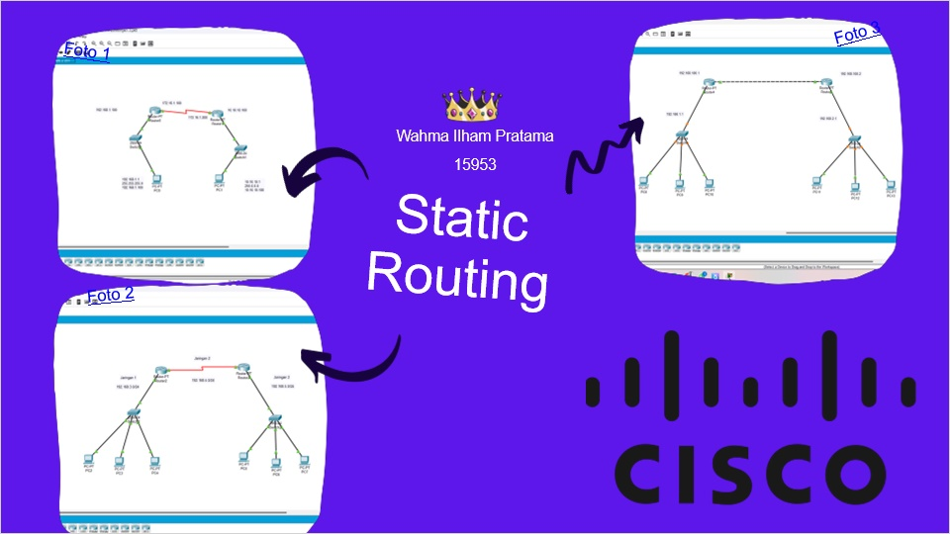

1.2 Untitled Slide
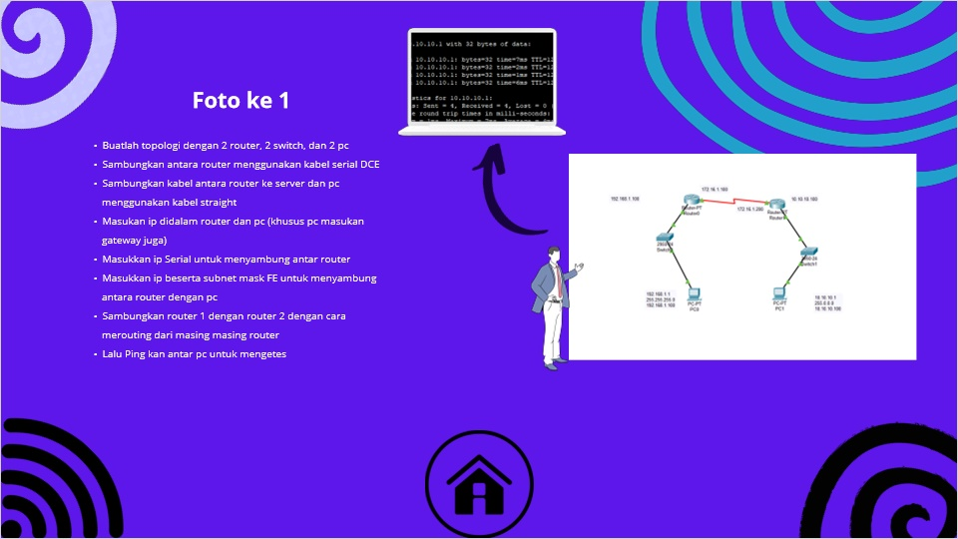

1.3 Untitled Slide
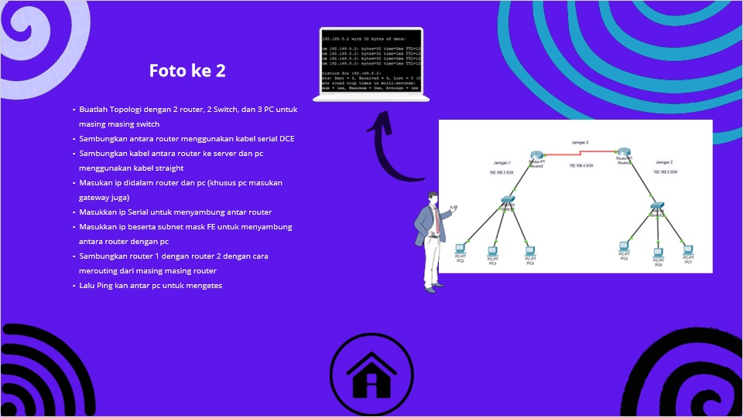

1.4 Untitled Slide
