TACS Challenge Documents

SOP 5 – Data Sharing

Created by: Benedikt Zoefel; Revised by: Simon Hanslmayr, Sanne ten Oever
Last edited: 17 August 2026

List of material / Required hardware:

Quantity | Item
1 | Access to Sharepoint drive (email: ines.violante@kcl.ac.uk)
For each subject | tsv output for each experimental block
For each subject | tsv output for staircase
For each subject | tACS Challenge Data table (tsv)
For each subject | EEG data in BIDS format
1 | Notes.txt – optional, containing relevant information (e.g., additional participants because of technical issues)
Before you start:
It is very important that you follow the file naming and folder structure precisely as it is shown here, including the use of upper and lower-case letters. Not doing so will result in unnecessary delays and will likely involve us asking you to go back and make changes.
Tip: If you are unsure about the dataformat or file naming convention, please take a look at the folder ‘L18’ on the sharepoint which is not zipped and serves as a template. Request access to the tACS challenge sharepoint drive by sending an email to ines.violante@kcl.ac.uk
Required structure and files for data sharing
- Create a folder on your local computer and label it with a code (L+ number of your lab as assigned on https://tacschallenge.github.io/labs/). For example: ‘L06’ if you are in the Bergmann lab, or ‘L40’ if you are in the Tarantino lab.

- Create a folder for each subject that you can then store in your lab folder. Label each participant’s folder with your lab code and an individual participant code. Example: ‘sub-L01_S01’ for the first participant in the Aglioti lab.

- Create three subfolders inside each subject folder named: beh, eeg, metadata

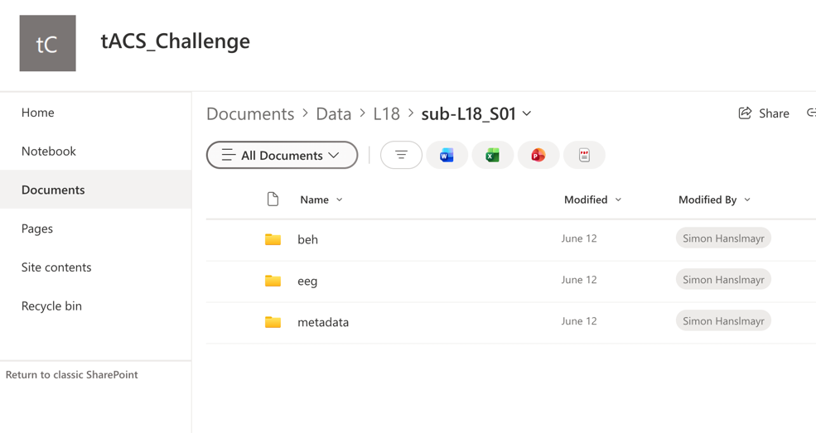

- beh folder
The following files are required in each subject’s beh folder:
- .tsv output file from each experimental block, labelled according to lab code, participant code, block number (between 1 and 13), condition label and timestamp (in year_month_day_hour_minute_seconds). Each file should therefore be named according to this format: sub-L[lab code]_B[block number]_[condition label]_yyyy_mm_dd_hh_mm_ss.

For example:

‘sub-L04_S03_B4_A_2026_12_17_18_54_32.tsv’

for the Battaglini Lab, participant nr 3, Block 4, Montage A, recorded on the 17th December 2026 at 6pm, 54 minutes and 32 seconds. Or

‘sub-L28_S06_Sh_ 2025_07_01_16_20_25.tsv’

Note that timestamps will automatically be added to your filenames by the Arduino device, so you should not have to manually enter those. Also note that the order of montages varies from participant to participant according to a latin square permutation (see here). Montage labels correspond to those on the tACS Challenge Sensation Questionnaire and the registered report (Sh = sham, A=occipital, B=phosphene, C=cutaneous).

- .tsv output file from the staircase procedure, labelled as described above, e.g.
sub-L01_S01_Staircase_2016_01_30_12_34_26.tsv

- .tsv file from TES associated sensations questionnaire with rows coding the questions (i.e. Q1: Do you see flashes/flickering of light?, etc.) and columns coding the responses in numeric values (insert 0 when no sensations are reported). The top row is the header row. The resulting file is labelled as described above, e.g. sub-L18_S02_TES_questionaire.tsv. No timestamps are needed for the questionnaire data. You can structure the file according to the example below:

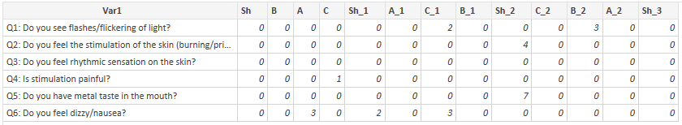

- eeg folder

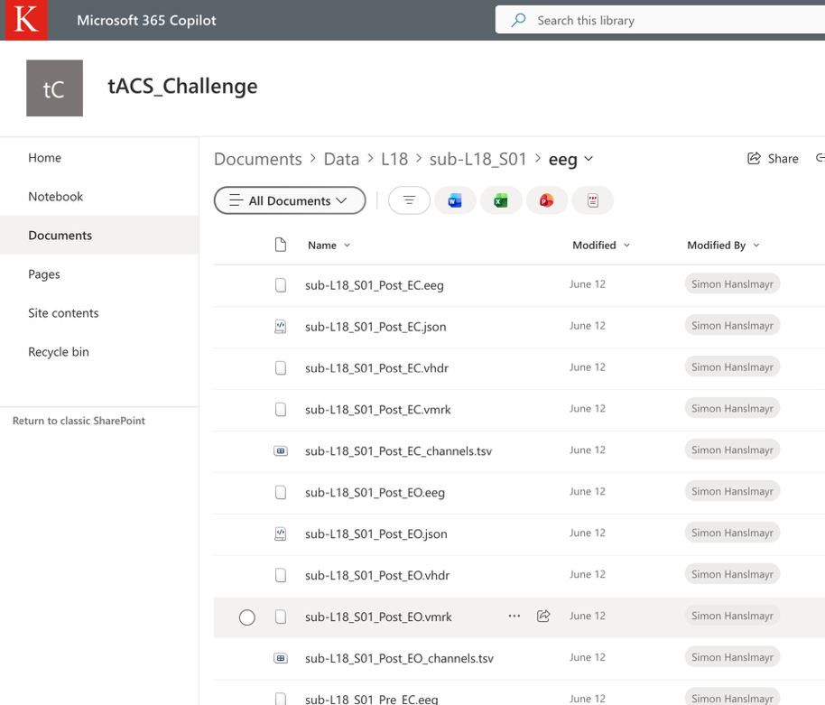

The following files are required in each subject’s eeg folder:

- .edf or .vhdr, .vmrk, .eeg files from Pre and Post, EO and EC EEG recordings, labelled according to lab code, participant code, Pre/Post, EO/EC

More information about eeg data formats here - https://bids-specification.readthedocs.io/en/stable/modality-specific-files/electroencephalography.html

Although other formats are available, we will follow EEG BIDS recommendation to use the European data format, or the BrainVision data format.

- .json files – one per EEG recording with information on EEG condition, EEG hardware, EEG electrodes, lab, etc. Follow the structure available for sub-L18_S01_Pre_EO.json
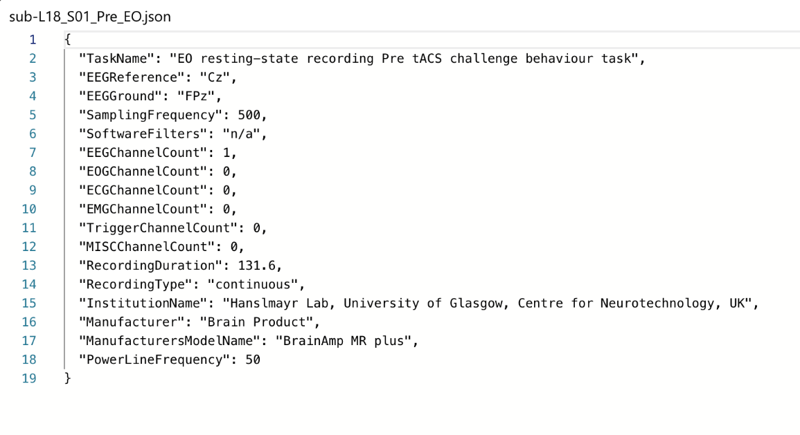

- *_channels.tsv – 2 files in total, one for Pre and one for Post, labelled according to labelled according to lab code, participant code, Pre/Post. For example:
‘sub-L04_S03_ Pre_EC_channels.tsv’
This file contains information on the EEG channels used as per below

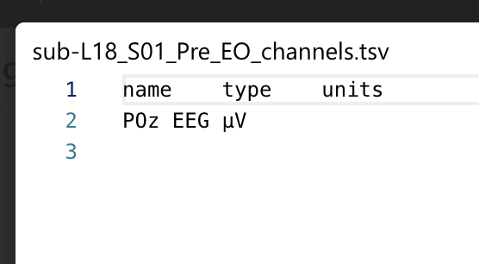

And following the EEG BIDS format

- We recommed to use the matlab script ‘BIDSify.m’ downloadable from https://github.com/tACSChallenge/analysis/tree/main/meta to bring your EEG data into the correct format. You may have to adapt the script to match your local eeg format.

- metadata folder
Add the table tACSChallenge_Data, labelled as described above, e.g.
sub-L01_S01_Meta_Data.tsv.
Please fill in the required information:
  - Lab Code (same as above)
  - Subject Code (same as above. Ideally the same as in the Demographic Information Form)
  - Gender (from the Demographic Information Form)
  - Age (5-year bracket; from the Demographic Information Form)
  - Individual Alpha frequency (IAF) (if applicable)
  - Impedances measured pre and post tACS (separately for each montage)
  - Use of EMLA cream (y/n)
Please follow the structure as the table below:
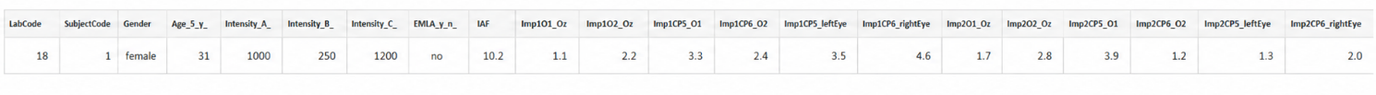

- Notes
If anything happened during the measurement that is important when using the data (e.g. missing data or deviations from the SOP), please provide this information in a .tsv file entitled ‘notes.tsv’ which can be added to the main folder.

8. Check data is correctly formatted
  - Copy your data into a folder named ‘Upload2sharepoint’
  - Download the script named ‘file_naming_check.m’ from https://github.com/tACSChallenge/analysis/tree/main/meta
  - Copy script into the folder you created above (i.e. ‘Upload2sharepoint’)
  - Run the script and fix errors until you see the message: All checks passed.

- Create Zip archive for your data and name it as described in step 1 ( L+ number of your lab as assigned on https://tacschallenge.github.io/labs/; i.e. L08.zip)

- Upload data to tACS challenge sharepoint drive

  - Request access to the tACS challenge sharepoint drive by sending an email to ines.violante@kcl.ac.uk
  - Open the Sharepoint drive using the link provided by Ines Violante.
  - Click on ‘Documents’ on the right-hand side navigation bar

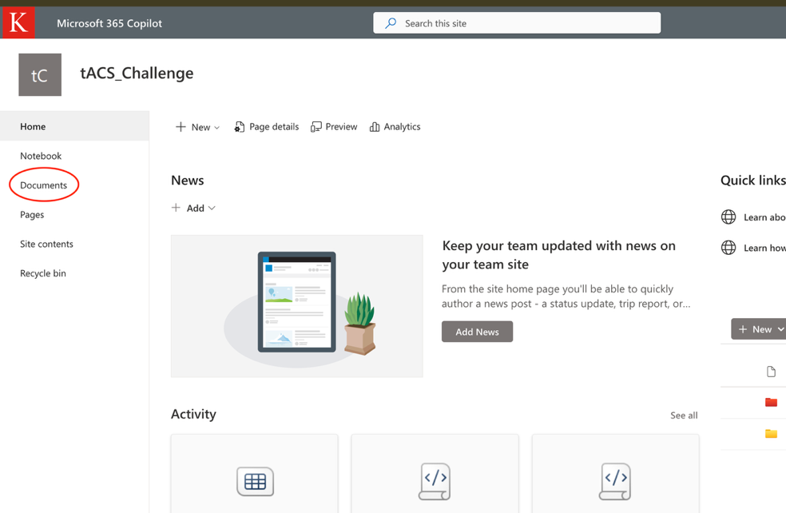

  - Click on the red ‘Data’ folder

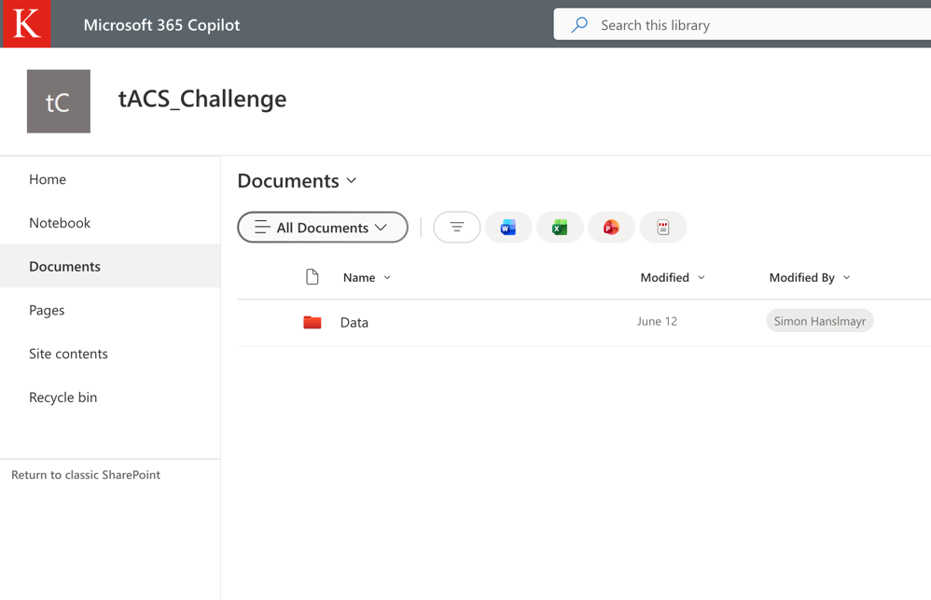
  - Drag and drop Zip archive into the ‘Data’ folder

- If you are unsure about the dataformat or file naming convention, please take a look at the folder ‘L18’ on the sharepoint which is not zipped and serves as a template.

