Link template PSD : <https://www.graphberry.com/item/moderno-creative-simpleportfolio-page>

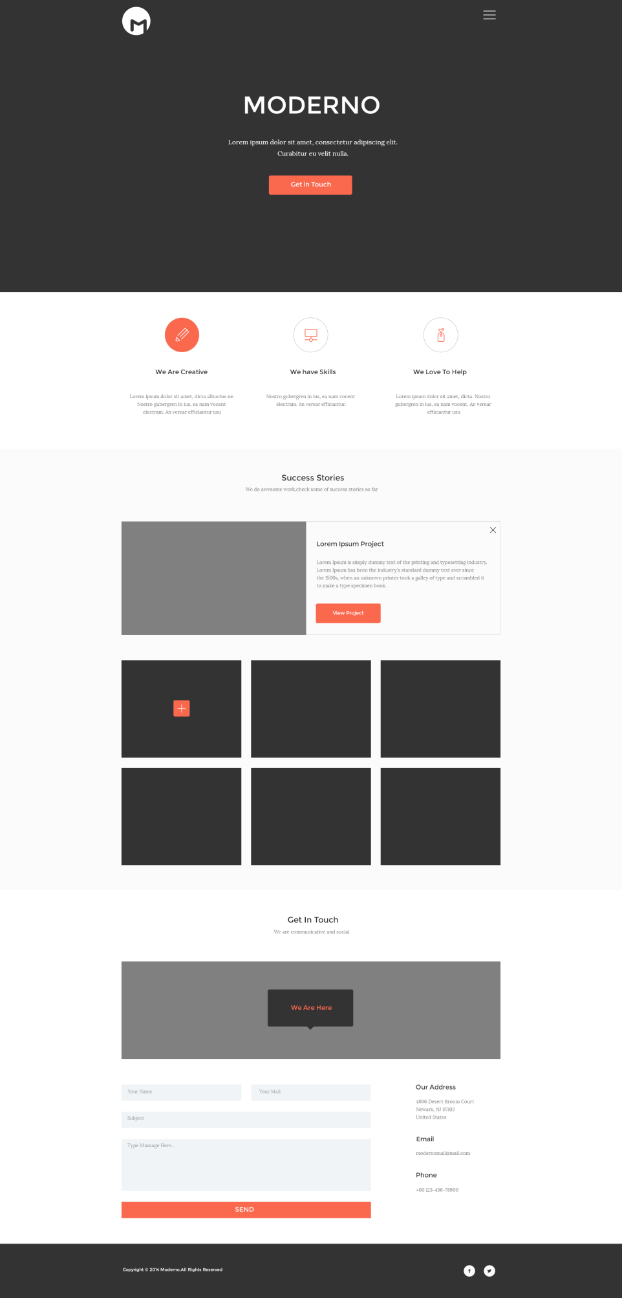Design PSD :