Assessment of Color Levels in Leaf Color Chart Using Smartphone Camera with Relative Calibration

Yuita Arum Sari, R V Hari Ginardi, and Riyanarto Sarno
Department of Informatics, Faculty of Information Technology, Institut Teknologi Sepuluh Nopember

Keywords:  Leaf Color Chart  Camera Calibration  Color Interpretation  Classification  KNN |  | ABSTRACT
 |  | Leaf Color Chart (LCC) is used in agriculture modeling for monitoring the plant performance by comparing the leaf color and its corresponding color in LCC. To digitize the acquisition and interpretation of leaf color, smartphone camera is used. A color calibration is necessary for a smartphone before it can be used to capture and interpret leaf color. The calibration process evaluates the camera performance with the operational lighting conditions and determine whether the smartphone camera can be used for leaf color interpretation or not. The result from camera color calibration is used as a relative color chart for interpreting leaf color. In this paper, we propose a method of relative color calibration which makes the system learns colors chart automatically without depending on specific standard colors. K-Nearest-Neighbor (KNN) classification is used for color learning process in RGB color space. Our method is sucessfully tested with two smartphone devices in different lighting condition. The test shows an average accuracy above the threshold value of 83%.
Copyright © 2013 Information Systems International Conference.
All rights reserved.
Corresponding Author:
Yuita Arum Sari,
Departement of Informatics, Faculty of Information Technology,
Institut Teknologi Sepuluh Nopember,
Jalan Raya Kampus ITS, Gedung Teknik Informatika, Sukolilo, Surabaya, Indonesia.
Email: yuita.sari12@mhs.if.its.ac.id

- INTRODUCTION
Leaf Color Chart (LCC) is a standard chart to assess leaf color level. It is developed by the International Rice Research Institute (IRRI) for monitoring the crop growth. In a precision agriculture approach, leaf color is observed regularly to determine the healthiness of the crop including its leaf chlorophyll content. To perform this observation, a farmer visually compares the color of a crop leaf with a set of color in the LCC and note the color level according to its corresponding color in the LCC based on the color similarity. This process requires a very good color perception of surveyor’s eye, and it should be performed consistently throughout the crop growth.
A portable chlorophyll-meter has been developed to help farmers precisely determine the chlorophyll content of a leaf. Eventhough this instrument has been used in agricultural research centre, it is not popular among farmers. As an alternative solution, smartphones are considered as promising devices for capturing and analysing leaf color. Smartphones have good computing capabilities, they can be programmed, they are equipped with a digital camera, and they are used by many farmers.
According to Statistics Indonesia (Badan Pusat Statistik / BPS), the number of mobile phone users are increased significantly from year to year. In 2008, the number of mobile phone users in Indonesia is 51.99%. It reached 61.84% in 2009, increased to 72.01% in 2010, and increased again to 78.96% in 2011[1]. Smartphones penetrate a very broad user segments including farmers. Considering the popular usage of smartphones among farmers, this technology will be used to capture, analyse and determine crop leaf color with our proposed methodology. The methodology includes color aquisition, color modeling, color classification, and color interpretation.
Several researches used color classification techniques for determining a color of an image. Rehanullah et.al [3], uses a color classification method for detecting skin color. This research used color transformation, and evaluated nine types of classification. Decision-tree is then selected as the most suitable algorithm for color detection. The best result is shown in a random forest classification with cylindrical color spaces. This result concerns about the influence of lightness and it is a complex algorithm to be implemented in a regular smartphone.
Other researcher [4], used KNN classification to improve the performance of predicting paddy crop fertilization with LCC. The technique was performed with a smartphone by capturing images with a white paper background and skin color. This research used 18 features extraction of RGB, including minimum, maximum, and average of R, G , and B, respectively. The result showed a low accuracy of 60%, because of ambiguity of color levels in captured paddy leaf images. The ambiguity persists because of the use of the concept of absolute color for assesing color levels.
This paper proposes a method for calibrating LCC color levels in an Android smartphone camera by using KNN. KNN is a lightweight classification algorithm, suitable to be implemented in a regular smartphone device. The proposed method uses a relative color calibration to recognize variety of green colors in each level of LCC. A learning process is used to tell the smartphone camera how it should recognize the LCC.
In Section 2, the research method will be explained, and experimental details are presented. The result is discussed in Section 3 and the paper is concluded in Section 4.

- RESEARCH METHOD
The datasets for this research cover three kinds of data: standard LCC benchmark, the captured image of LCC’s photo printing in an ideal lighting condition, the captured image in a non-ideal lighting condition. The initial standard LCC benchmark is taken from the IRRI’s website. It contains six levels of green color, and this six-level of green color is used as our color referenced data. This standard LCC is then printed on a glossy photo paper in 4R size with white background. The second data is a captured image of the printed LCC. Figure 1 shows the result of LCC standard from photo printing, which was captured by smartphone camera.

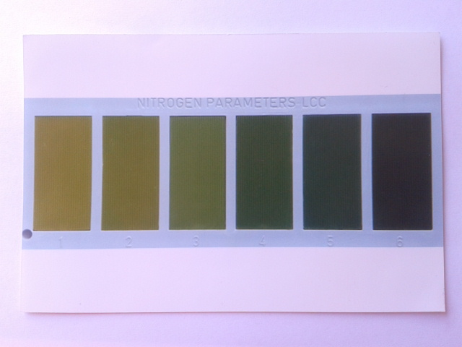
Figure 1. Printed Leaf Color Chart

In an ideal lighting condition, human eyes can interpret and distinguish every color in this printed LCC. With a good camera and a good lighting condition, this printed LCC can be reproduced digitally, and it should present a distinct color for each level of LCC. To capture this LCC, two types of smartphones are used, which are Samsung Galaxy ACE and LG Optimus. Instead of using a brand-specific camera application, a freeware application CameraFV-5 Lite is used. Pictures are taken randomly in the different lighting condition in the morning, at noon, and in the afternoon.
Taking each color level of the captured image into its corresponding color in LCC is the main part of the methodology. Each color is represented by its R, G, and B color element values. Data training of a supervised classification was prepared by computing mean and modus values in each color element. Data testing was derived from each level color of LCC, which was splitted into smaller 10x10 dimensions. This splitting gives information to the tested colors in order to classify themselves into predetermined training data. Supervised classification is performed by using a KNN algorithm. As showed in Figure 2, the procedure of KNN algorithm in this color classification is as follow:
- For each training example, add example to the list of 6 colour levels.
- Prepare dataset to be classified. Each dataset is spletted into a smaller 10x10 dimension.
- For each smaller tested dataset, a single RGB value is determined using statistical mean or modus analysis
- Denote k, and list of 6 color levels will be classified based on nearest similarity to data test.
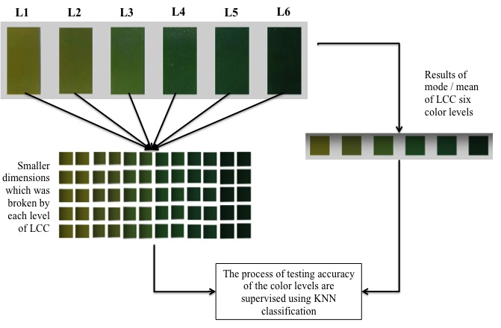
Figure 2. Procedure for color classification method using KNN

The accuracy was calculated by comparing the correct result of classification with the number of data in the collection. This accuracy value can be interpreted as a capability of the imaging sensor (i.e. a smartphone camera) to capture and distinguish a set of color. For a general use, the imaging sensor is expected to recognize at least (n-1) colors from a chart with n colors. For a LCC chart with six color as used in this experiment, an accuracy of 5/6 (83%) is expected and it is set as our measurement threshold. The purpose of the method was for testing the imaging system from a tested smartphone, whether it can recognize and distinguish LCC color. This experiment is conducted in a MATLAB environment.

- RESULTS AND ANALYSIS
Two types of smartphones are used as our tested imaging devices. LCC capturing was obtained in varieties of lighting conditions. For each imaging device, statistical mean and modus will be evaluated. As explained in Section 2 above, the LCC with six color is used. With this LCC, an accuracy of 83% or more is expected. Training data are prepared from a digital LCC. This step will be used as a benchmark test to evaluate the performance of statistical mean and modus in a nearly ideal color dataset. The training results shows an accuracy 0.8996 and 0.7115, of mean and modus, respectively. Figure 3 shows the comparison of mean and modus test. Eventhough the both color are very similar in human eyes perception, the calculated accuracy is different.

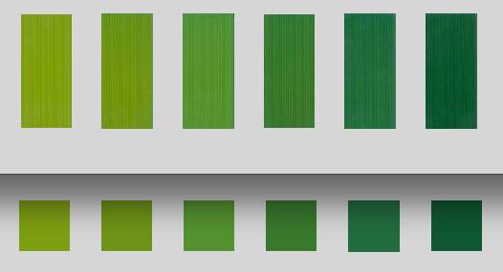
(A)

(b) | 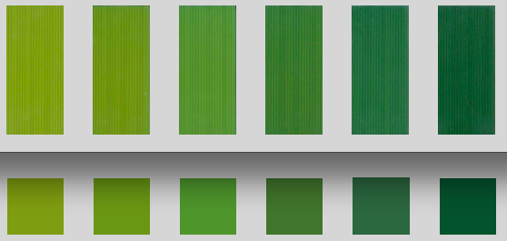  (c)

Figure 3. Result of Benchmark Assessment (a) Benchmark from digital reference (b) based on Mean (c) based on Modus.

Table 1. Color representation using mean and modus
Level | Mean |  |  |  | Modus
Level | R | G | B |  | R | G | B
L1 | 117 | 137 | 25 |  | 116 | 135 | 24
L2 | 101 | 126 | 25 |  | 99 | 128 | 23
L3 | 82 | 123 | 39 |  | 80 | 127 | 36
L4 | 59 | 98 | 35 |  | 62 | 94 | 34
L5 | 44 | 86 | 47 |  | 46 | 81 | 48
L6 | 31 | 67 | 37 |  | 27 | 63 | 34

Table 1 shows R,G, and B values for each color level which are calculated using statistical mean and modus. This detail shows, colors tend to be lighter in statistical mean compare to its modus. Both of mean and mode has little different value of R, G, B channel, but it can represent different color. Since the accuracy reaches the expected threshold, the method is considered works well, and it will be used to evaluate the usage of two types of smartphones in varieties of lighting conditions.

3.1. Color Assessment Using Different Devices
A printed LCC was captured twice in agood lighting condition using Samsung Galaxy ACE (ACE) and LG Optimus (LG) smartphones. The following Table 3 shows the accuracy of classification using those two devices.

Table 3. The Accuracy of Classification in Different Device
Device | Captured Image | Accuracy using mean | Threshold > 83 % | Accuracy using modus | Threshold > 83%
ACE | Image 1 | 0.9968 | Yes | 0.9698 | Yes
 | Image 2 | 0.8828 | Yes | 0.8659 | Yes
LG | Image 3 | 0.9167 | Yes | 0.8981 | Yes
 | Image 4 | 0.8294 | No | 0.7123 | No

Overall, Samsung Galaxy ACE showed a better accuracy in classification process compare to LG Optimus. However, both devices can be used for for this purpose since their accuracies are higher than the threshold value. The use of statistical mean shows better results of all experimental data.

3.2. Color Assessment with Various Lighting Conditions
A series of test was obtained with various lighting conditions to simulate the possible field survey circumstances. A printed LCC has been captured using Samsung Galaxy ACE in various lighting conditions, producing ten captured images to be valuated. From visual interpretation, it is obvious that lighting condition has a major influence in color assessment. The capture image of LCC can be brighter, lighter, color-shifted, noisy compare to its printed version. Image number 5 and image 7, as shown in Figure 4 were captured in a poor lighting condition. From a visual interpretation, those images show a series of color which are difficult to match their corresponding color in LCC.
The accuracy of classification is shown in Table 4. The accuracy is compared to the predefined threshold of 83%. Accuracy using statistical mean is better than using statistical modus in most of tests. Modus used dominant color that often arises, so that the captured images were not acquired as well.

- CONCLUSION
This paper presents a novel method to assess the color levels in LCC using smartphone cameras. In this method, a classification with KNN algorithm is used to assess the captured image and relatively calibrate its color. This relative color calibration, enables a wide-variety of imaging sensor to be used without the need of correcting the color value into its absolute color as usually done in an absolute color calibration. The test shows good results even in many non-deal lighting conditions. Moreover, it works well in a RGB color space without a color transformation as usually proposed. This makes a further implementation more feasible. The calibration result from this assessment method can be used to score imaging device to determine whether the device can be used for this purpose with the current lighting condition.
This research uses LCC as a color test. Further research will asses a real sugarcane leaf color and match its color levels with its corresponding LCC. This step opens a possibility to determine the chlorophylll or nitrogen level in a leaf using smartphone camera.

Table 4. The Accuracy of Classification in Various Lighting Condition
Captured Image | Accuracy using mean | Threshold > 83% | Accuracy using modus | Threshold>83%
Image 1 | 0.8775 | Yes | 0.8456 | Yes
Image 2 | 0.9076 | Yes | 0.7344 | No
Image 3 | 0.9841 | Yes | 0.7402 | No
Image 4 | 0.7855 | No | 0.6262 | No
Image 5 | 0.5882 | No | 0.4975 | No
Image 6 | 0.8064 | No | 0.5453 | No
Image 7 | 0.8519 | Yes | 0.588 | No
Image 8 | 0.7515 | No | 0.7485 | No
Image 9 | 0.9767 | Yes | 0.962 | Yes
Image10 | 0.9877 | Yes | 0.9926 | Yes

Image in non-ideal lighting | Mean | Modus
Image 5  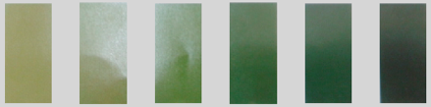 |  | 
Image 7  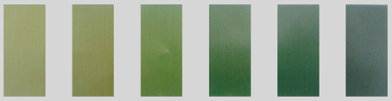 |  | 
Figure 4. Results of different color levels taken by different illumination

ACKNOWLEDGEMENTS
This work was conducted in the LBE Laboratory of Enterprise Intelligent System at The Department of Informatics, Faculty of Information Technology, Institut Teknologi Sepuluh Nopember. It supported by The Ministry of Agriculture, Republic of Indonesia through KKP3N (Kerjasama Kemitraan Penelitian dan Pengembangan Pertanian Nasional) research fund.

REFERENCES
- Badan Pusat Statistik. Perkembangan Beberapa Indikator Sosial Ekonomi Edisi Agustus 2012. 2012
- Global Young Leaders Programe. “Empowering Rice Farmers through Mobile Technology”, Executive Leadership Development Through Experiential Learning Hongkong and The Philipines, 2013
- R. Khan, et.al. “Color based Skin Classification”. Pattern Recognition Letters 33, no.2, 2012, pp. 157-163.
- I. Wayan Astika, “ The Use of Hand Phone Camera to Determine Paddy Leaf Color Level as Reference for Feritilizing Dosage”, AFITA 2010 International Conference, The Quality Information for Competitive Agricultural Based Production System and Commerce, 2010.

BIBLIOGRAPHY OF AUTHORS

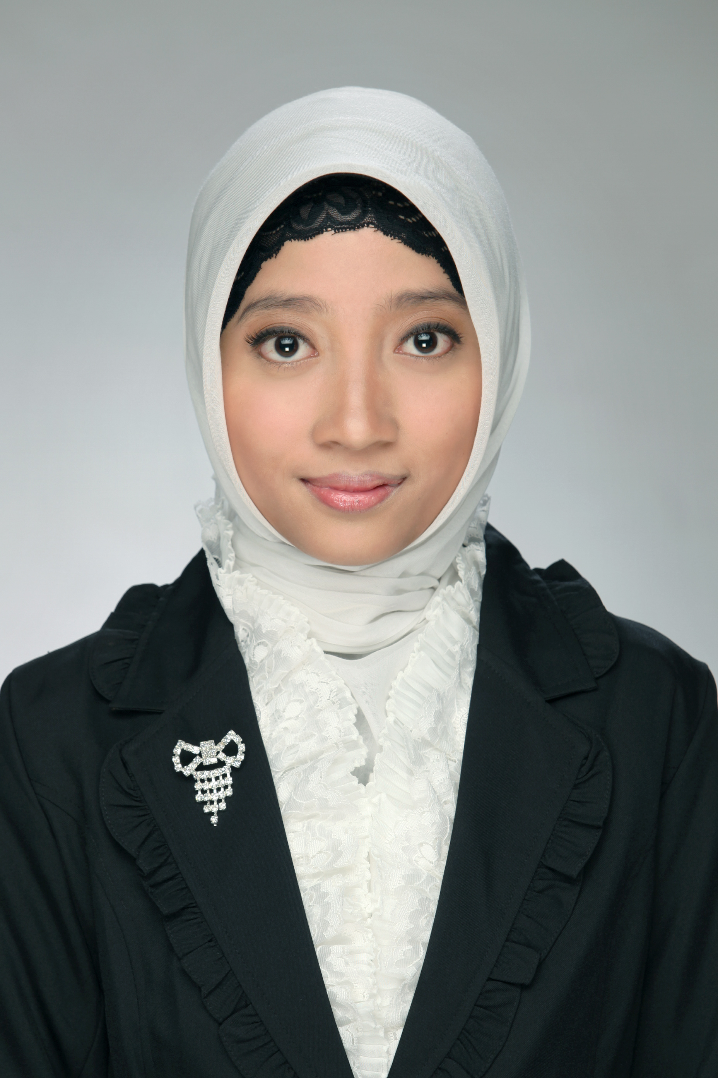 | Received her S.Kom degree in Computer Science from University of Brawijaya. Currently she has been studying in Informatics Engineering, at the third semester of Master Degree in Institut Teknologi Sepuluh Nopember (ITS). Her research interests include pattern recognition, data mining, and machine learning.
 | Received his Ir. degree in Electrical Engineering from Institiut Teknologi Sepuluh Nopember (ITS) Surabaya. Received his Msc. Degreein IT for Natural Resources Management from Instititut Pertanian Bogor (IPB). Received his Dr.Tech degree of Informatics and Geoinformation from Vienna University of Technology, Austria. Currently he is the head of The Laboratory of Intelligent Systems, Informatics Department - ITS, the coordinator of Intelligent Computing and Visualization (KCV) expert group in Informatics Department - ITS, and a senior researcher at the Laboratory of Enterprise Intelligent Systems, ITS-Surabaya.
 | Professor of Software Engineering, Informatics Department, Institut Teknologi Sepuluh Nopember (ITS). Received his Ir. degree in electrical engineering from Institut Teknologi Bandung. Received his Drs.Ec economics from Universitas Pajajaran. Received his MSc and Phd in Computer Science from University of New Brunswick, Canada. Currently he is the head of Lab Based Education (LBE) Enterprise Intelligent System in Institut Technologi Sepuluh Nopember. His research interest is enterprise computing.

