**BLACKBOX :**

1. **Equivalent:**

NIK: 16 digit

|  |  |  |  |
| --- | --- | --- | --- |
| invalid | valid | | invalid |
| -16 - 0 | 1-16 | A-Z | 17-25 |
| 0 | 16 | Z | 25 |

No KK : 16 digit

|  |  |  |  |
| --- | --- | --- | --- |
| invalid | valid | | invalid |
| -16 - 0 | 1-16 | A-Z | 17-25 |
| 0 | 16 | Z | 25 |

1. **Tabel Kebenaran**
2. Validasi Login

|  |  |  |  |  |
| --- | --- | --- | --- | --- |
| Username | F | F | T | T |
| Password | F | T | F | T |
| Hasil | eror | eror | eror | benar |

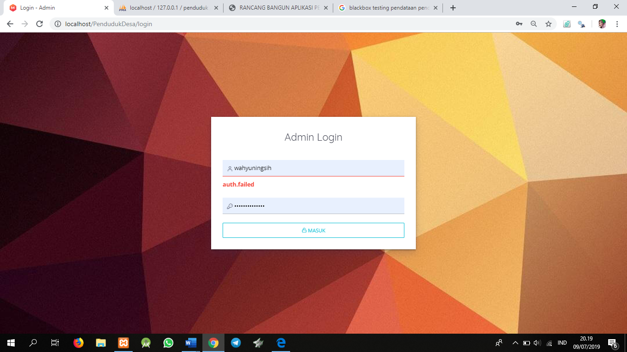

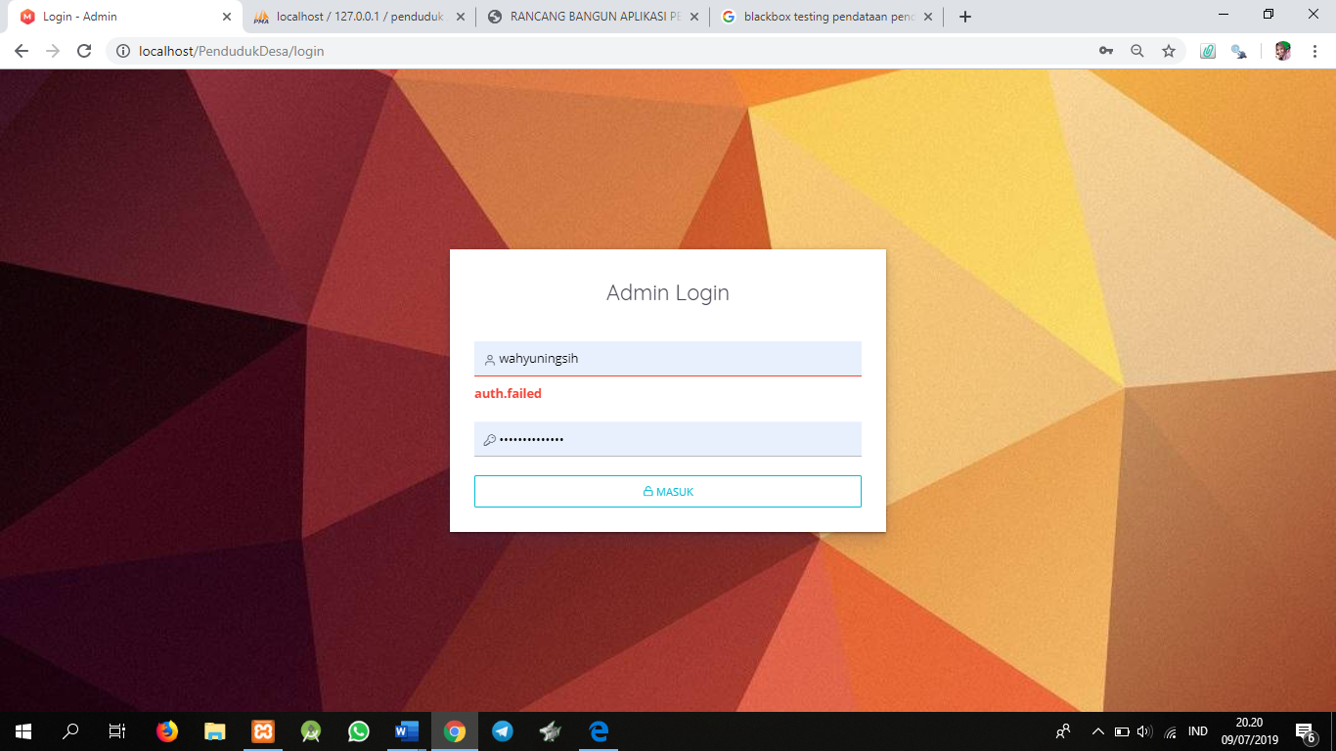

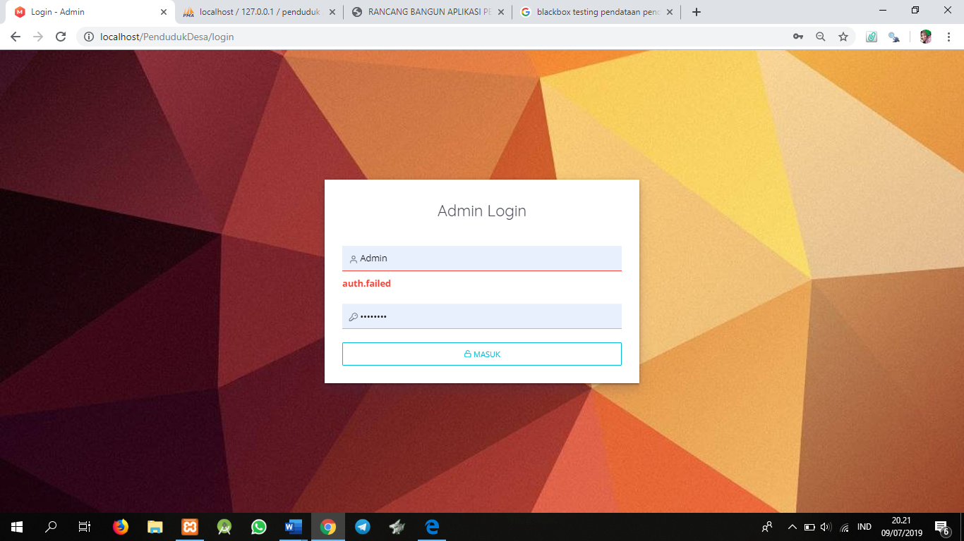

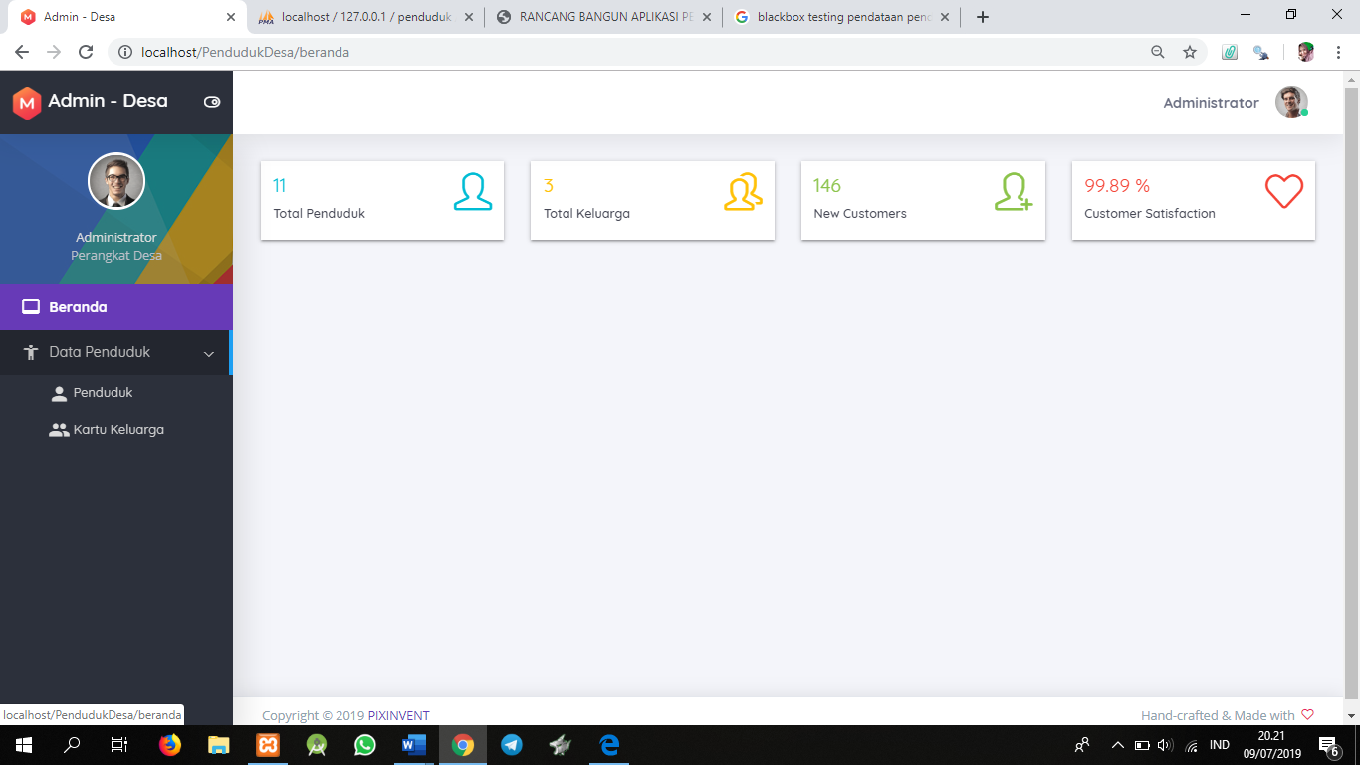

1. Validasi :

|  |  |  |  |  |  |
| --- | --- | --- | --- | --- | --- |
| NIK | F | F | F | F | T |
| No KK | F | F | F | T | T |
| Hasil | Eror | Eror | Eror | Eror | Benar |

