1. **Abstract**

The system utilizes fingerprint recognition technology to verify the identity of individuals based on their unique fingerprint patterns. Through the integration of advanced algorithms and machine learning techniques, the system is designed to accurately match and authenticate fingerprints in real-time. The project focuses on enhancing system performance by optimizing fingerprint image preprocessing, feature extraction, and matching algorithms. The proposed Fingerprint Authentication System project provides an efficient and robust solution for ensuring secure access control in various applications such as workplaces, universities, banking, government, and personal devices.

1. **Aim and Objectives**

Aim: The aim of the Fingerprint Authentication System project is to develop a secure and reliable biometric authentication system using fingerprint recognition technology.

**Objectives**

* To develop a real-time and reliable authentication fingerprint authentication system with user-friendly interface
* To create a powerful fingerprint authentication system that involves registration, verification, attendance recording, and email sending functions
* To apply fingerprint matching algorithm using machine learning and pattern recognition techniques
* To allow users to send attendance data via email, either to a specified recipient or a default address

1. **Benefits**

**• Enhanced Security**

**• Improved User Experience**

**• Strong Accountability**

**• Cost and Time Savings**

**• Scalability and Adaptability**

1. **Impact Area**

* Access Control Systems
* Mobile Devices
* Financial Transactions
* Identity Verification
* Attendance Systems
* Law Enforcement and Forensics
* Healthcare and Medical Records
* Data Security
* Border Control and Immigration
* IoT Security

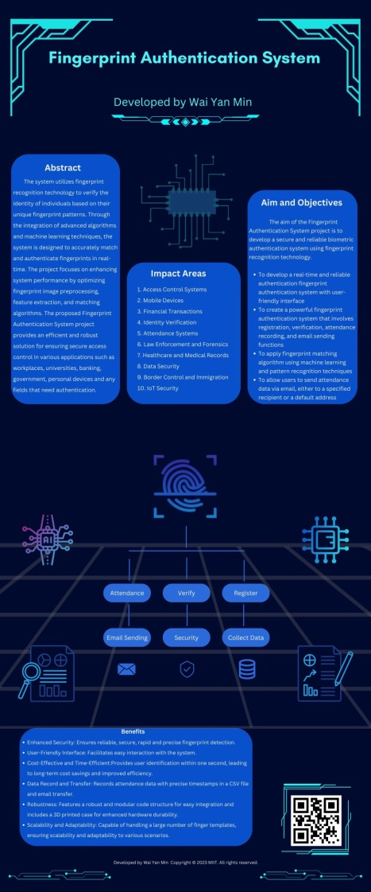

1. **Robustness**

**Hardware robustness**

The 3D printed case for the fingerprint sensor enhances the project's hardware robustness.

**Software robustness**

**Accuracy and Precision:** The project's algorithms and methodology are designed to achieve a high level of accuracy and precision in fingerprint recognition. Through extensive testing and optimization, the system minimizes false positive and false negative rates, ensuring that only authorized individuals are granted access.

**Noise and Variability Tolerance:** The system demonstrates robustness in handling variations in fingerprint quality and environmental conditions. It can effectively deal with common challenges such as partial prints, smudges, or minor distortions caused by pressure or moisture, without compromising the accuracy of the authentication process.

**Scalability:** Your project's architecture and algorithms are scalable, allowing for seamless integration into various systems and accommodating a growing number of users and fingerprint records. Whether deployed in small-scale environments or large enterprises, the system maintains its performance and accuracy, ensuring a consistent user experience.

**Security Measures:** The project incorporates robust security measures to protect the fingerprint data and prevent unauthorized access. Encryption techniques and secure storage mechanisms are employed to safeguard sensitive information, ensuring the privacy and integrity of the stored data.

**Real-time Performance:** The system's algorithms and processing capabilities are optimized to provide real-time performance, enabling swift and efficient authentication. Users can experience seamless and instant access to secured resources, eliminating delays or bottlenecks in the authentication process.

**Error Handling and Recovery:** The project incorporates robust error handling mechanisms to handle unexpected scenarios and recover gracefully from errors or system failures. This ensures uninterrupted operation and minimizes the impact of any potential disruptions.

1. **Equipment and Software Requirement**

**Equipment**

* Fingerprint sensor
* Computer or microcontroller
* USB to TTL converter
* 3-D printed case

**Software Requirement**

Fingerprint authentication system is written in **Python** Language using VS code. **Libraries and modules** used in the system are as follows.

* **Adafruit Fingerprint**
* **Tkinter**
* **Threading**
* **Pandas**
* **PIL**
* **Serial**
* **Datetime**
* **Smtplib**
* **Json**
* **Csv**
* **Os**

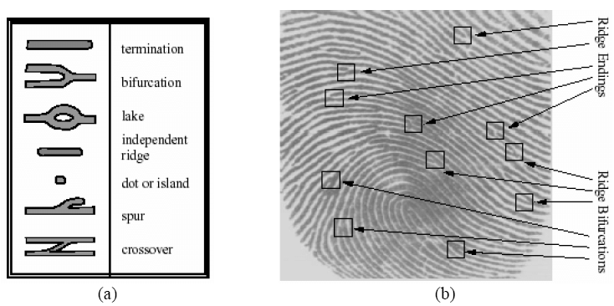The Fingerprint Authentication System incorporates several algorithms and programs to achieve its functionality. Here are some of the key components:

1. **Fingerprint Feature Extraction:**

- **Ridge Ending Detection**: This algorithm identifies the ending points of ridges in the fingerprint image, which are crucial features used for matching.

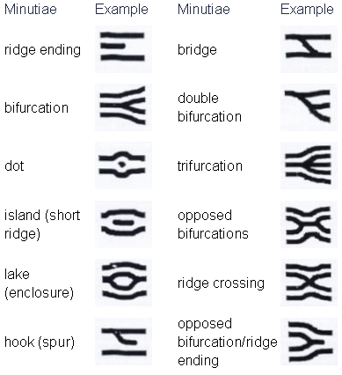- **Bifurcation Detection:** This algorithm detects the points where ridges split into two branches, providing additional distinct features for matching.

- **Image Enhancement:** Techniques like histogram equalization, filtering, or adaptive thresholding may be employed to enhance the fingerprint image quality, reducing noise and improving accuracy.

1. **Fingerprint Matching:**

- **Minutiae-based Matching:** This algorithm compares and matches the extracted minutiae points (ridge endings and bifurcations) from the input fingerprint with those stored in the database. Various matching techniques like Euclidean distance, angle-based comparison, or graph matching can be used to calculate the similarity score.

- **Ridge-based Matching:** This algorithm focuses on matching the ridge patterns of the fingerprint, considering the overall shape, curvature, and orientation information. It can employ techniques like Gabor filtering, orientation field analysis, or ridge structure comparison to determine the similarity between fingerprints.

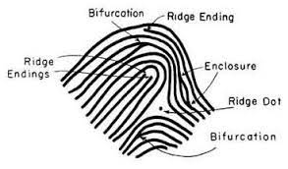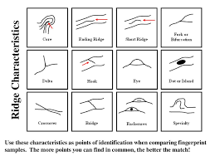

1. **CSV File Handling:**

- Python's CSV module: This built-in module in Python allows efficient handling and manipulation of CSV (comma-separated values) files. It enables storing and retrieving attendance records in a structured format, facilitating easy data management.

**4. Graphical User Interface (GUI):**

- tkinter: A standard Python library for creating GUI applications, tkinter provides the necessary tools for designing the system's user interface. It enables the creation of windows, buttons, text fields, and other interactive components, allowing users to interact with the system seamlessly.

**5. Email Sending:**

- Python's smtplib module: This module enables the system to send email notifications with attendance records. It provides functions to establish a secure connection with an email server and send emails using standard protocols like SMTP (Simple Mail Transfer Protocol).

Conclusion:

In conclusion, our Fingerprint Authentication System stands at the forefront of biometric security, offering a comprehensive and efficient solution for personal identification and attendance recording. Through advanced algorithms, secure data handling, and a user-friendly interface, our project demonstrates the power of innovative methodologies in addressing critical security challenges. By providing a secure and reliable means of authentication, we contribute to a safer and more efficient world.

**Methodology**

Our project follows a well-defined methodology that encompasses various stages of development, ensuring a robust and reliable fingerprint authentication system:

**1. Requirements Gathering:**

Extensive research and consultations were conducted to identify the essential requirements and desired functionalities of the system. User feedback and industry best practices played a crucial role in shaping the project's scope and goals.

**2. System Design:**

Based on the gathered requirements, a comprehensive system design was created, mapping out the GUI layout, functionality, and interaction flow. Attention to detail was given to ensure a user-friendly and intuitive interface.

**3. Implementation:**

Using Python as the primary programming language, the system's functionalities were developed and integrated. Advanced algorithms and modules, such as fingerprint feature extraction, matching, CSV handling, and email sending, were implemented using industry best practices and optimized code.

**4. Testing and Validation:**

A rigorous testing phase was undertaken to validate the system's performance, accuracy, and security. Extensive test cases, including positive and negative scenarios, were executed to ensure the system's reliability and robustness.

**5. User Feedback and Iteration:**

User feedback and suggestions were continuously gathered and incorporated into the project's development cycle. Iterative improvements were made to enhance usability, performance, and security base on real-world usage scenarios.

**Innovation:**

**Our project brings a significant level of innovation to the field of fingerprint authentication systems. Traditional authentication methods such as passwords or keycards are prone to security breaches and can be easily replicated or stolen. Our solution harnesses the uniqueness and complexity of fingerprints to provide a more secure and reliable means of authentication. By leveraging advanced algorithms and machine learning techniques, we have developed a system that accurately and efficiently verifies an individual's identity based on their unique fingerprint patterns. This innovative approach offers enhanced security and eliminates the need for users to remember passwords or carry physical tokens.**

**Usability:**

**Usability is a key aspect of our project. We have prioritized creating a user-friendly interface and seamless user experience to ensure that individuals can easily interact with the fingerprint authentication system. Our system features an intuitive interface that guides users through the enrollment and authentication processes, making it accessible to individuals with varying levels of technical expertise. Additionally, the system provides real-time feedback and prompts to ensure that users properly position their fingers for optimal fingerprint scanning. By focusing on usability, we have developed a solution that is efficient, convenient, and user-centric.**

**Technical Skill:**

**The development of our fingerprint authentication system required a high level of technical skill and expertise. Our team has deep knowledge in biometric technologies, pattern recognition, and machine learning algorithms. We have leveraged state-of-the-art techniques in fingerprint feature extraction, matching algorithms, and quality assessment to achieve accurate and efficient authentication. Additionally, we have implemented robust encryption mechanisms and secure storage protocols to safeguard the fingerprint data and protect against potential security threats. The technical complexity of our project demonstrates our team's strong technical skills and the ability to tackle challenging problems in the field of biometrics.**

**Impact Area:**

**The impact of our project extends to various areas, including security, convenience, and efficiency. From a security standpoint, our fingerprint authentication system significantly enhances the protection of sensitive information and resources. It reduces the risk of unauthorized access and identity theft, providing organizations and individuals with peace of mind. Additionally, our solution eliminates the need for cumbersome password management and reduces the reliance on physical tokens, improving convenience for users. Moreover, the system streamlines access control processes, saving time and resources for organizations. The broad impact of our project in these key areas demonstrates its potential to transform the way authentication is conducted across various industries and sectors.**

**Robustness:**

**Our fingerprint authentication system exhibits a high level of robustness, ensuring reliable and accurate performance under diverse conditions. The algorithms and methodology employed in our system have undergone rigorous testing and optimization to handle variations in fingerprint quality, environmental factors, and potential challenges such as partial prints or smudges. The system is designed to minimize false positive and false negative rates, providing consistent and dependable authentication results. Additionally, the system incorporates error handling and recovery mechanisms to ensure uninterrupted operation and mitigate the impact of system failures. The robustness of our project makes it suitable for deployment in real-world scenarios where reliability and accuracy are critical.**