Netflix Stock-Price Simulation Using the Heston Model
This project estimates Netflix’s future price distribution using the Heston stochastic-volatility model.
I calibrated the model using historical returns and rolling variance, then simulated 50,000 price paths to assess expected return, profit probability, downside risk, Value at Risk, and Expected Shortfall.

Simulation result:
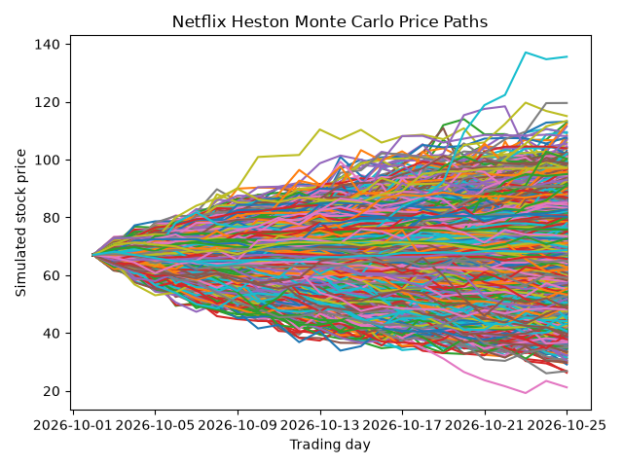
Calculation output:
- Expected return: 0.6802% (buy and hold from 2026-10-02 to 2026-10-25
  - Beginning stock price: $67.06 (real price)
  - Mean ending stock price: $67.652996 (with 50,000 simulations)Median return = -1.6165
- Probability of profit: 56.64%
- 95% Value at Risk: -0.200%
- Average return among the worst 5% of outcomes: -27.844%

Monte Carlo Terminal Price (2026-10-25):
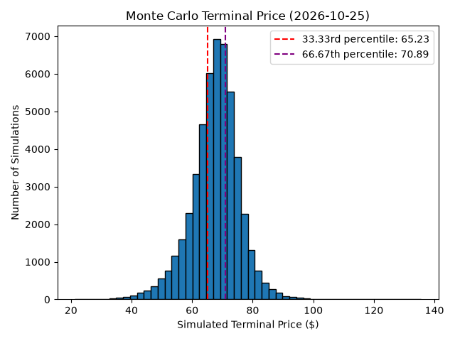
Case-by-case price analysis:
Conservative case: below $65.23
Base case: $65.23 to $70.89
Optimistic case: above $70.89

Comment: Normally, I would expect the price will fall in the base-case range, although future potential shocks can make the price falls into the conservative or the optimistic cases.

In addition, if an investor buys the stock at the price of $67.06 (real price) on 2026-10-02, the investor can receive the following return:

Monte Carlo Terminal Return Distribution (2026-10-25):
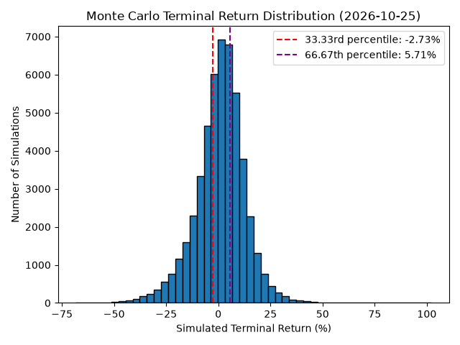
Case-by-case return analysis:
Conservative case: below -2.73%
Base case: -2.73% to 5.71%
Optimistic case: above 5.71%

Conclusion: The simulation indicates moderate upside potential but : -27.844% tail risk, demonstrating the importance of risk controls and position sizing.

