Axie Infinity centers around doing battles in the Arena and in Adventure Mode. To become good in battle you will need to learn the basics. These are:
- Abilities
- Class benefits
- Combat

1. Abilities
Every Axie has six body parts: Eyes, Ears, Horn, Mouth, Back & Tail. Four of these body parts give your Axie specific abilities:
- Horn
- Mouth
- Back
- Tail
For example, if your Axie has ‘Goldfish’ as the Back body part, then it will have the ability to use ‘Swift Escape’ in battle.
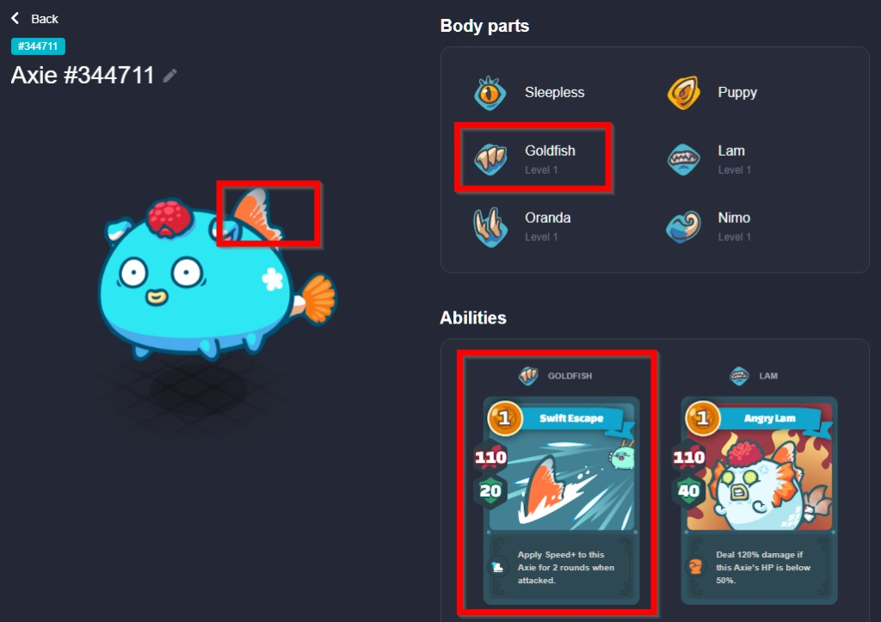
This means that you will be able to tell what abilities an Axie has, by looking at its body parts. Each body part is linked to an ability, for which you will receive an Ability Card when in battle with that Axie.
An Ability Card will show you three stats:
- Energy: The energy it will cost to play this card. You start with 3 energy and receive 2 energy each turn.
- Attack: The amount of damage a card does.
- Shield: The amount of damage you can block.
Besides statistics, some cards also have an ‘Effect’ that distinguishes it from other cards.
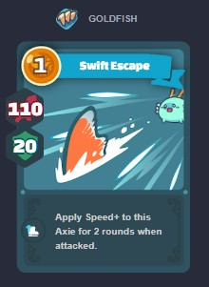
This card shows the ‘Swift Escape’ ability from the ‘Goldfish’ back body part. It costs 1 Energy and gives the Axie 110 Damage and 20 Shield that turn. The Effect will give the Axie a speed buff for 2 rounds, when attacked.
Each ability will generate 2 cards for your deck. Each team has 3 axies, with 4 abilities. This means you have 8 cards per Axie, with a total of 24 cards in a deck.

2. Class benefits
The class of an Axie is important for combat, because each class is weak and strong against other classes. The Axie that has the class advantage will deal 15% additional damage. The Axie that has the class disadvantage will deal 15% less damage. For example, a Bird class Axie deals 15% additional damage to a Beast class Axie.
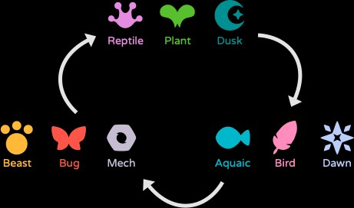
In addition, when an Axie of a certain class uses a card from its own class, it gets a 10% attack and shield bonus. For example, a Plant Axie playing a plant card will receive 10% extra attack/shield.
Important to note is that these bonuses stack. A Beast Axie using a Beast card against a Plant target will do 25% (10% + 15%) more damage.

2.1. Attributes
There are 4 stats in the game, Health, Morale, Skill and Speed.
- Health: The amount of damage your Axie can take before being defeated.
- Morale: Morale increases critical strike chance. It also makes entering last stand more likely and adds more last stand “ticks”.
- Skill: Skill adds damage when an Axie plays multiple cards at once (combo). The extra damage is calculated like this: (card attack * skill )/ 500.
- Speed: Speed determines turn order. Faster Axies attack first. Speed also decreases an Axie’s chance of being the victim of a critical strike. If two Axies have the same speed, this is how attack order is determined: High speed > Low HP > High Skill > High Morale > Low Fighter ID.
An Axie’s stats are dependent on two variables: its class and its body parts. For instance the base stats of an Aquatic Axie (body) are: 39 HP, 39 Speed, 35 Skill and 27 Morale. Each card will add stats based on the type:
- Aquatic: +3 Speed, +1 HP
- Beast: +3 Morale, +1 Speed
- Bird: +3 Speed, +1 Morale
- Bug: +3 Morale, +1 HP
- Plant: +3 HP, +1 Morale
- Reptile, +3 HP, +1 Speed
Class | HP | Speed | Skill | Morale
Aquatic | 39 | 39 | 35 | 27
Beast | 31 | 35 | 31 | 43
Bird | 27 | 43 | 35 | 35
Bug | 35 | 31 | 35 | 39
Plant | 43 | 31 | 31 | 35
Reptile | 39 | 35 | 31 | 35
Dawn | 35 | 35 | 39 | 31
Dusk | 43 | 39 | 27 | 31
Mech | 31 | 39 | 43 | 27

3. Combat
When the Battle begins you start with 3 Energy and 6 Cards. You have 60 seconds to select cards for your turn.
Speed determines turn order. This means that the fastest Axie will attack first. If two Axies have the same speed, attack order is determined by: Low HP > High Skill > High Morale > Low Fighter ID. You will see turn order at the top of your screen when in battle.
Once you have selected your cards, the battle will begin.
- Shield is applied immediately, when the cards are chosen
- Effects are applied when the Axie attacks during its turn
- Speed buffs that affect the attack order are applied next turn
Axies will attack the closest target, except when they are using an ability with an Effect to choose another target. For example ‘Dark Swoop’ will target the fastest Axie on the enemy team:
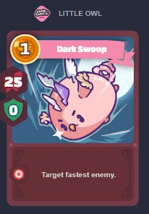

3.1. Combo & Chain
The Chain buff happens when multiple Axies use an ability card of the same class. Chains add a shield buff to these Axies.
A Combo happens when an Axie uses more than 2 ability cards in one round. Combos add damage.
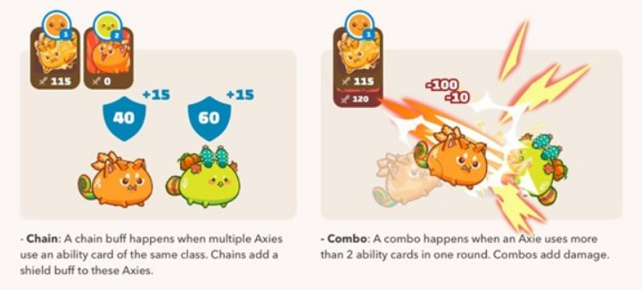

3.2. Last Stand
If an Axie’s health is depleted it will die, or enter Last Stand. An Axie with high Morale makes entering last stand more likely and adds more last stand “ticks”.

3.3. Buffs
Icon | Name | Description
 | Attack up | Increase the next Attack by 20% (stackable).
 | Morale up | Increase Morale by 20% for the next round (stackable).
 | Speed up | Increases Speed by 20% for the next round (stackable).
Buffs

3.4. Debuffs
Icon | Name | Description
 | Aroma | Target priority changes to affected Axie for the next round.
 | Attack down | Decreases the next Attack by 20% (stackable).
 | Chill | Affected Axie can’t enter last stand.
 | Fear | Affected Axie can’t attack.
 | Fragile | Shield takes double the damage for the next incoming attack.
 | Jinx | Affected Axie can’t land critical hits for the next round.
 | Lethal | Next hit against affected Axie is critical.
 | Morale Down | Decreases Morale by 20% for the next round (stackable).
 | Poison | Until removed, affected Axie loses 2 HP for every action (stackable).
 | Sleep | Next incoming attack ignores shields.
 | Speed Down | Decreases speed by 20% for the next round (stackable).
 | Stench | Affected Axie loses target priority for the next round.
 | Stun | Next attack misses / Next incoming attack ignores shields.

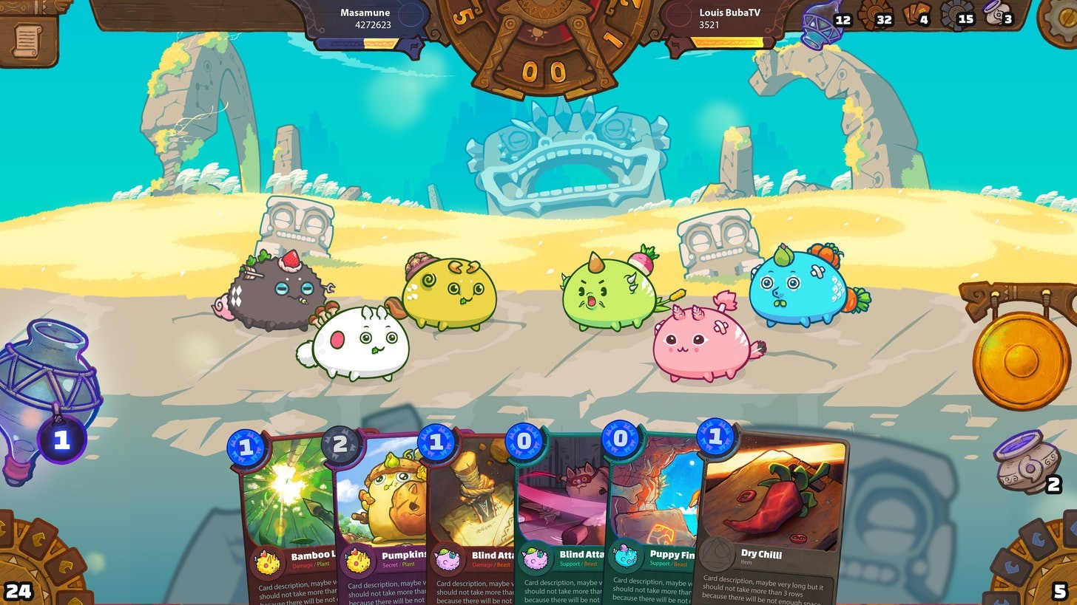
Arena now seems to be the main source of Smooth Love Potion (SLP) in Axie Infinity.
This is after the recent Season 18 update last August 10, 2021 that reduced SLP earnings in Adventure mode by half, and increased SLP rewards in Arena the higher you climb in the leaderboards.
With PVP now becoming more competitive and more rewarding than ever, let’s take a look at some tips and strategies on how to win more games in Arena.

Tips to Win More in Arena (PVP)
Here are some tips to help you win more PVP matches in the Axie Infinity Arena.

1. Understand Axie type strengths and weaknesses
Axie Infinity has a type advantage/disadvantage system similar to Pokemon, or rock-paper-scissors.
Here is the complete weaknesses chart for each Axie type:
- Reptile, Plant, Dusk deal 15% more damage vs. Aqua, Bird, Dawn
- Aqua, Bird, Dawn deal 15% more damage vs. Beast, Bug, Mech
- Beast, Bug, Mech deal 15% more damage vs. Reptile, Plant, Dusk
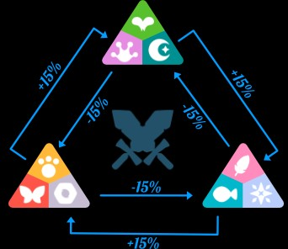
While attacking a weakness isn’t as significant as dealing double the damage like in Pokemon, dealing 15% more damage will definitely give you a huge advantage.
Familiarize yourself with these strengths and weaknesses and always use them to your advantage. For beginners, we recommend always having this chart open as soon as you enter a PVP battle!

2. Position your Axies properly
Regardless of your Axie team composition and their individual abilities, positioning is very important in Arena.
Normally, Axies will always attack the enemy Axie nearest to them.
The most obvious positioning rule is putting a tank Axie such as Plants on the front. Midlaners are usually a mix of damage dealer Axies and some decent amount of HP.
Backliners, or sometimes called glass cannons, are your main damage dealers but they also tend to have very low HP. Your DD (damage dealers) are usually the ones who close out and win matches.
Note that once you enter a battle, you can no longer change your Axie’s positions so make sure to plan them ahead carefully.
Always check your Axie’s move set and stats to determine where they should be placed in your team’s lineup.

3. Take advantage of combos
In Axie Infinity, a set of combo abilities may be more effective than when they are casted individually.
For example, one of the most common combo is the Nut Throw & Nut Crack combo. Both cards deal 105 Attack damage, but if they are casted together in one turn, both attacks will deal 120% more damage.
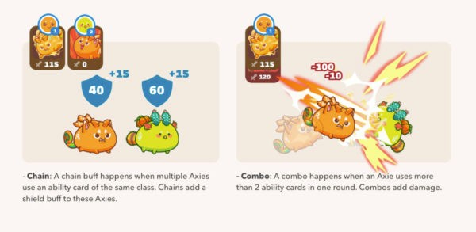
There are endless possibilities for combos in the game, and we have created a list of some of the best ones in our guide here.
Take these into consideration when choosing Axies for your team.
(Related Guide: Best Starter Teams in Axie Infinity)
Great combos can only be unleashed with proper Energy management. This leads us to our next tip…

4. Don’t be afraid to pass a turn
Players get 3 Energy at the start of a match, and gain 2 Energy on every succeeding rounds.
Sometimes, especially during the first turn, consider not casting any cards and just pass the turn. This will save up your current Energy and carry it over to the next round.
When you pass on the first turn, you can gain a max of 5 Energy for the next round, which allows you to cast more cards and perform a powerful combo.
This way, you’ll have more chances of killing an enemy Axie in just a single turn by unleashing a series of high-attack damage moves, giving the opponent no chance to recover.
Additionally, passing also gives you an opportunity to wait and gather more cards required for that perfect combo.
Don’t hesitate to pass a turn, you don’t have to always cast cards every round!

5. Beware of Energy steal cards
Actually, there are some rounds where you should avoid passing and spend your Energy right away.
And that is if the enemy team has some card abilities that lets them steal your Energy.
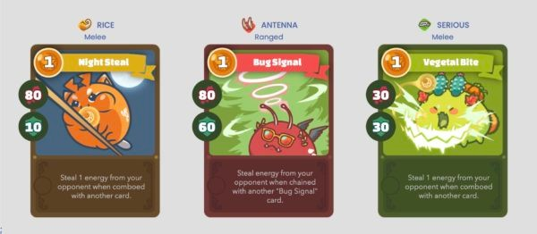
To counter this, it’s better to always use up your Energy right away, especially on Turn 1, since most Energy steal moves are usually casted from the start.
So, how do you know if your enemy has Energy steal? Simple—read the next tip!

6. Check your opponent’s parts/cards at the start of the match
Once a PVP match starts, the first thing that you should always do is check the cards of your opponent’s team.
You can do this by clicking on the enemy’s Axies.
Having an idea on what combos and tricks your enemy may have up their sleeves will always put you at an advantage.
That way, you can anticipate their moves and you can counter them with the appropriate cards.
(Related Guide: Best Cards for Each Class in Axie Infinity)
For example, did the opponent pass on the first round in preparation for a deadly Dark Swoop combo? Then counter it with some defensive cards first before going in for the attack.
Over time as you gain more experience with the game, you should be able to familiarize the corresponding card moves for an Axie just by looking at its body parts.

7. Learn all Buffs and Debuffs and what they do
Here is the list of all buff and debuff effects that can be inflicted to your Axie or the enemy Axie:
Buffs:
- Attack Up — Increases the next Attack by 20% (Stackable)
- Morale Up — Increases Morale by 20% for the next round (Stackable)
- Speed Up — Increases Speed by 20% for the next round (Stackable)
Debuffs:
- Aroma — Target priority changes to affected Axie for the next round.
- Attack Down — Decreases the next Attack by 20%. (Stackable)
- Chill — Affected Axie can’t enter last stand.
- Fear — Affected Axie can’t attack
- Fragile — Shield takes double the damage for the next incoming attack.
- Jinx — Affected Axie can’t land critcal hits for the next round.
- Lethal — Next hit against affected Axie is critical.
- Morale Down — Decreases Morale by 20% for the next round. (Stackable)
- Poison — Until removal, affected Axie loses 2 HP for every action. (Stackable)
- Sleep — Next incoming attack ignores shields.
- Speed Down — Decreases speed by 20% for the next round. (Stackable)
- Stench — Affected Axie loses target priority for the next round.
- Stun — Next attack misses / Next incoming attack ignores shields.
(Full Guide: Complete List of Buffs/Debuffs and their Icons & Effects)

8. Learn attack formulas, calculations, and mechanics
This is what separates the high MMR players at the top of the leaderboards vs. an average Arena player.
While you don’t have to memorize each damage formula or perform calculations in real-time during a game, it’s important to have at least some idea of how battle mechanics work in the game.
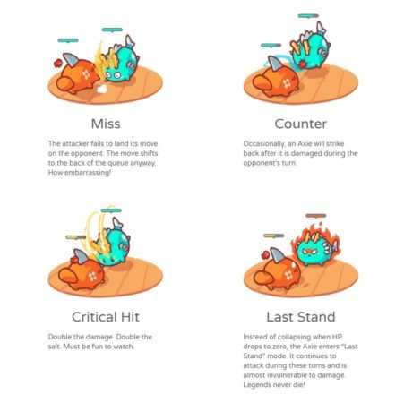
Having this knowledge will help you in making decisions during combat.
For example, if you understand how the Last Stand mechanic works, you will know how to prevent enemies from entering Last Stand which can potentially turn an unfavorable match around.

Best Axie Builds for Arena PVP
Here are some of the meta PVP Axie builds for Axie Infinity Arena.

1. Terminator
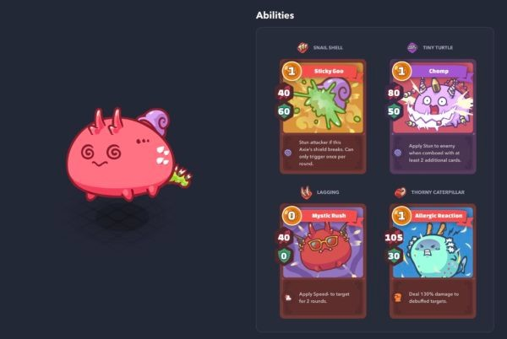
- Body: Bug or Reptile
- Cards/Parts: Sticky Goo (Snail Shell), Chomp (Tiny Turtle), Mystic Rush (Lagging), Allergic Reaction (Thorny Caterpillar) or Tiny Swing (Tiny Dino)
- Position: Backline
The Terminator build revolves around applying a debuff to the enemy using either if the three cards, and then combo them up with Allergic Reaction (Thorny Caterpillar) which deals 130% damage to a debuffed target.
This Axie build is not pack a deadly offensive, it also is very hard to kill due to its array of stuns and speed reduction debuffs.

2. Shrimpinator
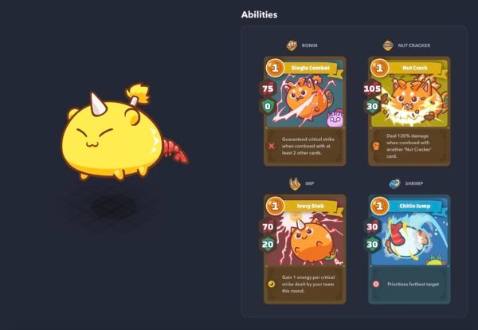
- Body: Beast
- Cards/Parts: Single Combat (Ronin), Ivory Stab (Imp), Chitin Jump (Shrimp)
- Position: Middle or Backline
This Beast build is a 1-turn backline killer machine, thanks to its Shrimp body part which lets the Axie prioritize the furthest target.
When Chitin Jump (Shrimp) is paired with powerful attack combos such as the RIMP (Ronin + Imp) combo or Nut Crack combo, the Shrimpinator can easily take down enemy glass cannons positioned at the back.
Killing the enemy damage dealer at the start will give you a huge advantage throughout the game as it denies your opponent from dealing deadly attacks against you.

3. Sniper Aqua / Idle Killer
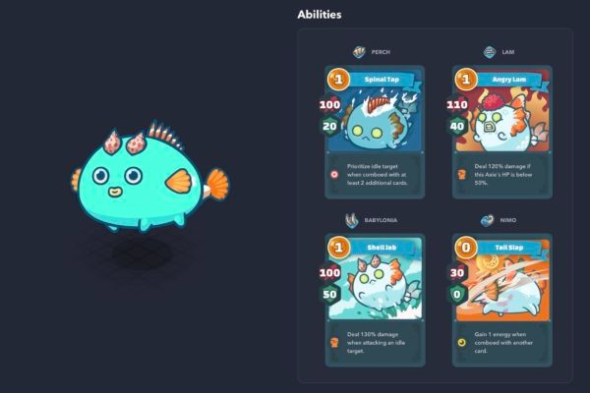
- Body: Aqua
- Cards/Parts: Spinal Tap (Perch), Shell Jab (Babylonia)
- Position: Middle or Backline
The Sniper Aqua, a.k.a. The Idle Killer, is exactly what its name suggests. Its aim is to target weak, shieldless targets and catch them off-guard—quite literally.
Spinal Tap (Perch) prioritizes idle Axies when comboed with 2 additional cards, while Shell Jab (Babylonia) deals 130% more damage to idle targets.
The downside with this build is you have to learn the proper timing on when to perform the anti-idle combo.

4. Double Anemone Aqua
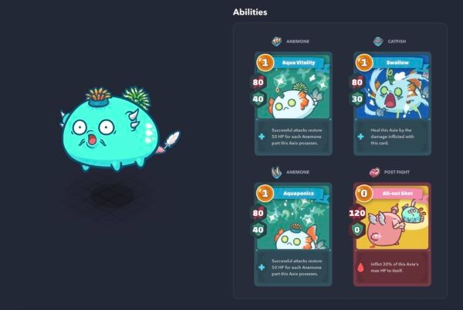
- Body: Aqua
- Cards/Parts: Aqua Vitality (Anemone), Aquaponics (Anemone), Swallow (Catfish), All-out Shot (Post Fight)
- Position: Middle or Backline
This Aqua Axie revolves around abusing its healing abilities which makes it very hard to kill, as long as it doesn’t die in 1 turn.
Both Anemone cards (Aqua Vitality and Aquaponics) restore 50 HP for each Anemone card the Axie possesses. This means each attack gives 100 HP, making this Aqua Axie very hard to kill.
Another great card that goes well with this build is Swallow (Catfish) which gives another heal based on the damage inflicted with the card.
Lastly, the zero-Energy card All-out Shot (Post Fight) deals a whopping 120 damage at the cost of 30% max HP. But, with this Axie’s virtually unlimited heal abilities that can quickly recover the lost HP, this card is basically free to cast.
This build is weak against anti-heal effects and 1-turn kill moves.

5. Backdoor Killer Bird
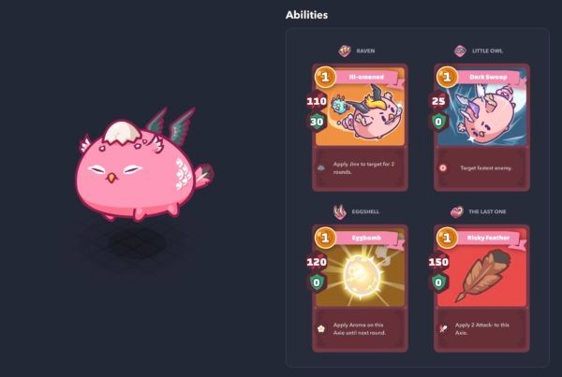
- Body: Bird
- Cards/Parts: Dark Swoop (Little Owl) + high-attack cards such as Eggbomb (Egg Shell), or Risky Feather (The Last One)
- Position: Middle or Backline
The Backdoor Killer Axie is very annoying to deal with.
This Bird Axie is another build that prioritizes the enemy team’s backline, depriving them of DPS throughout the match.
This Axie uses Dark Swoop (Little Owl) as an opener attack to target the fastest enemy—that is, the one with the highest Speed.
Combo this with high-attack damage cards such as Eggbomb (Egg Shell), Headshot (Kestrel), or Risky Feather (The Last One) and you’ll easily eliminate enemy backliners!

6. Sticky Tank
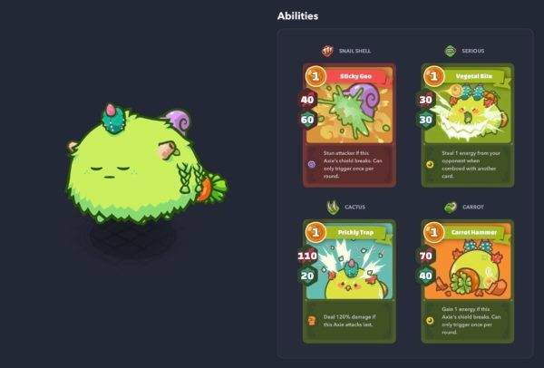
- Body: Plant
- Cards/Parts: Sticky Goo (Snail Shell), Carrot Hammer (Carrot)
- Position: Front
This Plant Axie serves as a tank that absorbs all incoming damage and disrupt your enemy’s burst combos.
Sticky Goo (Snail Shell) stuns an enemy if this Axie’s shield breaks, which is great for stopping combos just by tanking attacks.
A great combo that takes advantage of the shield breaking is Carrot Hammer (Carrot) which gives you 1 Energy once the shield breaks.
Since this tank build Axie wants to receive lots of damage to trigger its effects, aim for a Plant with about 55+ HP.

More Axie Guides
- Best Starter Teams for Beginners
- How to Play Axie Infinity: Ultimate Beginner’s Guide
- How to Earn Money in Axie Infinity (and How Much)
- How Much it Costs to Start Playing Axie Infinity
- How to Earn SLP in Axie Infinity (Farming Tips & Tricks)
- PVP Guide: How to Win More in Arena (Builds, Strategy, Tips)
- Adventure Guide: How to Farm EXP & Level Up Fast
- How to Breed Axies (Breeding Guide)
- Best Cards for Each Class in Axie Infinity
- Best Combos in Axie Infinity (Tank, Support, Damage)
- What is an Axie Scholarship? (How to Apply as a Scholar)
- How to Download & Install Axie Infinity (Android, iOS, Windows, Mac)
Plant
 | Plant | Aqua | Beast
Serious | 34

Aqua
 | Plant | Aqua | Beast
Risky | 110 | 128 | 146
Shuriken | 115  (137) | 134 | 153  (174)
Nimo | 30(35) | 35 | 40
KOI | 110 | 128 | 146

