CSIS3275 Group 4

Swapify Install Instructions

1. Swapify should be able to run smoothly at Douglas College Computers. Can skip to step 3 if so.
2. Install node.js:  
   <https://nodejs.org/en>
3. Open with Visual Studio Code. You may drag the whole folder onto Visual Studio Code.

1. Open New Terminal (Ctrl+Shift+`)

1. Open one more terminal:

1. Change one of the directions of terminal to backend folder (cd backend):

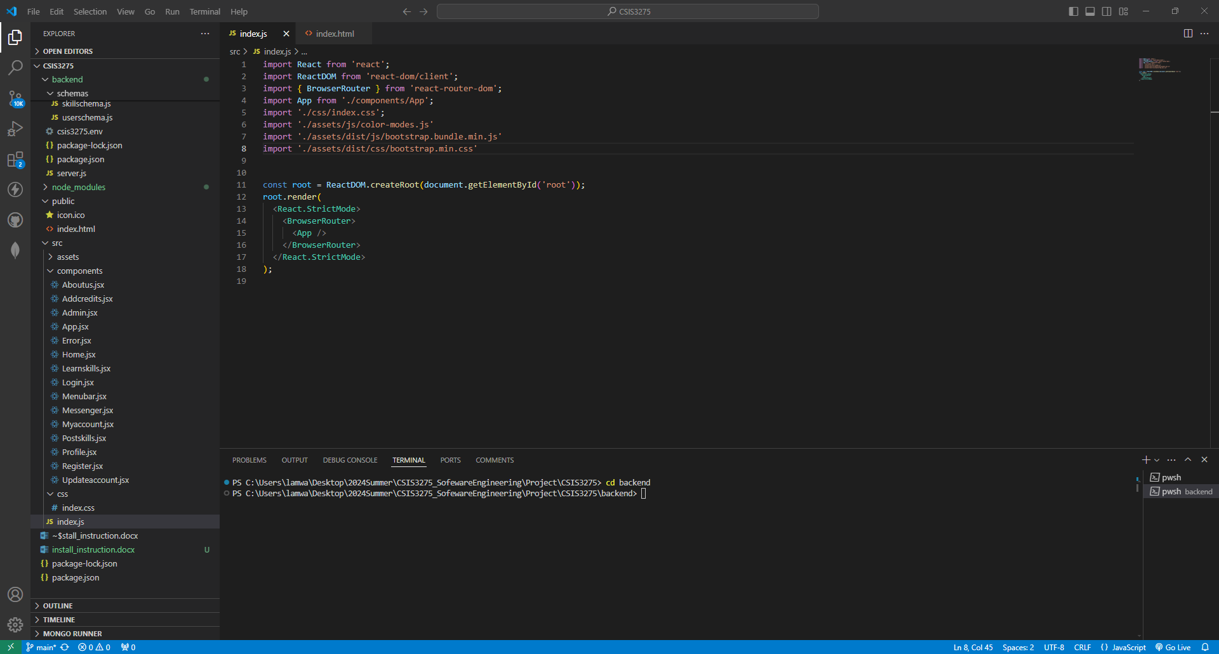

1. Install node_modules with command “npm i” at both terminals. It takes ~400MB storage in total:

1. Before starting Swapify, please ensure port 3000 and port 5000 are open.
2. Use command “npm start” at backend terminal to start the backend server.  
   You can see “Database is running on port: 5000” and “MongoDB Connected” if success. The Web Application is using MongoDB Atlas as online storage, which is open for all IP to access the data.

1. Similarly, use the command “npm start” at frontend terminal. The browser should pop up with the Home page of Swapify if successful.

Remark: The admin page is <http://localhost:3000/admin>

Name: admin  
Password: admin

The page can not be accessed by navigating Swapify directly