**DQ:** How can we develop a free online platform which supports in building community resilience through integrated wellness resources for Myanmar?

**EQ:** How can we, Yr-9 students develop a non-profit Library website which encourages learning communities in Myanmar to contribute to reading while providing accessible e-books and fostering engagement?

**Group Members:**

* Min Khant Si Thu Win @Albus Justin
* Hsu Latt Mon
* Phone Htet Paing @Noah
* Wai Yan Lin Aung

**Wireframes**

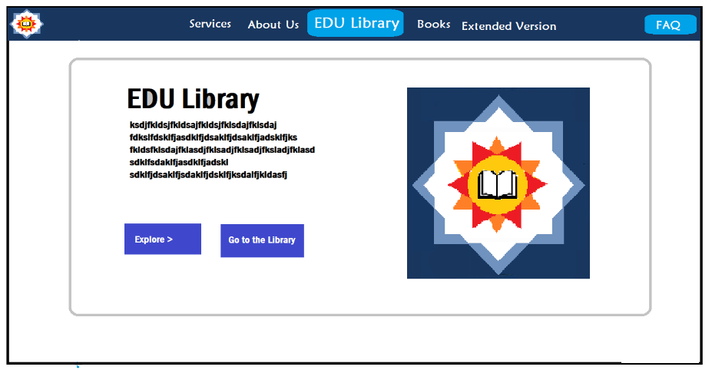

Advanced Category

Library Guide

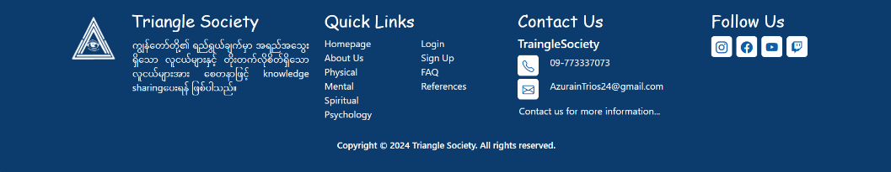

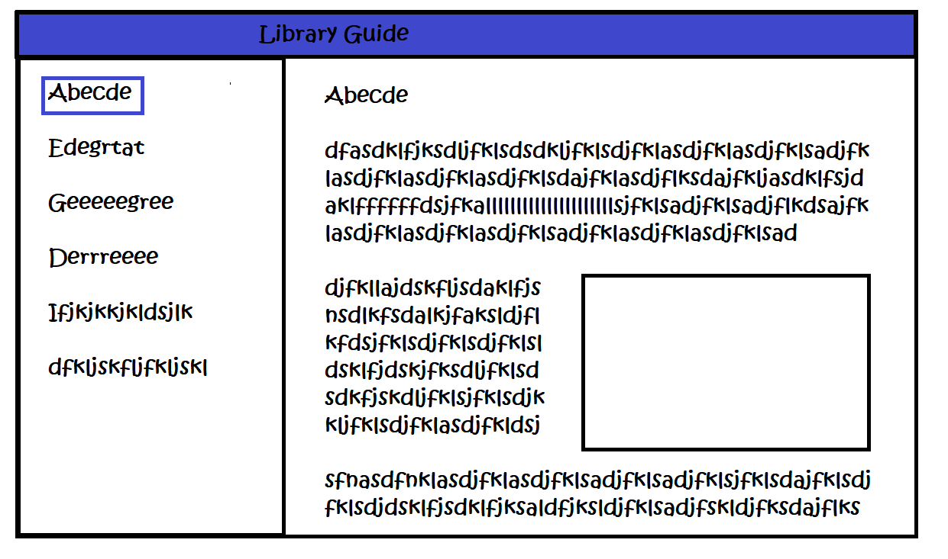

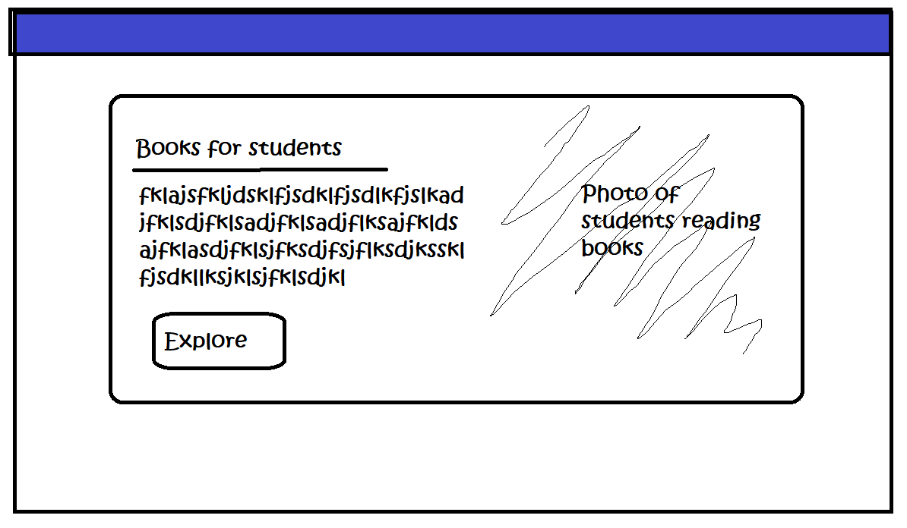

Advanced Category

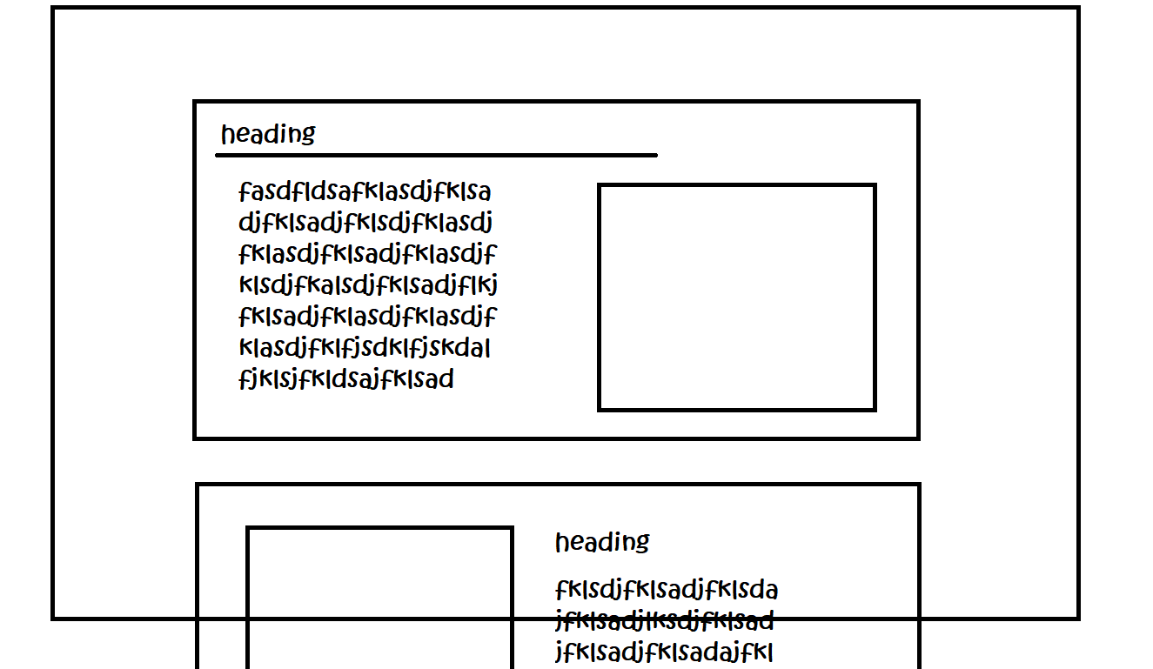

About Us

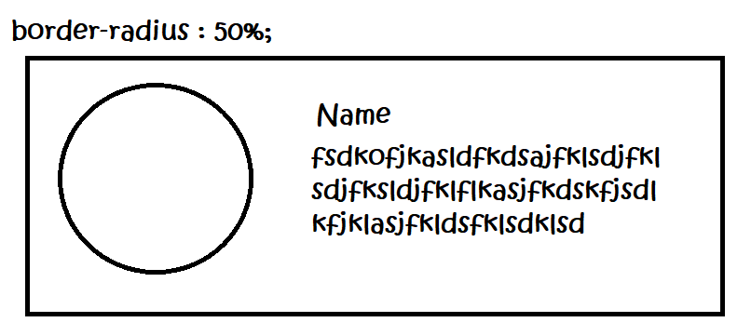

**Books**

**Total: 293 books**

**Educational Books:**

Future 35 (The future of Native Languages) – L. Whaley

Languages:

Latin:

1. New Latin Grammar Autor Charles E. Bennett – InfoBooks Library
2. Latin Autor Wikibooks – InfoBooks Library
3. Greek and Latin Roots Part I Autor Peter Smith– InfoBooks Library
4. The Latin Alphabet Autor Home Page of Mahdi Cheraghchi – InfoBooks Library
5. Classical Latin Autor Hackett Publishing – InfoBooks Library
6. Getting Started on Classical Latin Autor the open University – InfoBooks Library
7. Regular Verbs Autor St. Charles Preparatory School – InfoBooks Library
8. Traditional Grammatical Terminology Latin Auto A.G. Rigg – InfoBooks Library
9. Latin Word Order Autor Lawrence Public School – InfoBooks Library
10. Latin Autor Daneshill School – InfoBooks Library

Japanese

1. Japanese Grammar Guide Author Tae Kim – InfoBooks Library
2. Hacking Japanese Supercourse author Nikolai Walker – InfoBooks Library
3. Easy Japanese Author NHK – InfoBooks Library
4. First Year Japanese I Author Yoko Sato – InfoBooks Library
5. Intensive Japenese I Grammar Lesson 1 Author UDE – InfoBooks Library
6. 80-20 Japanese, 10 steps to 500 sentences author Richard Webb – InfoBooks Library
7. Introduction to the Transcription and Pronunciation of Contemporary Japanese author Rafael E. Beermann – InfoBooks Library
8. Pronouncing Japanese! (Article) author Red Cedar Zen Community – InfoBooks Library
9. Reading Japanese author VU University Amsterdam – InfoBooks Library
10. The First 103 Kanji Author Nihon Ichiban – InfoBooks Library
11. Basic Knji 120 author Meguro Language Center – InfoBooks Library
12. Hiragana and Katakana Worksheets author Meguro Language Center – InfoBooks Library
13. Introduction to the Japanese Writing System author Rafael E.Beermann – InfoBooks Library
14. Beginning Japanese for Professionals Book 1 author Emiko Konomi – InfoBooks Library
15. First Year Japanese II, Yoko Sato – InfoBooks Library
16. Hiragana, Nihongo Library – InfoBooks Library
17. Katakana, Nihongo Library – InfoBooks Library
18. Second Year Japanese – Yoko Sato – InfoBooks Library

Italian:

1. Italian with Elisa author Bernd Sebastian Kamps – InfoBooks Library
2. Learn Italian author Paul Noble – InfoBooks Library
3. Overall Grammar Author UNiversita di Bologna & Politecnico di Milano – InfoBooks Library
4. MFLE Italian Reference Grammar author Education Scotland – InfoBooks Library
5. Indirect Object Pronouns author Italy Made Easy – InfoBooks Library
6. Italian Pronunciation – A Primer for Singers Author The Llewellyn Choir – InfoBooks Library
7. Italian Pronunciation Guide, Quick Start Author Mansfield University of Pennsylvania – InfoBooks Library
8. Present Tense Irrefular Author Italy Made Easy – InfoBooks Library
9. Past Tense of Reflexive, Reciprocal, Impersonal Verbs author Italy Made Easy – InfoBooks Library
10. Some Notes on the Passato Prossimo author Department of Education and Training, Victoria – InfoBooks Library
11. 22. 100 most used Italian verbs author The Metalearners – InfoBooks Library
12. 23. English-Italian Dictionary author MareaSistemi – InfoBooks Library
13. 25. Word of the Week. A weekly word to help improve your Italian vocabulary author Italy Magazine – InfoBooks Library
14. 26. Basic Italian Vocabulary and Grammar author Astalaweb – InfoBooks Library
15. Basic Italian Phrases, Think In Italian – InfoBooks Library
16. Collins Italian 3000 Words and Phrases, Collins – InfoBooks Library
17. Spunti Italiano elementare 1, Daniel Leisawitz and Daniela Viale – InfoBooks Library
18. The Adventures of Pinocchio, Carlo Collodi – InfoBooks Library

French:

1. 02. French author Wikibooks – InfoBooks Library
2. 04. French Language Studies – Grammar Reference Resource author Alison – InfoBooks Library
3. 06. Learn French with Paul Noble author Paul Noble – InfoBooks Library
4. 09. Prepositions and Articulated Prepositions author Italy Made Easy – InfoBooks Library
5. 10. Sons and Lettres. A Pronunciation Method for Intermediate-level French author Stephen Walton – InfoBooks Library
6. 12. Introduction to French Pronunciation author Yolaine Petitclerc-Evans – InfoBooks Library
7. 13. French Pronunciation Charts author Will Dudziak – InfoBooks Library
8. 17. French Verb Summary author Various authors – InfoBooks Library
9. 19. French Adjectives author Evan Faidley – InfoBooks Library
10. 23. The 100 Most Common French Words author French Together – InfoBooks Library
11. 24 French Vocabulary List, OCR– InfoBooks Library
12. 25. Glossary of Cognates author NYU– InfoBooks Library
13. French−English Dictionary, Unknown Author– InfoBooks Library
14. Introduction to Basics of French Language, Uttarakhand Open University– InfoBooks Library
15. The Little Prince, Antoine de Saint-Exupery – InfoBooks Library

English:

1. 01. Practise English on your own author Minitoba – InfoBooks Library
2. 03. Learn English Now author The Church of Jesus Christ of Latter-day Saints – InfoBooks Library
3. 04. English for Intermediate Students author Harijs Marsavs – InfoBooks Library
4. 08. Basic English Grammar for ESL Students author Espresso English – InfoBooks Library
5. 13. Tenses author Ankommen - St.Gallen– InfoBooks Library
6. 14. Writing Skills Practice Book for EFL author Patricia Wilcox Peterson – InfoBooks Library
7. 15. Put English phonetics into practice author Szilágyi László – InfoBooks Library
8. 17. English pronunciation author NanoPDF– InfoBooks Library
9. 21. What, Why, and How Grammar author San Mateo County Community College District – InfoBooks Library
10. Learn English in an easy, fast and fun way, .Angela Cecibel Moreno Novillo, Cristina Chamorro Ortega, Silvia Bejarano Criollo – InfoBooks Library
11. Learning Spoken English .in half the time, Lynn Lundquist – InfoBooks Library
12. Let's Learn English Level 1, VOA – InfoBooks Library

Chinese:

1. 01. Elementary Chinese Grammar author Centre for Teaching Chinese as a Foreign Language 1 – InfoBooks Library
2. 03. The ultimate guidebook to learning Mandarin Chinese author Various authors 1 – InfoBooks Library
3. 04. Chinese (Mandarin) author Wikibooks 1 – InfoBooks Library
4. 05. A Grammar of Mandarin Chinese author Hua Lin 1 – InfoBooks Library
5. 06. General number and the semantics and pragmatics of indefinite bare nouns in Mandarin Chinese author Hotze Rullmann and Aili You 1 – InfoBooks Library
6. 07. Chinese Language. Mandarin author Peace Corps China 1 – InfoBooks Library
7. 12. Hanyu Pinyin Pronunciation Guide author Stephen M. Hou 1 – InfoBooks Library
8. 15. Na (Mosuo)-English-Chinese dictionary author Alexis Michaud 1 – InfoBooks Library
9. 16. English-Chinese Pinyin Dictionary author Monash University 1 – InfoBooks Library
10. 18. Resources for Beginners The Definitive Guide to Pinyin & Chinese Pronunciation author Written Chinese 1 – InfoBooks Library
11. 20. The most common Chinese characters in order of frequency author Patrick Hassel Zein 1 – InfoBooks Library
12. Basic Chinese Grammar, Alison 1 – InfoBooks Library
13. Elementary Chinese I, Wenying Zhou 1 – InfoBooks Library
14. Mandarin Chinese 3000 words and phrases, Collins 1 – InfoBooks Library
15. Mandarin Chinese Words and Parts of Speech, Chu-Ren Huang, Shu-Kai Hsieh and Keh-Jiann Chen 1 – InfoBooks Library
16. NEW(3.0) HSK 1 Vocabulary. Your First 500 Chinese Words, Everyday Chinese 1 – InfoBooks Library
17. Tao Te Ching, Lao Tzu 1– InfoBooks Library

Arabic:

1. 1. The Beginners Guide To Arabic Author Mohtanick Jamil – InfoBooks Library
2. 2. Basic Introduction to Arabic Author The Yojik Website – InfoBooks Library
3. 3. Understand & Speak Arabic Author Jazaka Allahu ahsanal-jaza – InfoBooks Library
4. 4. Arabic_English Book Author Language Partners BC – InfoBooks Library
5. 5. Common arabic words Author eGyanKosh – InfoBooks Library
6. 7. Basic Arabic Expressions & Words - Syrian Dialect (Presentation) Author Reset training– InfoBooks Library
7. 8. Useful Arabic Words and Phrases (Article) Author Islam Hashtag– InfoBooks Library
8. 9. Learn arabic in 15 easy lessons Author Imam Abdul Quddoos Azhari - Baqavi – Qasimi– InfoBooks Library
9. 11. The easiest way ever to learn reading and writing - Unit 1 Author Quranic Arabic– InfoBooks Library
10. 12. The easiest way ever to learn reading and writing - Unit 2 Author Quranic Arabic– InfoBooks Library
11. 13. The easiest way ever to learn reading and writing - Unit 3 Author Quranic Arabic– InfoBooks Library
12. 14. The easiest way ever to learn reading and writing - Unit 4 Author Quranic Arabic– InfoBooks Library
13. 15. The easiest way ever to learn reading and writing - Unit 5 Author Quranic Arabic– InfoBooks Library
14. 16. The easiest way ever to learn reading and writing - Unit 6 Author Quranic Arabic– InfoBooks Library
15. 17. The easiest way ever to learn reading and writing - Unit 7 Author Quranic Arabic– InfoBooks Library
16. 18. The easiest way ever to learn reading and writing - Unit 8 Author Quranic Arabic– InfoBooks Library
17. 19. The easiest way ever to learn reading and writing - Unit 9 Author Quranic Arabic– InfoBooks Library
18. 20. The easiest way ever to learn reading and writing - Unit 10 Author Quranic Arabic– InfoBooks Library
19. 21. The easiest way ever to learn reading and writing - Unit 11 Author Quranic Arabic– InfoBooks Library
20. 22. The easiest way ever to learn reading and writing - Unit 12 Author Quranic Arabic– InfoBooks Library
21. 23. The easiest way ever to learn reading and writing - Unit 13 Author Quranic Arabic– InfoBooks Library
22. 24. The easiest way ever to learn reading and writing - Unit 14 Author Quranic Arabic– InfoBooks Library

**Science & Tech:**

1. Introduction to information & communications technology Author LCA – InfoBooks Library
2. Introduction to information and communication technologies - Module 1 Author Lourdes T. David – InfoBooks Library
3. Introduction to ICT Author FDRE ministry of education – InfoBooks Library

**Stories & Novels:**

1. A Fistful of Horror_Tales of Terror From the old West – Bufton, Kevin G (editor) – 2012 – Curentus Libri Press (Anna’s Archive)
2. Blending In – Blain, R J – Magical Romantic Comedy (with a body count) (Anna’s Archive)
3. Fantastic Beasts and Where to Find Them – J.K Rowling (Teacher Su’s students Library)
4. Harry Potter (full seven series) – J.K Rowling (Teacher Su’s students Library) – ([www.pottermore.com](http://www.pottermore.com) )
5. Gallery of Horror – Charles L – Grant(Ed_); Stephen King; Bernard Taylor; Tanith (Anna’s Archive)
6. Jokes in Greek Comedy_From Puns to Poetics – Naomi Scott- Bloomsbury Academic (Anna’s Archive)
7. Master of Gothic Horror – Classics, Delphi – 2012 (Anna’s Archive)
8. The Comedy Bible – Judy Carter – 2001 – Touchstone (Anna’s Archive)
9. The Killer Corset (Florence Nightingale Comedy mystery – Barbara Silkstone
10. The Fellowship of the Ring (Tolkien, John Ronald Reuel) (Z-Library)
11. The Hobbit (J. R. R. Tolkien [Tolkien, J.R.]) (Z-Library)
12. The Lord of the Rings Book 3 – The Return of the King (J. R. R. Tolkien) (Z-Library)
13. The Two Towers (J.R.R Tolkien) (Z-Library)

**Healthcare:**

1. Home Remedies for COLON HEALTH – Temmy Miller (<https://www.amazon.com/stores/Temmy-Miller/author/B09T5VQR2H?ref=ap_rdr&isDramIntegrated=true&shoppingPortalEnabled=true> ) (Anna’s Archive)
2. Improving sleep – Publishing, Harvard Health – Harvard Health (Anna’s archive)
3. Protecting Children’s Health in a changing environment – WHO regional office for Europe – WHO, Copenhagen
4. Women’s health and development_a global challenge – McElmurry, Beverly J., Kathleen F. Norr, Randy Spreen Parker; Jones & Bartlett Learning LLC.
5. Make Sleep your superpower_A Guide to Greater Health_Robert Roy Britt (Anna’s archive)
6. The ABCs of Health_That You Should Give a FK about—Wagg, Dr Samuel_2021 (Anna’s archive)
7. The Real-Life Body Book_A Young Woman’s Complete Guide to—Hope Ricciotti – Monique Doyle Spencer – 2010 – Celestial Arts (Anna’s archive)
8. The Role of Public Health Organizations in Addressing Public – B, Rechel; A, Marresso; A, Sagan; C, Hernandez-Quevedo; E, --WHO—2018 (Anna’s archive)
9. Healing from Within_Life-Changing Keys to Calm – Spiritual—Okawa Ryuho – 2017 (Anna’s archive)

**Philosophy & Religion:**

1. အဘိဓမ္မာပို့ချချက်များ - ဆရာတော် ဦးဉာဏဝရ
2. သတိပဌာန် တရားတော် အနှစ်ချုပ် - ဆရာတော် ဦးဉာဏဝရ
3. လူသားနှင့် အဘိဓမ္မာ - ဆရာတော် ဦးဉာဏဝရ
4. ကံဟူသည် - ဆရာတော် ဦးဉာဏဝရ
5. သစ္စာဒေသနာ ဓမ္မစကြာ - ‌အရှင်ဒေါက်တာနန္ဒမာလာဘိဝံသ ([www.dhammadownload.com](http://www.dhammadownload.com))
6. အဘိဓမ္မာမြတ်ဒေသနာ - ၁ - ‌အရှင်ဒေါက်တာနန္ဒမာလာဘိဝံသ([www.dhammadownload.com](http://www.dhammadownload.com))
7. အဘိဓမ္မာမြတ်ဒေသနာ - ၂ - ‌အရှင်ဒေါက်တာနန္ဒမာလာဘိဝံသ([www.dhammadownload.com](http://www.dhammadownload.com))
8. မင်္ဂလသုတ် အနှစ်ချုပ် - ‌အရှင်ဒေါက်တာနန္ဒမာလာဘိဝံသ ([www.dhammadownload.com](http://www.dhammadownload.com))
9. မြတ်ဗုဒ္ဓဒေသနာနဲ့ ယနေ့ခေတ်ကမ္ဘာ- ‌အရှင်ဒေါက်တာနန္ဒမာလာဘိဝံသ ([www.dhammadownload.com](http://www.dhammadownload.com))
10. ဥပဒါနပစ္စယာ ဘဝေါ - ‌အရှင်ဒေါက်တာနန္ဒမာလာဘိဝံသ([www.dhammadownload.com](http://www.dhammadownload.com))

**Pastime Activities:**

Cooking:

1. EASY CHINESE CUISINE A Collection of 160 Chinese Recipes Author Ailam Lim – InfoBooks Library
2. Chinese in 50 dishes Author HSBC – InfoBooks Library
3. Falafel Author FAO – InfoBooks Library

Art:

1. Art explained –Cumming, Robert –Rev_ed—2017—DK Pub (Anna’s Archive)
2. False Colours – Heyer, Georgette – 2011 – Random House (Anna’s Archive)
3. Leonardo Da Vinci’s notebook (noteboo00leon)
4. Socially engaged art after socialism_art and civil society – Galliera, Izabel – International library of modern and contemporary art
5. The Art of Control – Dominguez, Ella – Art of Submission 3, 2013 – MF (Anna’s Archive)
6. Painting in the Dutch Golden Age Author National Gallery of Art, Washington – InfoBooks Library

Other:

* 1997_chess-teaching-manual ([www.chess.ca](http://www.chess.ca))

**Psychology:**

1. The 48 Laws of Power – Robert Greene
2. The Like switch – pdfcoffee.com_the-like-switch-an-ex-fbi-agent-s-guide-to-influencing-attracting-winning-people-over-by-jack-pdf-free

**Animal & Zoology:**

1. [APA PsycNet FullTextHTML page](https://psycnet.apa.org/fulltext/2023-63358-001.html)
2. Longman’s illustrated animal encyclopedia – Longman’s (Anna’s Archive)
3. The Illustrated Encyclopedia of the Animal Kingdom (Set of -- Herbert Kondo; Percy Knauth -- Place of publication not identified, ©1968 -- Daubury - Anna’s Archive
4. Loving Animals_ Toward a New Animal Advocacy -- Kathy Rudy -- 2011 -- University of Minnesota Press -- 9780816674688 -- 1fb03b4209abcf5de6d3e63c1f470f71 -- Anna’s Archive
5. Animal Attraction -- Diamond, Vincent -- 0 -- 073e25e44a88fb1eed637e19a72b5e21 -- Anna’s Archive
6. Learning Their Language_ Intuitive Communication with -- Marta Williams -- 2010 -- New World Library -- 9781577312437 -- b65c93ea1916391c9e885f2fa97c9564 -- Anna’s Archive (1)
7. Fear of the Animal Planet -- Hribal, Jason -- 2013 -- AK Press -- 680a46337d3801c41b077a1461a96c4d -- Anna’s Archive
8. Christmas in Animal Land -- Thompson, G H -- Children's Christmas Book Collection, 2015 -- d78ede3bb86454ddbfc2242d98f4158e -- Anna’s Archive
9. 101 Facts___ Polar Animals! Polar Animal Books for Kids (101 -- IP Factly, IC Wildlife -- 2014 -- IP Factly -- 9785912581373 -- b605de023a5da13a59621a5cf154922f -- Anna’s Archive

**Specific Categories:**

**Short Reads:  
(Crd: All are provided by Sir Thiha Win, Principal at EDUSN)**

Health:

1. Food diary for the good health Harvard-health
2. 5 numbers linked to ideal heart health – Harvard health
3. Exercises can boost your memory and thinking skills- Harvard health
4. How Healthy are apples – The New York times
5. Genes and nutrition can shape baby brain growth – Neuro Science
6. Handwriting boosts brain connectivity and learning – Neuro Science
7. Diet & Weight Loss – Harvard Health
8. Health and Happiness go hand in hand – Harvard Health
9. Healthy brain, healthier heart – Harvard Health
10. One more reason to brush your teeth – Harvard Health
11. Overeating? Mindfulness exercises may help – Harvard Health
12. Eating more tomatoes may help lower high blood pressure – Harvard Health
13. Blood pressure – Harvard Medical – Harvard Health
14. Energy-boosting coffee alternatives – Harvard Medical – Harvard Health
15. Live music’s unqiue spark – A brain’s emotional journey – Neuro Science
16. How diet impacts brain’s health – Neuro Science
17. How much Protein you need as you age – The New York times
18. Could a Calorie-Restricted diet or fast… - You live longer – The New York Times
19. How do my Calorie need change as I age? – The New York times
20. How Healthy are avocadoes? – The New York times
21. How much coffee is too much? – The New York times
22. How your diet affects your skin – The New York times
23. Is Matcha Good for you? – The New York times
24. New Covid Variants – The New York times
25. Should you exercise when you are sick? – The New York times
26. The Best and Worst Habits for Eyesight – The New York times
27. The Mediterranean Diet Really is that good… you – The New York times
28. What is a fever? Why your body temperature … than 98.6 – The New York times
29. Why do I wake up right before my alarm? – The New York times
30. Holiday eating to boost Immunity – Readers Digest
31. 10 Nutrition Myths – Readers Digest
32. The sleep habits that is more important than getting 8 hours – Alex Janin
33. Is it bad to wash your hair every day? – The New York Times
34. The smart phone in your hand changes how you walk – The New York Times

Educational:

1. Man spends 93 days under Atlantic Sea becomes 10 years younger – Science News
2. Harvard and Caltech will require test scores for admission – The New York times
3. This shark lives 400 years. Its DNA may explain why. – The New York times
4. Largest known ocean reptile – The New York Times
5. Mars Rocks return mission – The New York Times
6. GEMINI AI – Launch by Google – The New York Times
7. Can robots shape the future – IEEE Spectrum
8. When is daylight saving Time? – Why do we change the clocks, anyway?- The New York Times
9. Did Mexican really find a mummified alien? – The New York Times
10. Don’t be afraid of iPhone’s NameDrop Feature – The New York Times
11. Singapore workers are the world’s fasted in adopting AI skills – LinkedIn
12. The new everyday reality of service robots – WSJ
13. Europe to ChatGPT: Disclose your sources – WSJ
14. How AI & Algorithms are changing our lives – WSJ
15. Using AI to help – Edutopia
16. ChatGPT is banned in Italy over Privacy concerns – The New York Times

**Teachers:**

Shorts:

1. 8 Proactive Classroom Management tips for new teachers – Edutopia (Provided by Principal Thiha Win, EDUSN)
2. Welcoming students with a smile – Edutopia (Provided by Principal Thiha Win, EDUSN)
3. The test preparation-checklist - <https://barbaraoakley.com/books/learning‐how‐to‐learn/> (Provided by Principal Thiha Win, EDUSN)
4. When administrators keep teaching – Edutopia (Provided by Principal Thiha Win, EDUSN)
5. How to stay connected to students as a new administrator- Edutopia (Provided by Principal Thiha Win, EDUSN)
6. ChatGPT vs CheatGPT – Wrote my AP English Essay – I passed – WSJ (Provided by Principal Thiha Win, EDUSN)
7. 6 ways to use ChatGPT that can save teachers’ time (Provided by Principal Thiha Win, EDUSN)
8. How should schools respond to ChatGPT – The New York Times (Provided by Principal Thiha Win, EDUSN)

Teaching advices:

1. Flip your classroom – Jonathan Bergmann, Aaron Sams (Provided by Principal Thiha Win, EDUSN)
2. Penny Urs 100 Teaching Tips (Provided by Principal Thiha Win, EDUSN)
3. Improving school culture (Guide) – We are teachers (Provided by Principal Thiha Win, EDUSN)
4. Teachers’ Guide to PBL (Provided by Principal Thiha Win, EDUSN)
5. A Guide to Teaching Practice – V N Bedekar Institue of Management studies
6. Advice_to_New_Teachers_Turn_It_Inside_Out – Research Gate
7. Effective-Teaching-and-Successful-Learning – English EFL
8. Essential Teaching Skills, Third Edition by Chris Kyriacou (z-lib.org) – Khazar University
9. Pratical teaching advice to teachers – Waldorf Research Institute
10. ReallyGoodStuff_500TeachingTips – dkc1jod44tx50.cloudfront.ent
11. Teaching skills 2nd TB editEducasia
12. teaching-for-learning-in-a-fast-changing-world-e-version – University of Johannesburg
13. Teachingskills – The Curriculum Project
14. the-essential-teaching-skills-ebook – Job.ac.uk

**Parents:**

Child’s education:

1. Schools want to ban phones. Parents say No. – Julie Jargon – WSJ (Provided by Principal Thiha Win, EDUSN)
2. SAT exam will now be fully online – New York Times (Provided by Principal Thiha Win, EDUSN)
3. 4. Helping Your Child with Homework Author Margaret Spellings – InfoBooks Library
4. 5. Helping Your Child Author U S Department of Education – InfoBooks Library
5. 11. How to Motivate Your Child to do Homework (Article) Author Revize Content Management Made Simple – InfoBooks Library

Child management:

1. How to actually work out with your kids – The New York Times (Provided by Principal Thiha Win, EDUSN)
2. Why 16 should be minimum age for social media – WSJ (Provided by Principal Thiha Win, EDUSN)
3. 3. Top Tips for Parents Teenagers Author Blogs eBooks and More for Schools Finalsite Learning Center – InfoBooks Library
4. 7. Having Their Say Parents Describe Why and How They are Engaged in Their Childrens Learning Author Karen L Mapp – InfoBooks Library
5. 8. Communicating Effectively whit Children (Article) Author Sara Gable – InfoBooks Library
6. 15. Ten Ways to Be a Better Dad (Article) Author Child Welfare Information Gateway – InfoBooks Library
7. 16. Reading Tips for Parents (Article) Author Florida Department of Education – InfoBooks Library

**Students:**

Educational:

1. Ask the Right Questions: ChatGPT-WSJ (Provided by Principal Thiha Win, EDUSN)

Advices for Teens:

1. 01. Parenting Positively. Helping teenagers to cope with Bullying author Tusla – InfoBooks Library
2. 04. The Teen Survival Guide to Dating & Relating author Annie Fox – InfoBooks Library
3. 05. Love Doesn’t Have to Hurt Teens author American Psychological Association – InfoBooks Library
4. 16. Teen Survival Guide. Health Tips for On-the-go Girls author U.S. Department of Health and Human Services. Office on Women’s Health – InfoBooks Library
5. 19. Dealing With Depression. Antidepressant Skills for Teens author Dan Bilsker, Merv Gilbert, David Worling and E. Jane Garland – InfoBooks Library
6. 22. Digital Friendships. The Role of Technology in Young People’s Relationships author UK Safer Internet Centre – InfoBooks Library
7. 27. Self-esteem and Self-confidence author Student Health Service. Department of Health – InfoBooks Library
8. 33. Playing With Anxiety. Casey’s Guide for Teens and Kids author Reid Wilson and Lynn Lyons – InfoBooks Library
9. 34. Teen Stress. Tips on Managing Daily Stress author Jordan C. Hensley – InfoBooks Library
10. A guide for teenagers with eczema, National Eczema Society – InfoBooks Library
11. A Teenager’s Guide to ADHD, ADHD Foundation – InfoBooks Library
12. Activity Book for Teens, The Painted Turtle – InfoBooks Library
13. Anxiety Management, Hampshire CAMHS – InfoBooks Library
14. Mental Health Guide for Teens, Santa Clara County – InfoBooks Library
15. Success for Teens, The SUCCESS Foundation – InfoBooks Library
16. Yes I Can. Leadership for Teens, Women’s Learning Partnership – InfoBooks Library

Math:

1. Basic Arithmetic student workbook author Donna Gaudet, Amy Volpe, Jennifer Bohart - Infobooks Library
2. Arithmetic A textbook for math 01 author Anthony Weaver - Infobooks library
3. Modern Computer Arithmetic author Richard P. Brent and Paul Zimmermann - Infobooks Library
4. DOE FUNDAMENTALS HANDBOOK MATHEMATICS Volume 1 of 2 author U.S. Department of Energy, Washington, D.C. - Infobooks Library
5. Introduction to ARITHMETIC GROUPS author Dave Witte Morris – Infobooks Library

**All about teens:**

1. Teenagers Vs AI technology – The New York Times (Provided by Principal Thiha Win, EDUSN)
2. Make learning a lifelong habit – Harvard Business Review (Provided by Principal Thiha Win, EDUSN)
3. 1. Mental health and physical activity among adolescents Author Jenny Veitch, Clare Hume, Anna Timperio and others – InfoBooks Library
4. 2. Developing Adolescents Author American Psychological Association – InfoBooks Library
5. 3. Childhood And Adolescent Psychology Author Dr. Dominic U. Ngwoke – InfoBooks Library
6. 4. Depression Among Adolescents And Young Adults– Social And Gender Differences Author Therese Wirback – InfoBooks Library
7. 5. Mental health problems among adolescents Author Marie Dahlen Granrud – InfoBooks Library
8. 6. Understanding-Depression In Children And Adolescents Author Junette Ranttila, Trishna Shrestha – InfoBooks Library
9. 7. Self and Others in Adolescence Author Eveline A. Crone and Andrew J. Fuligni – InfoBooks Library
10. 8. Adolescence and Academic Well-being; Parents, Teachers, and Students’ Perceptions Author Kiran Hashmi – InfoBooks Library
11. 9. Depression in Adolescence-Implications for School Counsellors Author Kenneth G. Rice, Nancy Leffert – InfoBooks Library
12. 10. Psychology of Adolescence-A Scandinavian Perspective Author Lars Rossen, Carla Caetano, Ph.D – InfoBooks Library
13. 11. The M ental Health of Adolescents-A National Profile, 2008 Author David K nopf, M. Jane Park , & Tina Paul Mulye – InfoBooks Library
14. 12. Effectiveness of psychological interventions for child and adolescent specific anxiety disorders Author Teresa Galán-Luque, Marina Serrano-Ortiz, & Mireia Orgilés– InfoBooks Library
15. 13. A Study of Psychological Well-being of Adolescents in Relation to School Environment and Place of living (Article) Author Bilal Ahmad Bhat– InfoBooks Library
16. 14. Anxiety and Depression Signs Among Adolescents in 26 Low- and Middle-Income Countries (Article) Author Filipa de Castro, Claudia Cappa, and Jennifer Madans– InfoBooks Library
17. 15. Adolescent Psychosocial, Social, and Cognitive Development (Article) Author Renata Arrington Sanders– InfoBooks Library
18. 16. Adolescent Mental Health Time For Action (Article) Author UNICEF– InfoBooks Library
19. 17. Adolescent mental health in the European Region (Article) Author WHO-Europe– InfoBooks Library