**RISE-EDU**

*Software Design Specification*

*Phase 2*

Revision History

|  |  |  |  |
| --- | --- | --- | --- |
| **Date** | **Revision** | **Description** | **Author** |
| 10/15/2025 | 1.0 | Initial Version | Wail Mohammed |
| 10/15/2025 | 1.1 | Purpose, Scope, Definitions Updated | Wail Mohammed |
| 10/15/2025 | 1.2 | Updated class candidates 01,02,03,04,05 | Wail Mohammed |
| 10/17/2025 | 1.3 | Updated class candidates 06,07,08,09,10 | Wail, Yesenia, Emmanuel, Shichang |
| 10/23/2025 | 1.4 | Updated Class Diagram and Sequence diagrams | Wail Mohammed |
| 10/25/2025 | 1.5 | Updated all class candidates, added class 11 | Wail, Yesenia, Emmanuel |
|  | 1.6 |  |  |
|  | 1.7 |  |  |
|  | 1.8 |  |  |
|  | 1.9 |  |  |
|  | 1.10 |  |  |
|  | 1.11 |  |  |
|  | 1.12 |  |  |
|  | 1.13 |  |  |

Table of Contents

1. Purpose 5

1.1. Scope 5

1.2. Definitions, Acronyms, Abbreviations 5

1.3. References 5

1.4. Overview 5

2. Overall Description 6

2.1. Product Perspective 6

2.2. Product Architecture 6

2.3. Product Functionality/Features 6

2.4. Constraints 7

2.4. Assumptions and Dependencies 7

3. Specific Requirements 8

3.1. Functional Requirements 8

3.1.1. Common Requirements: 8

3.1.2. The Student Module Requirements: 8

3.1.3. The School Administrator Module Requirements: 8

3.1.4. The Reporting Module Requirements: 9

3.2. External Interface Requirements 9

3.3. Internal Interface Requirements 9

4. Non-Functional Requirements 10

4.1. Security and Privacy Requirements 10

4.2. Environmental Requirements 10

4.3. Performance Requirements 10

5. Use Case Specification 11

Use Case 1: Manage User Login 11

Use Case 2: Course Enrollment 12

Use Case 3: Course Drop 13

Use Case 4: Course Waitlist 14

Use Case 5: Course Prerequisites Check 15

Use Case 6: Access Student Class Schedule 16

Use Case 7: Manage Student Hold 17

Use Case 8: Enrollment Reporting 18

Use Case 9: Update Changes Report 19

Use Case 10: Create courses 20

Use Case 11: Editing courses 21

6. UML Use Case Diagrams 22

Use Case 1: Manage User Login 22

Use Case 2: Course Enrollment 22

Use Case 3: Course Drop 23

Use Case 4: Course Waitlist 23

Use Case 5: Course Prerequisites Check 24

Use Case 6: Access Student Class Schedule 24

Use Case 7: Manage Student Hold 25

Use Case 8: Enrollment Reporting 25

Use Case 9: Update Changes Report 26

Use Case 10: Create courses 27

Use Case 11: Editing courses 28

7. Class Diagrams 29

8. Sequence Diagrams 30

Use Case 1: Manage User Login 30

Use Case 2: Course Enrollment 31

Use Case 3: Course Drop 32

Use Case 4: Course Waitlist 33

Use Case 5: Course Prerequisites Check 34

Use Case 6: Access Student Class Schedule 35

Use Case 7: Manage Student Hold 36

Use Case 8: Enrollment Reporting 37

Use Case 9: Update Changes Report 38

Use Case 10: Create courses 39

Use Case 11: Editing courses 40

# Purpose

This document outlines the system design for the College Course Enrollment System Project. This expands on the software requirements specifications and outlines the system architecture, components, use case classes designs, communication models and the overall implementation of the system

## Scope

This document will catalog the user, system, and hardware requirements for the CCES (College Course Enrollment) system. It will not, however, document how these requirements will be implemented. It will allow school administrators to create and manage the school’s course schedule, while also providing students with tools to enroll, drop, and withdraw from courses. The system will also manage prerequisites for courses and allow users to waitlist if class sizes are full.

## Definitions, Acronyms, Abbreviations

1.2.1 CCES: College Course Enrollment System

1.2.2 Student User: User that will be able to enroll, drop, waitlist and withdraw from classes.

1.2.3 Administrator: School admin user that will be responsible for managing course listings.

1.2.4 TCP/IP: A piece of software suite that will allow communication between client and server.

1.2.5 Client: Users interact with the client entity to be able to send and receive information from the server.

1.2.6 Server: The server is responsible for listening to and interacting with multiple clients at the same time, and managing information being received from the clients.

1.2.7 Add/Drop period is the same as registration period.

1.2.8 Withdrawal period is another period when student will be allowed to withdraw from a course.

## References

Use Case Specification Document

UML Use Case Diagrams Document

Class Diagrams

Sequence Diagrams

## Overview

The CCES (College Course Enrollment System) allows for the creation of college course schedules

by administrators and allows students to enroll in these courses. The system will support class sizes,

waiting lists, prerequisites, and reports. This system supports a network of universities, students, and

Administrators. This is a Java application with a GUI that operates over TCP/IP. This system requires

a server application and a client application. There is no web or HTML component.

# Design Description

## Product Perspective

The CCES system is a platform designed for university students and administrators. Administrators can control the number of courses, class size, waiting list size, prerequisites list, and issue reports. Students can enroll in courses, drop courses, and withdraw from courses. The logging module enables administrators to issue reports and for students to display their class schedules.

## System Architecture

2.2.1 (Talk about how the system is designed)

# Class Design

## Class 1: User

Note: may be updateprofile???

## Class 2: Student

Note: May remove hasPriority registration

## Class 3: Administrator

Note: may include username/password/nameand email as attributes.

## Class 4: System Manager

## 

## Note: please call date attribute as Date type and then look at including university id in the class methods.

## Class 5: Course

Note:   
Also, look at creating courseList (list of courses)

Add CourseList or ListoFCourses or CourseCatalog

## Class 6: Schedule (List of courses)

Note: Lets look at this later. (may be fine)

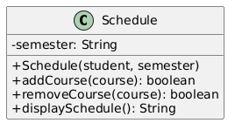

## 

## Class 7: Hold

## Class 8: Waitlist

## Class 9: Report

Class 10: Data Manager

Class: 11: University

# Class Diagram

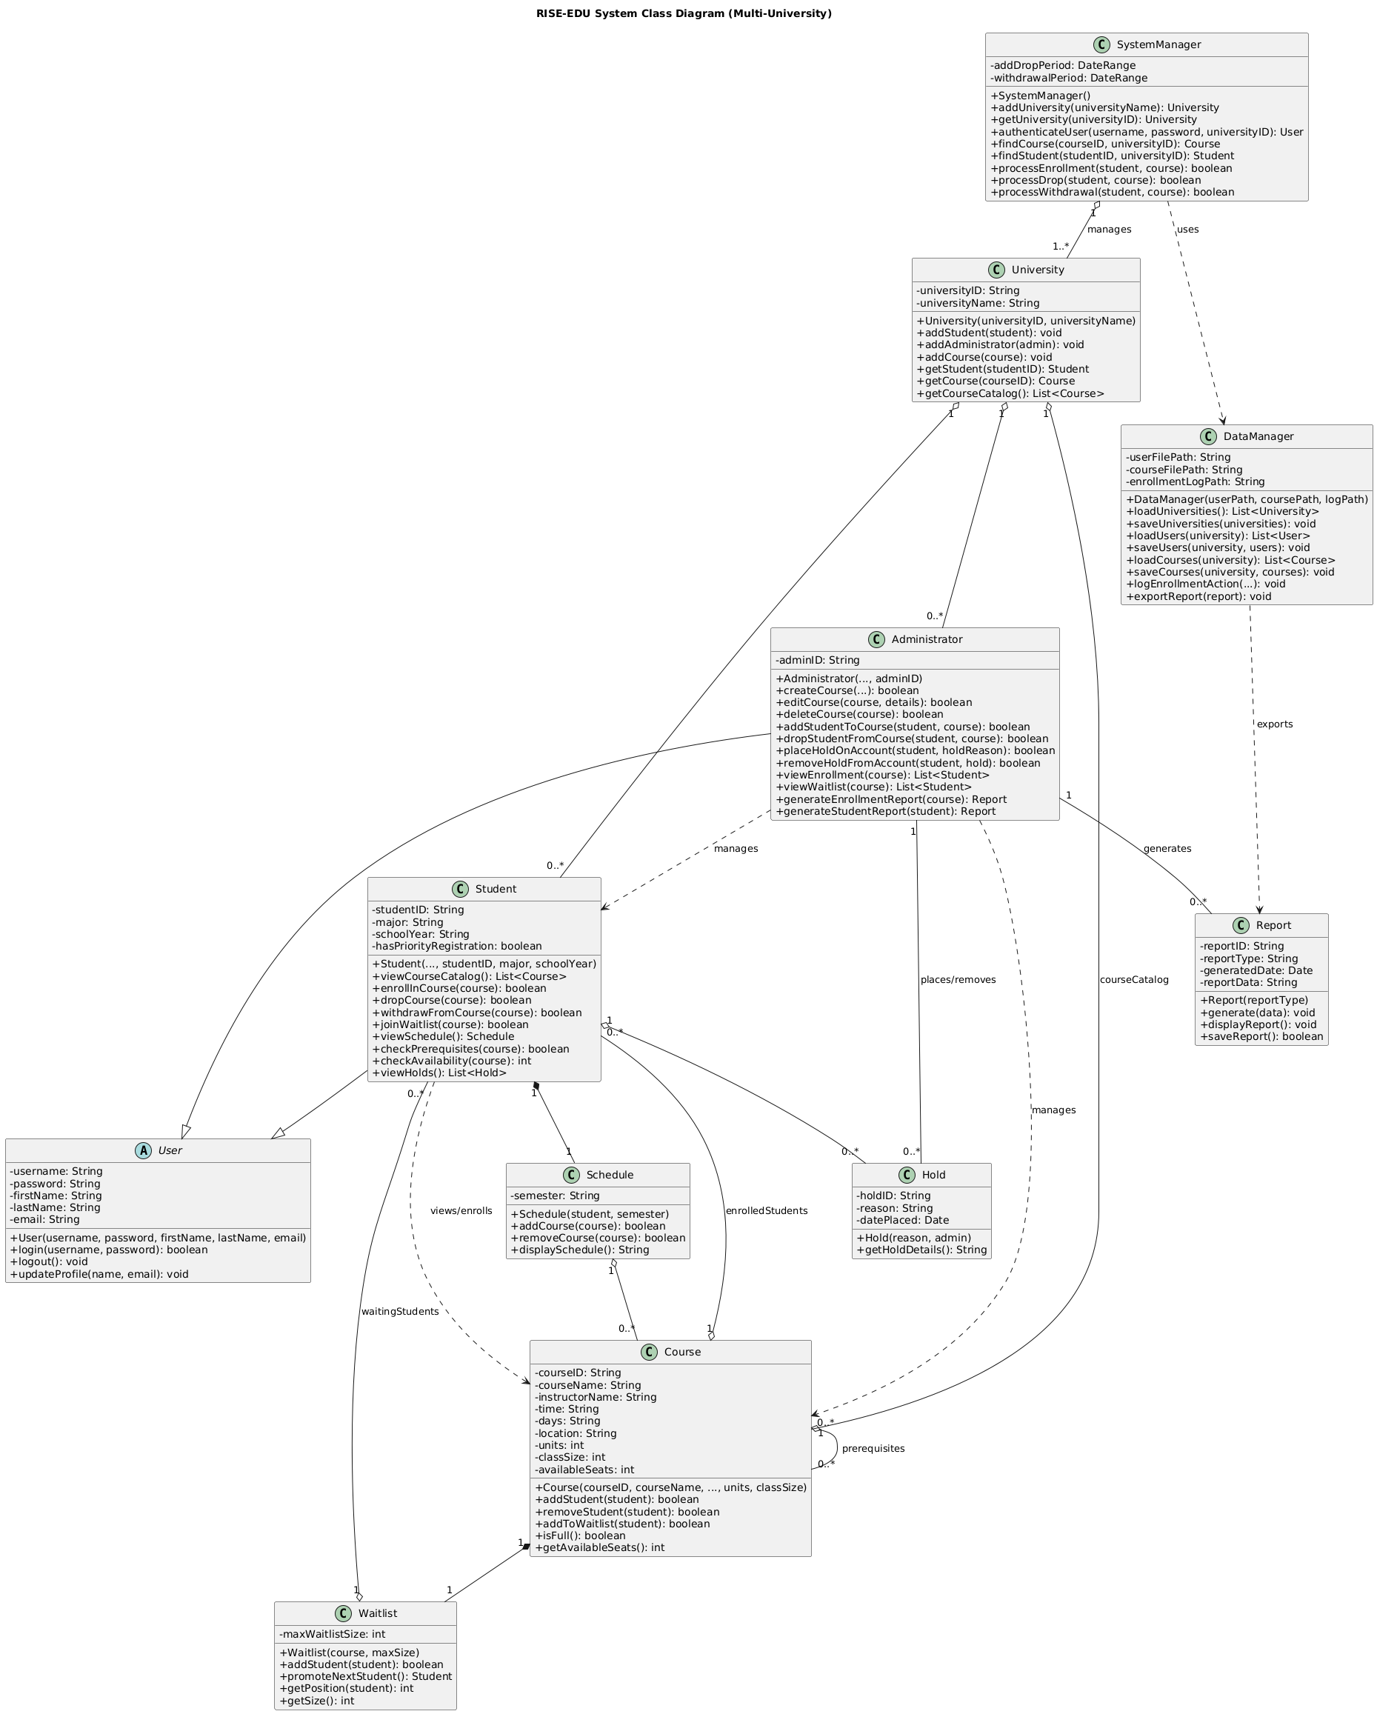

# Use Cases

* 1. **UC01 : Manage User Login**

Actor : Student, Admin

Description:

* 1. UC02: Course Enrollment

* 1. UC03: Course Drop

* 1. UC04: Course Waitlist

* 1. UC05: Course Prerequisites Check
  2. UC06: Access Schedule

* 1. UC07: Enrollment Reporting

* 1. **UC08: Manage Hold**

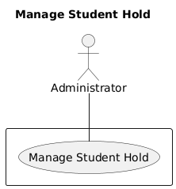

* 1. **UC09: Update Changes Report**
  2. **UC10: Create Courses**

Actor :

Description:

* 1. **UC11: Edit Courses**

# Sequence Diagrams

## Use Case 1: Manage User Login

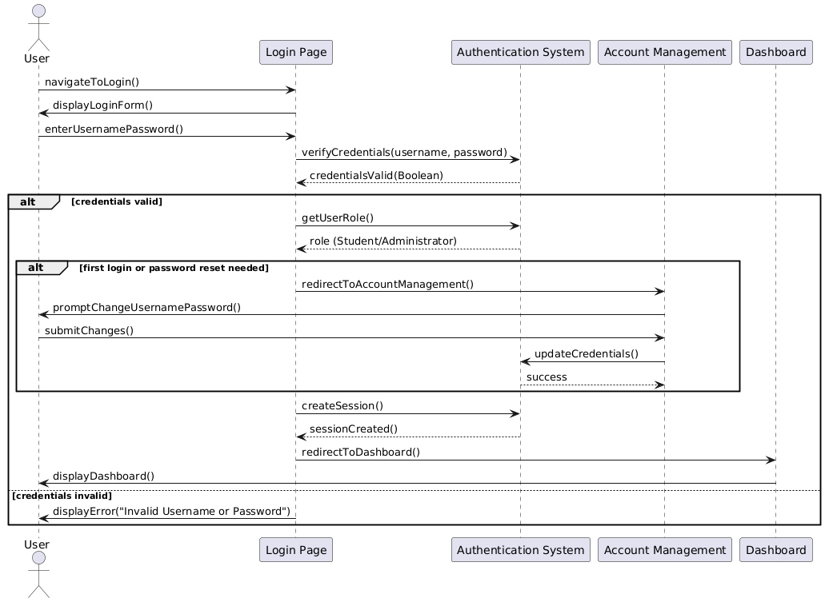

## Use Case 2: Course Enrollment

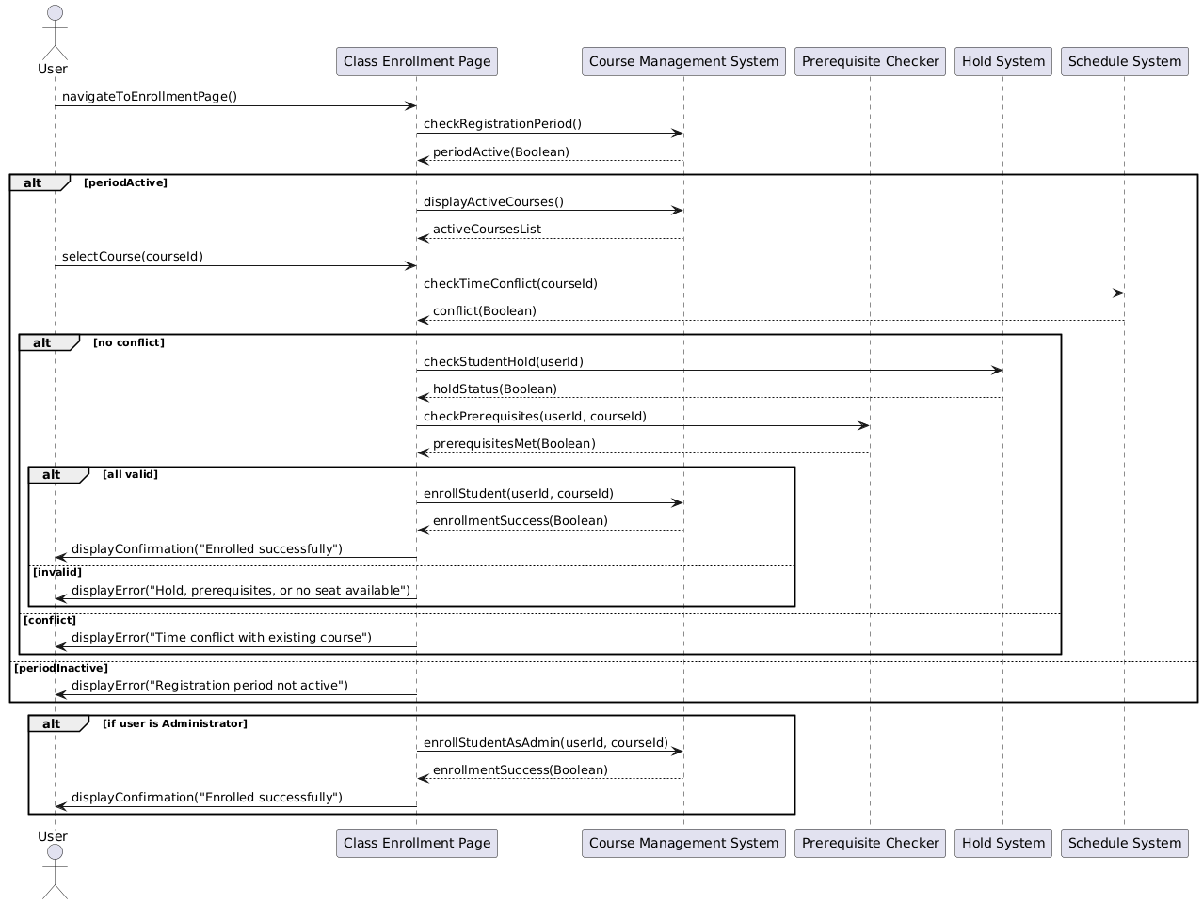

## Use Case 3: Course Drop

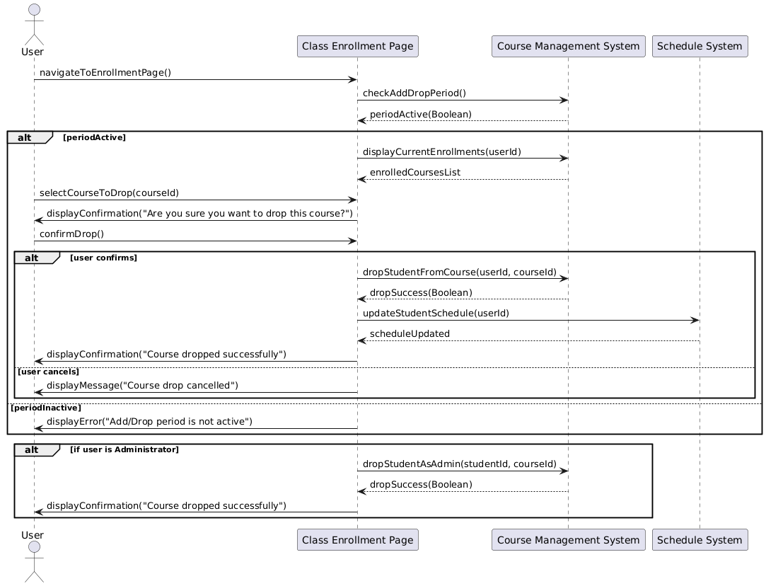

## Use Case 4: Course Waitlist

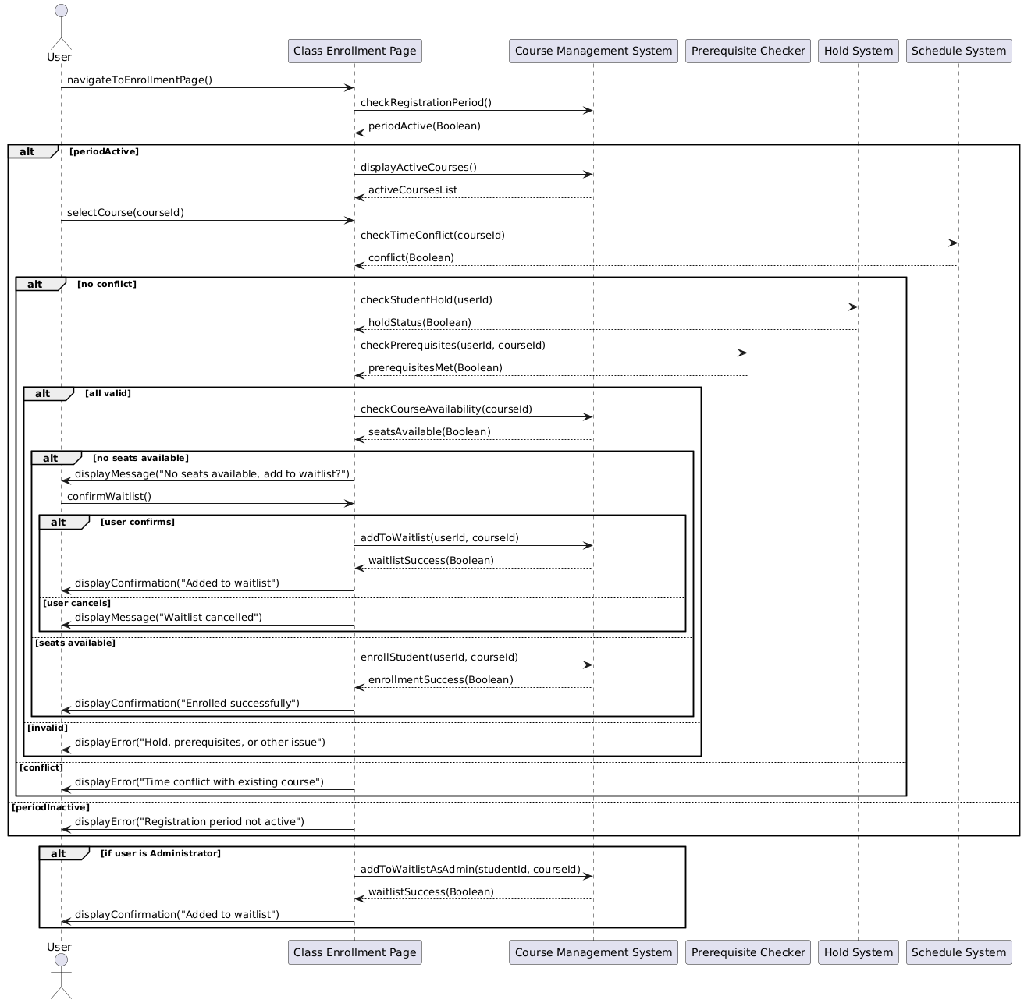

## Use Case 5: Course Prerequisites Check

## Use Case 6: Access Student Class Schedule

## Use Case 7: Manage Student Hold

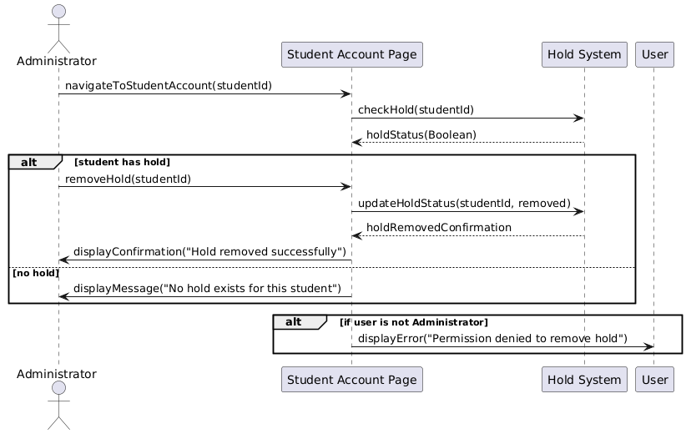

## Use Case 8: Enrollment Reporting

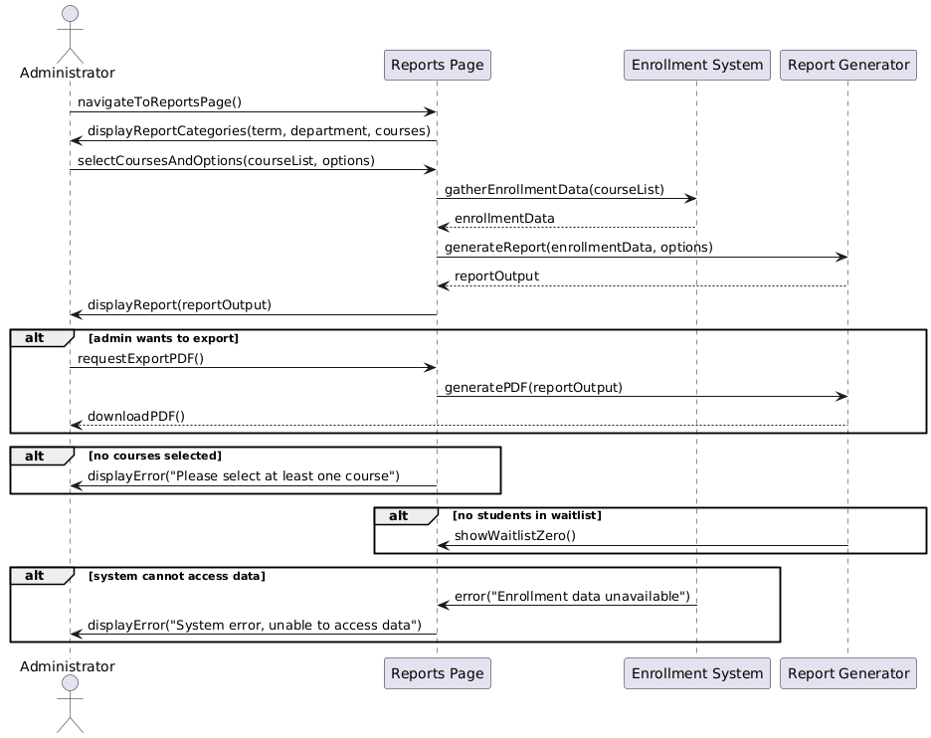

## Use Case 9: Update Changes Report

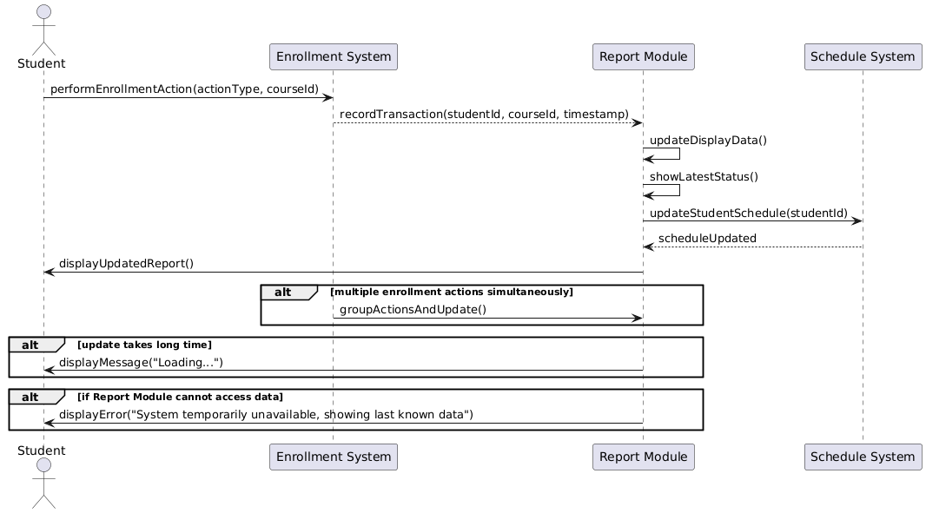

## Use Case 10: Create courses

## Use Case 11: Editing courses

