**RISE-EDU**

*Software Design Specification*

*Phase 2*

Revision History

|  |  |  |  |
| --- | --- | --- | --- |
| **Date** | **Revision** | **Description** | **Author** |
| 10/15/2025 | 1.0 | Initial Version | Wail Mohammed |
| 10/15/2025 | 1.1 | Purpose, Scope, Definitions Updated | Wail Mohammed |
| 10/15/2025 | 1.2 | Updated class candidates 01,02,03,04,05 | Wail Mohammed |
| 10/17/2025 | 1.3 | Updated class candidates 06,07,08,09,10 | Wail, Yesenia, Emmanuel, Shichang |
| 10/23/2025 | 1.4 | Updated Class Diagram and Sequence diagrams | Wail Mohammed |
| 10/25/2025 | 1.5 | Updated all class candidates, added class 11 | Wail, Yesenia, Emmanuel |
| 10/26/2025 | 1.6 | Updated the System Architecture | Emmanuel |
| 10/27/2025 | 1.7 | Updated Course Prerequisites Check | Shichang Wang |
| 10/27/2025 | 1.8 | Updated Project Description, Product Architecture. | Wail Mohammed |
| 10/27/2025 | 1.9 | Updated class candidates 1 to 11. Added description and new diagrams. | Wail Mohammed |
|  | 2.0 |  |  |
|  | 2.1 |  |  |
|  | 2.2 |  |  |
|  | 2.3 |  |  |

Table of Contents

1. Purpose 5

1.1. Scope 5

1.2. Definitions, Acronyms, Abbreviations 5

1.3. References 5

1.4. Overview 5

2. Overall Description 6

2.1. Product Perspective 6

2.2. Product Architecture 6

2.3. Product Functionality/Features 6

2.4. Constraints 7

2.4. Assumptions and Dependencies 7

3. Specific Requirements 8

3.1. Functional Requirements 8

3.1.1. Common Requirements: 8

3.1.2. The Student Module Requirements: 8

3.1.3. The School Administrator Module Requirements: 8

3.1.4. The Reporting Module Requirements: 9

3.2. External Interface Requirements 9

3.3. Internal Interface Requirements 9

4. Non-Functional Requirements 10

4.1. Security and Privacy Requirements 10

4.2. Environmental Requirements 10

4.3. Performance Requirements 10

5. Use Case Specification 11

Use Case 1: Manage User Login 11

Use Case 2: Course Enrollment 12

Use Case 3: Course Drop 13

Use Case 4: Course Waitlist 14

Use Case 5: Course Prerequisites Check 15

Use Case 6: Access Student Class Schedule 16

Use Case 7: Manage Student Hold 17

Use Case 8: Enrollment Reporting 18

Use Case 9: Update Changes Report 19

Use Case 10: Create courses 20

Use Case 11: Editing courses 21

6. UML Use Case Diagrams 22

Use Case 1: Manage User Login 22

Use Case 2: Course Enrollment 22

Use Case 3: Course Drop 23

Use Case 4: Course Waitlist 23

Use Case 5: Course Prerequisites Check 24

Use Case 6: Access Student Class Schedule 24

Use Case 7: Manage Student Hold 25

Use Case 8: Enrollment Reporting 25

Use Case 9: Update Changes Report 26

Use Case 10: Create courses 27

Use Case 11: Editing courses 28

7. Class Diagrams 29

8. Sequence Diagrams 30

Use Case 1: Manage User Login 30

Use Case 2: Course Enrollment 31

Use Case 3: Course Drop 32

Use Case 4: Course Waitlist 33

Use Case 5: Course Prerequisites Check 34

Use Case 6: Access Student Class Schedule 35

Use Case 7: Manage Student Hold 36

Use Case 8: Enrollment Reporting 37

Use Case 9: Update Changes Report 38

Use Case 10: Create courses 39

Use Case 11: Editing courses 40

# Purpose

This document outlines the system design for the College Course Enrollment System Project. This expands on the software requirements specifications and outlines the system architecture, components, use case classes designs, communication models and the overall implementation of the system

## Scope

This document will catalog the user, system, and hardware requirements for the CCES (College Course Enrollment) system. It will not, however, document how these requirements will be implemented. It will allow school administrators to create and manage the school’s course schedule, while also providing students with tools to enroll, drop, and withdraw from courses. The system will also manage prerequisites for courses and allow users to waitlist if class sizes are full.

## Definitions, Acronyms, Abbreviations

1.2.1 CCES: College Course Enrollment System

1.2.2 Student User: User that will be able to enroll, drop, waitlist and withdraw from classes.

1.2.3 Administrator: School admin user that will be responsible for managing course listings.

1.2.4 TCP/IP: A piece of software suite that will allow communication between client and server.

1.2.5 Client: Users interact with the client entity to be able to send and receive information from the server.

1.2.6 Server: The server is responsible for listening to and interacting with multiple clients at the same time, and managing information being received from the clients.

1.2.7 Add/Drop period is the same as registration period.

1.2.8 Withdrawal period is another period when student will be allowed to withdraw from a course.

## References

Use Case Specification Document

UML Use Case Diagrams Document

Class Diagrams

Sequence Diagrams

## Overview

The CCES (College Course Enrollment System) allows for the creation of college course schedules

by administrators and allows students to enroll in these courses. The system will support class sizes,

waiting lists, prerequisites, and reports. This system supports a network of universities, students, and

Administrators. This is a Java application with a GUI that operates over TCP/IP. This system requires

a server application and a client application. There is no web or HTML component.

# Design Description

## Product Perspective

The CCES system is a platform designed for university students and administrators. Administrators can control the number of courses, class size, waiting list size, prerequisites list, and issue reports. Students can enroll in courses, drop courses, and withdraw from courses. The logging module enables administrators to issue reports and for students to display their class schedules.

## Product Architecture

* + 1. The system uses a multithreaded client-server design pattern in which one server application can handle many client applications simultaneously.
    2. The Server Application is responsible for listening to and interacting with clients while handling the business logic and data validation.
    3. The Client Application is responsible for the Java-based GUI. This will allow system users (students and school administrators) to interact with the system. This client application will provide two different GUI views with different functionalities depending on whether the logged-in user is a Student or an Administrator.
    4. All communication between the client and server occurs over TCP/IP.
    5. The GUI system is designed using Java Swing and all data will be stored using a locally created file.

## Product Features

2.3.1 The system is divided into two primary components: the Client Application and the Server Application. The core business logic happens in the server, in which it processes all client requests. The main modules of the server business logic include:

* + - 1. System Manager: To handle all user authorization and authentication using a predefined users data file, one for student users and another for admin users. The system manager also manages universities, courses, registration periods , and withdrawal periods. It processes the core enrollment , drop , and withdrawal requests.
      2. Course Manager: To handle creating, deleting, editing , and updating of all course information that include class size , waitlist size , and prerequisites.
      3. Enrollment Manager: To handle student course enrollment , course drop , course withdrawal , and checking for waitlist size. This will check for enrollment course limits and check prerequisites.
      4. Report Manager: To generate reports for system users. For example, administrators can use it to generate course enrollment reports while student users will use it to generate class schedules.
      5. Data Manager: To handle all system data. It will use a locally created database to load and save data on users, courses, and any enrollment actions such as enroll, drop, waitlist, and withdraw.

2.3.2 The system’s client and server will use a request/response model. In which the client will initiate a request to the server, the server will acknowledge the request, processes it, then sends the response back to the server. The information being sent will be encapsulated in a serializable Message class.

# Class Design

## Class 1: User

Description : Abstract user class which prevents the creation of a new User object.

## Class 2: Student

Description: This class represents a student user. It inherits all the properties of User (like username, password) and adds student-specific methods such as viewCourse, enrollInCourse, viewSchedule, etc..)

## Class 3: Administrator

Description: This class represents an admin user. It inherits all the properties of User (like username, password) and adds admin-specific methods such as addStudent, createCourse, placeHoldOnAccount, generateEnrollmentReport, etc..)

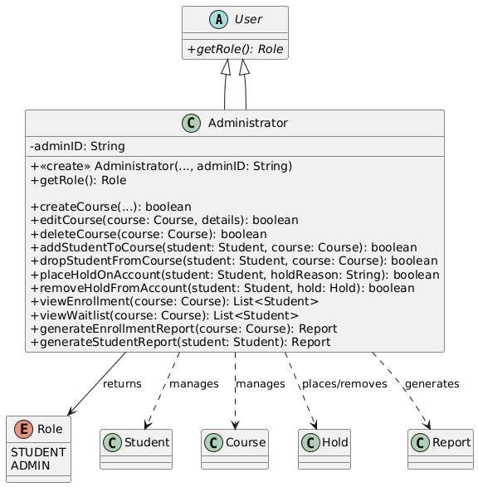

Class 4: University

Description: This class represents a university that contains all students, admins and courses per university. The system manager (next class) will first use this class to first get the correct university, then get all the students or courses dealing with that university.

Class 5: System Manager

Description: This class represents the system manager, which handles the core business logic of the application. It manages the entire system and controls data flow.

## Class 6: Course

Description: This class holds the data for a single course such as course name, time, location, instructor, class size, units, etc. It also manages students being added or removed. It also holds prerequisites if needed.

## Class 7: Schedule (List of courses)

Description: This class is to hold a list of Course object for a specific student in a specific semester. For instance, if the Student class calls student.viewSchedule() it will create and return a Schedule object.

## Class 8: Hold

Description: This is a data class that holds any student holds. The Adminstrator class creates an instance of this class whenever an admin needs to place a hold on a particular student.

## Class 9: Waitlist

Description: This is a data class that holds and manages the waitlist for a particular course. A Course class will create only one Waitlist object. The Waitlist class will then be used to determine the correct order, promote the correct student to join the class or get the current position of a particular student in the waitlist.

## Class 10: Report:

Description: This is a data class that holds the logs which the Administrator class will create an object to pass in data and generate and save reports.

## Class 11: Data Manager:

Description: This class will handle the data management, saving and loading of universities, users and courses to and from local file which helps to keep file-handling logic in one place.

# Class Diagram

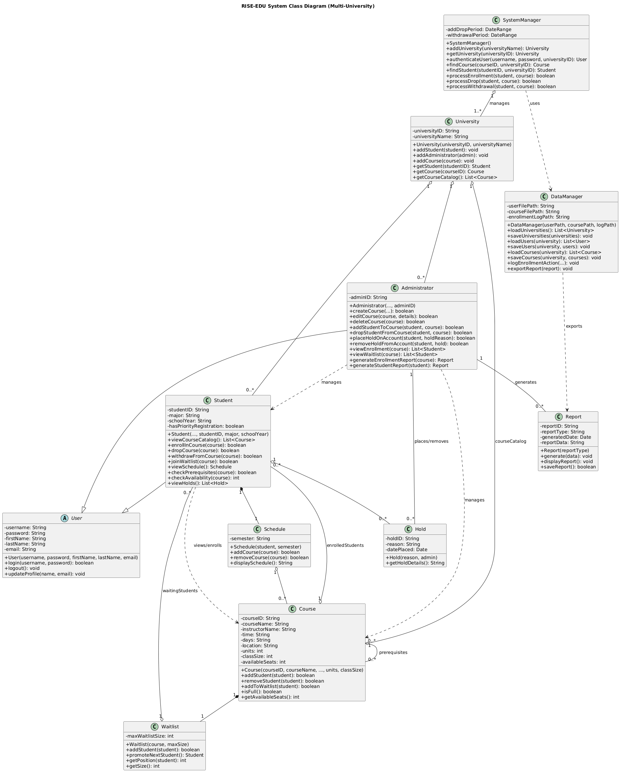

# Use Cases

* 1. **UC01 : Manage User Login**

Actor : Student, Admin

Description:

* 1. UC02: Course Enrollment

* 1. UC03: Course Drop

* 1. UC04: Course Waitlist

* 1. UC05: Course Prerequisites Check

* 1. UC06: Access Schedule

* 1. UC07: Enrollment Reporting

* 1. **UC08: Manage Hold**

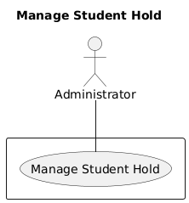

* 1. **UC09: Update Changes Report**
  2. **UC10: Create Courses**

Actor :

Description:

* 1. **UC11: Edit Courses**

# Sequence Diagrams

## Use Case 1: Manage User Login

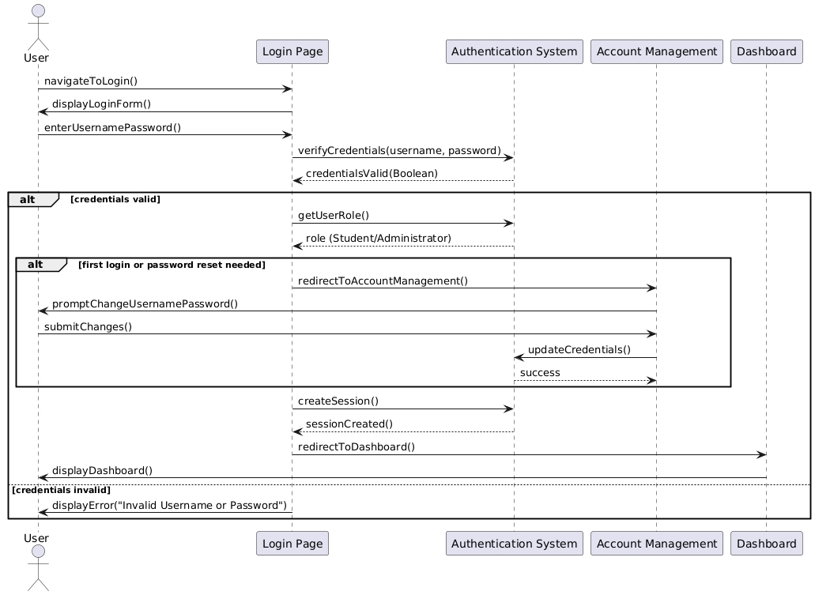

## Use Case 2: Course Enrollment

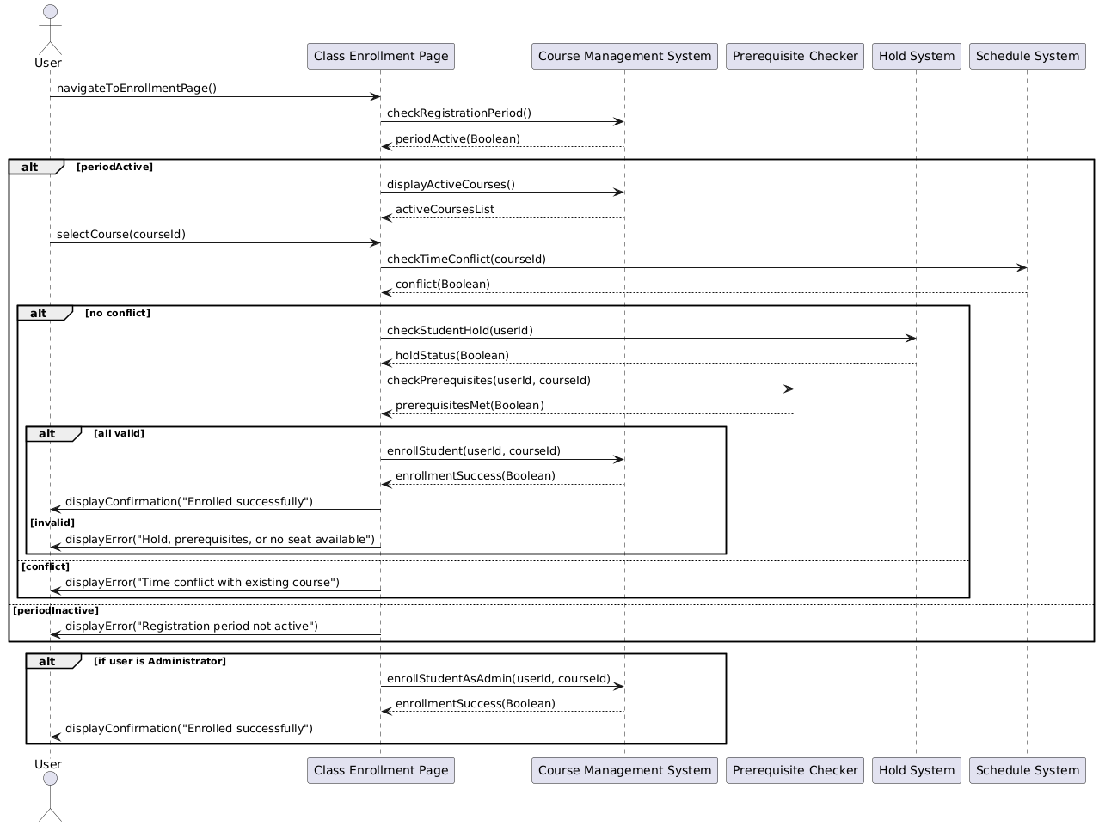

## Use Case 3: Course Drop

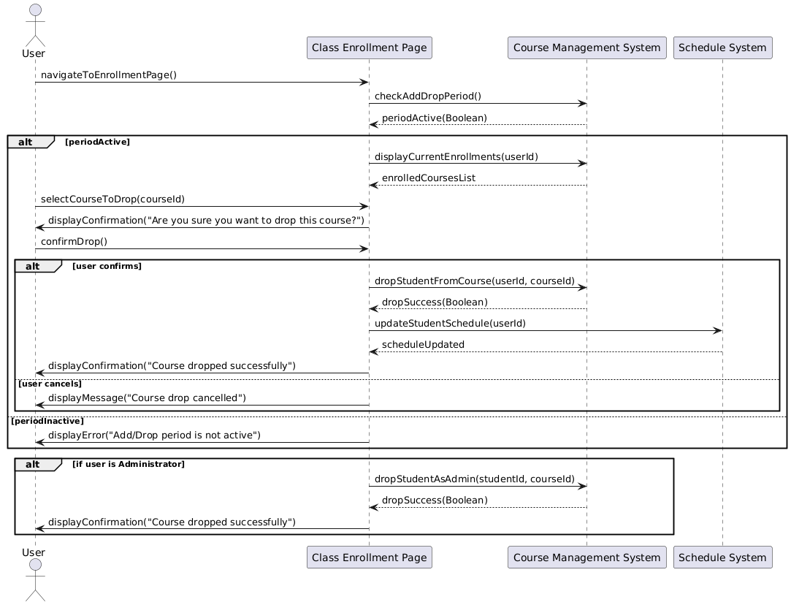

## Use Case 4: Course Waitlist

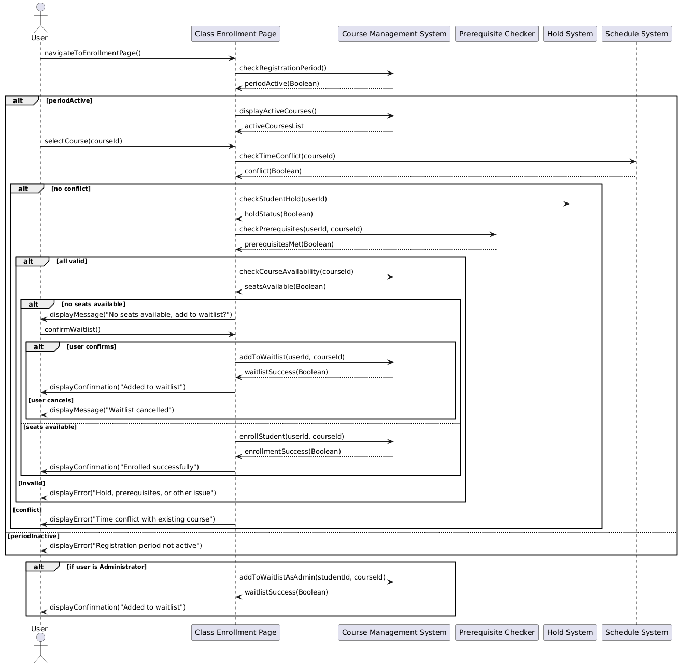

## Use Case 5: Course Prerequisites Check

## Use Case 6: Access Student Class Schedule

## Use Case 7: Manage Student Hold

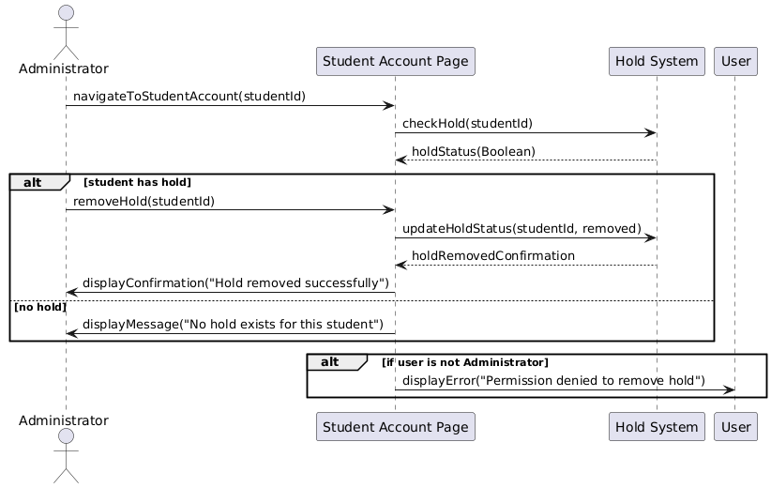

## Use Case 8: Enrollment Reporting

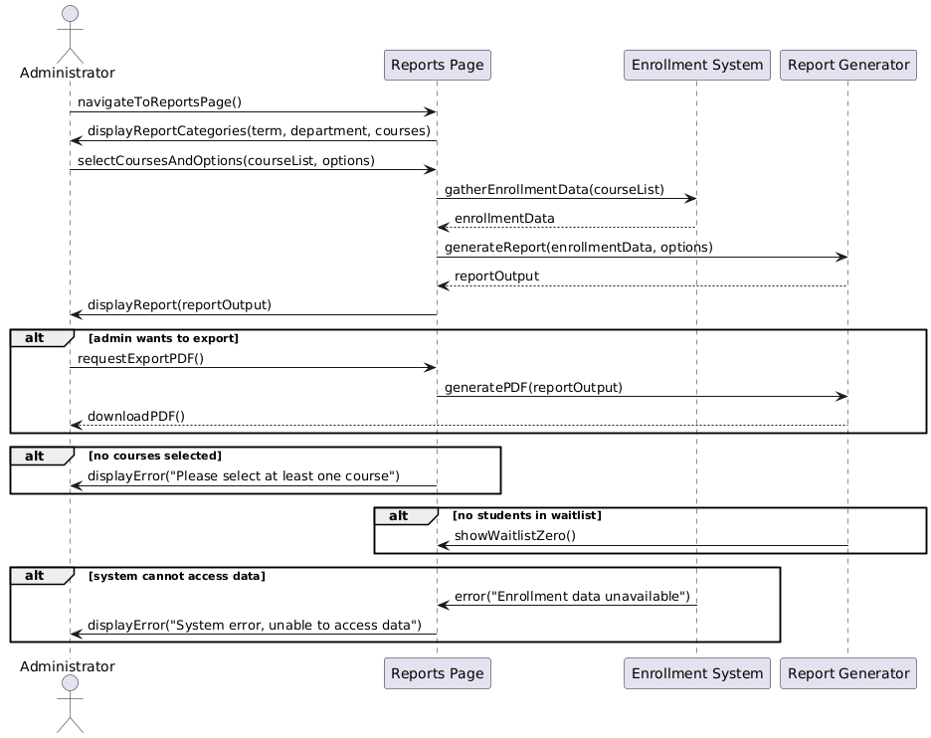

## Use Case 9: Update Changes Report

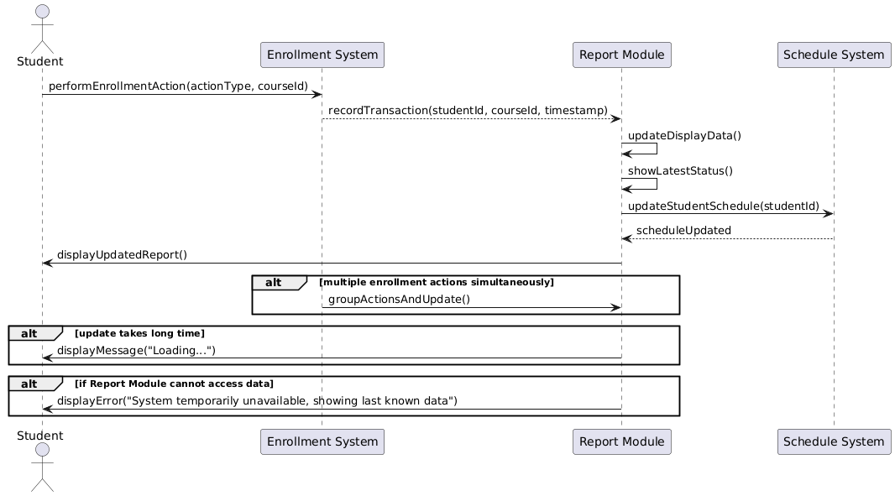

## Use Case 10: Create courses

## Use Case 11: Editing courses

