

NAME: MAXWELL WAIME
ADM NO: BSCCS/2024/59239
UNIT: ETHICAL HACKING
COURSE: BACHELOR OF SCIENCE IN COMPUTER SCIENCE
DEPARTMENT: COMPUTING AND INFORMATICS
LECTURER : MICHAEL NYORO

Table of Contents
1
WEEK 1 ASSIGNMENT 2
SELECTED TOOL: NMAP 2
WEEK 4 ASSIGNMENT 7
ORGANIZATION SELECTED: MOZILLA 7
Task 1 7
10
Task 2 12

WEEK 1 ASSIGNMENT

SELECTED TOOL: NMAP

PRACTICALS

- Installing Nmap and confirming the version

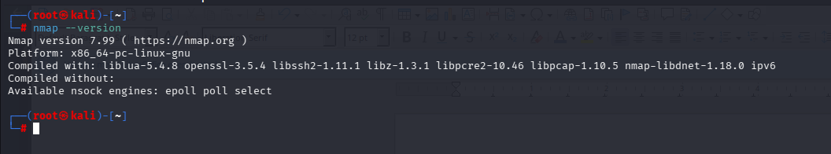

- Do a basic scan

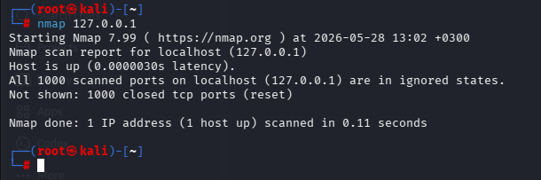

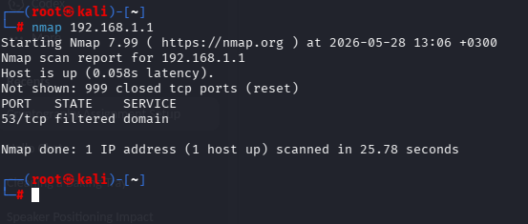

- Port Scanning

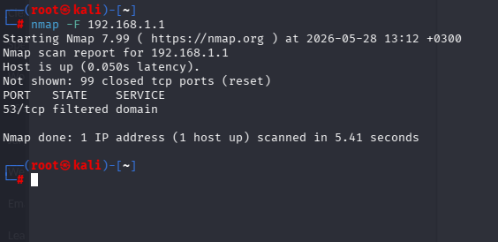

Scan all ports
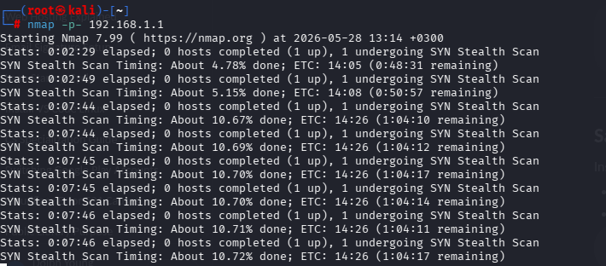

- Foot Printing
1. Install who is
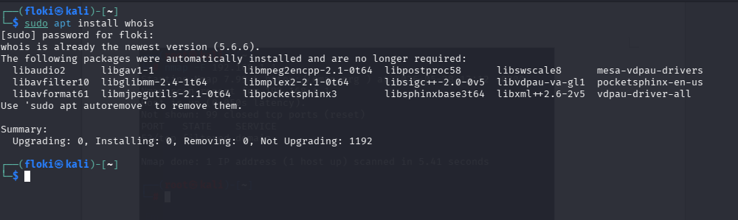

2. Run whois example.com
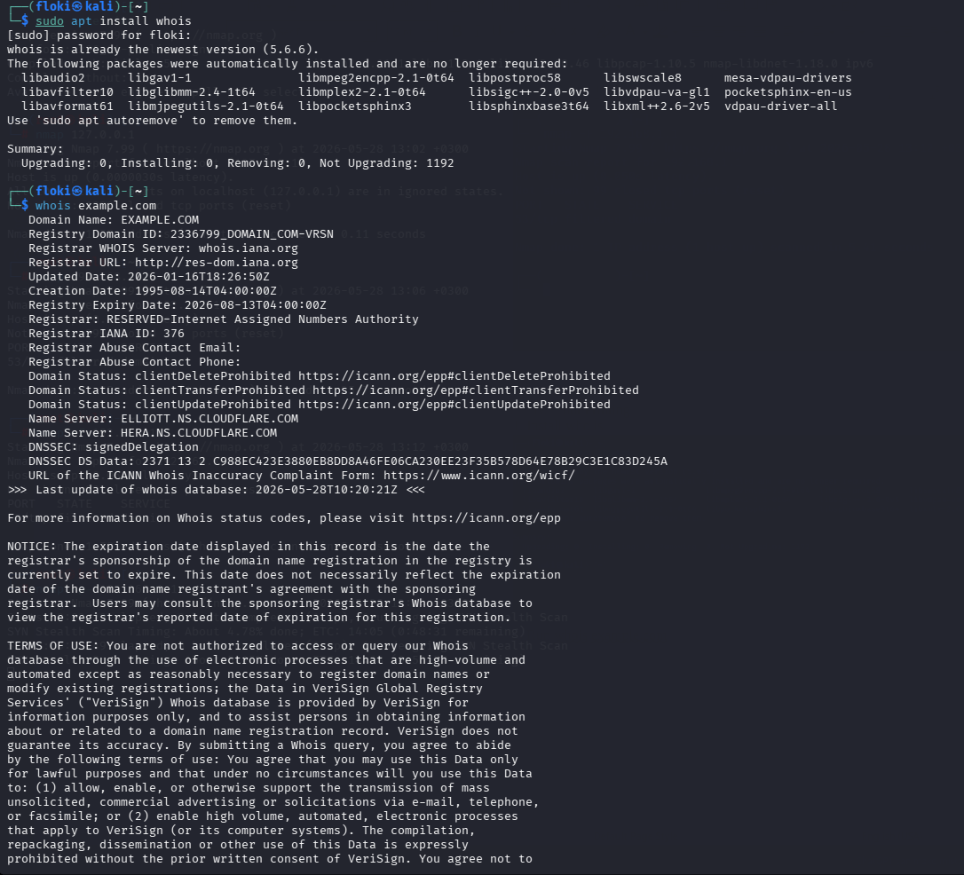

WEEK 4 ASSIGNMENT

ORGANIZATION SELECTED: MOZILLA

Task 1

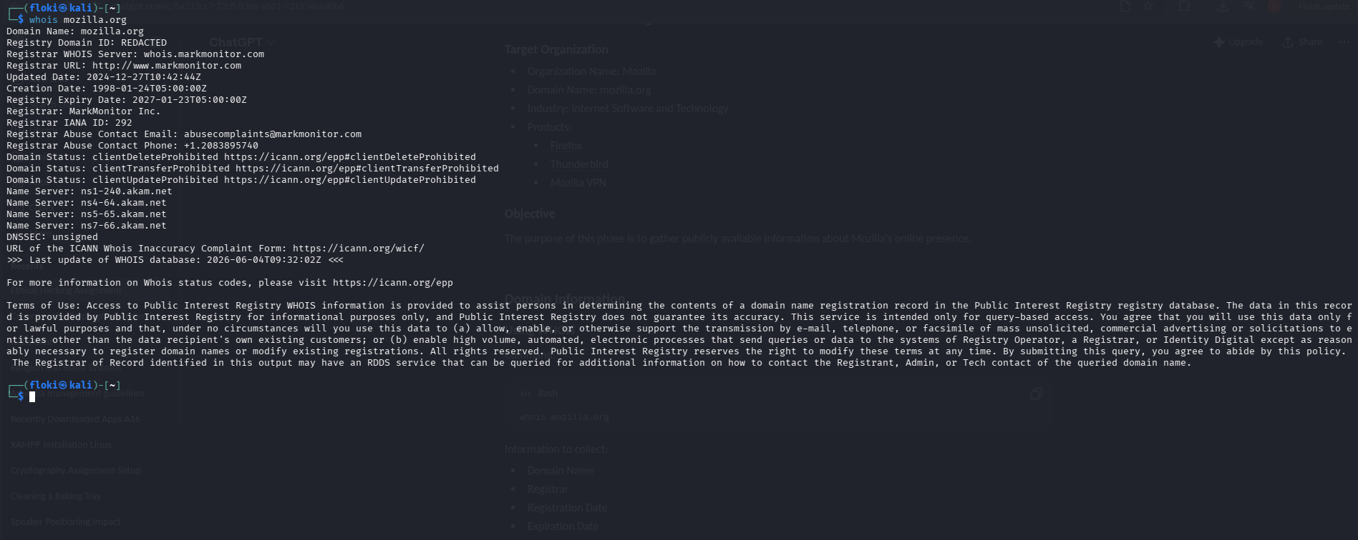
Figure 1 domain register, creation date, server names

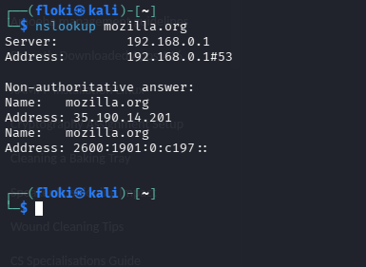
Figure 2 dns server details

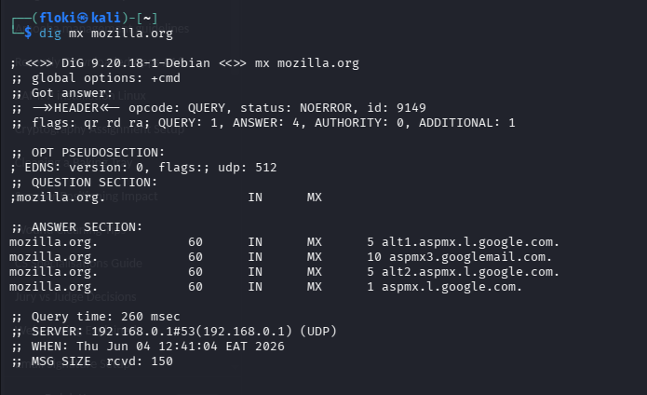
Figure 3 the email provider
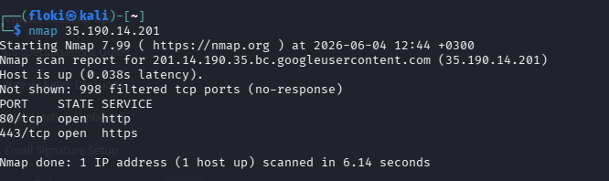
Figure 4 mozilla.co.ke nmap scan for one of its ipaddress

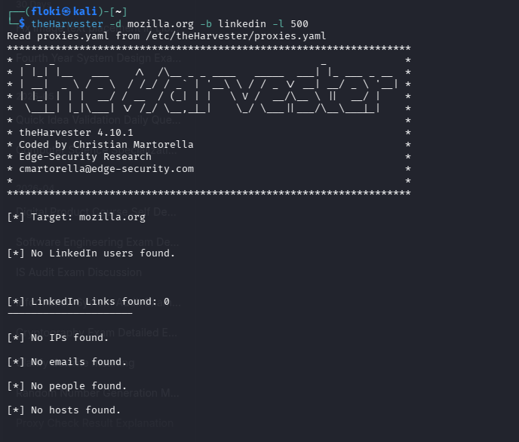
Figure 5 associated emails that can be found on linked in(employees)

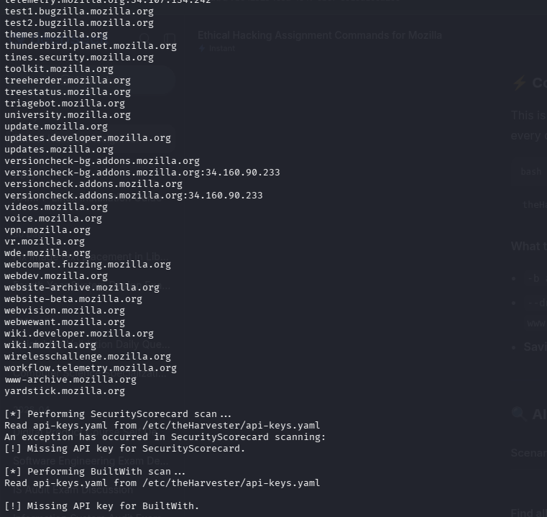
Figure 6 different email provider results after scanning

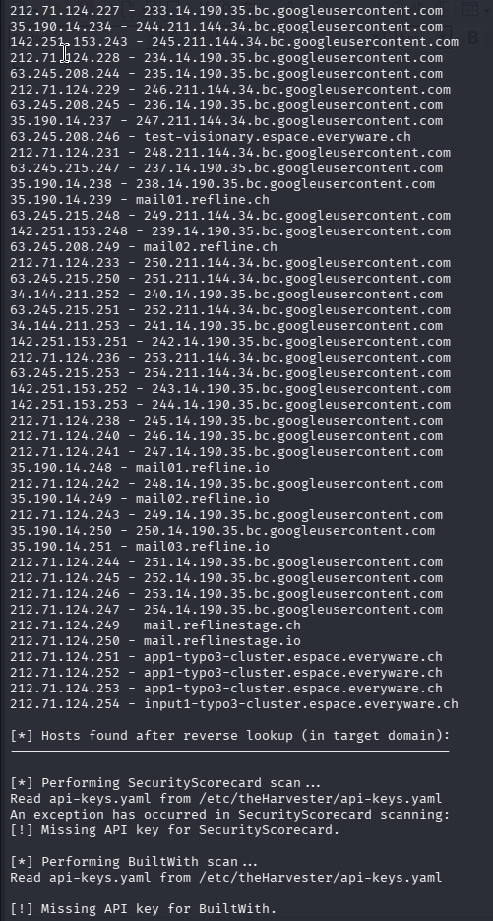
Figure 7 available ip address found

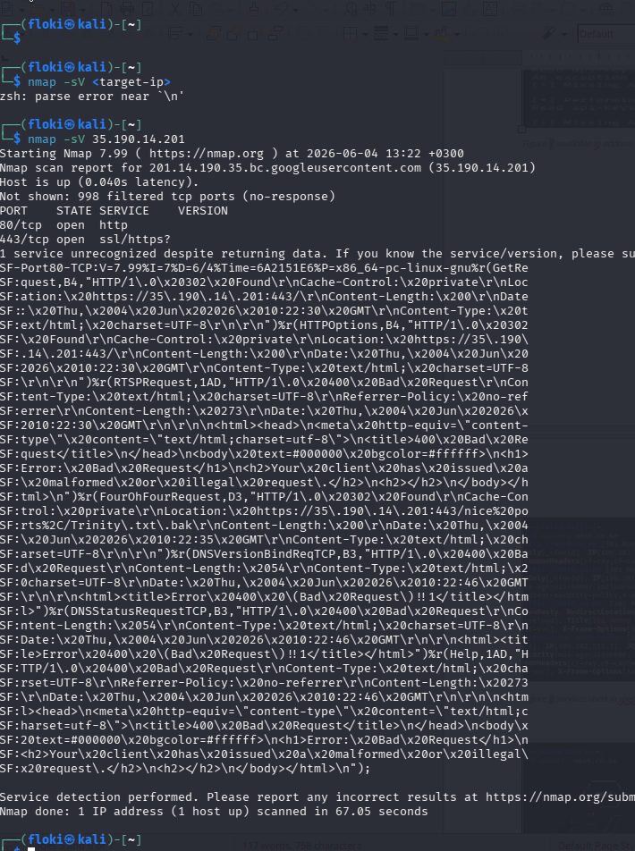
Figure 8 services used in mozilla.co.ke

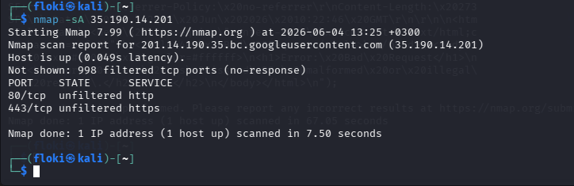
Figure 9 the firewall and the firewall provider

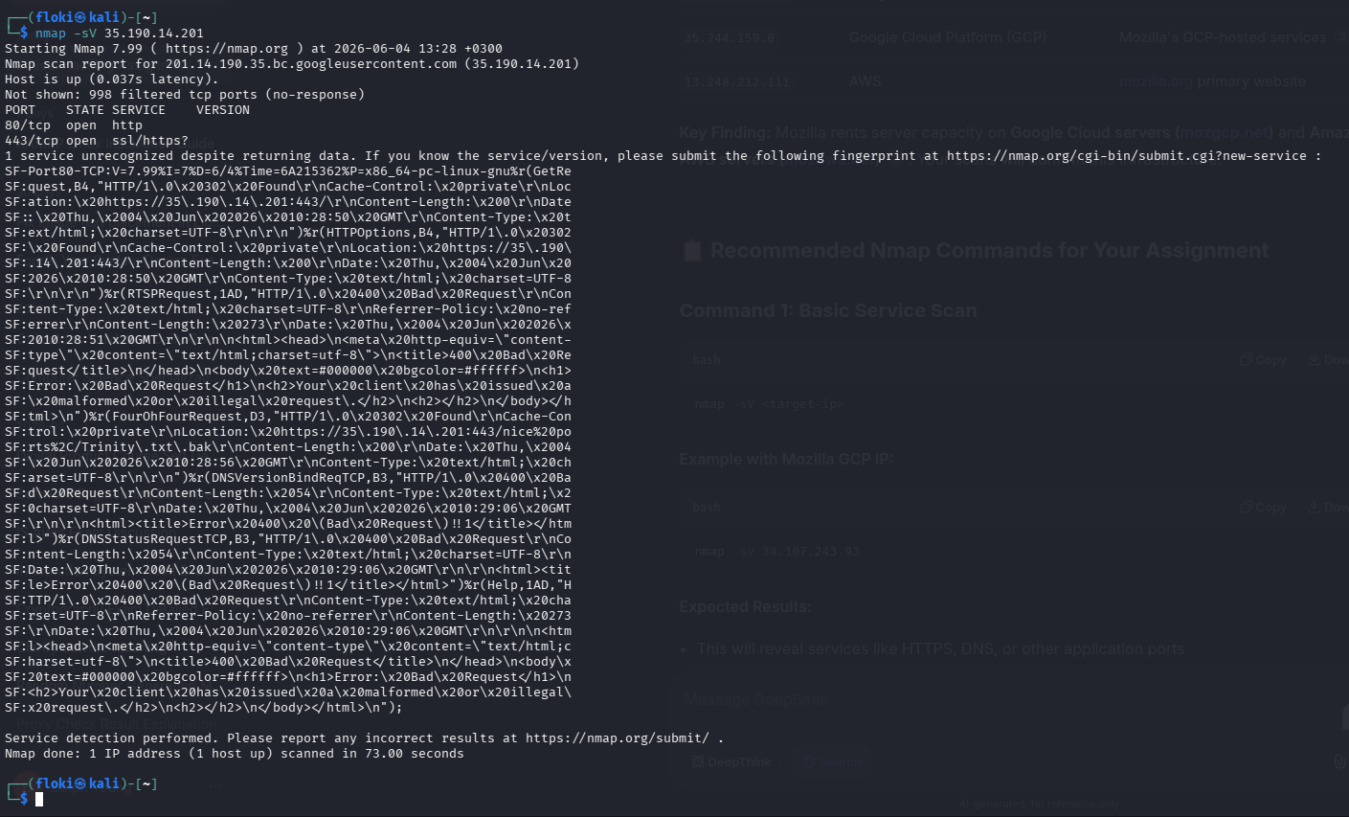
Figure 10 an nmap scan for mozilla.co.ke ipaddress

Task 2

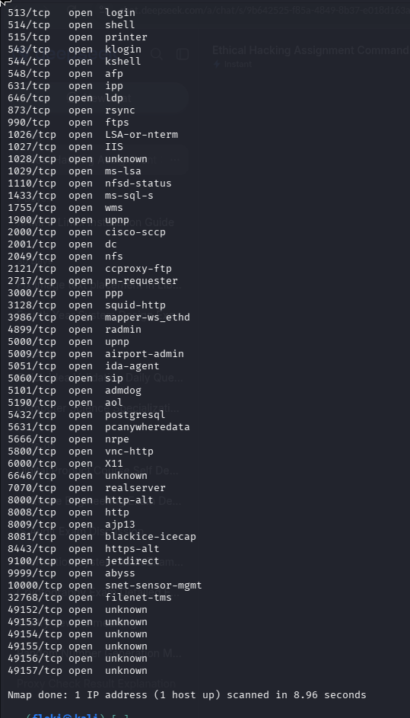
Figure 11 nmap scan of the ports of an ip address

Scanning and Enumeration
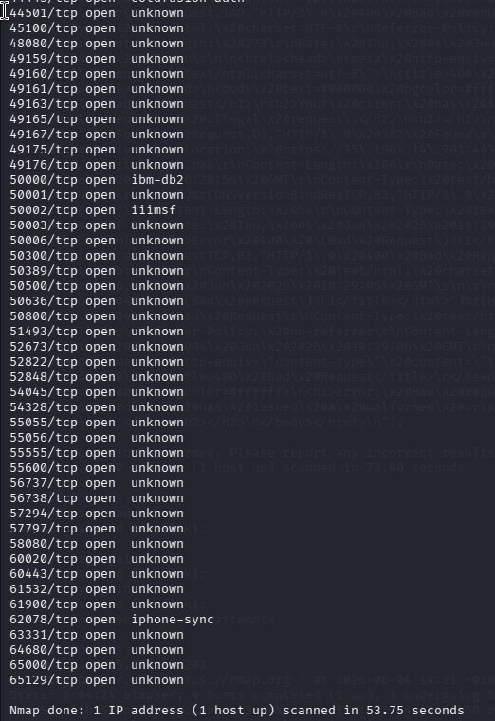

Figure 12 enumerating and port scanning

Operating systems detection
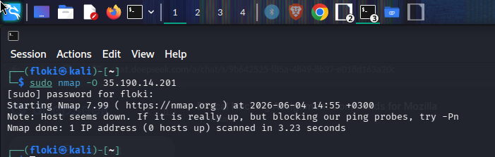

Figure 13 operating system detection

Service Detection and Enumeration

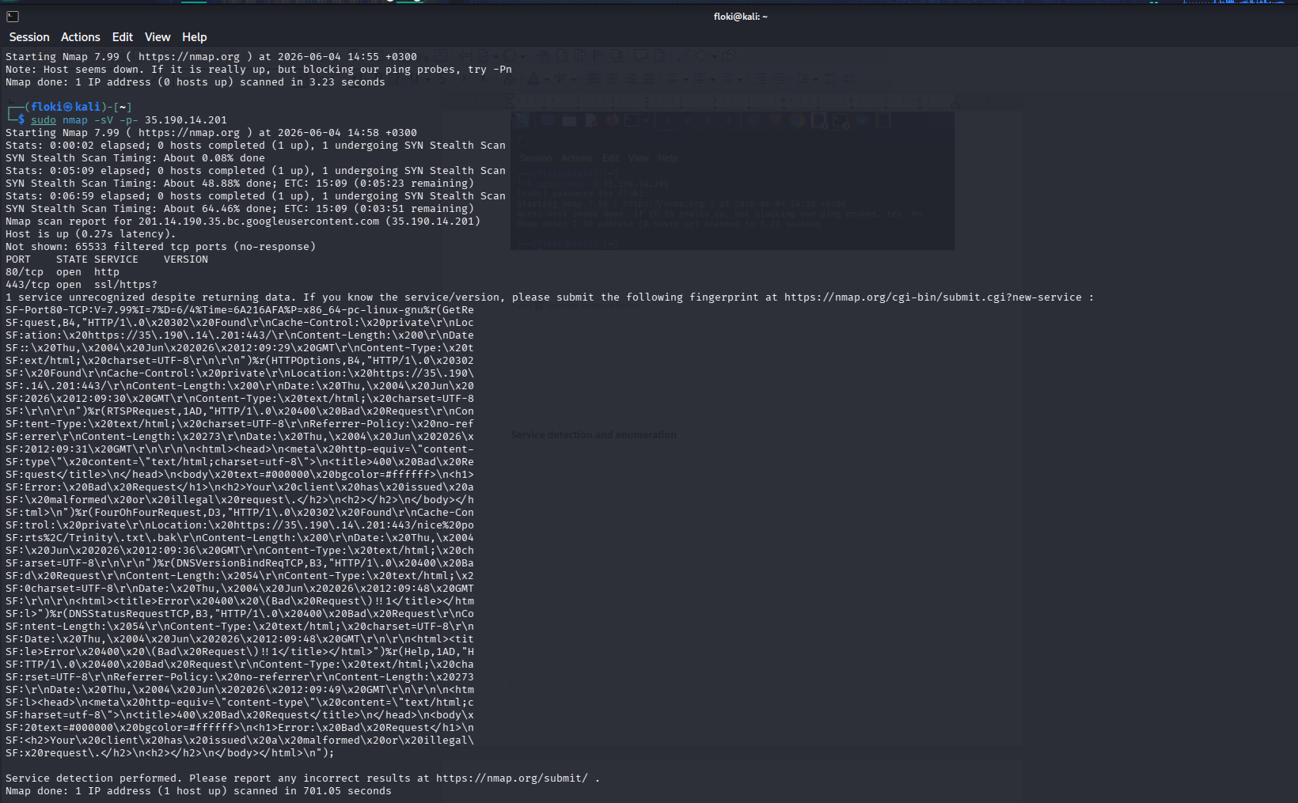
Figure 14 service detection

Vulnerability Identification
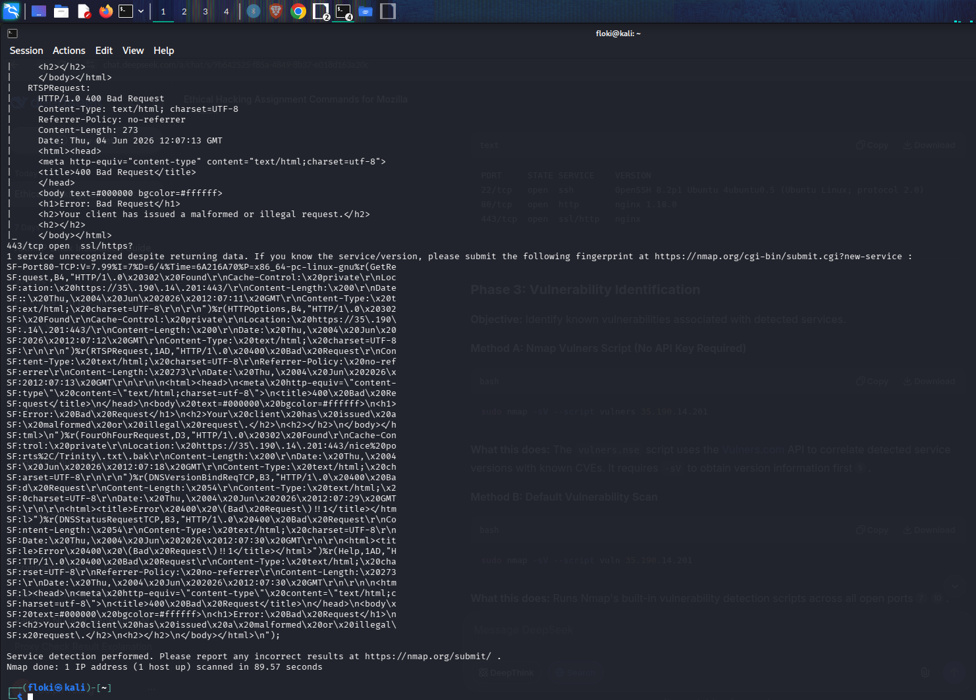

Figure 14 vulnerability identification

