PMW3389 Breakout Board
Quick Assembly Guide
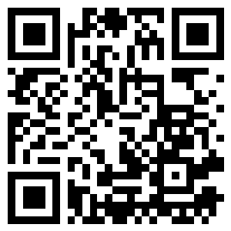
Scan for documentation and firmware

Overview
This breakout board provides a simple interface for the PMW3389 optical mouse sensor. The board includes JST-SH connectivity and standard SPI pinout for easy integration into custom keyboard and pointing device projects.

Assembly Instructions
- Remove the polyimide dust cover
The PMW3389 sensor comes with a thin polyimide (amber/brown colored) protective film over the lens opening. This MUST be removed before installing the lens. IMPORTANT: Position the sensor vertically (upright) during removal so that dust cannot enter the sensor holes. Carefully peel off the film using tweezers or a fingernail.
- Install the lens
Place the optical lens directly onto the sensor opening. The lens should sit flat and centered over the sensor aperture. Ensure the lens is clean and free of fingerprints or debris. The lens is held in place by friction and should not require adhesive.
- Connect to your controller
Connect the breakout board to your microcontroller using either the JST-SH connector or the SPI header pins. The sensor requires 3.3V power and communicates via SPI. Pin assignments are labeled on the board.

Pin Assignments
SPI Interface:
• CS - Chip Select
• MOSI - Master Out Slave In
• MISO - Master In Slave Out
• SCK - Serial Clock
• GND - Ground
• 3v3 - 3.3V Power Supply

Important Notes
⚠ Important: Always remove the polyimide film with the sensor positioned vertically to prevent dust from entering the sensor holes.
⚠ Warning: The sensor requires 3.3V power. Do not connect to 5V.
💡 Tip: Keep the lens clean for optimal tracking performance. Use a microfiber cloth if cleaning is needed.

About This Design
This design is a complete rebuild from the ogen open source design, with significant improvements including ferrite beads for EMI hardening and better filtering capacitors for enhanced stability.
An improved trackball mount design will be introduced to Cosmos (keyboard generator at www.ryanis.cool/cosmos) featuring a 2-part design with precision trackball positioning using captive ceramic ball bearings. High-quality resin mounts will be available soon.

Support & Contact
For assistance with this breakout board:
Email: thebigskree@gmail.com
Discord: #Alakuu
YouTube: @skreellc
For more information, visit:
https://github.com/WainingForests/PMW3389

