PCOS CONNECT – FINAL PROJECT DOCUMENTATION

1. Introduction
PCOS Connect is a lightweight React + TypeScript application designed to help users track symptoms, monitor health metrics, and access curated resources related to PCOS wellbeing. This project fulfills the PLP Final Project requirements under SDG 3: Good Health & Wellbeing.

2. Problem Statement
Many individuals with PCOS struggle with inconsistent symptom tracking, lack of trend analysis, and minimal access to educational resources.
This app provides a centralized, easy-to-use platform for monitoring wellness indicators.

3. Project Objectives
- Provide an intuitive interface to log symptoms.
- Help users view their health patterns through insights.
- Offer educational resources.
- Deploy a fully functional frontend app.

4. Scope of the Project
This version focuses on UI & UX, local mock data, client-side tracking, and simple analytics. Backend integration is considered for future enhancement.

5. System Architecture
Frontend: React + TypeScript
Styling: Tailwind CSS
State Management: useState
Data: Local mock JSON
Deployment: Vercel

6. Technology Stack
Framework: React 19
Language: TypeScript
Styling: Tailwind CSS
Build Tool: Vite
Deployment: Vercel
Icons: lucide-react
Development Tools: ESLint

7. Implementation Details
Folder Structure:
Final Project/
├── src/
│ ├── components/
│ │ ├── Header.tsx
│ │ ├── Dashboard.tsx
│ │ ├── SymptomTracking.tsx
│ │ ├── Insights.tsx
│ │ └── Footer.tsx
│ ├── data/
│ │ └── mockData.ts
│ ├── types/
│ │ └── index.ts
│ ├── App.tsx
│ └── main.tsx
├── public/
│ └── index.html
├── tailwind.config.js
├── postcss.config.js
├── tsconfig.app.json
└── vite.config.ts

8. How the Application Works
Dashboard: Displays metrics and trends.
Symptom Logging: Users enter symptoms, severity, notes.
Insights: Shows patterns and health insights.
Resources: Educational materials.
Footer: Branding and copyright.

9. Screenshots
Dashboard screenshot:
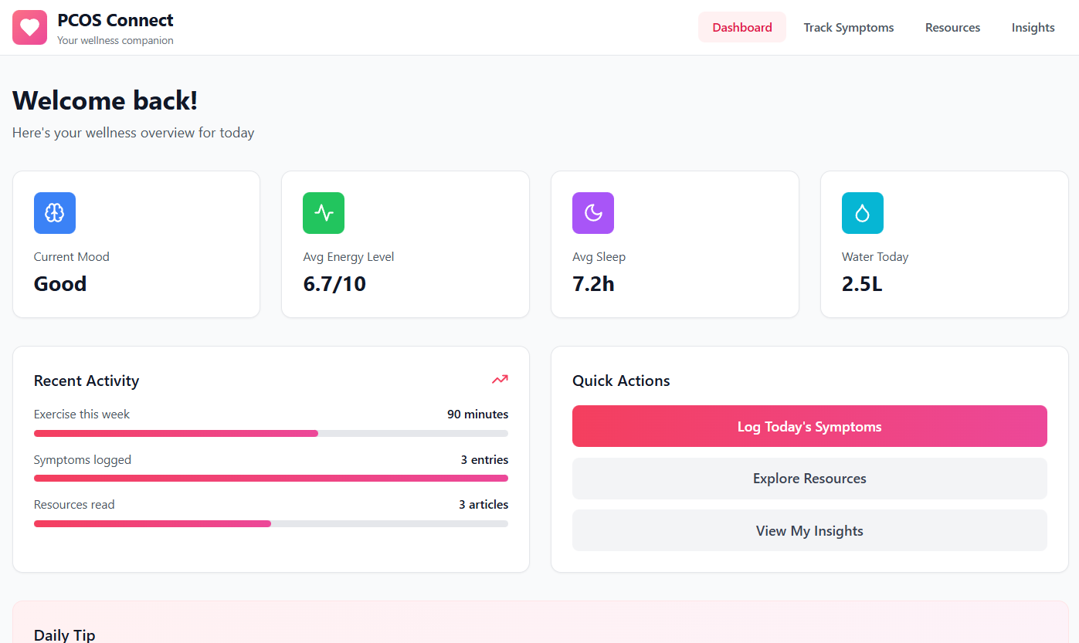
Insights page screenshot:
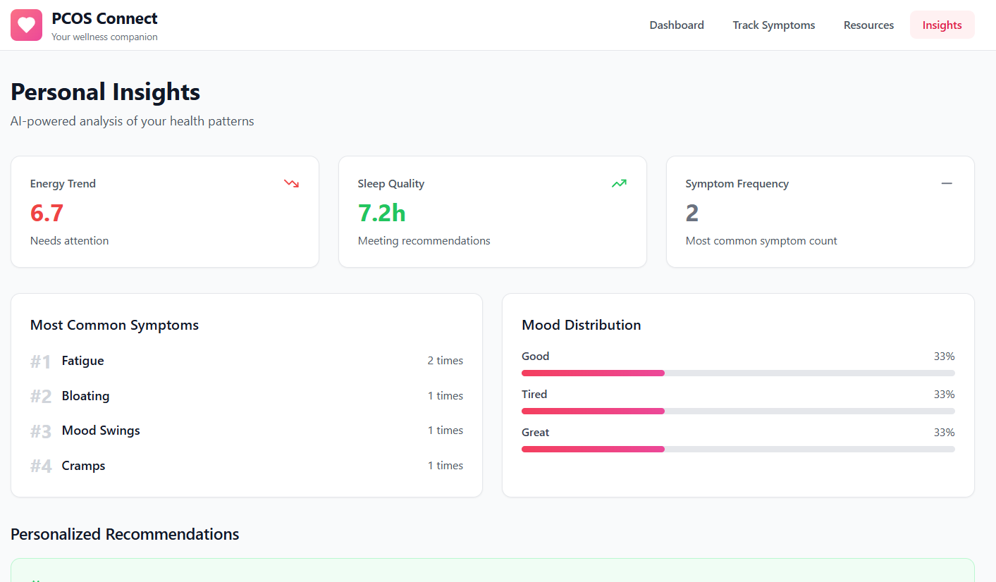

10. Testing
UI testing through manual interactions. Component rendering validation. Error-state handling.

11. Deployment (Vercel)
Live Demo: https://finalproject-f9i6l6a2l-elizabeths-projects-04752da5.vercel.app/
Steps: Upload repo, build automatically, production deployment.

12. Challenges & Solutions
Typing errors → fixed prop types.
Tailwind not loading → fixed PostCSS config.
Dependency conflicts → correct lucide-react version.
Build errors → cleaned node_modules.

13. Future Improvements
Add backend & auth. Add charts. Add calendar. Add reminders. Export logs.

14. Conclusion
PCOS Connect provides awareness, tracking and insights. It is the foundation for a more advanced health monitoring system.

15. Acknowledgments
Vercel, TailwindCSS docs, React docs, PLP mentors, ChatGPT.

