Chapter Eleven Assignment

To perform the following assignments, refer to the tables created in the *New Build Script Chapter 11.sql* script in Black Board Learn/Course Content/ Chapter 11 Group Functions Folder.

1. Determine the highest gross pay by the employees in the table employee_x.

**SQL Statement Goes Here**

**select to_char(max(hours*JOB_BASE_PAY),'$9,999,999.99') as "highest weekly grosspay"**

**from EMPLOYEE_X,job,hours ;**

**Screen Shot Goes Here**

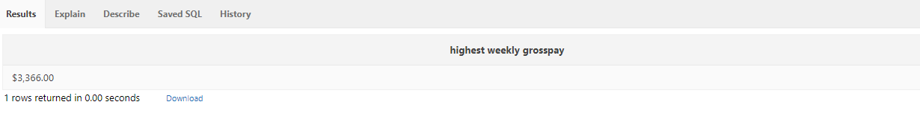

1. Determine the lowest YTD sales from the table Store2

**SQL Statement goes Here**

**select to_char(min(STORE_YTD_SALES),'$9,999,999.99') as "lowest YTD sale"**

**from store2;**

**Screen Shot goes here**

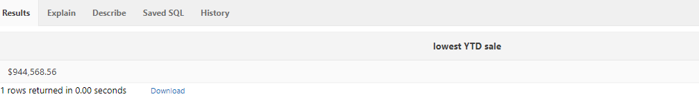

1. Determine the lowest starting bid for the item where the opening bid is in the month of January.

**SQL Statement Goes Here**

**select to_char(min(STARTINGBID),'$9,999,999.99') as "lowest starting bid"**

**from item**

**where OpenDATETIME like '%JAN%';**

**Screen Shot goes here**

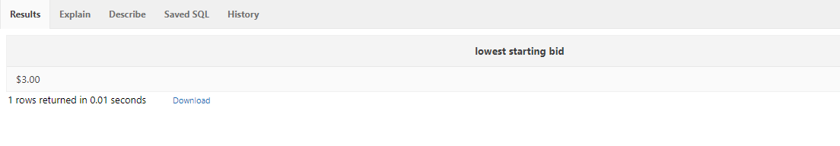

1. List the just the store name once and total weekly sales of the stores and the total weekly sales for the all the stores. Use the STORE table and the STORE-SALES table only.

**SQL Statement Goes Here**

**select STORE_NAME as store, to_char(sum(STORE_WEEKLY_SALES),'$999,999,999.99') as "weekly sales"**

**from STORE_SALES natural join store**

**group by grouping sets ((STORE_name), ());**

**Screen Shot goes here**

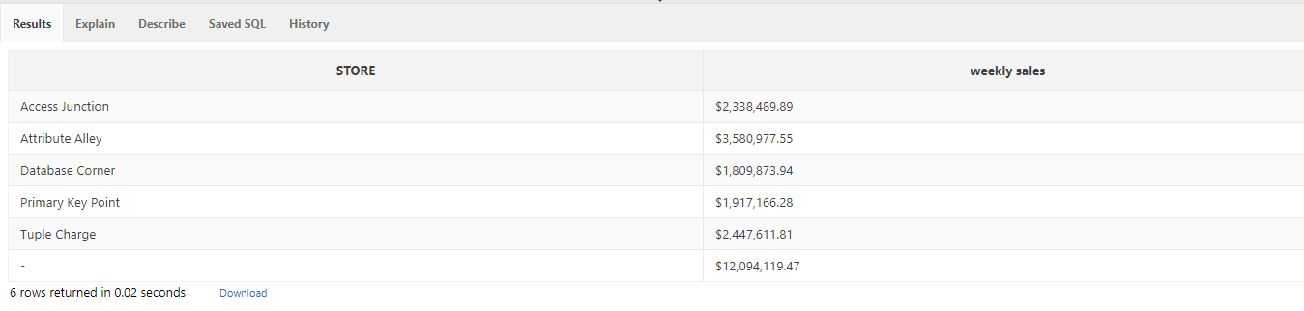

1. List the total weekly sales by store name, region and the grand total. Use the STORE table, REGION table, and the STORE_SALES table.

**SQL Statement Goes Here**

**select store_name "store name", to_char(sum(store_weekly_sales),'$999,999,999.99') "weekly Sales", REGION_DESCRIPT "region"**

**from store join store_sales using (store_code) join region using (REGION_CODE)**

**group by**

**grouping sets ((REGION_DESCRIPT),(store_name, REGION_DESCRIPT), ());**

**Screen Shot goes here**

