Chapter Ten Assignment

To perform the following assignments, refer to the tables created in the *New Build Script Chapter 10.sql* script in Black Board Learn/Course Content/ Chapter 10 Selected Single-Row Functions Folder.

1. Create a list of the first and last name with the last name of “Smith” from the agent table.

**SQL Statement goes here**

select agent.agent_fname ||' '|| agent.agent_lname as agent

from agent

where lower(agent_lname) like '%smith%';

**Screen shot goes here**

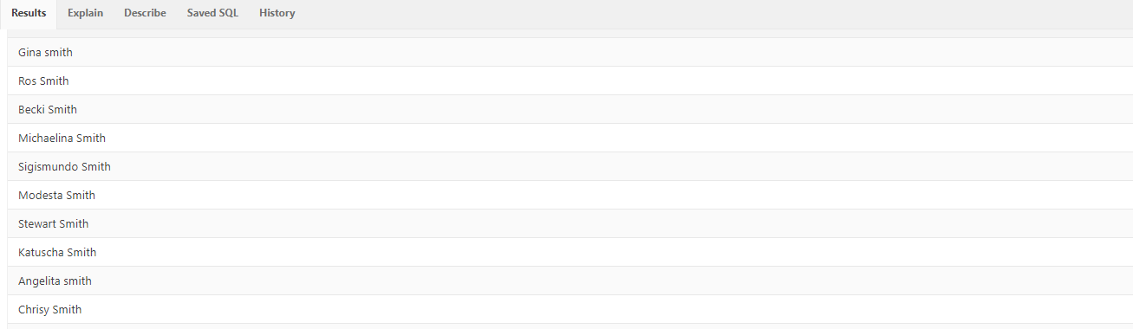

1. Create a list of the first and last name with the last name that sounds like “Smith” from the agent table.

**SQL Statement goes here**

select agent.agent_fname ||' '|| agent.agent_lname as agent

from agent

where soundex(agent_lname) = soundex('Smith');

**Screen shot goes here**

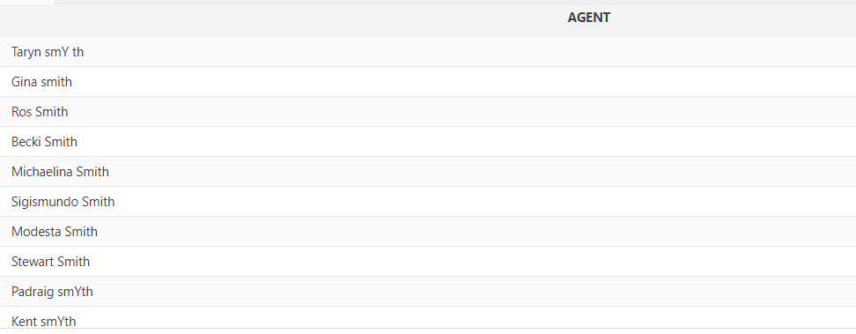

1. Create a list of the first and last name with the last name that begin with O’ of from the agent table.

**SQL Statement goes here**

select agent.AGENT_fNAME "first name" ,agent.agent_lname "last name"

from AGENT

where substr(agent.agent_lname,1,2)='O''';

**Screen shot goes here**

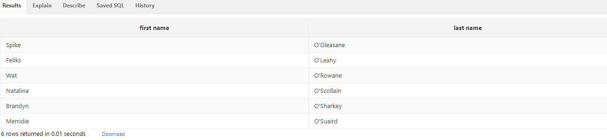

1. Create a list of the first and last name with the last name that sounds like “Smith” that have dependents. Create a column and put in Yes if they have dependents and No if they do not have dependents from the agent table.

**SQL Statement goes here**

select agent.agent_fname ||' '|| agent.agent_lname as agent , nvl2 (Agent_dep, 'yes' , 'no ') as dependent

from agent

where soundex(agent_lname) = soundex('Smith');

**Screen shot goes here**

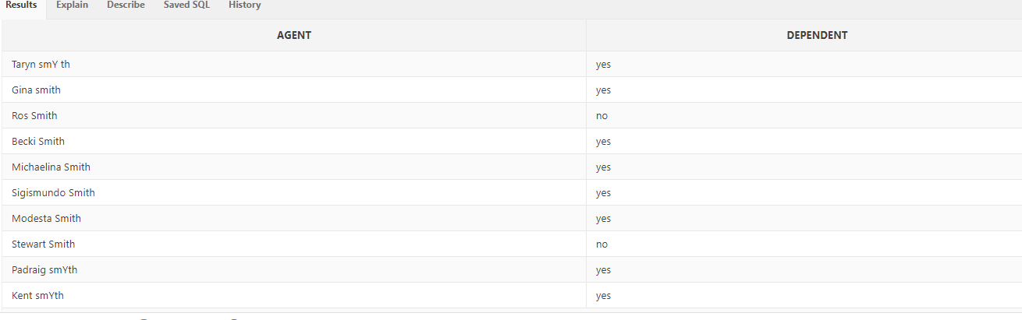

1. Create a list of the first and last name and the net pay of anyone making over $99,000.00 gross pay from the agent table. Format the Net Pay column as show in the example.

**SQL Statement goes here**

**select agent.agent_fname ||' '|| agent.agent_lname as agent , to_char(agent_YTD_pay - agent_YTD_fit - agent_YTD_fica - agent_YTD_sls, '$99,000.00') as NetPay**

**from agent**

**where agent.agent_YTD_pay >= 99000 ;**

**Screen shot goes here**

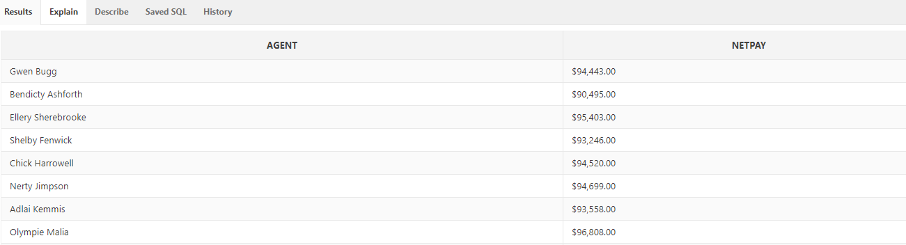

1. Create a list of the first and last name and the net pay of anyone making over $99,000.00 gross pay from the agent table. Format the Net Pay column as show in the example precede the value in the Net Pay column with asterisks so that the width of the displayed field is 20

**SQL Statement goes here**

**select agent.agent_fname ||' '|| agent.agent_lname as agent , lpad(to_char(agent_YTD_pay - agent_YTD_fit - agent_YTD_fica - agent_YTD_sls, '$99,000.00'),20,'*') as NetPay**

**from agent**

**where agent.agent_YTD_pay >= 99000 ;**

**Screen shot goes here**

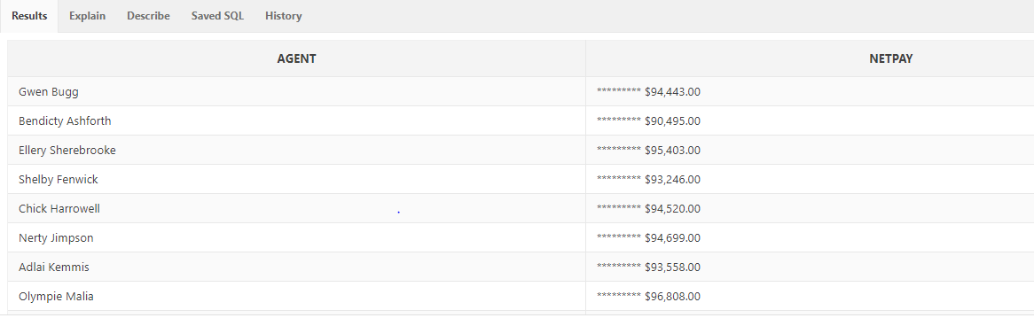

1. Create a list of the title and description from the item table that have “80GB hard drive” in the description.

**SQL Statement goes here**

select item.TITLE as item, item.DESCRIPTION as DESCRIPTION

from item

where regexp_like(DESCRIPTION,'80GB hard drive');

**Screen shot goes here**

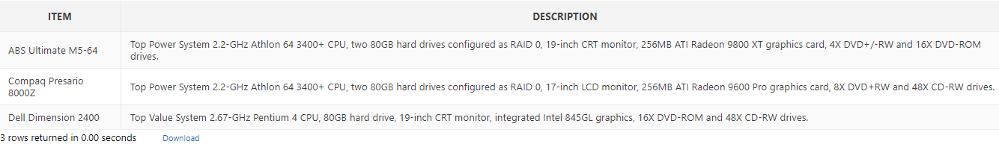

1. Create a list of the first name, last name, the date of hire, and the current date of anyone in the agent table that was hired less than a year ago.

**SQL Statement goes here**

select agent.AGENT_LNAME ||' '||agent.agent_fname as agent, agent.agent_date_hired "date of hire" , sysdate "todays date"

from AGENT

where AGENT_DATE_HIRED between '01-JAN-17'and'31-DEC-17';

**Screen shot goes here**

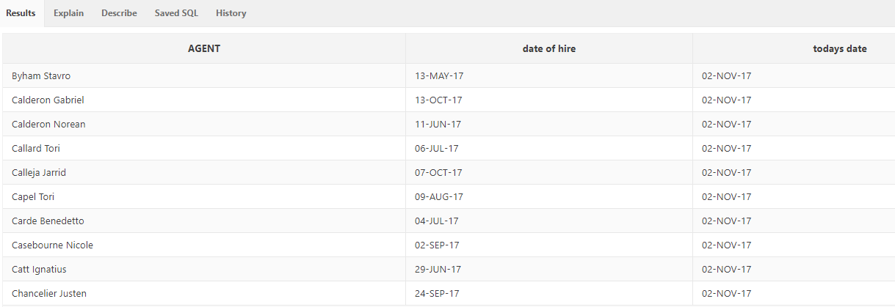

1. Create a list of the first name, last name, and the state from the agent table that live in Florida. In the state column change “Florida” to “FL”.

**SQL Statement goes here**

select agent.AGENT_LNAME ||' '||agent.agent_fname as agent, replace(agent.AGENT_STATE, 'Florida', 'FL' )as state

from AGENT

where agent_state ='Florida';

**Screen shot goes here**

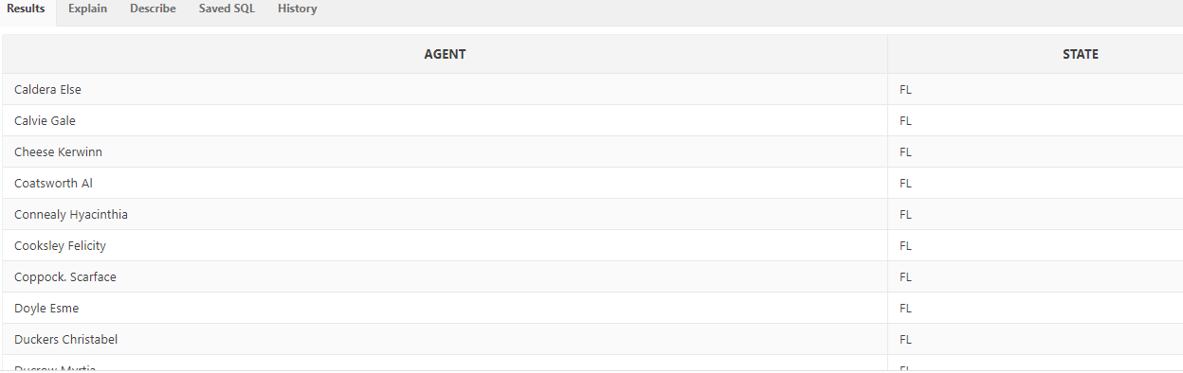

1. Create a list of the first name, last name, and the phone number from the agent table that where the area code starts with the number 4.

**SQL Statement goes here**

select agent.AGENT_LNAME ||' '||agent.agent_fname as agent, agent.AGENT_PHONE "Phone Number"

from AGENT

where regexp_like(agent_Phone,'[4][0-9]{2}[-.][0-9]{3}[-.][0-9]{4}');

**Screen shot goes here**

