Chapter Thirteen Assignment view

To perform the following assignments, refer to the tables created in the *New Build Script Chapter 13.sql* script in Black Board Learn/Course Content/ Chapter 13 Views Folder.

1. Create a of all the movies out for rental.

**SQL statement here**

**create or replace view out_of_rental as select MM_MOVIE.MOVIE_TITLE as "movie title", MM_MOVIE.MOVIE_ID as "movie id"**

**from MM_RENTAL , MM_MOVIE**

**where MM_RENTAL.movie_id = MM_Movie.movie_id;**

**PATE YOU OUTPUT HERE!**

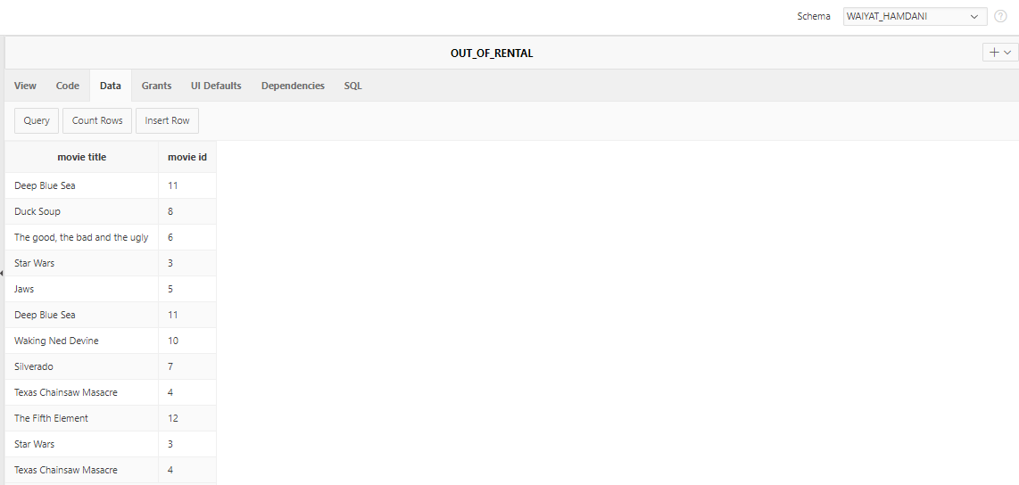

1. Create a view called NCC_Student, that contains the fields first_name, last_name, and BannerID from a table called does_not_exist. Execute the following SQL command: **select * from NCC_Student;** after you create the view.

**SQL statement here**

**create or replace force view NCC_Student as select first_name ||' '|| last_name as "student first and last name", BannerID as "banner Id" from does_not_exist ;**

**PATE YOU OUTPUT HERE!**

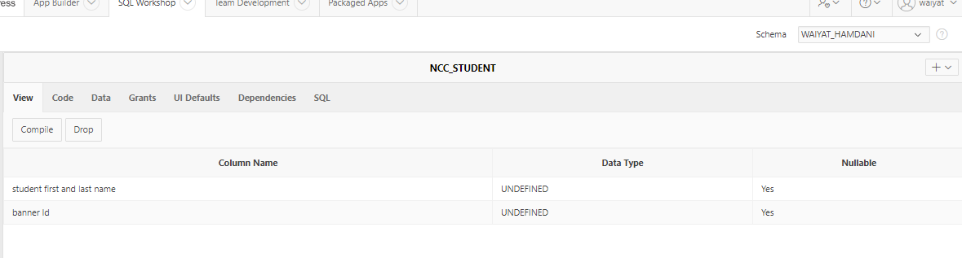

1. Create a view named xx_student that has, stu_num, stu_lname, stu_fname from the x_student table, and crs_code, enroll_grade from the x_enroll table. Insert the following values into the view: (STU_NUM, STU_FNAME, STU_LNAME, crs_code, enroll_grade) values('your banner id', 'Your', 'Name', 'CSC 233', 'A');

**SQL statement here**

**create or replace view xx_student as select X_STUDENT.STU_NUM as "student number", X_STUDENT.STU_LNAME ||' '|| X_STUDENT.STU_FNAME as "student" ,X_CLASS.CRS_CODE as "crs code" ,X_ENROLL.ENROLL_GRADE as "grade"**

**from X_STUDENT, X_CLASS, X_ENROLL**

**where X_STUDENT.STU_NUM = X_ENROLL.STU_NUM**

**and X_ENROLL.CLASS_CODE = X_CLASS.CLASS_CODE;**

**note: the insert its going to be error**

**PATE YOU OUTPUT HERE!**

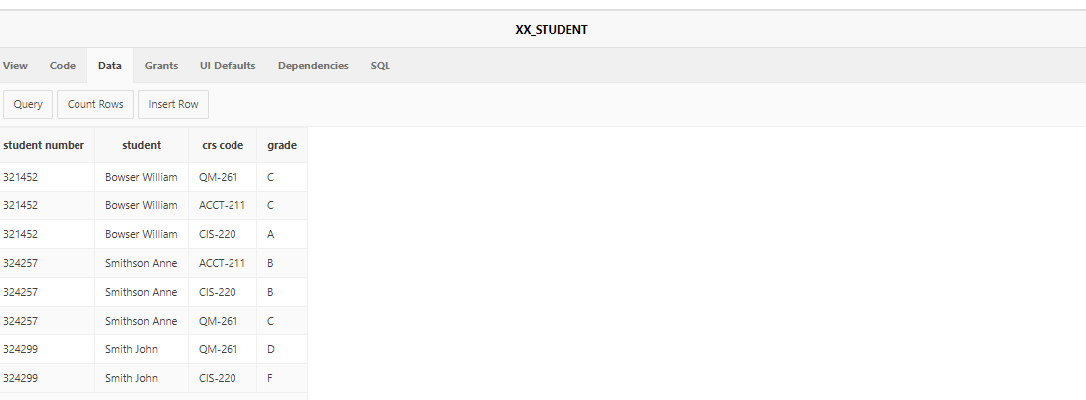

1. Delete the view NCC_Student, create a new view named NCC_Student from the x_student, and insert the following values into the view: (STU_NUM, STU_FNAME, STU_LNAME) values('your banner id', 'Your', 'Name'); (Insert both statements below)

Query both the NCC_Student view and the x_student table and paste your results below.

**SQL statement here**

**create or replace view ncc_student as select * from X_STUDENT ;**

**insert into NCC_STUDENT (STU_NUM, STU_FNAME, STU_LNAME) values (01659956, 'waiyat' , 'hamdani');**

**PATE YOU OUTPUT HERE!**

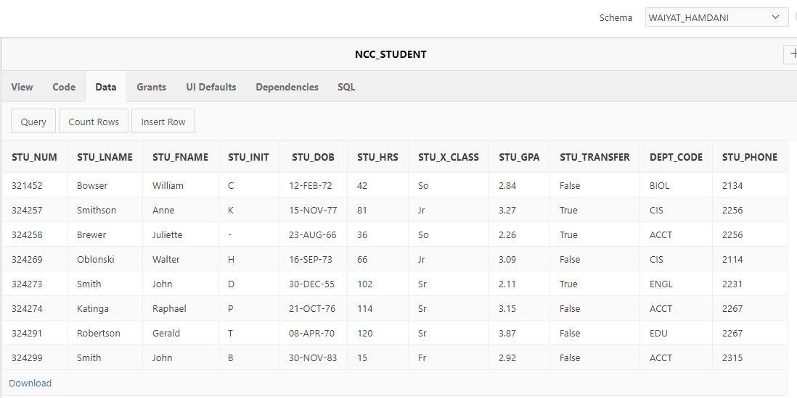

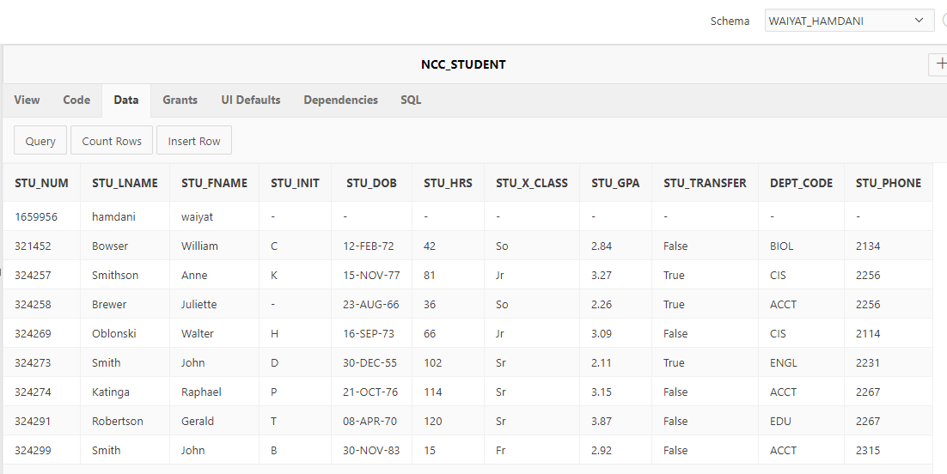

1. Create a new materialized view named Student_NCC with the same columns as NCC_Student and use the table x_student. In NCC_Student insert the following values: 'your banner id in reverse', 'your first name in reverse', 'your last name in reverse', i.e. ‘5604400’, ‘selrahc, ‘robag’. Execute the following select commands and copy and paste the results from these commands below.

* **select * from student_ncc;**
* **select * from ncc_student;**
* **select * from x_student;**

**SQL statement here**

**create Materialized view student_ncc as select * from X_STUDENT ;**

**insert into STUDENT_NCC (STU_NUM, STU_FNAME, STU_LNAME) values (65995610, 'tayiaw', 'inadmah');**

**PATE YOU OUTPUT HERE!**

