Chapter Twelve Assignment

To perform the following assignments, refer to the tables created in the *New Build Script Chapter 12.sql* script in Black Board Learn/Course Content/ Chapter 12 Subqueries and MERGE Statements Folder.

1. List the name and gross pay from the agent table that make more than the average (average of the gross pay) off all the agents.

**Insert SQL Statement Here**

**select AGENT_FNAME ||' '|| AGENT_LNAME "Agent Name", to_char(AGENT_YTD_PAY, '$9,999,999.99') "Gross Pay"**

**from AGENT**

**where AGENT_YTD_PAY > (select avg(AGENT_YTD_PAY)**

**from AGENT);**

**Insert Screen Shot Here**

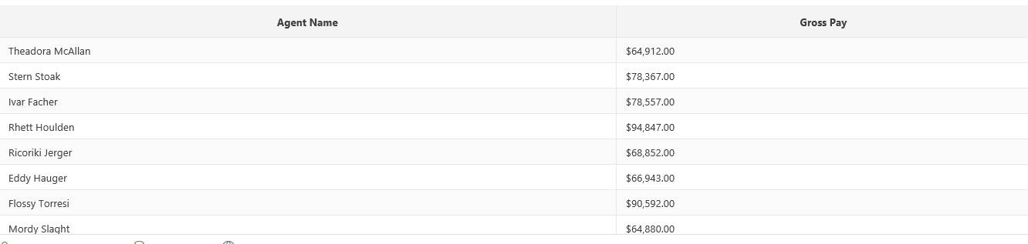

1. List the title and description from the item table where the winning bid is greater than the average of all the winning bids.

**Insert SQL Statement Here**

**select TITLE, DESCRIPTION**

**from ITEM**

**where (((CLOSEDATETIME-OPENDATETIME)*BIDINCREMENT)+STARTINGBID) > (select avg(((CLOSEDATETIME-OPENDATETIME)*BIDINCREMENT)+STARTINGBID)**

**from ITEM);**

**Insert Screen Shot Here**

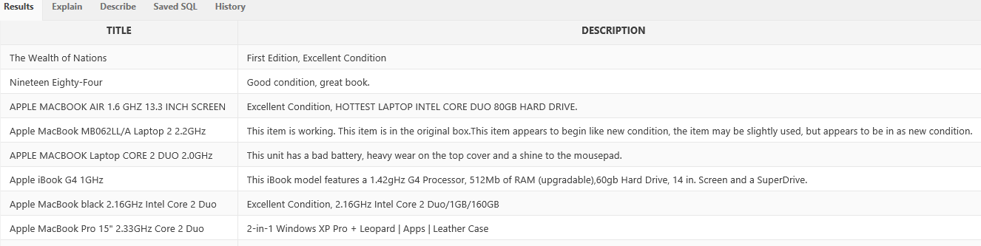

1. How many movies were rented by credit card? Use the mm_rental, and mm_pay_type tables.

**Insert SQL Statement Here**

**select count(PAYMENT_METHODS_ID) "Number Of Credit Cards Used"**

**from MM_RENTAL**

**where PAYMENT_METHODS_ID = (select PAYMENT_METHODS_ID**

**from MM_PAY_TYPE where PAYMENT_METHODS = 'Credit Card');**

**Insert Screen Shot Here**

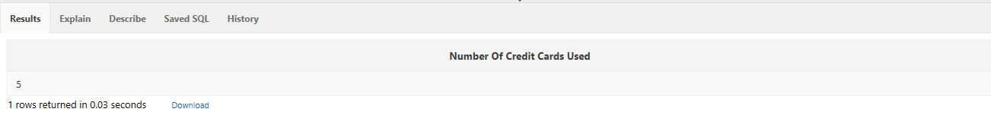

1. List the first name and last name of the person who rented the movie “The Fifth Element”. Use the mm_member table, mm_rental, and mm_movie tables.

**Insert SQL Statement Here**

**select FIRST||' '|| LAST "Name "from MM_MEMBER**

**where MEMBER_ID = (select MEMBER_ID from MM_RENTAL**

**where MOVIE_ID = (select MOVIE_ID from MM_MOVIE**

**where MOVIE_TITLE = 'The Fifth Element'));**

**Insert Screen Shot Here**



1. List the movies that are in the Horror category. Use mm_movie and mm_movie_type.

**Insert SQL Statement Here**

**select MOVIE_TITLE from MM_MOVIE**

**where MOVIE_CAT_ID = (select MOVIE_CAT_ID from MM_MOVIE_TYPE**

**where MOVIE_CATEGORY = 'Horror');**

**Insert Screen Shot Here**

