## unjChapter Nine Assignment

To perform the following assignments, refer to the tables created in the “*New Build Script Chapter 9.sql*” script in Black Board Learn/Course Content/ Chapter 9 Joining Data from Multiple Tables. Generate and test two SQL, queries for each of the following asks:

1. The SQL statement needed to perform the stated task with the traditional approach.
2. The SOL statement needed to perform the stated task with the JOIN keyword.
3. Create a list of all students (first name and last name separated by a comma) listed as “Student”, and their professors name (first name and last name separated by a comma) listed as “Professor”.

*select distinct student.stu_fname ||',' || stu_lname as "student", professor.PROFESSOR_FIRST_NAME || ',' || professor.PROFESSOR_LAST_NAME as professor from student, professor where professor.prof_num=student.prof_num;*

*B*

*Select distinct student.stu_fname ||',' || stu_lname as "student", professor.PROFESSOR_FIRST_NAME || ',' || professor.PROFESSOR_LAST_NAME as professor from student natural join professor;*

*Screen Shot goes here.*

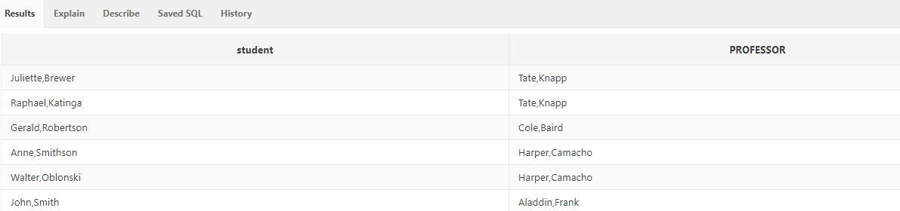

1. Create a distinct list of all professors (first name and last name separated by a space) listed as “Professor”, and their courses listed as “Courses”.

*Select distinct PROFESSOR_FIRST_NAME ||' '|| PROFESSOR_LAST_NAME as professor, course.crs_code as course from professor, course , class*

*where course.crs_code=class.crs_code and class.prof_num=professor.prof_num;*

*select distinct PROFESSOR_FIRST_NAME ||' '|| PROFESSOR_LAST_NAME as professor, course.crs_code as course*

*from professor join class on class.prof_num=professor.prof_num*

*join course on course.crs_code=class.crs_code;*

*Screen Shot goes here.*

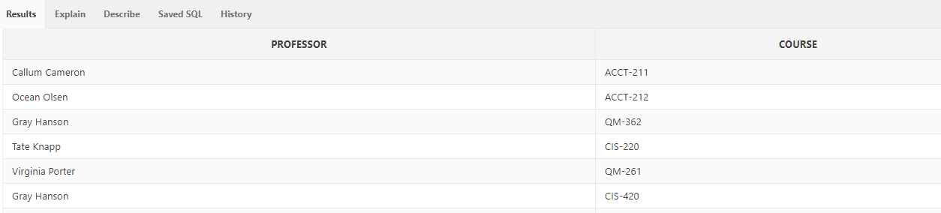

1. Create a distinct list of all professors (first name and last name separated by a space) listed as “Professor”, and the description of the courses they teach listed as “Courses”.

*Select distinct PROFESSOR_FIRST_NAME ||' '|| PROFESSOR_LAST_NAME as professor, course.CRS_DESCRIPTION as course from professor, course , class*

*where course.crs_code=class.crs_code and class.prof_num=professor.prof_num;*

*select distinct PROFESSOR_FIRST_NAME ||' '|| PROFESSOR_LAST_NAME as professor, course.CRS_DESCRIPTION as course*

*from professor join class on class.prof_num=professor.prof_num*

*join course on course.crs_code=class.crs_code;*

*Screen Shot goes here.*

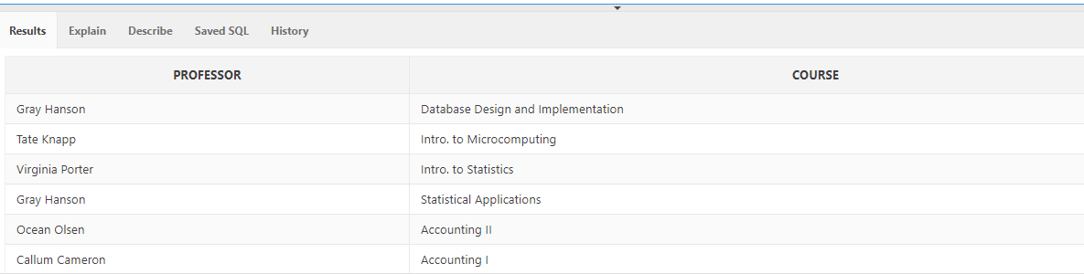

1. Create a list of students (first name and last name separated by a comma) listed as “Student” enrolled in course, also list the professors name (first name and last name separated by a comma) listed as “Professor” of the courses, the course description listed as “Course Description” and the student’s grade for the course listed as “Grade”.

*select student.stu_fname ||',' || student.stu_lname as "student", professor.PROFESSOR_FIRST_NAME || ',' || professor.PROFESSOR_LAST_NAME as professor, course.CRS_DESCRIPTION as CRS_description, course.crs_code as course, enroll.ENROLL_GRADE as grade*

*from student, professor, Enroll, course, class*

*where student.stu_num=enroll.stu_num*

*and student.prof_num=professor.prof_num*

*and enroll.class_code=class.class_code*

*and class.crs_code=course.crs_code*

*order by student.stu_lname desc;*

*b.*

*select student.stu_fname ||',' || stu_lname as "student", professor.PROFESSOR_FIRST_NAME || ',' || professor.PROFESSOR_LAST_NAME as professor, course.CRS_DESCRIPTION as CRS_description, course.crs_code as course, enroll.ENROLL_GRADE as grade*

*from student join enroll on student.stu_num=enroll.stu_num*

*join professor on professor.prof_num=student.prof_num*

*join class on class.class_code=enroll.class_code*

*join course on course.crs_code=class.crs_code*

*order by student.stu_lname desc;*

*Screen Shot goes here.*

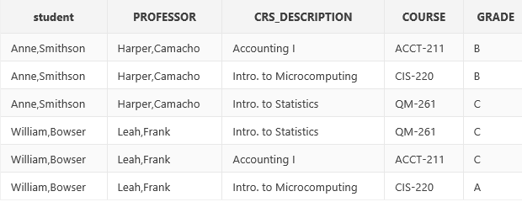

1. Create a list of all the stores and their managers names (first and last separated by a space including there title) list the stores even if there is no manager. Hint: There is only one way to do this problem and it in involves outer joins, but **DO NOT** use the **JOIN** keyword.
2. *select employee_x.EMP_fname||' '||employee_x.EMP_lname as manager, store.store_name as store*

*from employee_x, store*

*where employee_x.store_code (+)= store.store_code*

*and job_code(+)='MGR';*

*Screen Shot goes here.*

