**Hong Kong's Special Education: A Data-Driven Look at Rising Numbers and Resource Needs**

The increasing demand for special education in Hong Kong points to the need for a more inclusive and adaptive education system. New data reveal that the number of students requiring special education services has reached record highs, posing new challenges for resource allocation.

**Growing Numbers Signal a Need for Resource Reallocation**

The latest data from the Hong Kong government show a steady proportion of special students[1] , accounting for around 10% of all primary and secondary school students[2] . This significant and stable proportion underscores the necessity for special education to be recognized as a critical and long-term investment in the education sector. The total number of special students has risen from 49,080 in the 2018/19 academic year to 64,220 in the 2023/24 academic year, with an average annual growth rate of approximately 5.2%. To put this into perspective, this growth is equivalent to the student population of over six new schools each year if the size of each school is taken as a reference of 500 students.

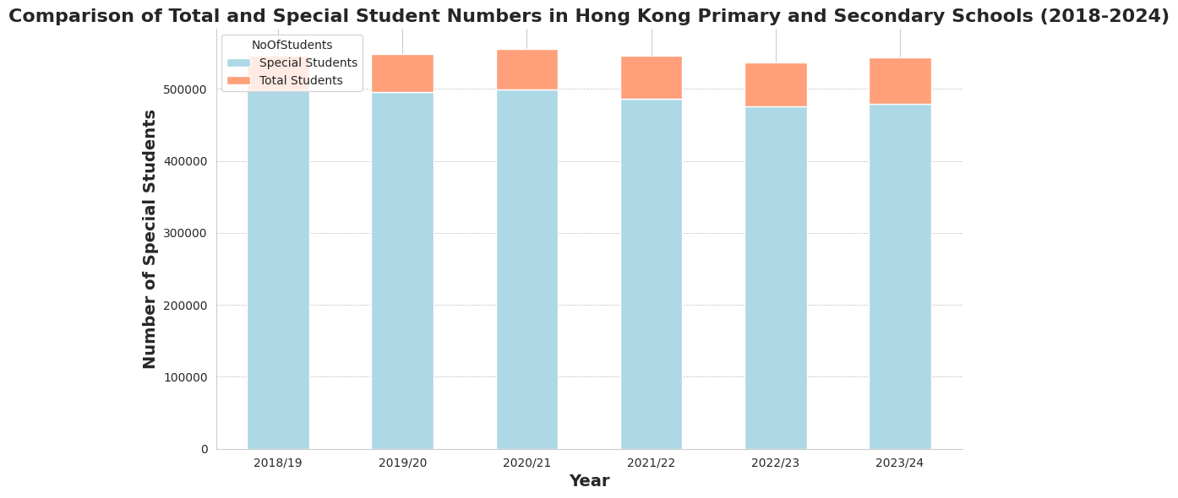

**Keeping Pace with Resource Allocation**

Both primary and secondary school special student numbers show an upward trend, consistent over the past few years. Notably, the number of secondary special students is increasing faster than that of primary special students, reflecting a heightened identification and support need for special education as students age.

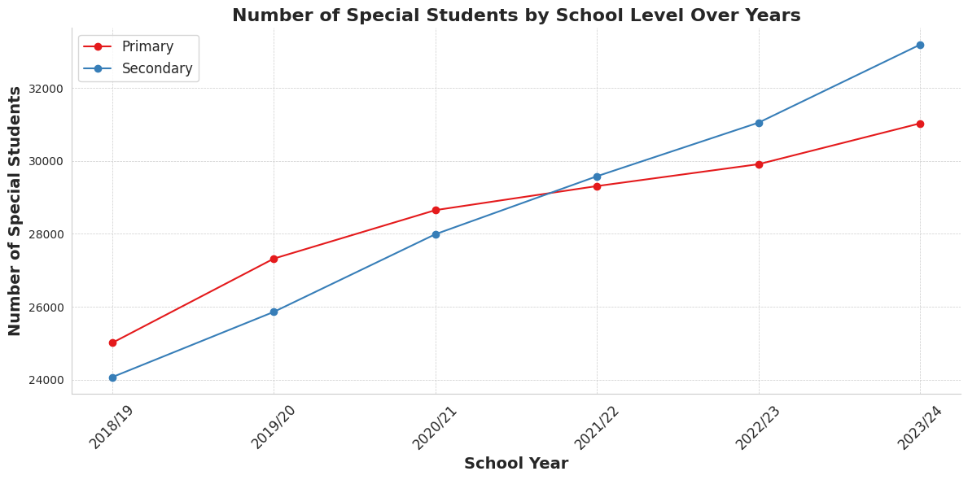

As the number of special students grows, the goverment should adjust the allocation of educational resources accordingly. In particular, students with Attention Deficit/ Hyperactivity Disorder and Autism Spectrum Disorder, which are growing at a faster rate and showing a significant trend, along with students with Specific Learning Disability, who are also numerous and steadily increasing, require urgent attention, such as providing more campus facilities and training specialized teachers.

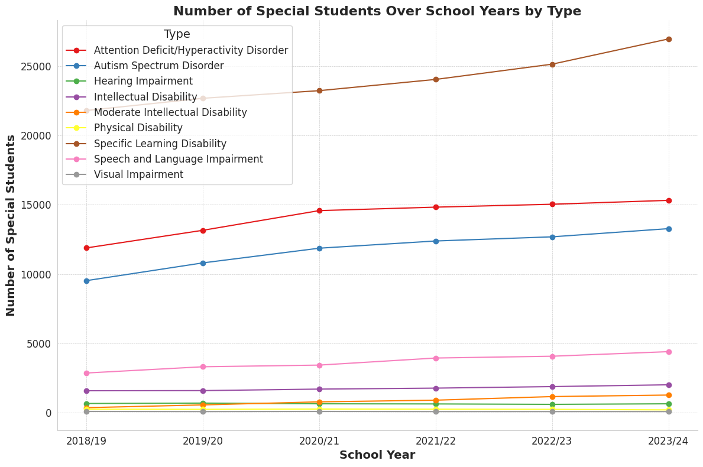

**Breaking Down Special Student Categories**

The spectrum of special student categories is broad, including Intellectual Disability, Autism Spectrum Disorder and ten other distinct groups. Detailed analysis of these categories is crucial for understanding different student populations' specific needs and developing targeted support policies and services. For instance, students with Specific Learning Disability have the widest distribution and the highest median, indicating that this category has the most special students with significant variability. In contrast, students with hearing impairment, intellectual disability, moderate intellectual disability, physical disability, speech and language impairment, and visual impairment are fewer and more concentrated in number.

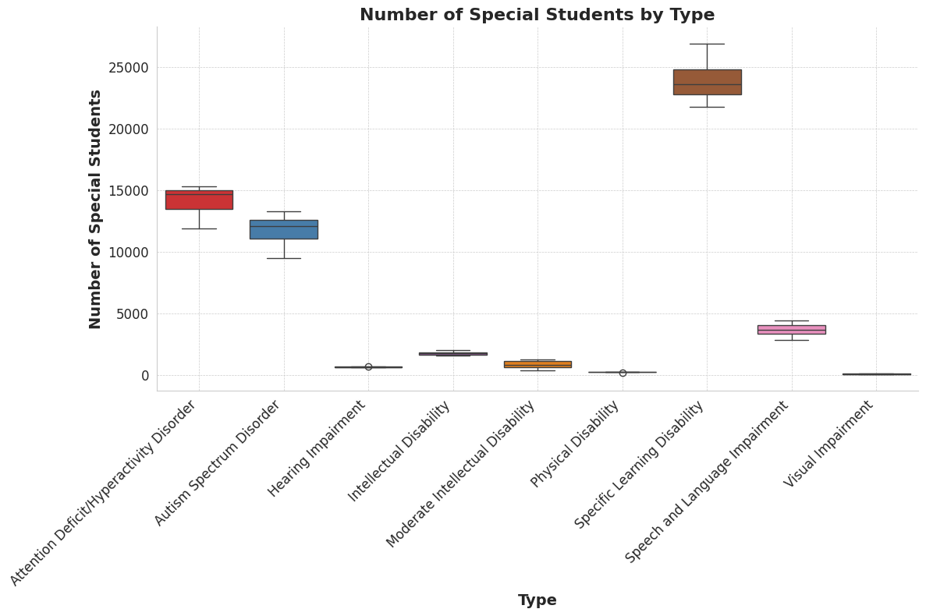

**Policy Recommendations for an Inclusive Future**

To address the challenges facing special education in Hong Kong, the Government should increase funding for special education, as well as utilize data-driven policy formulation to develop targeted support policies for various types of special students and strengthen the collaboration among the education, health and social welfare sectors to provide comprehensive support for special students.

**Looking Ahead**

As the special education landscape in Hong Kong continues to evolve, it is more important than ever to focus on precision in resource allocation and policy. With data-driven decision-making, and collaborative efforts, Hong Kong can strive to create a more equitable and inclusive educational environment in which every child receives the opportunities they deserve.

**Data Source:**

[1] Number of Students with Special Educational Needs (SEN) in Public Sector Ordinary Primary and Secondary Schools by School Level and SEN Type<https://data.gov.hk/en-data/dataset/hk-edb-sen-sen-list>

[2] 學生減少最壞情況已過？適齡學童基本盤跌 這年份出生率20年新低 | 香港01

https://www.hk01.com/article/918928?utm_source=01articlecopy&utm_medium=referral