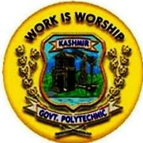
KASHMIR GOVERNMENT POLYTECHNIC COLLEGE SRINAGAR
Gogji Bagh Srinagar

COURSES OFFERED:
Three Years Diploma Programmes in:
1. CIVIL ENGINEERING
2. ELECTRICAL ENGINEERING
3. AUTOMOBILE ENGINEERING
4.COMPUTER ENGINEERING
5. ELECTRONICS AND COMMUNICATION ENGINEERING
6. MECHANICAL ENGINEERING
7. INFORMATION TECHNOLOGY
8. MEDICAL LAB TECHNOLOGY
9. LEATHER TECHNOLOGY
10. WOOD TECHNOLOGY

For further information contact on: 9906112210,9906457756
