Circular
Subject: Designation of Facilities and Disciplinary Guidelines.
The Following Facilities have been designated for the Male and Female Students of this institution.
- The washroom located near the Academic Block-3 is designated exclusively for FEMALE students of this institution.
- The washrooms located near the Electronics and Communication Department are designated exclusively for MALE students of this institution.
- The garden in front of the Administrative Office is designated exclusively for FEMALE students during the lunch break.
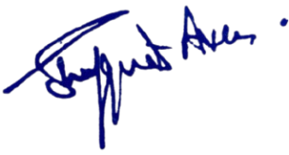
Any deviation from these regulations will be considered a breach of institutional discipline. All members of the Disciplinary Committee are hereby directed to enforce these rules strictly and report any instances of non-compliance to the undersigned immediately.
No: No: KGP/Estt/2025/1212
DaaDated:30-09-2025

Principal
Kashmir Government Polytechnic College
Srinagar

Copy to the:
1. All concerned for information and compliance.
2. Office File
FOR FEMALE STUDENTS(LUNCH) FOR MALE STUDENTS FOR FEMALE STUDENTS
