
Kashmir government polytechnic college
Gogji Bagh, Jawahar Nagar, Srinagar, Jammu and Kashmir 190008
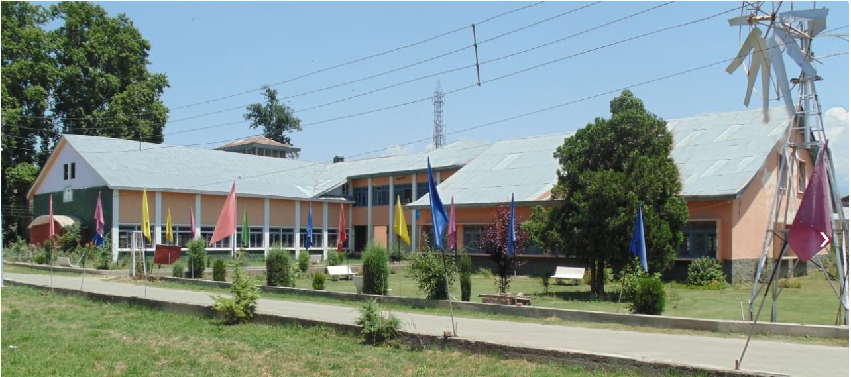

Contact: 9906457756 Email: kgp-srinagar@jk.gov.in , Web: www.kgpsrinagar.edu.in
DURATION | Three Years Diploma Programmes in: Intake Capacity
BRANCHES OFFERED WITH INTAKE & ENTRY LEVEL QUALIFICATION | - Civil Engineering | 60 | 10TH  With 35% Marks
BRANCHES OFFERED WITH INTAKE & ENTRY LEVEL QUALIFICATION | - Electrical Engineering | 30 | 10TH  With 35% Marks
BRANCHES OFFERED WITH INTAKE & ENTRY LEVEL QUALIFICATION | - Mechanical Engineering | 30 | 10TH  With 35% Marks
BRANCHES OFFERED WITH INTAKE & ENTRY LEVEL QUALIFICATION | - Automobile Engineering | 30 | 10TH  With 35% Marks
BRANCHES OFFERED WITH INTAKE & ENTRY LEVEL QUALIFICATION | - Electronics & Communication Engineering (E&C) | 30 | 10TH  With 35% Marks
BRANCHES OFFERED WITH INTAKE & ENTRY LEVEL QUALIFICATION | - Computer Engineering (C.E) | 45 | 10TH  With 35% Marks
BRANCHES OFFERED WITH INTAKE & ENTRY LEVEL QUALIFICATION | - Information Technology | 60 | 10TH  With 35% Marks
BRANCHES OFFERED WITH INTAKE & ENTRY LEVEL QUALIFICATION | - Leather Technology | 30 | 10TH  With 35% Marks
BRANCHES OFFERED WITH INTAKE & ENTRY LEVEL QUALIFICATION | - Wood Technology | 30 | 10TH  With 35% Marks
 | - Medical Lab Technology | 30 | 10+2 with science
DIRECT ENTRY IN 2ND YEAR  (3RD SEMESTER) | 2 Years ITI in the relevant trade  OR  12th class with pass in Physics/ Mathematics /Chemistry/computer Science/Electronics/Information Technology/ Biology/ Informatics Practices/ Biotechnology/ Technical Vocational subject/ Agriculture/ Engineering Graphics/ Business Studies/ Entrepreneurship/ Physics, Chemistry and Math.
FEE STRUCTURE | - FIRST YEAR : ₹2,130(Admission) + ₹118(Insurance)  - SECOND YEAR : ₹1,780(Admission) + ₹118(Insurance)  - THIRD YEAR : ₹1,780(Admission) + ₹118(Insurance)  - HOSTEL RENT : ₹800/Year
FACILITIES AVAILABLE | - Well-equipped Laboratories & Workshops.  - Experienced and well qualified faculty.  - Departmental Computer Centre with all-time internet Connectivity.  - State-of-the-Art Library having more than 25,000 books.  - Separate hostel for Boys and girls fully furnished with 24 hours power backup and security.  - State-of-art Smart classroom/Auditorium.  - Facilitation center available for counselling.
SCOPE | - Eligible for various openings in Government, Public & Private Sectors.  - Can become entrepreneur.  - Overseas Job Opportunities.  - Can pursue higher studies.
SCHOLARSHIPS | - PRAGATI Scholarship : ₹50,000/Year (for Girls Only)  - SAKSHAM Scholarship : ₹50,000/Year (for Physically Challenged)  - JKBOCW Scholarship : ₹30,000/Year (Wards of Construction Workers)  - Post-Matric Scholarship : ₹6,000/Year  - SWANATH Scholarship : ₹50,000/Year (Orphans, Wards of Parent(s) died due to COVID-19 etc…)

