The Chief Planning Officer,
Srinagar.

No: KGP/Estt/2025-26/1489 Dated:31-10-2025

Subject: Deputation of Resource Persons for One Day Orientation cum Training Programme on "NASHA MUKT ABHIYAN" at Auditorium, S.P. College, Srinagar.

Sir,

With reference to your letter No. DCCS/2024-25/NASHA/7311-20 dated 30-10-2025 on the subject cited above, I am to inform that in compliance with the directions of the Government of India (GOI) regarding the "Nasha Mukt Abhiyan" (Drug-Free India Campaign), the following resource persons from this institution are hereby deputed to participate in the one-day orientation cum training programme scheduled on 01-11-2025, from 10:30 AM to 04:30 PM at the Auditorium of S.P. College, Srinagar.
These resource persons will actively contribute to equipping teachers with the necessary knowledge and skills to effectively sensitize students about leading a healthy and drug-free lifestyle, while combating substance abuse and its harmful effects.
S. No. | Name of Resource Person | Designation | Department
1. | Mr. Aaqib Farooq | Demonstrator | Civil Engineering
2. | Dr. Aejaz Farooq | Demonstrator | Computer Engineering

Yours Faithfully
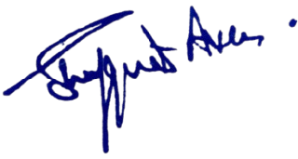

Principal
Kashmir Government Polytechnic College
Srinagar

