The Director,
Department of Skill Development,
Jammu and Kashmir.

No: KGP/Estt/2026/ Dated:24-07-2026

Subject: Status Report regarding Release of Earnest Money Deposit (EMD) – Ref: Your letter No. DSD/PUR/2026-27/e-79224921/173-174 dated 23-07-2026.

Sir,
Kindly refer to your letter under reference on the subject cited above, it is submitted that only Sl. No. 01 mentioned in the table pertains to this institution. The bid process for GeM Bid No. GEM/2025/B/6990519 dated 07-01-2026 has been completed. The contract has been awarded to M/s Jammu Enterprises and M/s Medsource Ozone suppliers.
Malik Scientific had participated in the said bid and their EMD/FD amounting to Rs. 15,720/- is no longer required. There is no objection from this institution for the release of the said EMD in favour of the supplier.

Encl: FD of Rs.15,720/-

Yours faithfully,

Principal
Kashmir Government Polytechnic College
Srinagar

Copy to the:
- Accounts Officer, Directorate of Skill Development, J&K – for information and necessary action.

Yours Faithfully
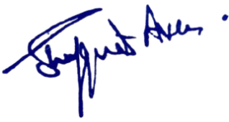

Principal
Kashmir Government Polytechnic College
Srinagar
Copy to the:
  - Accounts Officer, Department of Skill Development for information.

