The Principal
Government Polytechnic college,
Anantnag.

No: KGP/Estt/2025-26/493 Dated:30-06-2025

Subject: Deputation of Experts for 3rd Party Verification.
Sir,
With reference to your letter (NO: GPCA/F-151/529) dated 20/06/2025, It is to inform you that the following experts from the Automobile Engineering Department of our college will be deputed to Government Polytechnic College Anantnag for the 3rd Party Verification of various Automobile Engineering related equipment on July 3, 2025, and July 8, 2025.
- Er. Yamin Kinah, Lecturer-1, Automobile Engineering
- Er. Mudasir Rashid, Lecturer-1, Automobile Engineering.

Yours Faithfully
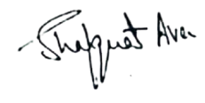

Principal
Kashmir Government Polytechnic College
Srinagar

Copy to the:
1.Concerned Officers for Compliance.

