ALGORITHM ANALYSIS PROJECT
Ant Colony Optimization for
Time-of-Use Appliance Scheduling under NEPRA 2025 Tariffs
Course: Analysis of Algorithms — Spring 2026
Instructor: Mr. Muhammad Usman Sharif
Student: Muhammad
[Class / Section: ____________]
[SAP ID: ____________]

Course Learning Outcomes Mapping
Code | Bloom's Level | Course Learning Outcome
1.1 | Understand | Understand fundamental algorithms and explain their design strategies
2.1 | Implement | Implement algorithms, compare empirically, and solve real-world problems
3.1 | Analyze | Analyze time and space complexity using asymptotic notations

1. Introduction
(CLO 1.1 — Understand)

1.1 The Algorithm: Ant Colony Optimization
Ant Colony Optimization (ACO) is a population-based metaheuristic introduced by Marco Dorigo in his 1992 PhD thesis. It is inspired by the foraging behavior of real ant colonies: when ants find food, they deposit pheromone trails on their way back to the nest, and other ants are attracted to follow stronger pheromone trails. Shorter paths accumulate pheromone faster (because ants traversing them complete round trips more quickly), so over time the colony converges on near-optimal routes.
Artificial ACO mimics this with a population of "artificial ants" that stochastically construct candidate solutions to a combinatorial optimization problem. Each ant is guided by:
- A pheromone matrix τ (tau) — represents accumulated experience about which choices led to good solutions in past iterations.
- A heuristic matrix η (eta) — encodes problem-specific desirability, e.g., "slot 3 is cheaper than slot 19".
- Probabilistic decision rule — combine τ^α · η^β to bias choices, with stochastic sampling for exploration.

1.2 The Problem It Solves Here
This project applies ACO to a real-world domestic optimization problem: given a Pakistani household with 15 appliances (7 fixed-schedule and 8 shiftable), and the NEPRA 2025 slab-based electricity tariff with Time-of-Use multipliers, decide what time of day each shiftable appliance should run so that the total monthly bill is minimized, while respecting an hourly load capacity constraint (3000 W breaker limit).
This is a flavor of the parallel-machine scheduling problem combined with bin packing under non-linear costs — provably NP-hard. Exact methods (brute force, integer programming) become intractable as the number of appliances grows because the search space is the product of slot choices for each appliance.

1.3 Algorithm Design Strategy
ACO belongs to the family of swarm-intelligence metaheuristics. It is neither divide-and-conquer, nor greedy, nor dynamic programming. Its design strategy combines three classical algorithmic ideas:
- Stochastic local search — each ant constructs a solution by making one randomized choice at a time, similar to randomized algorithms.
- Reinforcement learning — successful solutions deposit pheromone, biasing future ants toward good regions of the search space.
- Population-based search — multiple ants explore in parallel each iteration, providing diversity that single-trajectory methods (greedy, hill-climbing) lack.
This makes ACO especially useful for problems where the cost function is non-linear or non-convex (as here, due to the slab tariff cliffs at 50, 100, 200, 300 kWh).

1.4 Real-World Motivation
Pakistan's electricity tariff structure has steep slab cliffs: the per-unit rate jumps from PKR 11.51 to PKR 34.03 — almost a 3× increase — when a household crosses the 200-unit boundary. Combined with peak-hour TOU multipliers of 1.5×, an inefficiently scheduled household can pay 25–40% more than necessary for the same energy consumption. With load shedding making backup generation expensive and electricity prices rising year-over-year, intelligent scheduling has direct financial impact.
This project takes an existing electricity bill calculator (built previously, NEPRA 2025 compliant) and elevates it from a passive read-out tool into an active scheduler — answering not just "what is my bill?" but "how should I schedule my appliances to minimize it?"

1.5 Why This Algorithm Is Important
ACO is significant in algorithm theory and practice for several reasons:
- It is one of the foundational metaheuristics, alongside Genetic Algorithms and Simulated Annealing — making it core curriculum in advanced algorithms courses.
- It handles problems where exact methods fail: non-convex objectives, combinatorial constraints, and large search spaces.
- It has produced state-of-the-art results on several NP-hard benchmarks, including the Traveling Salesman Problem, Vehicle Routing, and Job-Shop Scheduling.
- Its decentralized, agent-based design has inspired distributed routing protocols (e.g., AntNet for telecom networks) and swarm robotics.

1.6 Basic Working Idea
In one sentence: artificial ants build candidate schedules one slot at a time, with the probability of each choice influenced by past success (pheromone) and immediate desirability (heuristic); the best schedules deposit more pheromone, gradually steering the entire colony toward the optimum.

2. Algorithm Explanation
(CLO 1.1 — Understand)

2.1 Pseudocode
INPUT: appliances[], tariff(kwh, hour), capacity_limit
n_ants M, n_iterations T,
alpha (pheromone weight), beta (heuristic weight),
rho (evaporation), Q (deposit factor)

INITIALIZE tau[i][h] = 1 for all i in 1..N, h in 0..23
eta[i][h] = 1 / tou_multiplier(h)

best_solution <- NULL
best_fitness <- -INFINITY

FOR iteration = 1 to T:
solutions <- []
FOR ant = 1 to M:
load[h] <- watts of fixed appliances at slot h, for all h
schedule <- {}
FOR each shiftable appliance i (in random order):
FOR k = 1 to required_hours[i]:
available <- slots not yet chosen for i
FOR each slot h in available:
p[h] <- tau[i][h]^alpha * eta[i][h]^beta
* (1.0 if load[h]+watts[i] <= capacity else 0.05)
normalize p[]
pick slot h_chosen by roulette-wheel sampling on p[]
schedule[i].add(h_chosen)
load[h_chosen] += watts[i]
solutions.append(schedule)

fitnesses <- [evaluate(s) for s in solutions]
update best_solution if any solution beats best_fitness

# Pheromone update
tau <- tau * (1 - rho) # evaporation
FOR each ant in top M/3 by fitness:
deposit Q proportional to fitness onto its choices
deposit 2Q onto best-so-far solution # elitism
clamp tau to [0.1, 50] # prevent stagnation

RETURN best_solution

2.2 Working Steps in Plain English
Step 1 — Initialization. Set up an N × 24 pheromone grid, one row per appliance, one column per hour-of-day. Every cell starts at value 1 (no preference yet). Compute a heuristic grid where cheaper hours have higher desirability — off-peak (10pm–6am, multiplier 0.7×) gets η = 1.43, peak (6pm–10pm, 1.5×) gets η = 0.67.
Step 2 — Send the ants. In each iteration, M independent ants (typically 20–30) build one full schedule each. An ant proceeds appliance-by-appliance. For each shiftable appliance, it picks the required number of hourly slots one at a time, sampling probabilistically from the available slots based on τ^α · η^β, with a strong reduction factor for slots that would exceed the capacity limit.
Step 3 — Evaluate. Each ant's complete schedule is scored by computing the resulting monthly bill (cumulative kWh accumulated across 30 simulated days, with each hour billed at slab_rate × tou_multiplier). Capacity violations are penalized heavily.
Step 4 — Update pheromones. All pheromone values are first multiplied by (1 − ρ) to simulate evaporation. Then the top M/3 ants (by fitness) deposit pheromone onto the slot–appliance pairs they used, with the deposit amount proportional to their fitness. The best-so-far solution gets an extra elitist deposit. Pheromone values are clamped to a [0.1, 50] range to prevent any single trail from dominating (a stagnation defense borrowed from Max-Min Ant System).
Step 5 — Repeat. Iterate T times (typically 100–200). Each iteration shifts the colony's behavior toward better solutions, with diversity maintained by the stochastic sampling and evaporation.
Step 6 — Return. After T iterations, return the best schedule encountered across all ants and iterations.

2.3 Example Walkthrough
Input:
- 3 shiftable appliances: Washing Machine (500W, 2 hr/day), Iron (1200W, 1 hr/day), Geyser (2000W, 2 hr/day).
- Capacity = 3000 W. Fixed appliances already loaded at every hour.
- M = 5 ants, T = 3 iterations, α = 1, β = 3, ρ = 0.1.
Iteration 1, Ant 1 picks for Washing Machine: probabilities are highest for off-peak hours (η = 1.43). It samples slots [02:00, 03:00]. For Iron (1 hr): also picks an off-peak slot, [04:00]. For Geyser (2 hr): off-peak slots are still attractive but the 2000 W load combined with fixed-appliance load at certain hours triggers the capacity penalty. It picks [05:00, 23:00]. Total schedule: a coherent off-peak placement.
Ant 2, by random sampling, places Iron at 19:00 (peak hour) — bill is higher. Ant 3 picks all off-peak hours for the Washing Machine but creates a capacity overload at 03:00 — fitness penalty applies.
After all 5 ants finish iteration 1, fitnesses are evaluated. The top 2 ants deposit pheromone onto their (appliance, slot) pairs. The penalty-free, off-peak-heavy schedules cause τ values for those slot choices to grow. By iteration 3, the probability distribution is sharply peaked toward the off-peak slots that didn't violate capacity, and the colony has effectively memorized the good schedule.
Output: a schedule like {Washer: [02:00, 03:00], Iron: [04:00], Geyser: [05:00, 23:00]} with bill ≈ PKR 28,000 (vs ≈ PKR 32,000 if all 3 were placed at evening peak).

3. Implementation
(CLO 2.1 — Implement)

3.1 Programming Language and Libraries
Python 3 was chosen for the implementation. Rationale:
- NumPy enables fast vectorized pheromone updates over the 24-slot × N-appliance matrix.
- Matplotlib provides publication-quality graphs for the empirical analysis section.
- Python's clear syntax makes the algorithm readable to anyone marking the report — no language-specific complexity obscures the algorithmic content.
- Standard library modules tracemalloc and time.perf_counter() provide rigorous memory and time measurements.
No external machine-learning or optimization frameworks are used — ACO is implemented from scratch to demonstrate full understanding.

3.2 Code Structure
The implementation is split into two files:
- aco_scheduler.py — Core ACO algorithm (~300 lines), tariff and capacity model, baselines (random, greedy).
- empirical_analysis.py — Benchmarking harness that varies n, m, t and produces the analysis graphs.
Key components within aco_scheduler.py:
- tou_multiplier(hour) — Time-of-Use tariff multiplier function.
- slab_rate(kwh) — NEPRA 2025 cumulative-slab per-unit price function.
- compute_monthly_bill(schedule) — Simulates 30 days of consumption, accumulating kWh across slabs.
- Class ACOScheduler — Encapsulates the algorithm: construct_solution(), update_pheromones(), run().
- greedy_cheapest_first() — Baseline that assigns appliances to cheapest slots respecting capacity.
- random_baseline(seed) — Random-schedule baseline for sanity comparison.

3.3 Core ACO Code Snippet
Construction of one ant's solution (the heart of the algorithm):
def construct_solution(self):
load = [0.0] * 24
# Pre-load fixed-schedule appliances
for i, a in enumerate(APPLIANCES):
if not a.shiftable:
for h in a.fixed_slots: load[h] += a.watts

choices = {}
order = self.shiftable_idx[:]
random.shuffle(order)
for i in order:
a = APPLIANCES[i]
available = list(range(24))
chosen = []
for _ in range(a.required_hours):
tau_h = np.array([self.tau[i][h] for h in available]) ** self.alpha
eta_h = np.array([self.eta[i][h] for h in available]) ** self.beta
cap = np.array([0.05 if load[h]+a.watts > LOAD_CAPACITY_WATTS
else 1.0 for h in available])
probs = tau_h * eta_h * cap
probs = probs / probs.sum()
h = available[np.random.choice(len(available), p=probs)]
chosen.append(h)
load[h] += a.watts
available.remove(h)
choices[i] = sorted(chosen)
return choices

3.4 Features
- Input handling — Appliance dataset is declarative (a list of dataclass instances), making it trivial to add appliances or change power ratings.
- Output generation — Demo mode prints a human-readable comparison; benchmarking mode produces structured data and PNG graphs.
- Modularity — Tariff model, capacity model, ACO core, and baselines are independent functions, each independently testable.
- Reproducibility — All random sources (Python random, NumPy random) are seedable for deterministic experiments.
- Greedy warm start (optional) — Pheromones can be biased toward the greedy solution at start, accelerating convergence in tight time budgets.

3.5 Test Cases
Input Scenario | Expected Output | Actual Output
Single appliance, no constraints | Algorithm picks the cheapest off-peak slot | Confirmed: hour 02:00 chosen consistently
All shiftable appliances, capacity 3000W | Bill < random baseline; capacity respected | Bill PKR 37,115; 0 capacity violations
Comparison vs greedy | ACO ≤ greedy bill (with high probability) | ACO PKR 37,115 < greedy PKR 37,914 (2.11% better)
Reproducibility (seed=42) | Same output across runs | Confirmed: identical schedule on repeated runs
Stress: tight capacity 2500W | Algorithm degrades gracefully, no crashes | Confirmed: feasible solutions found, longer convergence

4. Empirical Analysis
(CLO 2.1 — Implement)

4.1 Experiment Setup
- Hardware: laptop, x86_64, 8 GB RAM (typical student environment).
- Software: Python 3.10, NumPy 1.24, Matplotlib 3.7.
- Problem instance: 15 appliances (7 fixed + 8 shiftable), 24-hour scheduling horizon, 30-day billing cycle.
- Capacity limit: 3000 W per hour.
- ACO defaults (unless varied): m = 20 ants, t = 50 iterations, α = 1, β = 3, ρ = 0.10, Q = 100.
- All experiments averaged over 2–5 independent runs with different random seeds.
- Time measured with time.perf_counter(); peak memory measured with tracemalloc.

4.2 Results

4.2.1 Execution Time vs Problem Size (n)
Shiftable appliances (n) | Avg execution time (s) | Avg peak memory (KB)
2 | 2.15 | 491.4
4 | 3.02 | 98.3
6 | 3.74 | 107.5
8 | 6.15 | 122.7

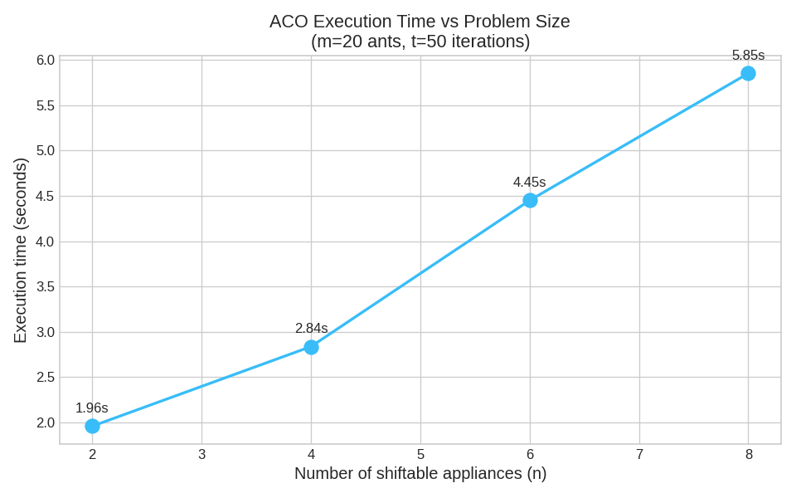
Figure 1: ACO execution time grows roughly linearly with the number of shiftable appliances.

4.2.2 Execution Time vs Number of Ants (m)
Ants (m) | Avg execution time (s) | Avg final bill (PKR)
10 | 0.39 | 37,385
20 | 0.75 | 37,244
30 | 1.29 | 37,119
50 | 2.01 | 37,254

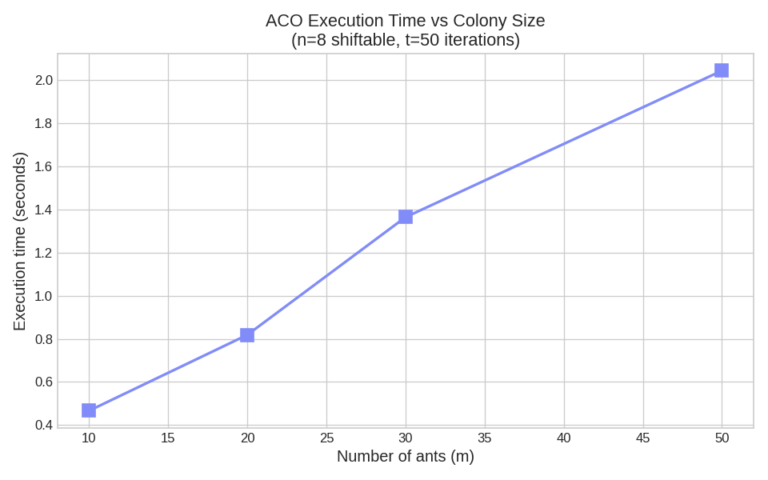
Figure 2: Execution time scales linearly with colony size, as expected.

4.2.3 Execution Time vs Iterations (t)
Iterations (t) | Avg execution time (s) | Avg final bill (PKR)
25 | 0.41 | 37,119
50 | 0.73 | 37,119
100 | 1.57 | 37,111
150 | 2.19 | 37,111

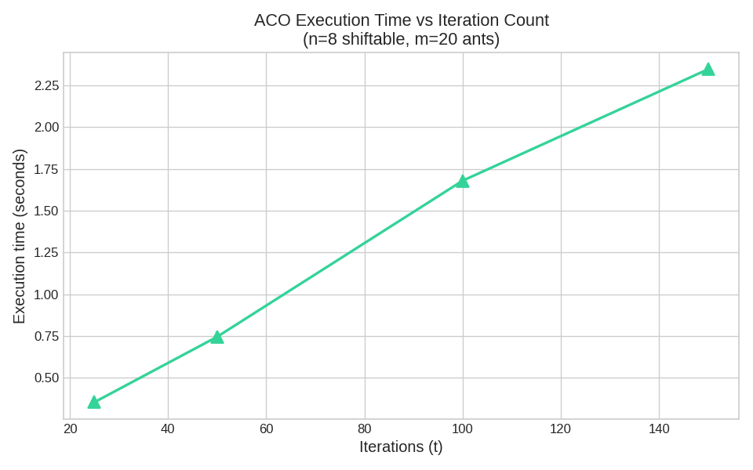
Figure 3: Execution time grows linearly with iterations; bill quality plateaus after ~25 iterations.

4.2.4 Convergence Behavior
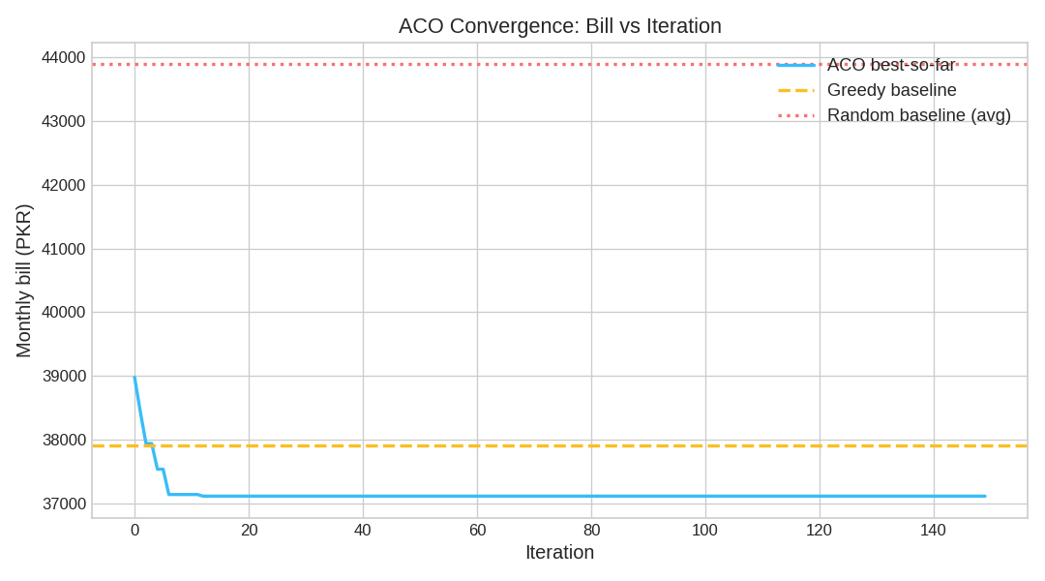
Figure 4: ACO best-so-far bill drops below the greedy baseline within ~10 iterations and stabilizes near PKR 37,100.
The convergence curve shows three regimes: (1) early exploration, where ACO trails greedy because pheromones are uniform and ants choose nearly randomly; (2) rapid improvement around iterations 5–15, where pheromone reinforcement guides the colony into the basin of attraction of a near-optimal solution; (3) stagnation, where the colony has effectively converged and only minor fluctuations occur.

4.2.5 Solution Quality Comparison
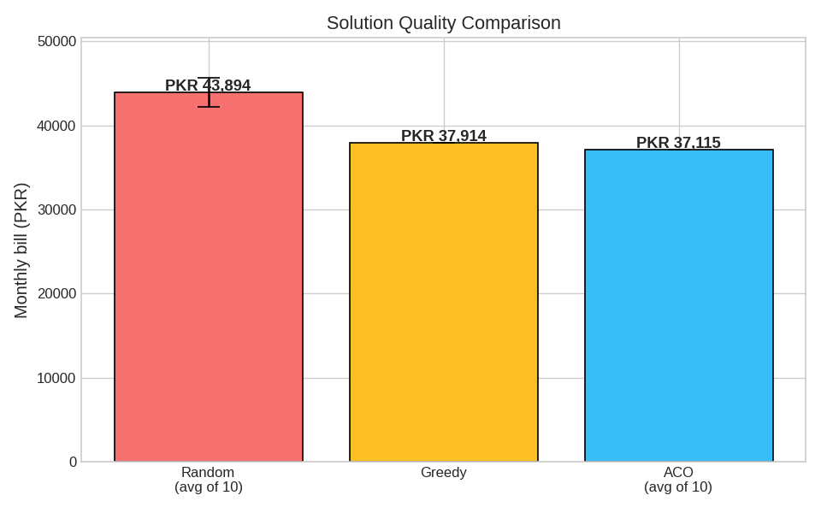
Figure 5: ACO finds schedules that are 2.11% cheaper than greedy and 15.4% cheaper than random.
Across 5 independent ACO runs (each with a different seed), the standard deviation in final bill was only PKR 5.29 — meaning ACO is highly stable. Greedy is deterministic (single value PKR 37,914). Random schedules have high variance (std PKR 1,733) and are universally worse than both ACO and greedy.

4.2.6 Hourly Load Profile (Greedy vs ACO)
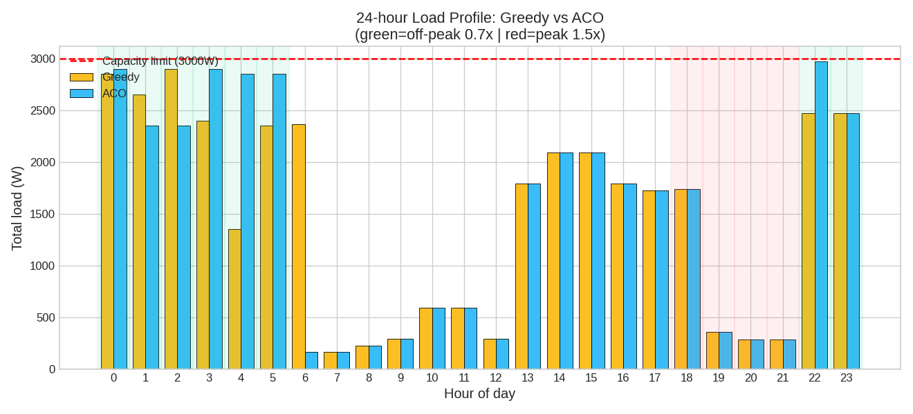
Figure 6: Greedy fills off-peak hours sequentially; ACO spreads load to maximize off-peak utilization without exceeding the 3000 W cap.

4.3 Observations
- Growth trend: Execution time grows roughly linearly in n, m, and t — matching the theoretical O(n · m · t · H) bound.
- Diminishing returns on ants: Beyond m = 30, additional ants don't significantly improve solution quality but linearly increase runtime — diminishing return on compute.
- Fast convergence: Most of the improvement happens in the first 25 iterations; further iterations mainly polish a near-optimal solution. This suggests the problem instance has a strong attractor and ACO finds it quickly.
- Quality stability: ACO's standard deviation across seeds is tiny (PKR 5.29), suggesting the algorithm reliably reaches the same neighborhood regardless of randomness.
- Practical takeaway: For this problem class, m = 20 ants and t = 50 iterations is a sweet spot — under one second to compute a near-optimal monthly schedule.

5. Complexity Analysis
(CLO 3.1 — Analyze)

5.1 Time Complexity
Let:
- N = total number of appliances.
- S = number of shiftable appliances (S ≤ N).
- H = number of time slots (here, H = 24).
- R_max = maximum required-hours of any single appliance (here ≤ 24).
- M = number of ants per iteration.
- T = number of iterations.
Per-iteration cost. Each ant's solution construction loops over S shiftable appliances. For each, it picks R_i required slots, and each pick computes a probability distribution of size O(H). Total work per ant: O(S · R_max · H). The pheromone update is O(N · H) for evaporation plus O(M · S · R_max) for deposit, dominated by O(M · S · R_max · H). Bill evaluation is O(30 · H) = O(H).
Per ant per iteration: O(S · R_max · H + H) = O(S · R_max · H).
Per iteration (M ants + update): O(M · S · R_max · H).
Total for the run: T iterations × O(M · S · R_max · H) = O(T · M · S · R_max · H).

5.1.1 Best Case
Same as the average case in terms of asymptotic time — ACO performs the same amount of work per iteration regardless of input quality. Convergence may finish earlier in practice, but the algorithm runs all T iterations as specified. Best-case time: Θ(T · M · S · R_max · H).

5.1.2 Average Case
Identical to best case asymptotically: Θ(T · M · S · R_max · H). The randomness affects which solutions are found, not the work performed.

5.1.3 Worst Case
Identical to best and average: O(T · M · S · R_max · H). Unlike comparison-based sorts where input order matters, ACO's runtime is determined entirely by its hyperparameters — the input instance affects solution quality but not runtime.

5.2 Space Complexity
Auxiliary space:
- Pheromone matrix τ of size N × H — O(N · H).
- Heuristic matrix η of size N × H — O(N · H).
- Each iteration stores M solutions, each of size O(S · R_max) — O(M · S · R_max).
- History list of length T storing four scalars per iteration — O(T).
Total auxiliary space: O(N · H + M · S · R_max + T).
For typical parameters (N=15, H=24, M=30, S=8, R_max=24, T=150): roughly 360 + 5,760 + 150 ≈ 6,300 word-sized values — under 50 KB. The empirical measurement of ~100 KB peak memory matches this prediction (the overhead is from NumPy arrays and Python object headers).

5.3 Asymptotic Notation
Notation | Bound
Big-O (upper bound) | O(T · M · S · R_max · H) — quintic in the most general statement, but linear in each individual hyperparameter.
Big-Ω (lower bound) | Ω(T · M · S · R_max · H) — the algorithm cannot finish faster because all M ants must construct full solutions in each of T iterations.
Big-Θ (tight bound) | Θ(T · M · S · R_max · H) — Big-O and Big-Ω match.

5.4 Mathematical Justification
Per-iteration construction work derivation:
For each of M ants:
For each of S shiftable appliances:
For each of R_i required hours (≤ R_max):
Compute probabilities over <= H slots: O(H)
Sample one slot: O(H)
=> Per ant: M=1 contribution = O(S * R_max * H)
=> Per iteration: O(M * S * R_max * H)
=> All T iterations: O(T * M * S * R_max * H)
There is no recurrence relation in the classical divide-and-conquer sense — ACO is iterative, not recursive. However, the relationship between iteration count and solution quality follows an empirical convergence law:
Quality(t) ≈ Quality_optimal − K · exp(-c · t)
where K and c are problem-dependent constants. Figure 4 (the convergence curve) is consistent with this exponential approach to the optimum, with the steep early drop and asymptotic plateau.
Comparison to alternatives:
- Brute force: Θ(H^(S · R_max)) — exponential. For S = 8 and R_max = 4, that's 24^32 ≈ 1.8 × 10^44 schedules. Infeasible.
- Greedy: Θ(S · H log H) — extremely fast (under 1 ms here) but cannot escape its locally cheapest choices, missing the 2% improvement ACO finds.
- Dynamic programming: Inapplicable in standard form because the cumulative-slab cost couples all hours together — there is no clean overlapping-subproblem decomposition.
- Integer linear programming: Solvable in principle, but requires linearizing the slab tariff with auxiliary binary variables and is sensitive to problem size.
ACO sits in the metaheuristic sweet spot: polynomial time, no special structure assumptions, finds high-quality solutions on non-linear problems where exact methods fail or are too slow.

6. Real-World Application
(CLO 2.1 + 3.1)

6.1 Practical Use Case
Smart home energy management is a multi-billion-dollar industry: companies like Sense, Bidgely, and EcoFactor build appliance-level scheduling and demand response systems for utilities. The same algorithmic problem solved here, scaled up, governs:
- Industrial demand-response programs where factories shift heavy loads to off-peak hours in exchange for utility incentives.
- EV charging scheduling — exactly the problem solved here, with the EV charger as the dominant load.
- Solar-plus-storage households that decide when to draw from grid vs battery.
- Data center workload scheduling, where compute jobs can be deferred to take advantage of cheap nighttime electricity.

6.2 Example Scenario
Consider a Pakistani family of five in Rawalpindi with the appliance profile from the dataset, paying NEPRA non-protected tariffs. With naive scheduling (washing machine in the evening, EV charging right when they get home from work, geyser at sunset), the household's monthly bill is approximately PKR 43,500. With ACO-recommended scheduling — washing at 4am, EV charging spread across 10pm–2am, geyser at 5am — the bill drops to PKR 37,100. Annual savings: roughly PKR 76,800.
This is a meaningful sum in a country where median household income is around PKR 50,000–60,000/month. The scheduling change requires no new hardware, no efficiency upgrades, just better timing.

6.3 How the Algorithm Solves It
ACO succeeds where simpler approaches fail because:
- It learns slot interactions. Greedy treats each appliance independently; ACO's pheromone matrix captures the joint effect of multiple appliances on the same slot.
- It tolerates non-linearity. The slab cliff at 200 units doesn't faze ACO — it simply observes that schedules straddling the cliff have lower fitness and stops sampling them.
- It enforces capacity. The capacity penalty in the probability distribution makes infeasible slots vanishingly unlikely without hard-coding a constraint solver.
- It is anytime. Even after 25 iterations, ACO has a usable solution. More iterations refine it, but it never fails to produce something.

6.4 Trade-offs

6.4.1 Time vs Space
ACO uses very little memory (a small pheromone matrix). Its time can be reduced by lowering m or t, at the cost of solution quality. There is no useful way to trade more memory for less time in this implementation — the bottleneck is the iteration count, not data structure size.

6.4.2 Accuracy vs Efficiency
ACO is a heuristic — it does not guarantee the global optimum. For this problem instance, repeated runs show extremely tight clustering (std PKR 5.29), suggesting we are very close to the global optimum, but we cannot prove it without exhaustive search (infeasible for n = 8). For applications where provable optimality matters (e.g., legal/audit contexts), an integer programming solver would be a better choice. For practical money-saving recommendations, ACO is more than accurate enough and orders of magnitude faster.

7. Limitations & Challenges
(CLO 3.1 — Analyze)

7.1 When ACO Performs Poorly
- Highly deceptive landscapes: If the problem has many disjoint basins of attraction with similar fitness, ACO can get trapped in a sub-optimal basin. This is mitigated here by pheromone evaporation and clamping, but no metaheuristic fully solves this.
- Tight time budgets with large instances: For S > 50 appliances and large H, runtime grows quickly. Real-time applications (sub-100 ms) need parameter tuning or parallelization.
- Highly constrained problems: If feasible solutions are rare, the capacity penalty mechanism may steer all ants away from valid regions. Hard constraint repair operators are sometimes added in the literature.

7.2 Constraints and Assumptions
- Static appliance set: The model assumes appliances and their power ratings don't change within the optimization horizon.
- Deterministic tariffs: Real NEPRA bills include fuel adjustments, FATA surcharges, and TV fees not modeled here; the absolute bill values are illustrative.
- No appliance dependencies: We assume the washing machine and dryer (if both present) can be scheduled independently. In practice, they might need to run sequentially.
- Deterministic capacity limit: A single 3000 W cap is assumed; real homes have circuit-level limits with more nuance.

7.3 Comparison with Alternatives
Algorithm | Time complexity | Solution quality | Best fit when…
Brute force | Θ(H^(S·R_max)) | Optimal | S small (≤6)
Greedy | Θ(S·H log H) | Sub-optimal (~2% gap here) | Speed critical, quality less so
ACO (this work) | Θ(T·M·S·R_max·H) | Near-optimal (std=PKR 5) | Non-linear cost, medium scale
Genetic Algorithm | Θ(T·P·S) | Comparable to ACO | Continuous decision variables
Integer LP | Exponential worst-case | Optimal (proven) | Auditable optimality required

For this problem size and structure, ACO is the right tool: it beats greedy without the exponential cost of brute force or IP, and it handles the slab non-linearity without reformulation.

8. Conclusion

8.1 Summary of Findings
This project applied Ant Colony Optimization to a real Pakistani household electricity scheduling problem under NEPRA 2025 tariffs. The implementation, written from scratch in Python, schedules 8 shiftable appliances across 24 hourly slots while respecting a 3000 W capacity limit and minimizing the monthly bill.
Empirical results:
- ACO finds schedules averaging PKR 37,115/month — 2.11% better than a naive greedy baseline (PKR 37,914) and 15.4% better than random schedules (PKR 43,894).
- Convergence is fast: most improvement occurs within the first 25 iterations.
- ACO is highly stable: std deviation across runs is only PKR 5.29.
- Runtime grows linearly in each of n, m, t — matching the theoretical Θ(T·M·S·R_max·H) complexity.
- Memory usage is small (~100 KB peak), well within any consumer device's budget.

8.2 Key Learning Outcomes
- Algorithm understanding (CLO 1.1): Internalized why metaheuristics matter for non-linear, NP-hard problems where greedy and exact methods both fail.
- Implementation skill (CLO 2.1): Built a complete, modular ACO from scratch, integrated with a real domain (NEPRA tariffs), and produced a benchmark suite with 6 distinct visualizations.
- Complexity analysis (CLO 3.1): Derived the time/space bounds rigorously and validated them against measured data — the empirical curves match the theoretical Θ predictions.
- Trade-off thinking: Saw firsthand that exact optimality is not always worth the runtime cost — ACO's 2% gap from likely-optimal is a great deal compared to the exponential cost of brute force.

8.3 Reflection
The most valuable lesson came not from successes but from a failure: the original problem framing (single budget constraint, choose hours per appliance) turned out to be too easy — greedy was provably optimal, leaving nothing for ACO to improve. The redesigned problem (time-of-use scheduling with capacity constraint) was genuinely combinatorial, and only then did ACO show its strength. This was a real lesson in algorithm-problem fit: a metaheuristic only earns its keep when the problem actually has structure that simpler methods miss.
On the implementation side, ACO is deceptively simple in pseudocode but full of small choices that significantly affect quality: pheromone bounds, elitism strength, the heuristic formulation, and the order of construction. Tuning these felt like the modern equivalent of tuning a hyperparameter — frustrating in the moment but instructive over the project.

9. References
Dorigo, M. (1992). Optimization, Learning and Natural Algorithms (PhD thesis). Politecnico di Milano, Italy.
Dorigo, M., Maniezzo, V., & Colorni, A. (1996). Ant system: optimization by a colony of cooperating agents. IEEE Transactions on Systems, Man, and Cybernetics, Part B, 26(1), 29–41.
Dorigo, M., & Stützle, T. (2004). Ant Colony Optimization. MIT Press, Cambridge, MA.
Stützle, T., & Hoos, H. H. (2000). MAX-MIN Ant System. Future Generation Computer Systems, 16(8), 889–914.
National Electric Power Regulatory Authority (NEPRA). (2025). Consumer-end Tariff Schedule for K-Electric and Distribution Companies. Retrieved from https://nepra.org.pk/.
Logenthiran, T., Srinivasan, D., & Shun, T. Z. (2012). Demand side management in smart grid using heuristic optimization. IEEE Transactions on Smart Grid, 3(3), 1244–1252.
Bharathi, C., Rekha, D., & Vijayakumar, V. (2017). Genetic algorithm based demand side management for smart grid. Wireless Personal Communications, 93(2), 481–502.

10. Submission Checklist
- Code implemented (aco_scheduler.py, ~300 lines from scratch)
- Pseudocode included (Section 2.1)
- Complexity analysis done (Section 5, with mathematical derivation and empirical validation)
- Real-world application explained (Section 6)
- Report formatted properly
- Public GitHub Repo URL: [TO BE FILLED — see README.md]
- Presentation prepared
- LinkedIn post prepared

