ResearchSense: A Research Information System


WAJAHAT GUL
01-134231-095
AMMAR JAMIL
01-134231-010
Supervisor: Dr. ARIF UR RAHMAN
Bachelor of Science in Computer Science
Department of Computer Science
Bahria University, Islamabad
JULY 13, 2026

Certificate
This is to certify that the Final Year Project entitled “ResearchSense: A Research Information System” has been carried out by the undersigned students under our supervision. The work presented in this report was completed at the Department of Computer Science, Bahria University, Islamabad, in partial fulfilment of the requirements for the degree of Bachelor of Science in Computer Science. In our opinion, the work is adequate in scope and quality for the said degree.

Wajahat Gul (01-134231-095)
Ammar Jamil (01-134231-010)
_______________________________
Supervisor: Dr. Arif Ur Rahman
_______________________________
Head of Department
Department of Computer Science, Bahria University, Islamabad

Abstract
Research is one of the core functions of a university, yet the record of that research is often scattered across faculty pages, external scholarly indexes, and personal profiles. ResearchSense is a web-based research information system built for Bahria University that brings this record into one clear, searchable place. It covers the faculty of every department across the university's four teaching campuses, namely Islamabad (E-8), Islamabad (H-11), Karachi, and Lahore, with 358 researcher profiles from 22 departments and more than 1,600 real publications matched from open scholarly databases including OpenAlex, Semantic Scholar, and Crossref.
The system offers researcher profiles, a filterable publication catalogue, research areas derived from each researcher's own published work, sample projects, a collaboration finder that combines real co-authorship evidence with shared research topics, and an analytics dashboard of publication and citation trends that also breaks output down by department and by international against domestic collaboration. A faculty portal lets a researcher claim their profile with a verified ORCID identity and submit new publications, which are held for administrator approval before they appear, as well as upload papers. A grounded, retrieval-augmented research assistant answers plain-language questions strictly from the indexed records and the full text of uploaded papers; when its records do not cover a question it says so and points the user to where to look, rather than inventing an answer.
The client is a React and TypeScript single-page application and the server is a FastAPI service organised into routers, services, and repositories. Read-only research records live in structured JSON behind a repository boundary, while mutable data such as accounts and uploads live in SQLite, so a full relational database can be adopted later without a rewrite. The result is a complete, working portal that makes the research strength of a campus visible, searchable, and conversational at zero running cost.

Acknowledgments
We are deeply grateful to Allah Almighty for granting us the strength, patience, and clarity to bring this Final Year Project to completion. We extend our sincere gratitude to our supervisor, Dr. Arif Ur Rahman, for his constant guidance, constructive feedback, and encouragement at every stage of this work. We also thank the faculty of the Department of Computer Science at Bahria University, Islamabad, whose teaching over the past four years prepared us for a project of this scope. Finally, we thank our families and friends for their unconditional support and patience throughout this journey.

Contents
Certificate 2
Abstract 3
Acknowledgments 4
Chapter 1 Introduction 10
1.1 Project Background and Overview 10
1.2 Problem Description 10
1.3 Project Objectives 11
1.4 Project Scope 11
Chapter 2 Literature Review 13
2.1 Overview 13
2.2 Existing Research Portals and Tools 13
2.3 Comparison of Existing Systems 14
2.4 Gaps and the Need for ResearchSense 14
2.5 References 15
Chapter 3 Requirement Specifications 16
3.1 Existing System 16
3.2 Proposed System 16
3.3 Functional Requirements 16
3.4 Non-Functional Requirements 17
3.5 Use Cases 18
Chapter 4 Design 20
4.1 System Architecture 20
4.2 Design Constraints 21
4.3 Design Methodology 22
4.4 High Level Design 22
4.5 Low Level Design 23
4.6 Database Design 25
4.7 GUI Design 26
4.8 External Interfaces 32

List of Figures
3.1 Use case diagram of ResearchSense 19
4.1 Three-tier system architecture of ResearchSense 21
4.2 Component diagram of the frontend and backend modules 23
4.3 Sequence diagram of the grounded assistant question flow 24
4.4 Sequence diagram of the ORCID-verified profile claim flow 25
4.5 Entity relationship diagram of the research corpus and account store 26
4.6 Home page with search, live counts, and featured researchers 26
4.7 Researcher directory with campus, department, and topic filters 27
4.8 Researcher profile with publications and suggested collaborators 27
4.9 Publications catalogue with filters 28
4.10 Research areas overview 28
4.11 Sample projects with their topic and lead researcher 29
4.12 Collaboration finder 30
4.13 Analytics dashboard 30
4.14 Ask ResearchSense, the grounded research assistant 31
4.15 Shared paper library 31
4.16 Faculty portal with claim, login, and admin views 32
4.17 System context diagram of the external interfaces 33

List of Tables
2.1 Existing research information systems compared 14

Acronyms and Abbreviations
API | Application Programming Interface
CSV | Comma-Separated Values
DOI | Digital Object Identifier
ERD | Entity Relationship Diagram
FYP | Final Year Project
HTTP | Hypertext Transfer Protocol
JSON | JavaScript Object Notation
JWT | JSON Web Token
LLM | Large Language Model
ORCID | Open Researcher and Contributor ID
PBKDF2 | Password-Based Key Derivation Function 2
PDF | Portable Document Format
RAG | Retrieval-Augmented Generation
REST | Representational State Transfer
SPA | Single Page Application
SQL | Structured Query Language
UI | User Interface
UML | Unified Modeling Language
URL | Uniform Resource Locator

Chapter 1
Introduction

1.1 Project Background and Overview
Research is one of the main tasks of any university. Faculty members write papers, lead research projects, and guide students into new areas of study. Over time this activity produces a large body of information: who works on which topic, what has been published, which projects are under way, and which researchers work together. When this information is easy to find, students can locate supervisors, researchers can find collaborators, and the university can present its research strength to the outside world.
At present, the research record of the Bahria University is hard to view as a whole. Faculty details sit on one set of pages, spread across separate campus directories. Publications are indexed in external scholarly databases under many name variants. Funded projects are recorded in internal documents. No single place connects a researcher to their papers, their topics, and their potential collaborators, and no tool answers a plain question such as “who works on computer vision at the Karachi campus?” without manual searching across several sites.
ResearchSense is a research information system that solves this problem. It collects the profiles of the faculty of every department across all four teaching campuses, their publications, the topics they work on, and their projects into one portal. On top of this record it adds search and filters, an analytics dashboard, a collaboration finder, a faculty portal for self-service updates, and a grounded conversational assistant that answers questions strictly from the indexed records. The system was built end to end as a Final Year Project and runs at zero cost using free and open-source services.

1.2 Problem Description
The main problem is that research information at the university is scattered and hard to search. This creates several smaller problems.
First, students and new researchers cannot easily find a supervisor or a partner who shares their interests. They have to ask around or read many separate pages by hand. Second, the university cannot easily measure or present its research output; simple questions about publication trends or cross-campus collaboration require manual data collection. Third, faculty members have no convenient way to keep their own record current, so profiles go stale. Fourth, the knowledge locked inside published papers is not reachable through a normal search box: finding out what a paper actually says still means downloading and reading it.
ResearchSense is built to remove these gaps by placing all the information in one searchable and connected system, by letting faculty members maintain their own verified profiles, and by adding an assistant that can read the indexed records and papers and answer questions about them in plain language.

1.3 Project Objectives
The objectives of the project are listed below.
- Build one web portal that shows researcher profiles, publications, research areas, and sample projects for the whole university.
- Make the information easy to search and filter by name, department, designation, topic, campus, and year.
- Show the research strength of the university through live counts, featured profiles, and an analytics dashboard of trends over time.
- Suggest possible collaborators by combining real co-authored publications with shared research topics, and let a visitor filter suggestions by campus.
- Provide a grounded assistant that answers plain-language questions using only the system's own records, points the user to the right people, papers, and areas, and declines to answer when its records do not support an answer.
- Let a faculty member claim their own profile with a verified ORCID identity, sign in, add new publications, and upload papers for the assistant to read.
- Give an administrator a simple way to review accounts and refresh the underlying research data on demand.
- Keep the read-only research records behind a clear repository boundary so that a full relational database can be added later without a rewrite.

1.4 Project Scope
ResearchSense delivers a complete, working portal together with a grounded conversational assistant. The data for this version comes from the real faculty directory of the university across every department, scraped and cleaned into 358 researcher profiles from 22 departments, and from open scholarly databases (OpenAlex, with Semantic Scholar and Crossref as further sources), from which more than 1,600 real publications were matched to those researchers with a field-overlap guard against same-name authors. Sample project records carry no funding figures and are clearly flagged as examples.
Within this scope, faculty members can claim their profile using their ORCID identifier, which is checked against the public ORCID registry so that a profile can only be claimed by its real owner. A signed-in member can submit publications by DOI or by hand, upload their own papers, and add papers of interest to a shared library. Open-access PDFs are also fetched automatically per researcher from OpenAlex and Semantic Scholar, chunked, and embedded locally so the assistant can answer questions about their full text. An administrator can review and activate or deactivate accounts and trigger a data refresh; a background task also refreshes publications and the index every seven days.
The following items are left for future work and are not part of this version: a full relational database for the read-only research corpus (which currently lives in structured JSON behind the repository boundary), integration with the university's official authentication system, coverage of faculties beyond computing, and a native mobile application. The system is a web application designed to work well on both desktop and mobile browsers.

Chapter 2
Literature Review

2.1 Overview
A literature review looks at systems that solve a similar problem, studies what they do well, and finds the gaps that a new project can fill. Research information systems are a mature product category, so this chapter reviews the leading commercial system, the leading open-source system, the public scholarly profile services, a representative university-built portal, and the recent line of research on retrieval-augmented generation that makes a grounded research assistant possible.

2.2 Existing Research Portals and Tools
Elsevier Pure [1] is a widely used commercial research information system. It gathers profiles, publications, and activities for a university and presents them through a polished public portal. It is powerful and well integrated with Elsevier's own indexes, but it is a paid product with a significant licence cost and a heavy deployment process, which puts it out of reach for a single campus or a student project.
VIVO [3] is an open-source system that stores research information as linked data. It is flexible and free, but it needs real technical effort to install, populate, and maintain, and its interface reflects its age. It solves data storage and interchange well but leaves discovery features, such as collaborator suggestion or conversational search, to the adopter.
ORCID [4] and Google Scholar solve a related but different problem. They give each researcher a personal identifier and a list of papers. They are useful building blocks, and ResearchSense itself uses ORCID for identity verification, but they are organised around the individual, not the institution, so they cannot show the combined research strength of one university or connect its people to each other.
Some universities build their own portals. A clear example is the research portal of Nazarbayev University [2], which presents profiles, research output, and projects through a modern interface backed by Pure. It shows what a university-scale portal should look like, while also showing the dependence of such portals on expensive commercial back-ends.
A separate line of recent work looks at retrieval-augmented generation (RAG), a method where a language model answers a question using text retrieved from a document collection rather than from its own memory. Lewis et al. [8] showed that this design grounds the model's answers in the supplied text and reduces invented facts. Later practice added confidence gates that make the system refuse when retrieval finds nothing relevant. This is the technique behind the ResearchSense assistant.

2.3 Comparison of Existing Systems
Table 2.1 compares the reviewed systems along the dimensions that matter for a single-campus deployment.
Dimension | Elsevier Pure | VIVO | ORCID / Scholar | ResearchSense (proposed)
Cost | High licence fee | Free, high setup effort | Free | Free end to end
Scope | Institution | Institution | Individual | Institution (campus)
Modern portal UI | Yes | Dated | Basic profile pages | Yes
Collaborator discovery | Limited | No | No | Co-authorship + shared topics
Analytics dashboard | Yes | No | Citations only | Yes, live from data
Grounded Q&A assistant | No | No | No | Yes, refuses when unsupported
Faculty self-service | Yes | Manual | Yes (own profile) | Yes, ORCID-verified claim
Table 2.1: Existing research information systems compared.

2.4 Gaps and the Need for ResearchSense
From this review three points stand out. The paid systems are strong but costly and heavy for a single campus. The free systems are open but need real technical investment and still lack modern discovery features. The profile services are personal, not institutional. None of the reviewed systems, in their base form, combines real co-authorship evidence with shared research topics to suggest collaborators, and none offers a conversational assistant that is grounded in the institution's own records and papers.
ResearchSense aims to fill this gap. It offers a clean, modern portal shaped for one university, it links researchers by shared topics and by real co-authorship, it lets faculty members maintain a verified profile, and it adds a retrieval-augmented assistant that answers only from the indexed records and declines otherwise, all of it built from free and open-source components.

2.5 References
[1] Elsevier. Pure Research Information Management System. Elsevier B.V. Available: elsevier.com/solutions/pure
[2] Nazarbayev University. NU Research Portal. Available: research.nu.edu.kz
[3] VIVO Project. VIVO: Open Source Research Networking Software. Available: vivoweb.org
[4] ORCID. Connecting Research and Researchers. Available: orcid.org
[5] DuraSpace. DSpace Repository Software. Available: dspace.org
[6] Bahria University. Faculty Directory. Available: bahria.edu.pk
[7] OpenAlex. An Open Catalog of Scholarly Works. Available: openalex.org
[8] P. Lewis et al., “Retrieval-Augmented Generation for Knowledge-Intensive NLP Tasks,” Advances in Neural Information Processing Systems, vol. 33, 2020.

Chapter 3
Requirement Specifications

3.1 Existing System
The existing way of sharing research information at the university is made of separate parts. Faculty names and titles appear on department web pages, maintained separately per campus. Publications appear in external scholarly indexes under several variants of each author's name. Funded projects are recorded in internal documents that visitors cannot see. A researcher's personal page, when one exists, is updated by hand and often out of date.
This existing setup has clear drawbacks. The information is spread out, so a full view is missing. Search is weak or absent, so finding a person by topic means reading pages one by one. There is no view of collaboration, no analytics, and no way to ask a question in plain language. Nothing connects a researcher to the full text of their papers.

3.2 Proposed System
The proposed system, ResearchSense, replaces the scattered setup with one connected portal. It stores researchers, publications, topics, and projects as linked records, presents them through a modern searchable interface, and keeps them current through automated refresh and faculty self-service. It adds features the existing setup cannot offer: live counts and analytics, ranked collaborator suggestions, an ORCID-verified faculty portal, and a grounded assistant that answers questions from the records and the full text of indexed papers.

3.3 Functional Requirements
The functional requirements describe what the system must do.
- The system shall show a home page with search, live counts, featured researchers, and a list of research areas.
- The system shall list all researchers and allow filtering by department, designation, campus, and topic, and searching by name.
- The system shall show a full profile for each researcher, including biography, research areas, publications, and suggested collaborators.
- The system shall list publications and allow filtering by year and topic and searching by title, and shall let a user open the paper itself or ask the assistant about it.
- The system shall list research areas and show how many publications and researchers belong to each area.
- The system shall list sample projects with their lead researcher and topic, clearly marked as examples that carry no funding figures.
- The system shall show a collaboration view that ranks suggested collaborators for a chosen researcher, first by real co-authored publications and then by shared topics, filterable by campus.
- The system shall show an analytics dashboard of publication counts over time by campus, citation growth, leading venues, and cross-campus collaboration.
- The system shall let a faculty member claim their profile using an ORCID identifier that is checked against the public ORCID registry, choose a password, and sign in.
- The system shall let a signed-in faculty member submit a new publication by DOI, with details fetched automatically and authorship verified before the record is added.
- The system shall let a signed-in faculty member submit a publication by hand when no DOI exists, recording the same core details.
- The system shall let a signed-in faculty member upload their own paper so the assistant can read and answer questions about its full text.
- The system shall let a signed-in faculty member add any paper of interest to a shared library, by DOI or by upload, for the assistant to read.
- The system shall let an administrator sign in separately, view and activate or deactivate accounts, and trigger a refresh of the research data and the assistant's index.
- The system shall provide an assistant that accepts a plain question and returns an answer with links to relevant people, papers, and areas, using only the system's own records.
- The assistant shall decline to answer a question that its records do not support, rather than inventing an answer.
- The assistant shall answer authorship and collaboration questions (who wrote a paper; whether two researchers have worked together) directly from the records.

3.4 Non-Functional Requirements
The non-functional requirements describe the quality goals of the system.
- Usability: the portal shall be clear and easy to use on both desktop and mobile screens.
- Performance: pages shall load quickly, and repeated data shall be cached on the client to avoid redundant requests.
- Maintainability: the code shall be split into small focused files, with the interface, the logic, and the data access kept separate.
- Portability: the system shall run in any modern web browser without special software on the user's side.
- Extensibility: the read-only research data shall sit behind a repository boundary so a full relational database can be added later with little change elsewhere.
- Reliability: when a service cannot be reached, the interface shall show a clear message instead of failing silently.
- Security: a profile shall only be claimed after its owner's ORCID identity has been verified; passwords shall be stored as salted PBKDF2 hashes; sessions shall use signed JWT tokens.
- Trustworthiness: the assistant shall only state facts present in the system's own records and shall say so plainly when a question falls outside them.

3.5 Use Cases
The main users of the system are the visitor (a student, a faculty member browsing anonymously, or an outside guest), the signed-in faculty member, and the administrator. Figure 3.1 shows the use case diagram of the system; the faculty member's publication and upload actions include a signed-in session, which in turn extends from the one-time profile claim.
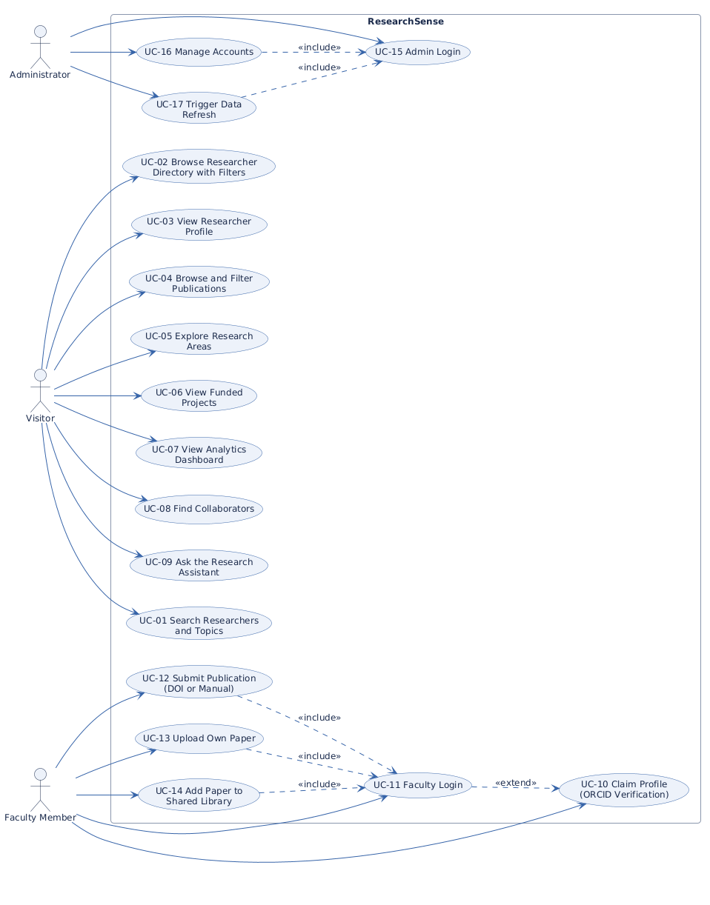
Figure 3.1: Use case diagram of ResearchSense
The visitor can search researchers and topics, browse the researcher directory with filters, open a full researcher profile, browse and filter publications, explore research areas, view sample projects, view the analytics dashboard, find collaborators for a chosen researcher, and ask the research assistant a question. The faculty member additionally claims their profile through ORCID verification, signs in, submits publications by DOI or by hand, uploads their own papers, and adds papers to the shared library. The administrator signs in separately, manages accounts, and triggers a refresh of the data and the assistant's index.

Chapter 4
Design

4.1 System Architecture
ResearchSense follows a three-layer client and server architecture, shown in Figure 4.1. The presentation layer is a single-page web application built with React and TypeScript. The application layer is a FastAPI service in Python, organised so that every request flows through the same path: a router receives the request, a service applies the business logic, and a repository reads or writes the data. The data layer holds the read-only research corpus in structured JSON, the mutable account and upload records in SQLite, and the assistant's vector index of embedded paper text.
A separate part of the application layer supports the assistant. A retrieval component turns the research corpus and the text of indexed papers into searchable passages and finds the passages closest in meaning to a user's question. A generation component sends only those passages to a hosted language model with a strict context-only prompt, so the answer is grounded in the system's own records. External services, namely the OpenAlex, Semantic Scholar, and Crossref scholarly databases, the ORCID registry, and the Groq LLM API, are reached only from the service layer.
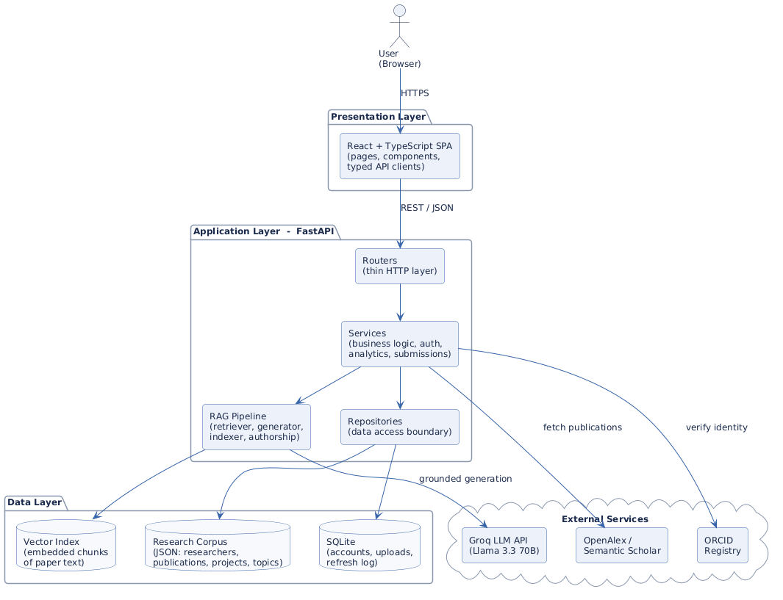
Figure 4.1: Three-tier system architecture of ResearchSense

4.2 Design Constraints
The design works within a few constraints. Publications are real and come from open scholarly databases including OpenAlex, Semantic Scholar, and Crossref, matched to university-affiliated authors with a field-overlap guard, and supplemented by publications that faculty members submit themselves once authorship has been verified; the quality of the record is therefore bounded by the coverage of the public index. Sample project records carry no funding figures and are clearly flagged as examples.
The assistant depends on a hosted large language model reached over the internet for the generative part of its answers, so a question can only be answered generatively while that service is reachable; the free tier of the service also caps request rates. To reduce this dependence, embedding is done locally on the CPU with an open-source model, direct authorship and collaboration questions are answered from the records without the language model, and the retrieval gate fails safely by declining to answer. A further constraint is set by the team itself: every source file stays small, with one clear purpose, which shapes how pages and server modules are divided.

4.3 Design Methodology
The project uses an object-based and component-based methodology. On the server, each resource (researcher, publication, topic, project, account, and library paper) has its own schema, service, and repository. On the client, the interface is built from small reusable components composed into pages, and every server call goes through a typed API client so the two sides agree on the shape of the data.
The guiding ideas are separation of concerns, loose coupling, and high cohesion. Separation of concerns means each part has one job: routers translate HTTP, services hold rules, repositories touch data. Loose coupling means parts depend on each other as little as possible, so the JSON corpus can later be replaced by a relational database without touching the services above it. High cohesion means the pieces inside one module all serve that module's single purpose. Development itself proceeded iteratively: the data pipeline first, then the portal pages, then the faculty portal and administration, and finally the assistant.

4.4 High Level Design
At a high level the system has four groups of parts, shown in the component diagram of Figure 4.2. The first group is the client interface: the pages, the shared components, and the typed API clients with their mirrored type definitions. The second group is the server logic: the routers and the services, with Pydantic schemas forming the contract between the two sides. The third group is the assistant's RAG services: indexer, retriever, generator, and the direct authorship answerer. The fourth group is storage: the JSON corpus, the SQLite database, and the vector index.
A typical request moves through these groups in a simple path. The user opens a page; the page calls a typed API function; the function sends a request to a router; the router calls a service; the service calls a repository, or the RAG pipeline for a question to the assistant, and the response flows back up the same path as JSON that the client already knows the shape of.
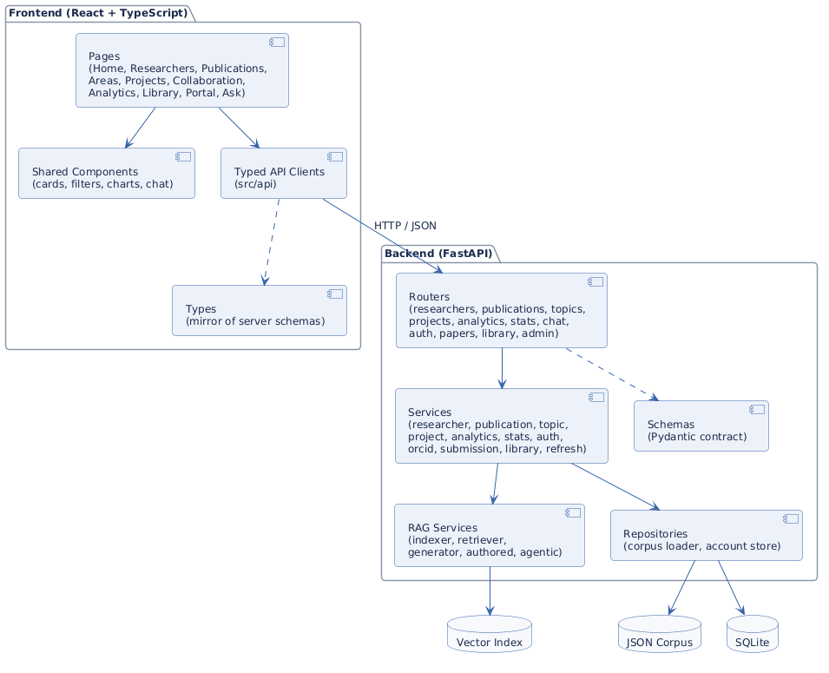
Figure 4.2: Component diagram of the frontend and backend modules

4.5 Low Level Design
At a low level each group is broken into focused files. On the server, schemas define the data shapes as Pydantic models; services contain the rules, such as how to filter a list, how to score a suggested collaborator, or how to verify authorship of a submitted DOI; repositories are the only code that touches a data source. On the client, types mirror the server schemas, pages set the layout of each screen, and components such as the researcher card and the stat card are small and reused across pages.
The two most operationally significant flows are shown as sequence diagrams. Figure 4.3 traces a question to the research assistant. The chat service first checks whether the question can be answered directly from the records (authorship and collaboration questions); otherwise the retriever embeds the query, ranks the indexed passages, and applies a confidence gate. Only confident retrievals reach the generator, which prompts the hosted model with the retrieved context alone, at temperature zero; a low-confidence retrieval produces an honest refusal instead of an invented answer.
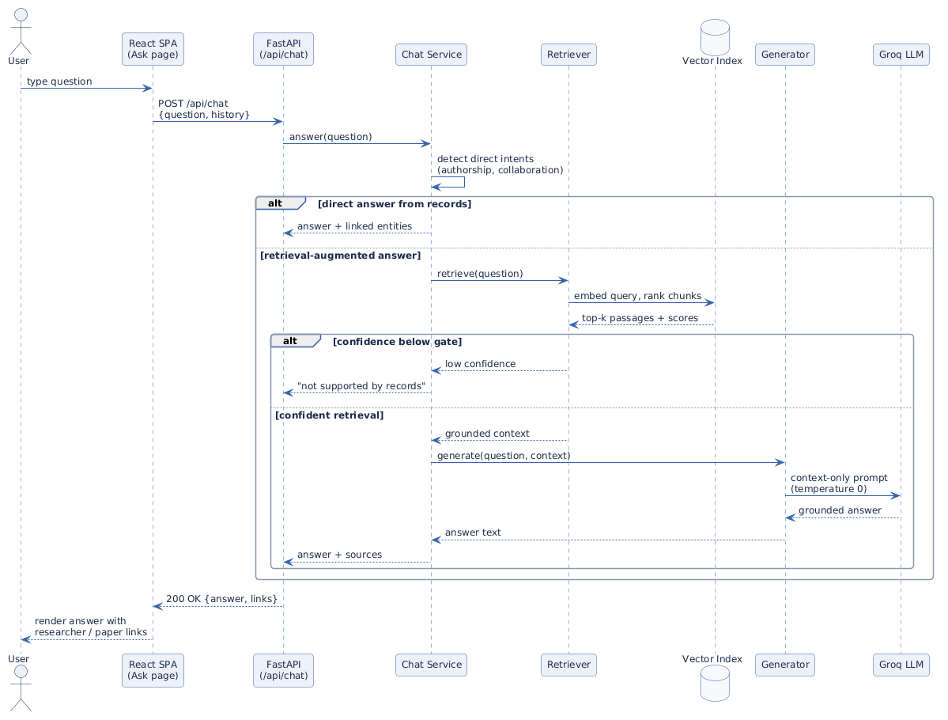
Figure 4.3: Sequence diagram of the grounded assistant question flow
Figure 4.4 traces the profile-claim flow of the faculty portal. The auth service verifies the claimed ORCID iD against the public ORCID registry and compares the registered name with the selected researcher profile. Only on a successful match is the password hashed with PBKDF2 and a salt, the account row created in SQLite, and a signed JWT issued for the session; the profile then shows a “claimed” badge.
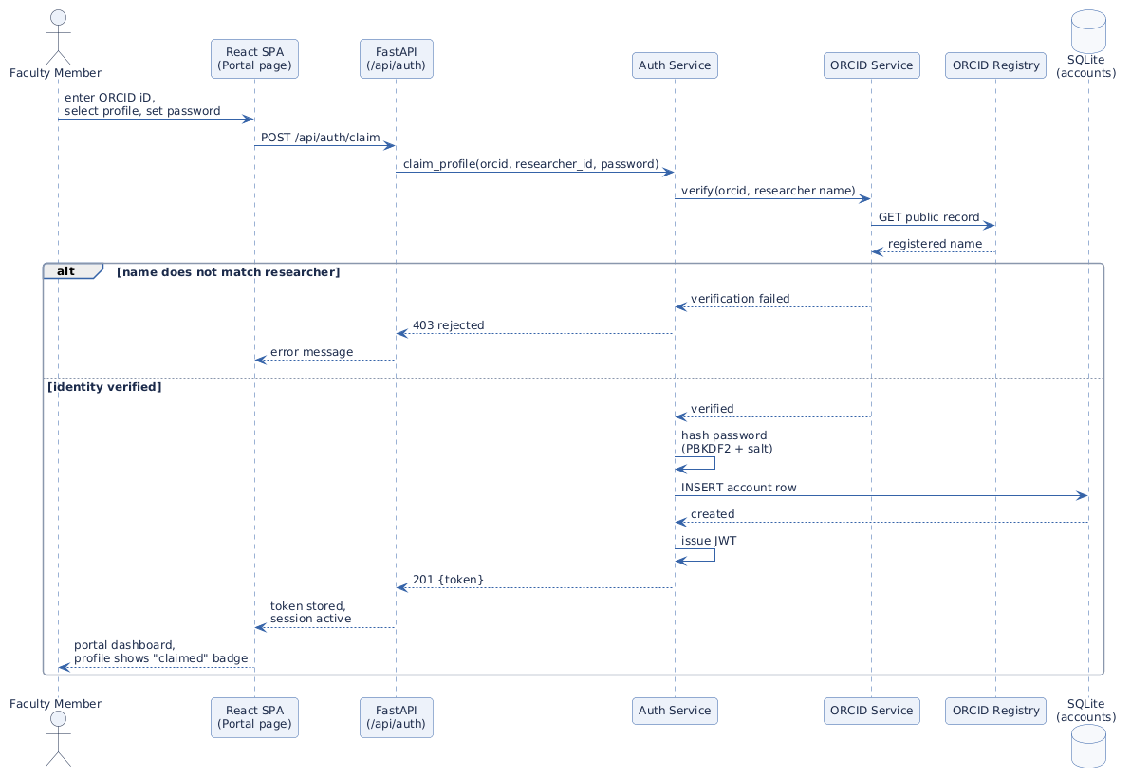
Figure 4.4: Sequence diagram of the ORCID-verified profile claim flow

4.6 Database Design
ResearchSense uses two kinds of storage today, designed under one entity-relationship model, shown in Figure 4.5. The read-only research corpus (researchers, publications, topics, and projects) follows the relational shape even though it currently lives in structured JSON files behind the repository boundary, so a full relational database can adopt the same schema later without redesign. The mutable data, that is accounts, uploads, and the refresh log, already lives in a real SQLite database.
A researcher writes many publications and a publication has many authors, so authorship is a many-to-many association that also carries the co-authorship signal used by the collaboration finder. Researchers, publications, and projects are each tagged with topics. A project is led by one researcher as principal investigator. An account belongs to exactly one researcher, keyed by the verified ORCID iD, and an upload belongs to the researcher who submitted it.
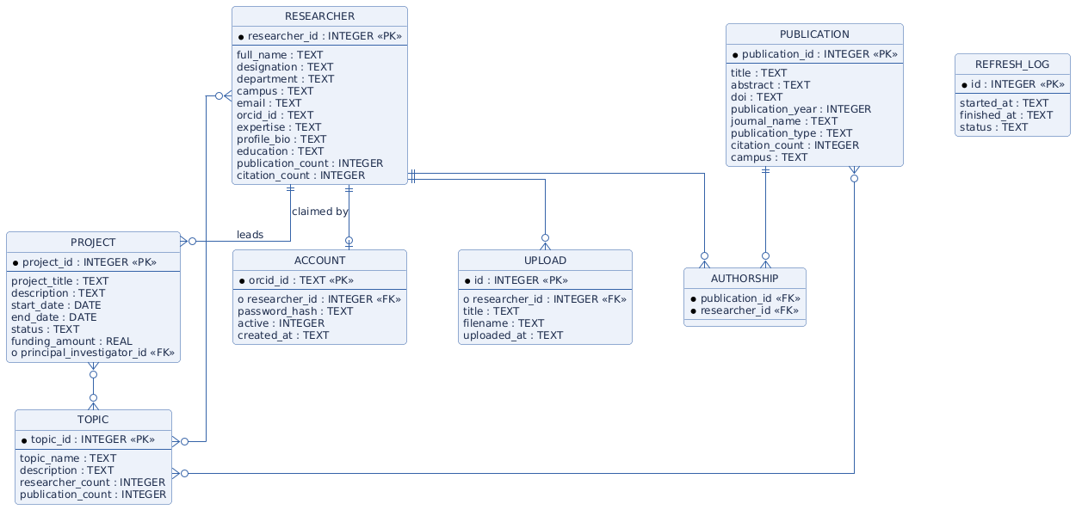
Figure 4.5: Entity relationship diagram of the research corpus and account store

4.7 GUI Design
The interface follows the style of a clean university research portal, carrying the navy-and-gold identity of the Bahria University. The screenshots below are captured from the running system. The home page (Figure 4.6) opens with a search area, live counts, featured researchers, and the list of research areas.
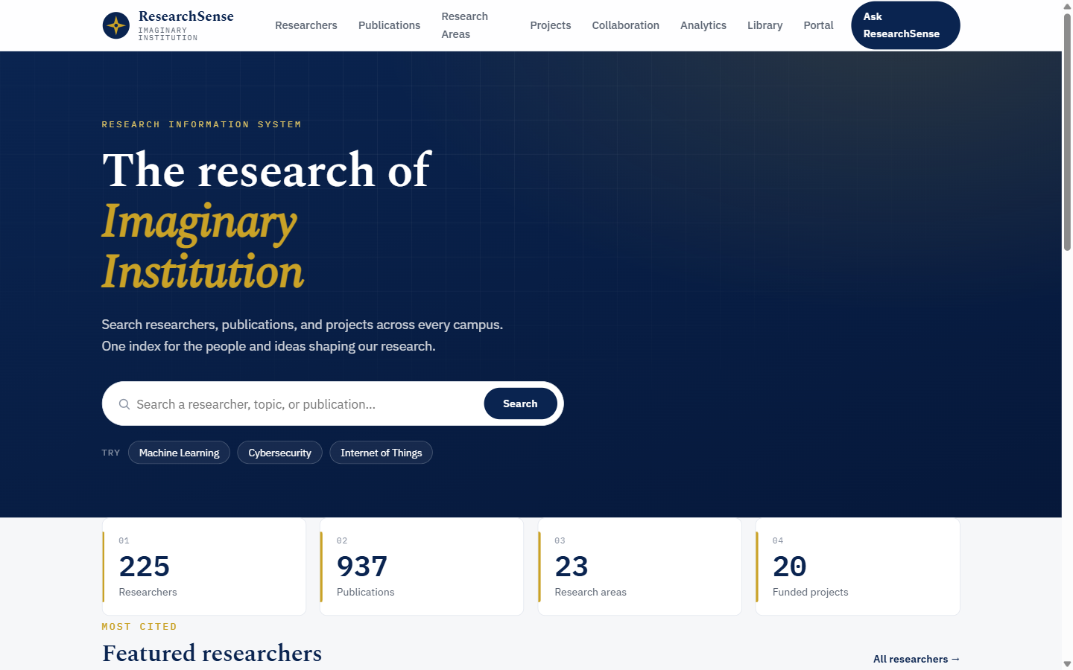
Figure 4.6: Home page with search, live counts, and featured researchers
The researcher directory (Figure 4.7) shows filterable, searchable cards. A profile page (Figure 4.8) presents one researcher's biography, research areas, publications, education, and suggested collaborators.
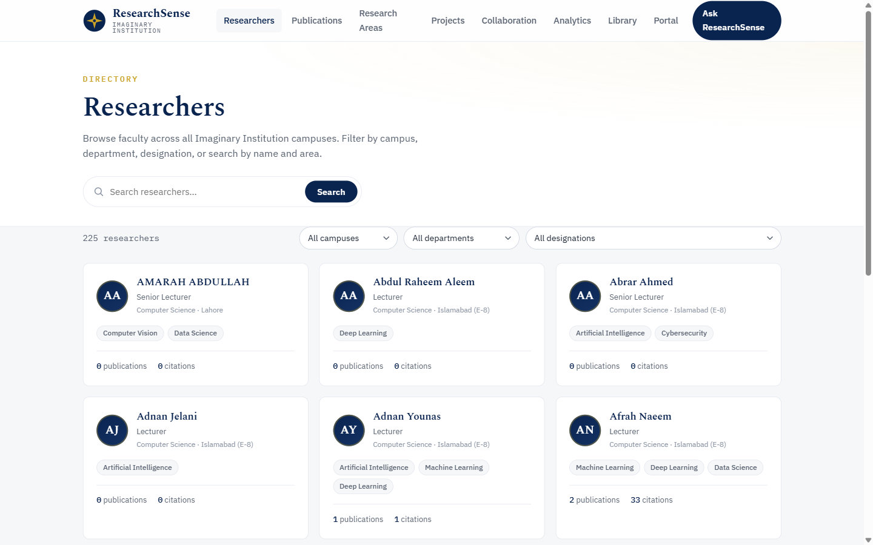
Figure 4.7: Researcher directory with campus, department, and topic filters
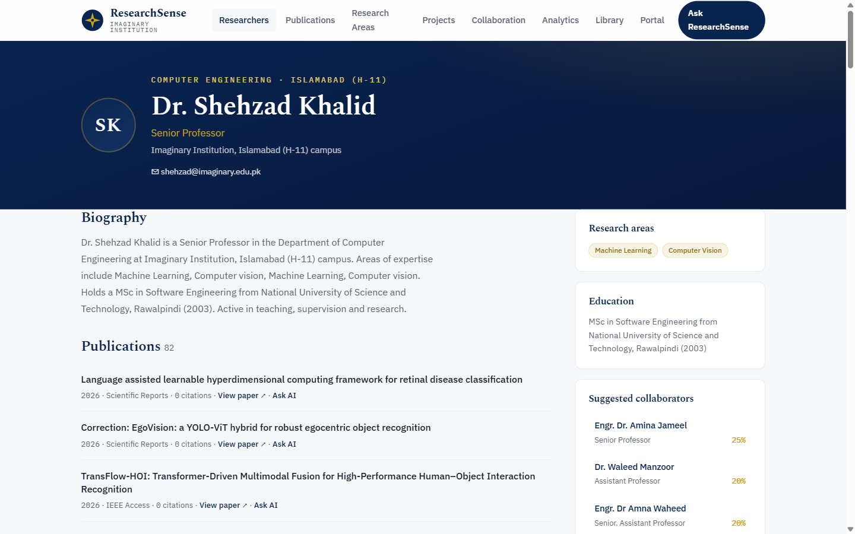
Figure 4.8: Researcher profile with publications and suggested collaborators
The publications catalogue (Figure 4.9) supports search and year and topic filters, and every entry links to the paper itself and to the assistant. The research areas page (Figure 4.10) and the sample projects page (Figure 4.11) organise the record by topic.
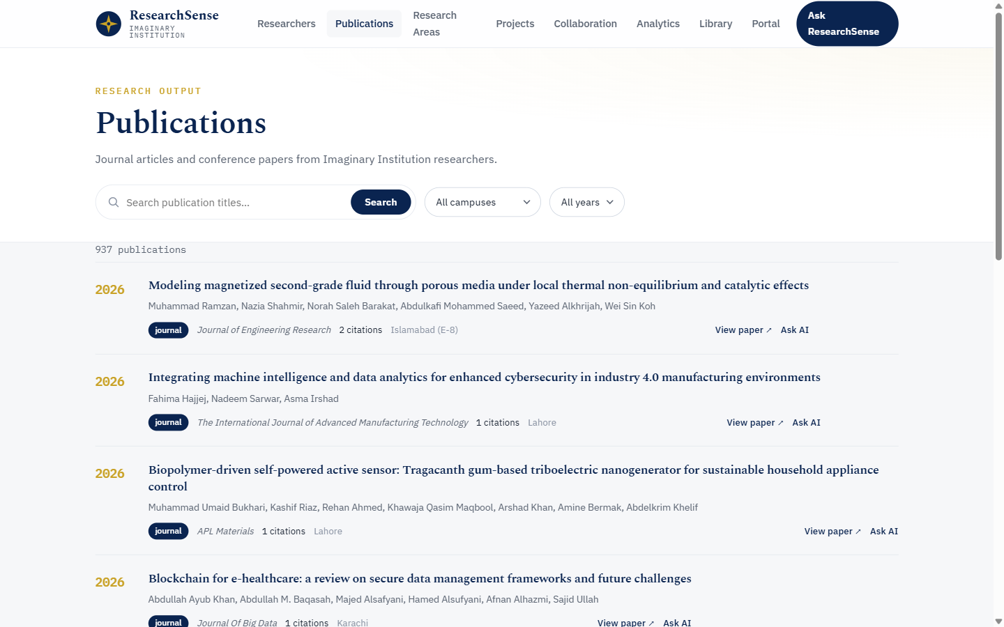
Figure 4.9: Publications catalogue with filters
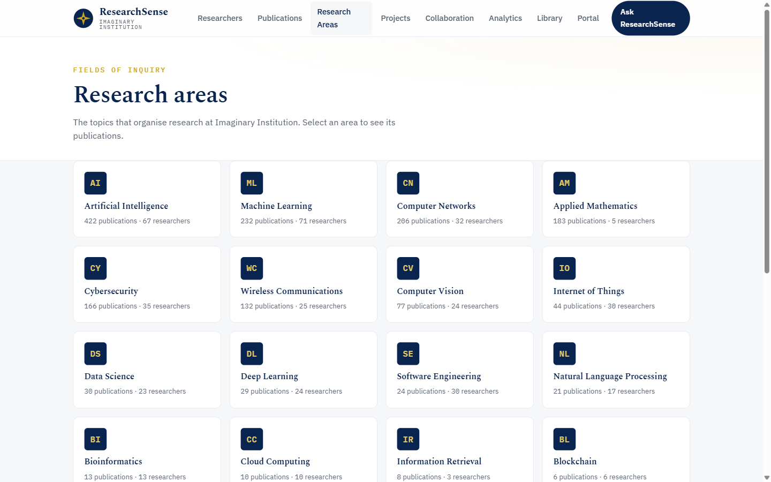
Figure 4.10: Research areas overview
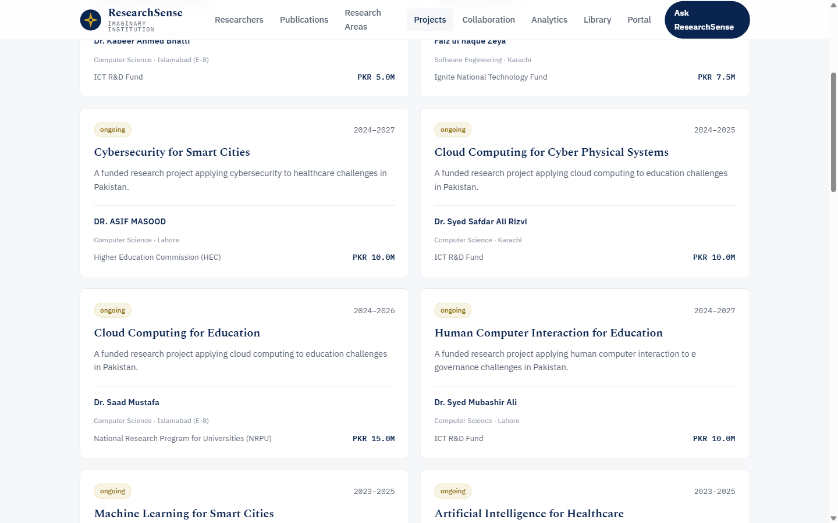
Figure 4.11: Sample projects with their topic and lead researcher
The collaboration finder (Figure 4.12) ranks suggested partners for a chosen researcher by co-authorship and shared topics. The analytics dashboard (Figure 4.13) charts publications per year by campus, citation growth, top venues, and cross-campus collaboration, computed live from the data.
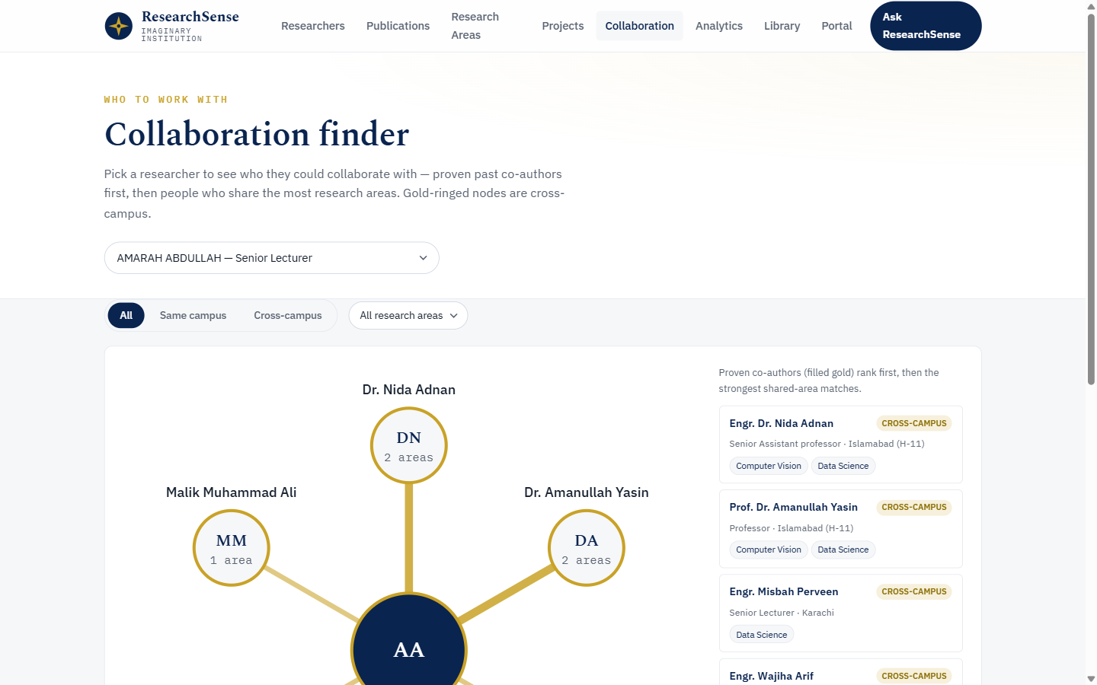
Figure 4.12: Collaboration finder
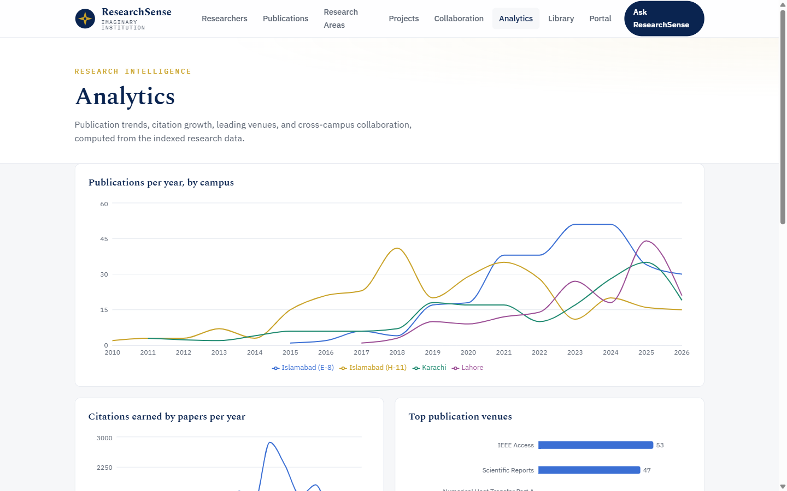
Figure 4.13: Analytics dashboard
The assistant page (Figure 4.14) hosts the grounded chat interface with suggested questions. The shared library (Figure 4.15) lists the papers the assistant can read. The faculty portal (Figure 4.16) carries the ORCID-based claim, login, and admin entry points.
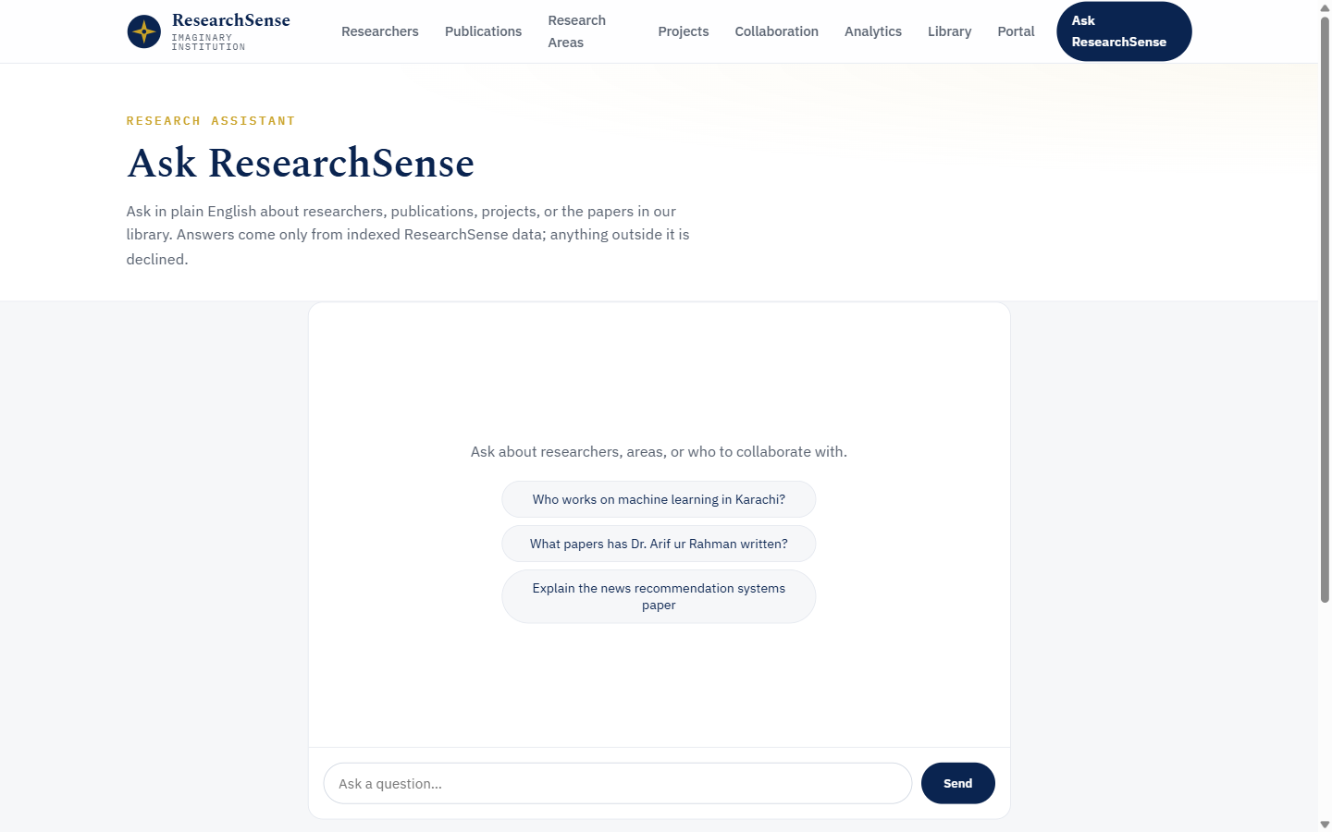
Figure 4.14: Ask ResearchSense, the grounded research assistant
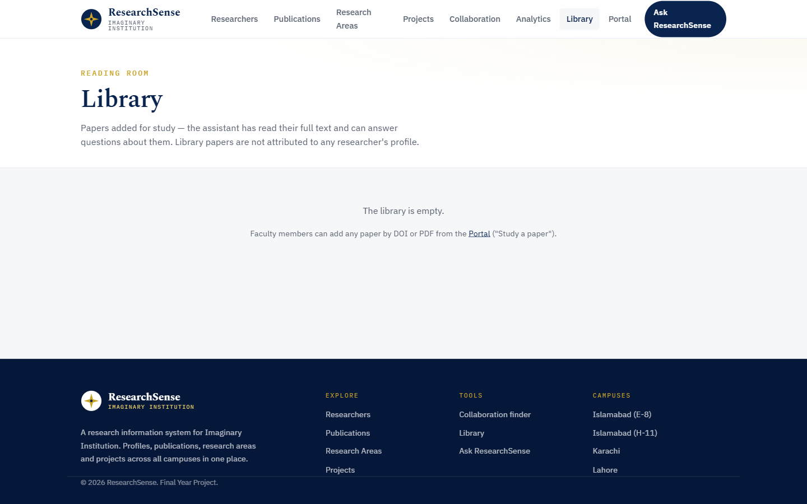
Figure 4.15: Shared paper library
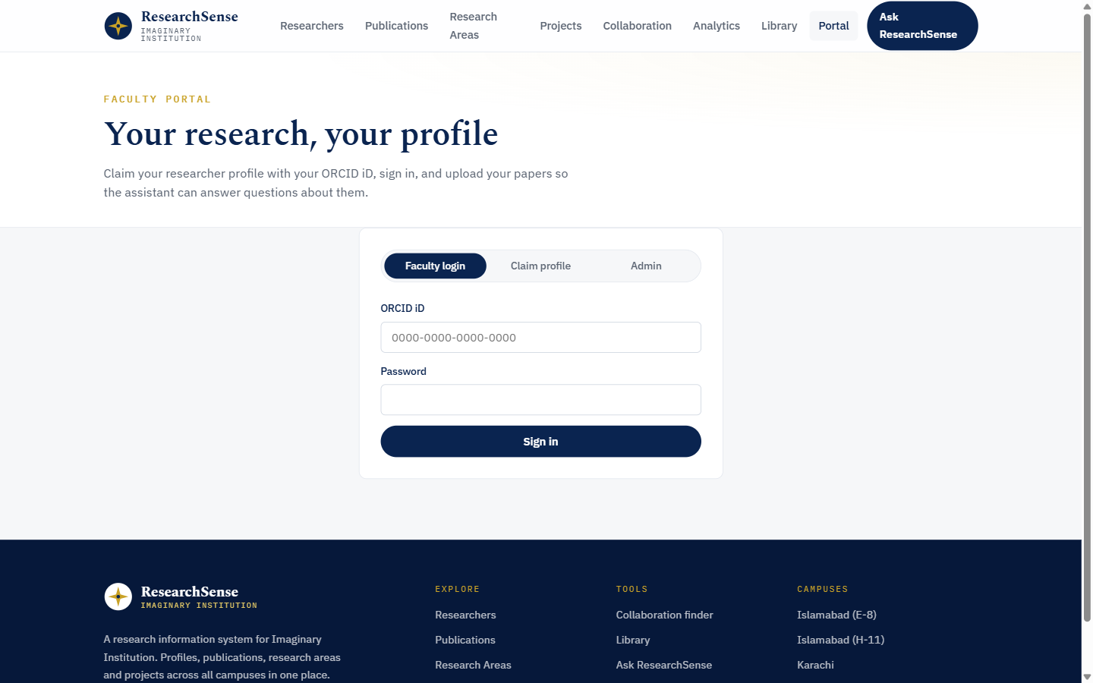
Figure 4.16: Faculty portal with claim, login, and admin views

4.8 External Interfaces
The main external interface is the web interface between the client and the server: the client sends HTTPS requests to fixed API routes and the server returns JSON whose shape is fixed by the Pydantic schemas and mirrored in the client's TypeScript types.
Several outside services support the data pipeline and the assistant, as shown in Figure 4.17. Build-time scripts read the public faculty directory of the university to construct the researcher records, and query open scholarly databases (OpenAlex, Semantic Scholar, and Crossref) to collect real publications and open-access PDF links for paper files. At run time, the ORCID registry is consulted once per profile claim to verify identity, and the Groq LLM API is called by the generation step of the assistant with retrieved context only. All external calls are isolated in the service layer, so any of these providers can be replaced without touching the rest of the system.
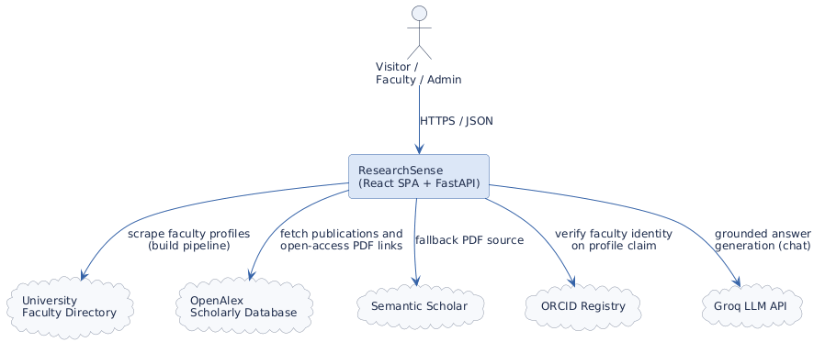
Figure 4.17: System context diagram of the external interfaces

