Introduction

In this report, I have been given temperature distribution 2D problems with boundary conditions that need to be specified. I have been given Jacobi 2D and Gauss-Seidel 2D. The aim of both these codes to solve dimensional heat conductivity within the 2D area. However, both codes that are given are run differently. Each task consists of executing both tasks using different variations by plotting the results and a comparison of each results. Each task will be explained of what changes are made, the test cases, and screenshots using different problem sizes.

Task 1

In this task, the aim of this task is to set the boundary condition of “top 20°C, bottom 100°C, left 10°C and right 140°C” by using different problem sizes. Each problem sizes needed to be ran using different compiler optimisation. We were advised to stop the printing to get accurate results. Please note that these changes have been reflected in both codes. Referring to Screenshot 1 and Screenshot 2, changes were made to these to make sure that this task is complete. The changes that were made for both were to fix the boundary conditions that were set, commented the printing for accurate results and including a runtime. To put a runtime within both of this, the start of the day needed to be recorded and the end of the day. This was recorded and printing using external libraries too. Again, please note that all these changes are reflected and highlighted within Figure 1 and Figure 2.

Different levels of compiler optimisation

As per the Wikipedia, an optimizing compiler tries to “minimise or maximise some attributes of executable computer programs” wit an aim of trying to compile algorithms so as to produce the same result using different, or less, resources and expecting the same result. The aim of using different levels of compiler optimisation within Jacobi and Gauss is to expect different results. These different optimisations turn on different flags enabling them to run the code faster. Please refer yourself to Table 1 to get a good idea of the difference between each compiler that is used within Task 1. Table 1 consists of what each compiler does and the effect it has on the code. Some of the new optimisations have been introduced that has not been used in Jacobi nor Gauss too. This is only for descriptive in detail for the definition of compiler optimisation.

 | COMPILER OPTIMISATION | DESCRIPTION
 | NO OPTIMISATION | Results without using any optimisation.
 | -O0 | “Reduces compiler time, however, only
 |  | recommended for debugging purposes”
 | -O1 | “Basic level of optimisation”. Aims at smaller
 |  | code for faster results only
 | -O2 | Recommended level. A step-up from previous
 |  | optimisation.
 | -O3 | “The highest level of optimisation”. Enables
 |  | optimisation of expensive compiler time.
 |  | However, it is known to break code too.
 | -OS | “Optimises code due to size”. However, not a
 |  | guarantee for results.
 | -OG | “Addresses fast optimization” A new level that
 |  | has been introduced
 | -OFAST | A new level that has a plus of O3.
 |  | Recommendation is not to use.

Jacobi 2D

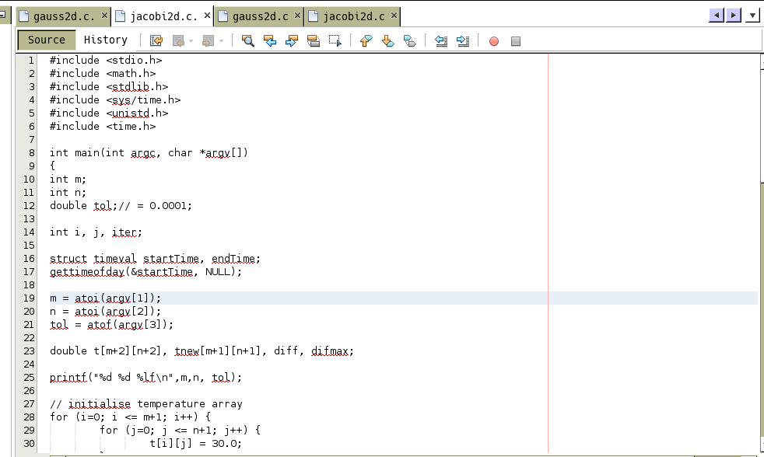
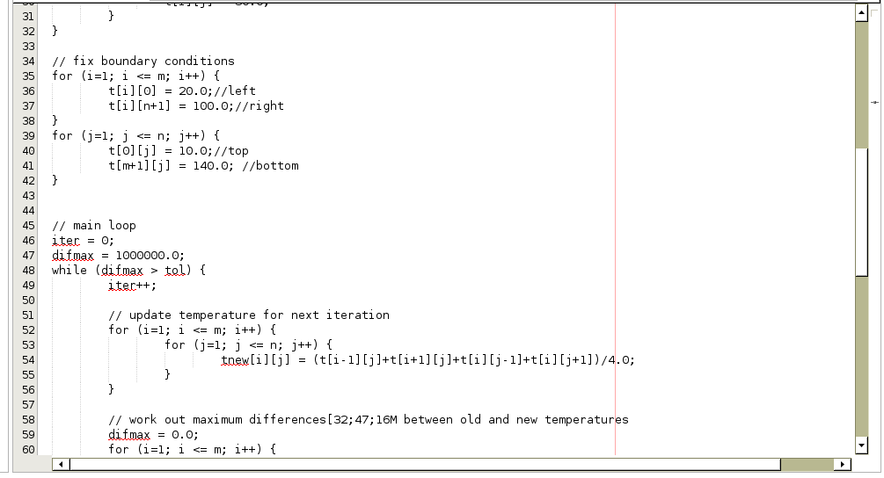

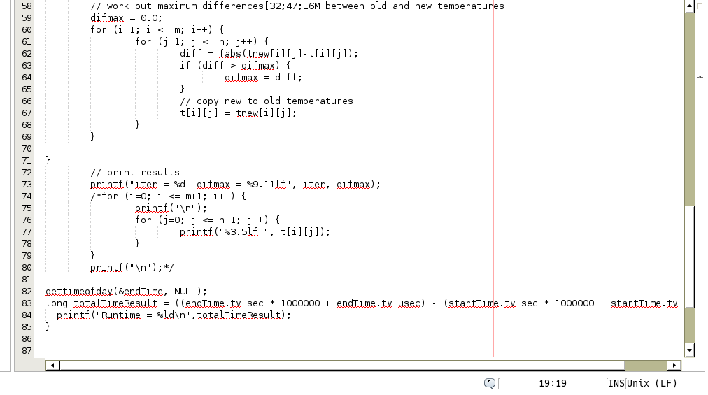
Screenshot 1 with changes made for Jacobi

6 | P a g e
Gauss 2D

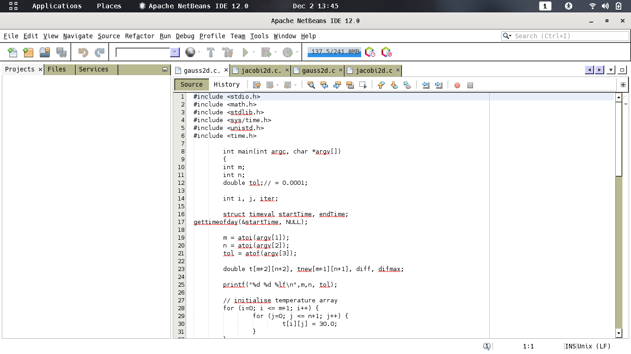
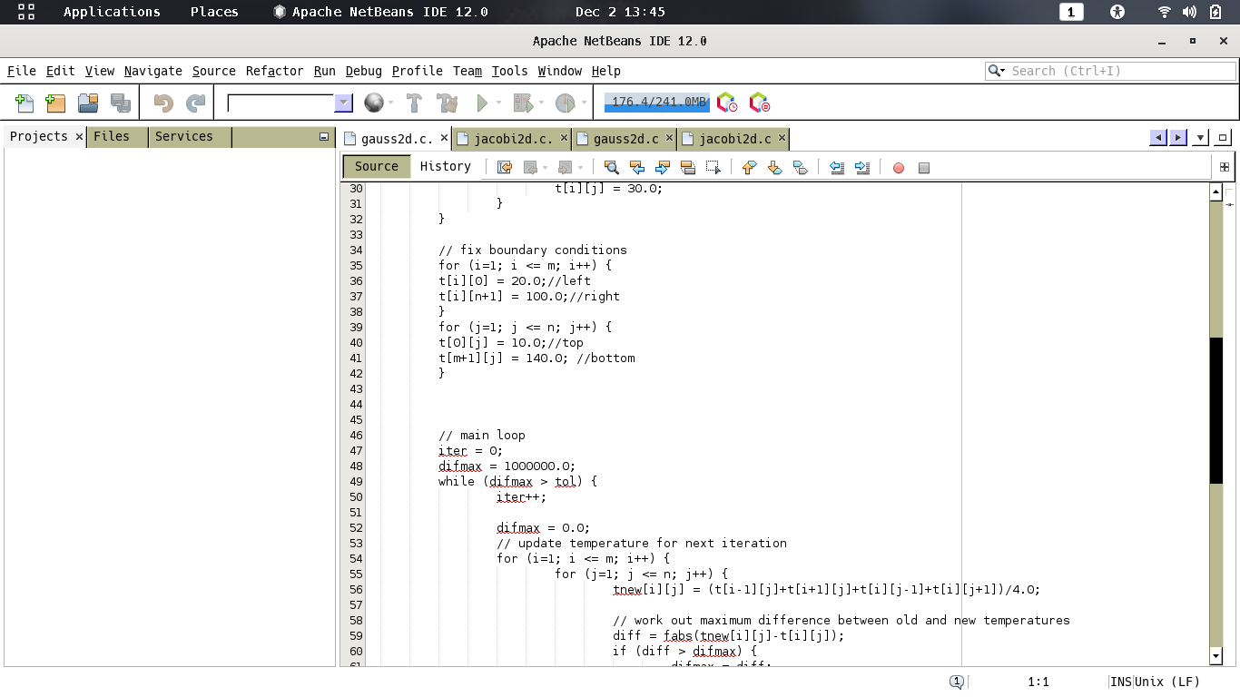
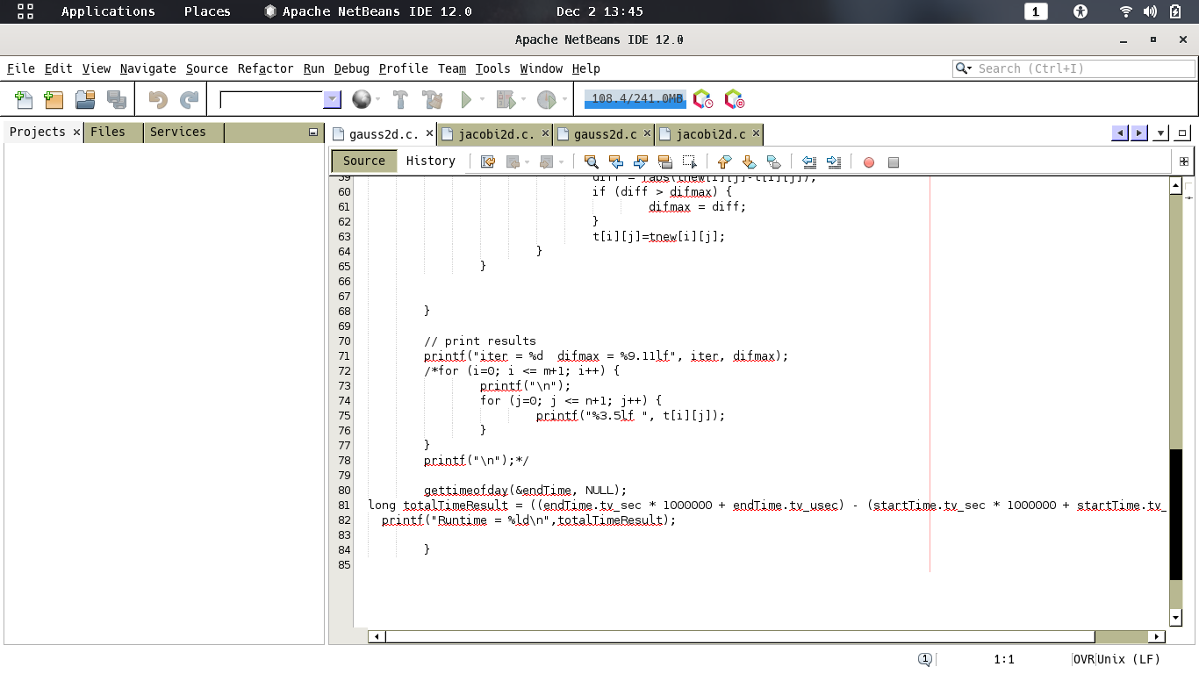

Figure 2 with changes made for Gauss. 7| Page
Screenshots Jacobi 2D
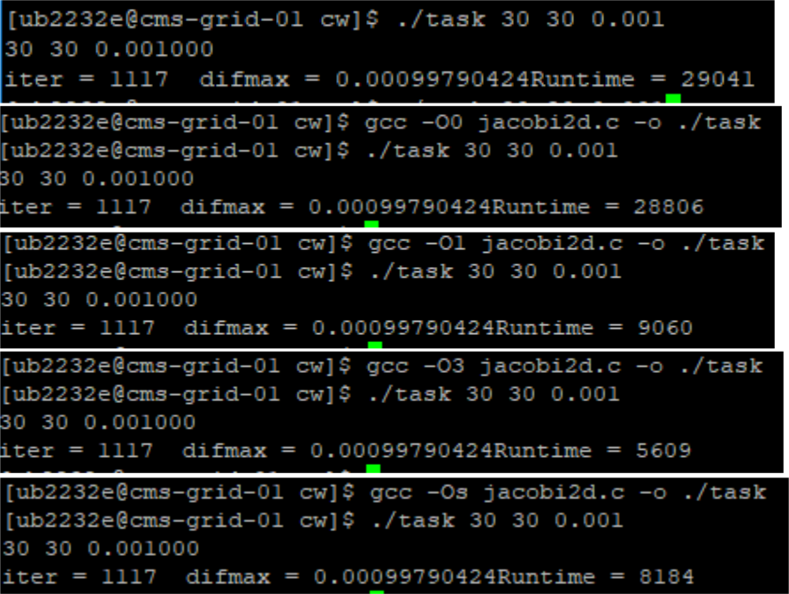

Screenshots Gauss 2D

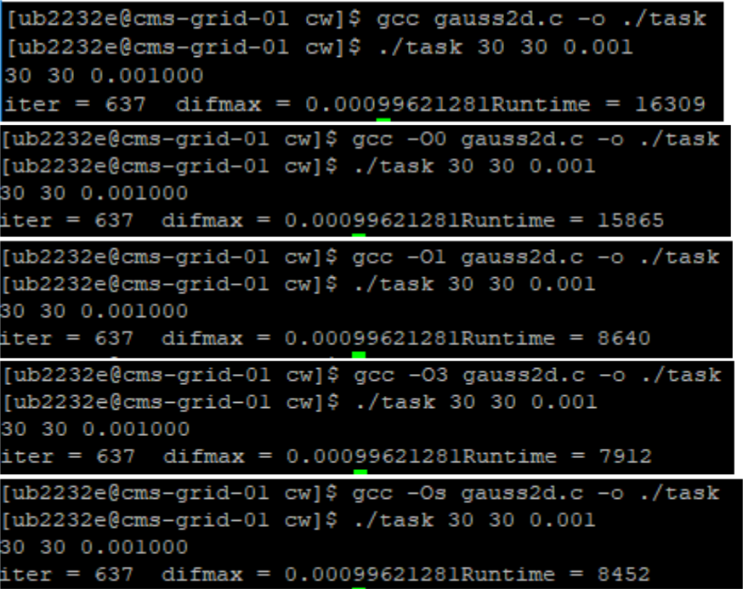

These are the screenshots that were used of a different compiler optimisation were used on the same problem size. As you can clearly see the difference between each of the screenshots is the fact that O3, as explained previously, is the most dominant and fastest optimisation level for both Jacobi and Gauss. The difference between both codes is that Gauss is the faster rate of executing the code. As you may see, without optimisation for both codes consist of a difference between 29,041 for Jacobi; and significantly lower is 16,309 for Gauss. Please note that these changes are relatively the same for test cases below. However, I do notice a change is that for Gauss, as the problem sizes increase for different optimisation; it stays the same. A consistent pattern throughout Gauss. This is not the case for Jacobi as O3 has a clear advantage. However, Gauss is not the same. Please refer yourself over to Table 2 and Table 3 where you can see these test cases.

8 | P a g e
Jacobi 2D Test Cases

 | Jacobi 2D |  |  | 20*20(s) |  | 100*100(s) |  |  | 250*250(s) | 500*500(s)
 |  | No Optimisation |  |  |  |  | RESULTS
 | TEST NO. 1 |  |  | 0.007007 | 1.259234 |  |  |  | 16.152857 | 98.223882
 |  | TEST NO. 2 |  | 0.009067 |  | 1.149241 |  |  | 17.118581 | 96.618963
 | TEST NO. 3 |  |  | 0.007411 | 1.121526 |  |  |  | 16.868968 | 96.646195
 |  | TEST NO. 4 |  | 0.007168 |  | 1.356270 |  |  | 16.083406 | 96.524509
 | TEST NO. 5 |  |  | 0.006946 | 1.088764 |  |  |  | 15.961578 | 96.540806
 |  | AVERAGE: |  | 0.0075198 |  | 1.195007 |  |  | 16.437078 | 96.910871
 | Jacobi 2D |  |  | 20*20(s) | 100*100(s) |  |  |  | 250*250(s) | 500*500(s)
 |  | -O0 |  |  |  | RESULTS
 | TEST NO. 1 |  |  | 0.006975 | 1.340728 |  |  | 16.347451 |  | 96.012711
 |  | TEST NO. 2 |  | 0.006981 | 1.244599 |  |  |  | 16.293195 | 96.143704
 | TEST NO. 3 |  |  | 0.007270 | 1.333791 |  |  | 16.244055 |  | 96.535460
 |  | TEST NO. 4 |  | 0.007418 | 1.115653 |  |  |  | 16.180131 | 98.309539
 | TEST NO. 5 |  |  | 0.007609 | 1.176860 |  |  | 15.847265 |  | 96.475462
 |  | AVERAGE: |  | 0.0072508 | 1.2423262 |  |  |  | 16.1824194 | 96.6953752
 | Jacobi 2D |  |  | 20*20(s) |  | 100*100(s) |  |  | 250*250(s) | 500*500(s)
 |  | -O1 |  |  |  | RESULTS
 | TEST NO. 1 |  |  | 0.002079 | 0.476736 |  |  | 5.232900 |  | 28.569098
 |  | TEST NO. 2 |  | 0.002082 | 0.343736 |  |  |  | 4.603637 | 27.434463
 | TEST NO. 3 |  |  | 0.002106 | 0.482531 |  |  | 4.580474 |  | 27.364959
 |  | TEST NO. 4 |  | 0.002027 | 0.424280 |  |  |  | 4.422464 | 27.664923
 | TEST NO. 5 |  |  | 0.002029 | 0.383116 |  |  | 4.375130 |  | 27.701728
 |  | AVERAGE: |  | 0.0020646 | 0.4220798 |  |  |  | 4.642921 | 27.7470342
 | Jacobi 2D |  |  | 20*20(s) | 100*100(s) |  |  |  | 250*250(s) | 500*500(s)
 |  | -O3 |  |  |  | RESULTS
 | TEST NO. 1 |  |  | 0.001531 | 0.307831 |  |  |  | 3.477413 | 18.369137
 |  | TEST NO. 2 |  | 0.001579 | 0.395744 |  |  |  | 3.450681 | 18.401564
 | TEST NO. 3 |  |  | 0.001446 | 0.296989 |  |  |  | 3.736732 | 18.566448
 |  | TEST NO. 4 |  | 0.001551 | 0.285333 |  |  |  | 3.050917 | 18.558907
 | TEST NO. 5 |  |  | 0.001606 | 0.274192 |  |  |  | 3.304717 | 18.306188
 |  | AVERAGE: |  | 0.0015426 | 0.3120178 |  |  |  | 3.404092 | 18.4404488
 | Jacobi 2D |  |  | 20*20(s) | 100*100(s) |  |  |  | 250*250(s) | 500*500(s)
 |  | -Os |  |  |  | RESULTS
 | TEST NO. 1 |  |  | 0.002140 | 0.306868 |  |  | 4.580550 |  | 27.528298
 |  | TEST NO. 2 |  | 0.002094 | 0.429638 |  |  |  | 4.541586 | 29.372532
 | TEST NO. 3 |  |  | 0.001981 | 0.412990 |  |  | 4.920604 |  | 29.053330
 |  | TEST NO. 4 |  | 0.001969 | 0.400632 |  |  |  | 4.479400 | 28.739711
 | TEST NO. 5 |  |  | 0.002156 | 0.356029 |  |  | 4.786950 |  | 28.919932
 |  | AVERAGE: |  | 0.002068 | 0.3812314 |  |  |  | 4.661818 | 28.7227606

Table 2 shows the test cases for Jacobi

9| P a g e
Gauss 2D Test Cases

 | Gauss 2D |  |  | 20*20(s) | 100*100(s) |  | 250*250(s) | 500*500(s)
 |  | No Optimisation |  |  |  | RESULTS
 | TEST NO. 1 |  |  | 0.004307 | 0.751120 |  | 12.371875 | 85.523379
 |  | TEST NO. 2 |  | 0.004081 | 0.859215 |  | 11.594849 | 85.372035
 | TEST NO. 3 |  |  | 0.003826 | 0.862438 |  | 11.423719 | 84.873826
 |  | TEST NO. 4 |  | 0.003782 | 0.823397 |  | 11.486222 | 84.373195
 | TEST NO. 5 |  |  | 0.003873 | 0.761650 |  | 11.350337 | 86.579961
 |  | AVERAGE: |  | 0.003974 | 0.811564 |  | 11.6454 | 85.344479
 | Gauss2D |  |  | 20*20(s) | 100*100(s) |  | 250*250(s) | 500*500(s)
 |  | -O0 |  |  |  | RESULTS
 | TEST NO. 1 |  |  | 0.004004 | 0.757562 |  | 11.741479 | 84.546083
 |  | TEST NO. 2 |  | 0.004065 | 0.727403 |  | 11.492874 | 88.000630
 | TEST NO. 3 |  |  | 0.004003 | 0.844078 |  | 11.439810 | 86.134485
 |  | TEST NO. 4 |  | 0.003812 | 0.871283 |  | 11.804330 | 86.455544
 | TEST NO. 5 |  |  | 0.003789 | 0.879249 |  | 11.976221 | 85.236231
 |  | AVERAGE: |  | 0.003935 | 0.815915 |  | 11.690943 | 86.074595
 | Gauss2D |  |  | 20*20(s) | 100*100(s) |  | 250*250(s) | 500*500(s)
 |  | -O1 |  |  |  | RESULTS
 | TEST NO. 1 |  |  | 0.001740 | 0.433881 |  | 6.917785 | 45.409179
 |  | TEST NO. 2 |  | 0.001794 | 0.421155 |  | 6.316302 | 45.812901
 | TEST NO. 3 |  |  | 0.001994 | 0.390309 |  | 6.169000 | 46.201633
 |  | TEST NO. 4 |  | 0.001734 | 0.466192 |  | 6.699500 | 45.466647
 | TEST NO. 5 |  |  | 0.001845 | 0.408194 |  | 6.144695 | 45.298540
 |  | AVERAGE: |  | 0.001821 | 0.423946 |  | 6.4494564 | 45.63778
 | Gauss 2D |  |  | 20*20(s) | 100*100(s) |  | 250*250(s) | 500*500(s)
 |  | -O3 |  |  |  | RESULTS
 | TEST NO. 1 |  |  | 0.001781 | 0.393659 |  | 6.396697 | 45.433953
 |  | TEST NO. 2 |  | 0.001709 | 0.383639 |  | 6.421257 | 45.106833
 | TEST NO. 3 |  |  | 0.001743 | 0.426180 |  | 6.373042 | 46.373132
 |  | TEST NO. 4 |  | 0.001700 | 0.428743 |  | 6.599847 | 46.148424
 | TEST NO. 5 |  |  | 0.001717 | 0.420797 |  | 6.416398 | 45.402019
 |  | AVERAGE: |  | 0.00173 | 0.410604 |  | 6.4414482 | 45.692872
 | Gauss 2D |  |  | 20*20(s) | 100*100(s) |  | 250*250(s) | 500*500(s)
 |  | -Os |  |  |  | RESULTS
 | TEST NO. 1 |  |  | 0.001738 | 0.537205 |  | 6.034644 | 45.268853
 |  | TEST NO. 2 |  | 0.001774 | 0.390633 |  | 6.364533 | 45.413866
 | TEST NO. 3 |  |  | 0.001718 | 0.405520 |  | 6.084089 | 46.646487
 |  | TEST NO. 4 |  | 0.001707 | 0.440929 |  | 7.141049 | 45.379514
 | TEST NO. 5 |  |  | 0.00943 | 0.490913 |  | 6.086839 | 44.906773
 |  | AVERAGE: |  | 0.003273 | 0.45304 |  | 6.3422308 | 45.523099

Table 3 shows the test cases for Gauss

10 | P a g e
Task 2

In this task, modifications are made from Task 1 to produce a parallel version of Jacobi and Gauss using OpenMP. The command that were used to produce the outcome was “gcc -fopenmp jacobi2d.c -* task”. This was also the same execution used for Gauss by including the relevant file. This tasks also asked us to include timers to report the run-time of each code. This was completed as an example of one of the labs that were done. The highlighted code shows that the start time needs to be at the front of the code and the end time needs to be when the code has been executed. Once both have each time, a simple print statement by subtracting the end time from the start time. This is how this was executing using the time. This version needed to be included using different threads. These threads, as highlighted, were given as an argument for the user to type in. Lastly, Gauss-Seidel code must be only 1 iteration using 1 and 2 threads. A difference in each of the solutions will be explained in this report. Please refer yourself to Figure 3 and Figure 4 to see these reflected changes that were made to parallelise Jacobi and Gauss 2D.

Parallelisation

In general, parallel programming is a type of computation that is broken and dissected into parts that can be solved separately (Barney, 2008). C programs often express their parallel by using for loops. This gets directly called to the compiler by communicating with what to do with it. As you can see for Figure 3 and Figure 4, many #pragmas are used as to parallelise these codes. Pragmas are a way of communicating directly to the compiler stating what this will do for you. Therefore, by including any information alongside this, it will tell the compiler of what to do. Please refer yourself to Table 4 where it can show the definitions used to parallelise Jacobi and Gauss.

PARALLEL CODE | DESCRIPTION
PRAGMA | Verify information as it will have information it
 | needs to schedule the loops iteration.
CRITICAL | A portion of the code so that a thread each time can
 | execute. Therefore, it has been noted as critical
SCHEDULE (STATIC) | Static means that the iteration blocks are mapped
 | statistically
SCHEDULE(DYNAMIC) | Dynamic works as a first-come first served basis
PRIVATE | Private is declared so that it can only be used within
 | the relevant section
SHARED | Shared is so that the variables can be shared with
 | the threads in a team
OMP_SET_NUM_THREADS() | Returns the number of threads used within the
 | parallel region
OMP_GET_WTIME() | Returns a double value relevant to the clock time
Table 4 shows the definitions used in for parallelisation

Parallel Jacobi 2D
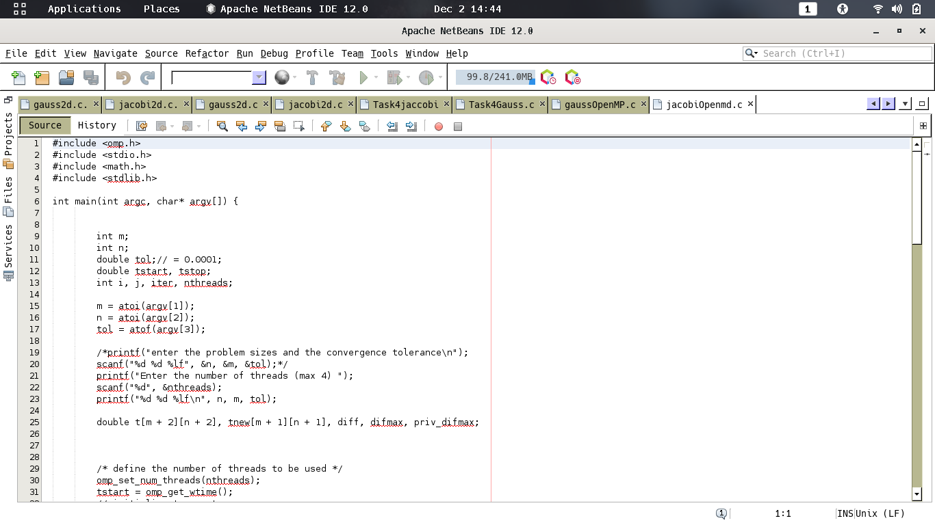
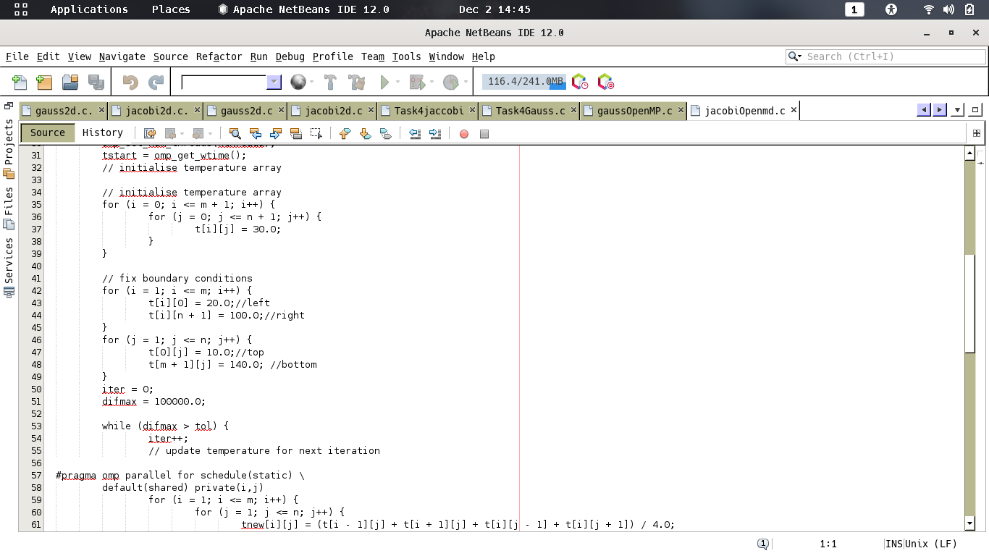
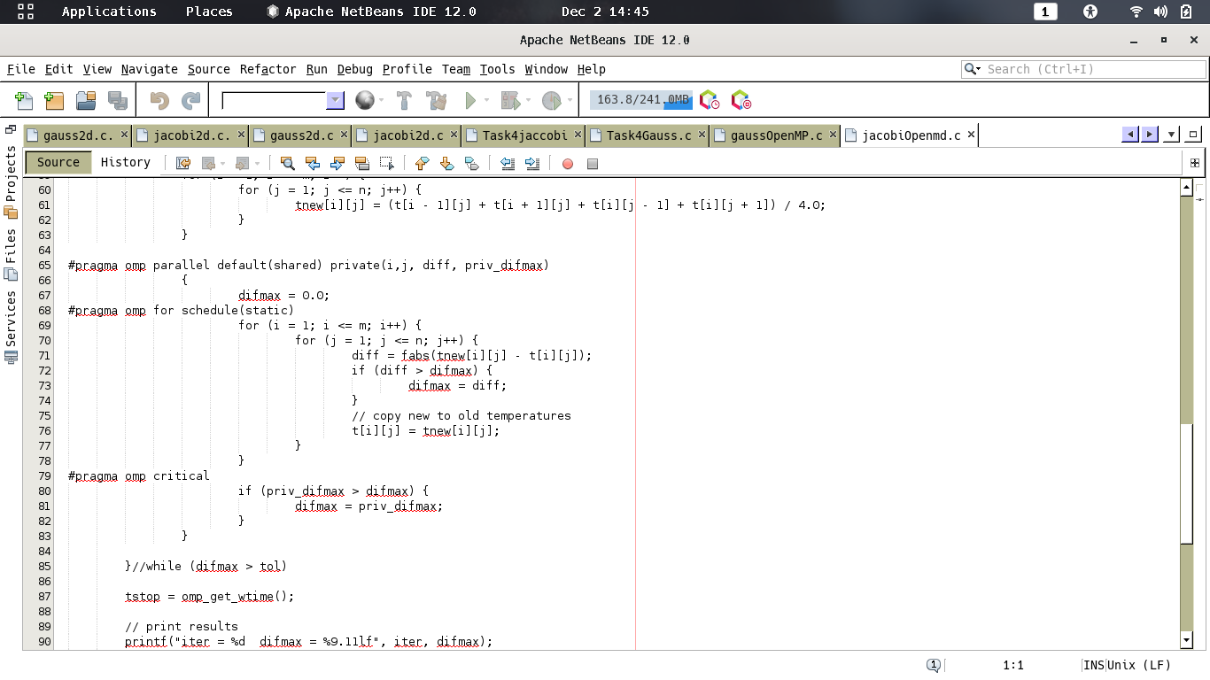
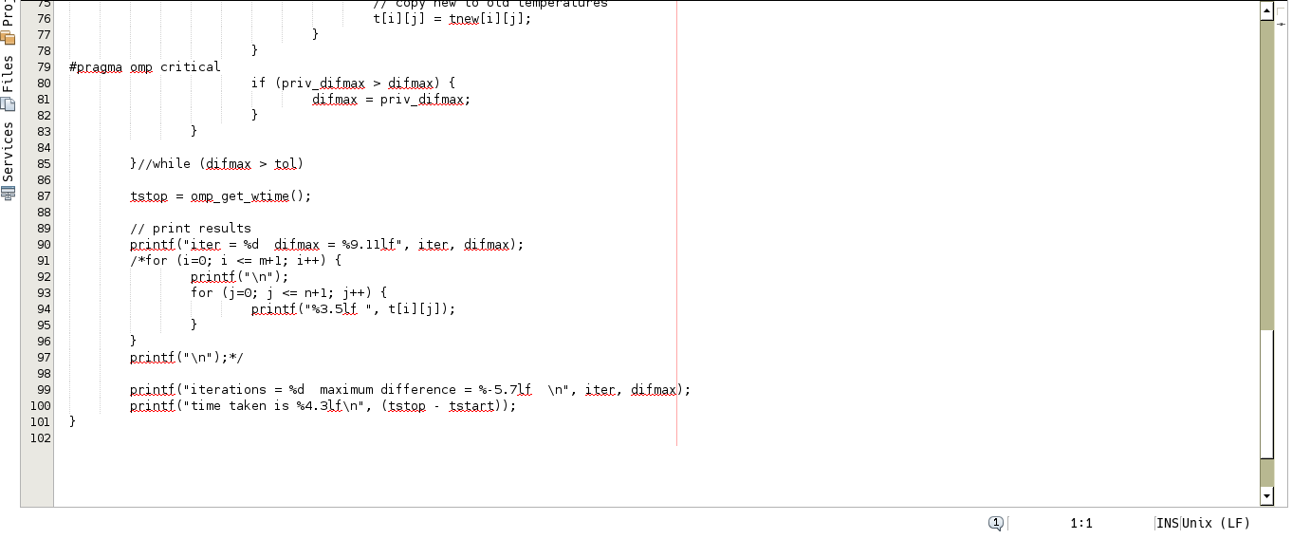
Figure 3 shows the changes that were made to Jacobi

12| Page

Parallel Gauss 2D
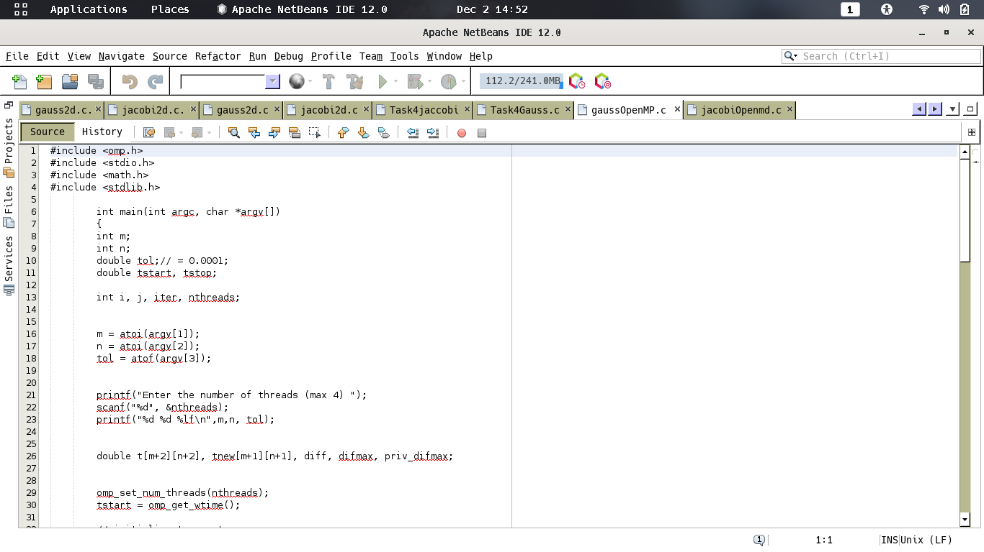

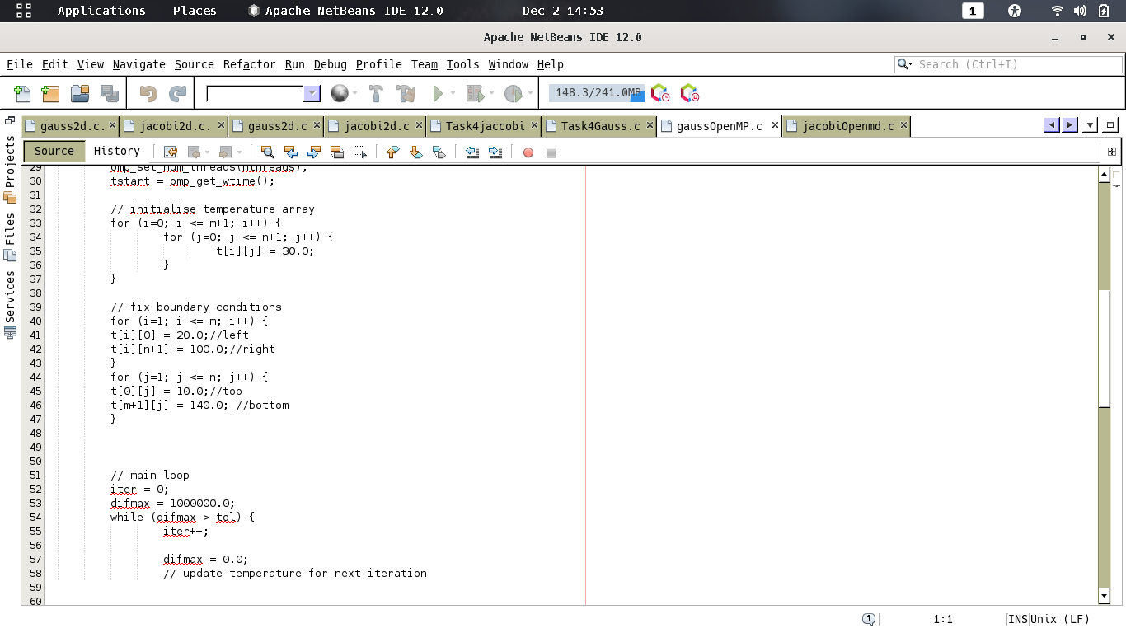
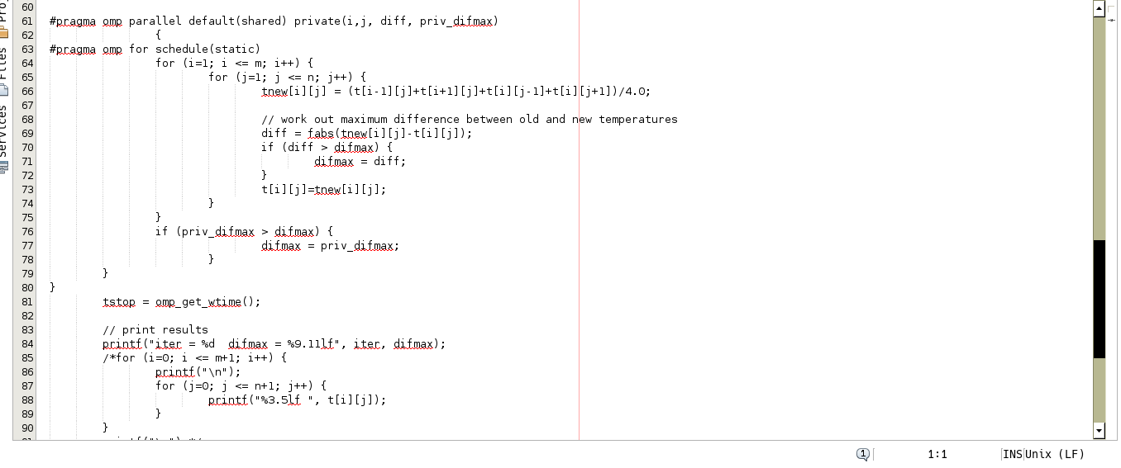
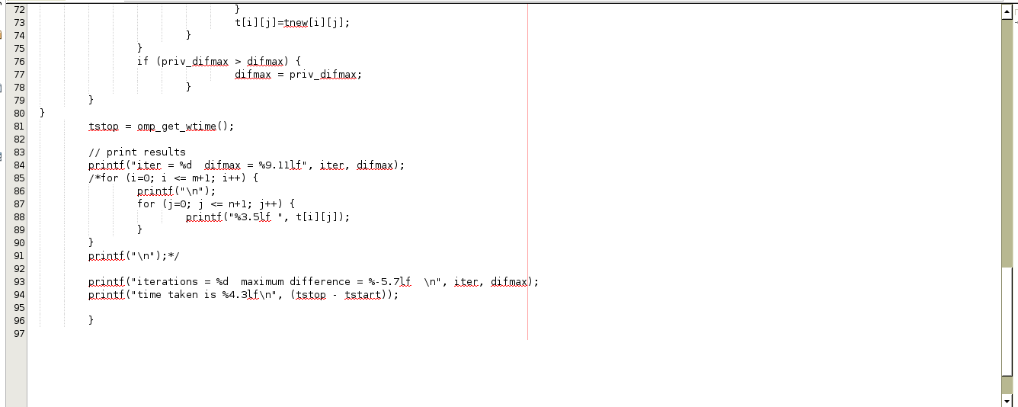
Figure 4 Gauss after changes.

13| Page

Screenshots Jacobi 2D (Smaller)
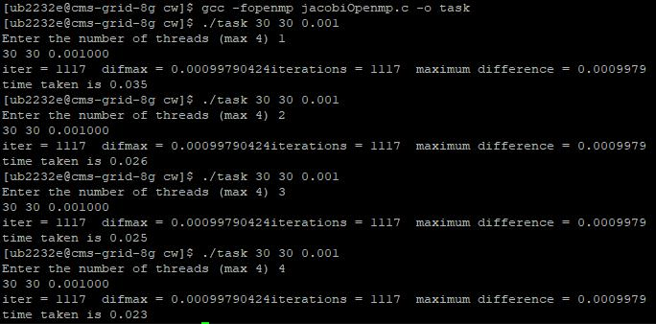

Figure 5 shows the smaller difference for Jacobi

Screenshots Jacobi 2D (Bigger)
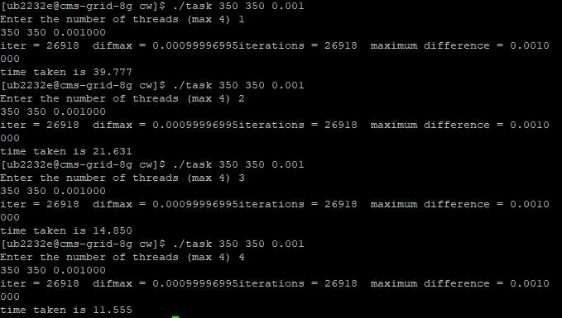

Figure 6 shows the bigger results for Jacobi

Figure 5 and Figure 6 both demonstrates the difference between the smaller and bigger results. As you can see, the difference between each thread is not much different for each thread. The difference between each thread is not much great considering the size of the problem. However, the bigger the result, the greater the difference. As you can see, the difference is much larger compared to the result of the smaller problem size. Please refer yourself to Table 5, Table 6 and Table 7 to show the test cases for this.

14 | P a g e
Screenshots Gauss 2D (Bigger)
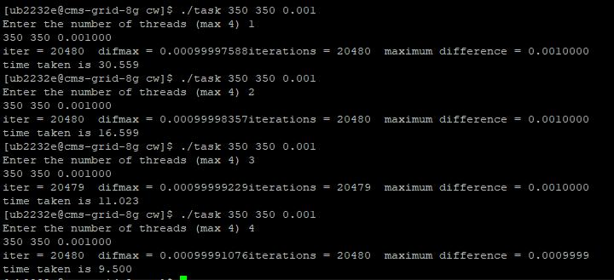

Figure 7 shows the screenshots in Gauss.

Referring to Figure 7, this shows us that the same results show us the better difference. I did not include a smaller problem size for Gauss, as this would have been the same outcome. The difference of results shows us that, at the moment, Gauss is much faster when paralleling both together.

Table 5 shows us the consistency of each threat. However, the results do not show the greater difference for both. Hence, the reason to increase the problem size. When I ran both codes, I used Grid 01 for these results. These results came very in accurate as the greater the thread, the more fluctuated results that were presented. I was later advised to use 8G, as this shows much greater and accurate results. Once this was changed for all tables including Table 5, 6 and 7; these were the results that showed much more accurate results. To run this, I used the following command: ssh cms-grid-8G. However, I was advised that the greater the threads, performance is an issue. This is when the more people use this grid, it would affect the results of the run time.

Furthermore, Table 6 and Table 7 shows us the results of Jacobi and Gauss. As you can see for both tables are that Gauss is faster when executing the same results. However, the same issue, within Task 1 appears with Gauss, is that the greater the problem size; the more time it takes to execute the code. When specifically comparing the average of 600 of 3 threads of Jacobi and Gauss; there is any a slight difference between the two. This is the same difference for 700, as when the third and fourth thread is used; Gauss has a greater time than Jacobi. This could be a performance issue. However, I have ran the code doing more than 5 results; and I noticed that this is still the same. Possibly, this could be an area where this could be improved. To improve the parallelisation of Gauss and make sure that the greater threads of greater problem sizes are executed faster.

15 | P a g e
Jacobi 2D Test Cases

 | Jacobi 2D | 20*20(s) | 100*100(s) | 250*250(s)
 | 1 |  | RESULTS
 | TEST NO. 1 | 0.010 | 1.114 | 16.081
 | TEST NO. 2 | 0.010 | 1.198 | 16.316
 | TEST NO. 3 | 0.010 | 1.277 | 15.985
 | TEST NO. 4 | 0.010 | 1.073 | 16.171
 | TEST NO. 5 | 0.010 | 1.116 | 15.868
 | AVERAGE: | 0.010 | 1.1556 | 16.0842
 | Jacobi 2D | 20*20(s) | 100*100(s) | 250*250(s)
 | 2 |  | RESULTS
 | TEST NO. 1 | 0.010 | 0.686 | 8.261
 | TEST NO. 2 | 0.009 | 0.863 | 8.887
 | TEST NO. 3 | 0.009 | 0.887 | 8.370
 | TEST NO. 4 | 0.012 | 0.692 | 8.346
 | TEST NO. 5 | 0.009 | 0.690 | 8.969
 | AVERAGE: | 0.0098 | 0.7636 | 8.5666
 | Jacobi 2D | 20*20(s) | 100*100(s) | 250*250(s)
 | 3 |  | RESULTS
 | TEST NO. 1 | 0.008 | 0.551 | 6.307
 | TEST NO. 2 | 0.008 | 0.508 | 6.147
 | TEST NO. 3 | 0.009 | 0.483 | 6.462
 | TEST NO. 4 | 0.010 | 0.479 | 5.881
 | TEST NO. 5 | 0.009 | 0.584 | 5.740
 | AVERAGE: | 0.0088 | 0.521 | 6.1074
 | Jacobi 2D | 20*20(s) | 100*100(s) | 250*250(s)
 | 4 |  | RESULTS
 | TEST NO. 1 | 0.008 | 0.491 | 4.998
 | TEST NO. 2 | 0.009 | 0.456 | 4.855
 | TEST NO. 3 | 0.009 | 0.514 | 4.461
 | TEST NO. 4 | 0.009 | 0.403 | 4.863
 | TEST NO. 5 | 0.010 | 0.517 | 4.954
 | AVERAGE: | 0.009 | 0.4762 | 4.8262
Table 5 shows the results of smaller cases in Jacobi

16 | P a g e
 | Jacobi 2D | 500*500(s) | 600*600(s) | 700*700(s)
 | 1 |  | RESULTS
 | TEST NO. 1 | 96.677 | 141.888 | 197.405
 | TEST NO. 2 | 96.213 | 144.529 | 193.793
 | TEST NO. 3 | 97.788 | 146.178 | 194.471
 | TEST NO. 4 | 97.789 | 144.371 | 194.980
 | TEST NO. 5 | 98.164 | 144.354 | 198.203
 | AVERAGE: | 97.3262 | 144.264 | 195.7704
 | Jacobi 2D | 500*500(s) | 600*600(s) | 700*700(s)
 | 2 |  | RESULTS
 | TEST NO. 1 | 50.487 | 73.968 | 102.128
 | TEST NO. 2 | 50.899 | 65.811 | 102.056
 | TEST NO. 3 | 51.321 | 74.461 | 102.176
 | TEST NO. 4 | 53.019 | 75.049 | 102.947
 | TEST NO. 5 | 50.427 | 72.361 | 100.792
 | AVERAGE: | 51.2306 | 72.33 | 102.0198
 | Jacobi 2D | 500*500(s) | 600*600(s) | 700*700(s)
 | 3 |  | RESULTS
 | TEST NO. 1 | 34.650 | 49.899 | 69.409
 | TEST NO. 2 | 35.176 | 50.298 | 70.978
 | TEST NO. 3 | 34.044 | 45.535 | 69.057
 | TEST NO. 4 | 35.088 | 50.450 | 68.210
 | TEST NO. 5 | 34.338 | 49.940 | 68.287
 | AVERAGE: | 34.6592 | 49.2244 | 69.1882
 | Jacobi 2D | 500*500(s) | 600*600(s) | 700*700(s)
 | 4 |  | RESULTS
 | TEST NO. 1 | 27.599 | 38.919 | 52.695
 | TEST NO. 2 | 28.115 | 39.235 | 53.375
 | TEST NO. 3 | 25.971 | 38.059 | 51.279
 | TEST NO. 4 | 27.091 | 39.587 | 52.836
 | TEST NO. 5 | 26.371 | 37.368 | 52.029
 | AVERAGE: | 27.0294 | 38.6336 | 52.4428
Table 6 shows the test cases of bigger sizes in Jacobi

17 | P a g e
Gauss 2D Test Cases

 | Gauss 2D | 500*500(s) | 600*600(s) |  |  | 700*700(s)
 | 1 |  | RESULTS
 | TEST NO. 1 | 84.129 | 137.997 |  |  | 193.777
 | TEST NO. 2 | 85.345 | 138.249 |  |  | 192.524
 | TEST NO. 3 | 87.074 | 135.854 |  |  | 193.360
 | TEST NO. 4 | 85.531 | 135.050 |  |  | 193.002
 | TEST NO. 5 | 86.108 | 134.946 |  |  | 192.994
 | AVERAGE: | 85.6374 | 136.4192 |  |  | 193.1314
 | Gauss 2D | 500*500(s) | 600*600(s) |  |  | 700*700(s)
 | 2 |  | RESULTS
 | TEST NO. 1 | 53.751 | 69.592 |  |  | 101.084
 | TEST NO. 2 | 45.557 | 68.988 |  |  | 103.088
 | TEST NO. 3 | 44.759 | 69.650 |  |  | 101.144
 | TEST NO. 4 | 43.995 | 70.876 |  |  | 100.608
 | TEST NO. 5 | 43.960 | 70.311 |  |  | 99.528
 | AVERAGE: | 46.4044 | 69.8834 |  |  | 101.0904
 | Gauss 2D | 500*500(s) | 600*600(s) |  |  | 700*700(s)
 | 3 |  | RESULTS
 | TEST NO. 1 | 49.091 | 70.260
 | TEST NO. 2 | 29.657 | 48.641 |  |  | 70.279
 | TEST NO. 3 | 48.854 | 71.006
 | TEST NO. 4 | 30.960 | 47.723 |  |  | 70.939
 | TEST NO. 5 | 48.827 | 69.844
 | AVERAGE: | 30.3228 | 48.6272 |  |  | 70.4656
 | Gauss 2D | 500*500(s) | 600*600(s) |  |  | 700*700(s)
 | 4 |  | RESULTS
 | TEST NO. 1 | 22.465 | 38.209 |  |  | 53.531
 | TEST NO. 2 | 22.933 | 37.010 |  |  | 53.608
 | TEST NO. 3 | 22.619 | 37.585 |  |  | 53.254
 | TEST NO. 4 | 22.447 | 36.883 |  |  | 53.765
 | TEST NO. 5 | 22.327 | 37.740 |  |  | 52.797
 | AVERAGE: | 22.5582 | 37.4854 |  |  | 53.391
Table 7 shows the results in Jacobi

18 | P a g e
Gauss 2D 1 Iteration Test Cases

Referring to Table 8, these are the results of Gauss 2D being run through different problem sizes. This was enabled by increasing the tolerance enabling the problem to be ran in 1 iteration. The difference that has shown are that between each iteration there is not much difference when increasing the thread. However, when the problem sizes are increased for 1 thread, it shows a bigger difference than the second threat. The same problem sizes were used as previously to show the difference of each iteration. It would not make sense to make different problem sizes for this. Please refer yourself to Figure 8 to show that this has been done for this.

 | Gauss2d | 500*500(s) | 600*600(s) | 700*700(s)
 | 1 Thread |  | RESULTS
 | TEST NO. 1 | 0.013 | 0.017 | 0.022
 | TEST NO. 2 | 0.012 | 0.016 | 0.022
 | TEST NO. 3 | 0.012 | 0.016 | 0.027
 | TEST NO. 4 | 0.012 | 0.016 | 0.020
 | TEST NO. 5 | 0.012 | 0.016 | 0.021
 | AVERAGE: | 0.0122 | 0.0162 | 0.0224
 | Gauss2d | 500*500(s) | 600*600(s) | 700*700(s)
 | 2 Threads |  | RESULTS
 | TEST NO. 1 | 0.008 | 0.010 | 0.014
 | TEST NO. 2 | 0.008 | 0.012 | 0.014
 | TEST NO. 3 | 0.008 | 0.011 | 0.014
 | TEST NO. 4 | 0.009 | 0.011 | 0.014
 | TEST NO. 5 | 0.009 | 0.011 | 0.014
 | AVERAGE: | 0.0084 | 0.011 | 0.014
Table 8 shows the results of 1 iteration of Gauss
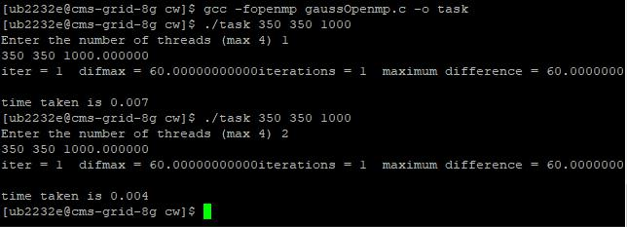

Figure 8 shows the execution of 1 iteration in Gauss

19 | P a g e
Task 3

In this task, speed up results were asked by executing range of problem sizes alongside a single optimisation processor. A similar optimisation to the parallel code was asked. Furthermore, it only made sense to use the best result that was gained from Step 1 by using O3 optimisation. A different range of threads were used from 2 to 8. For this, I used 2, 4, 6, 8 as the threads. However, it was not necessary to improve on the parallelisation that was completed from Step 2. Therefore, the following tests were running on the Step 2. There, no separate code is made. This would not make any sense as changes were not made for this task. As you can see within Figure 9 and 10, I ran these tests by using the following command: gcc -fopenmp -O3 jacobiOpenmp.c -o task.

Screenshots Jacobi 2D
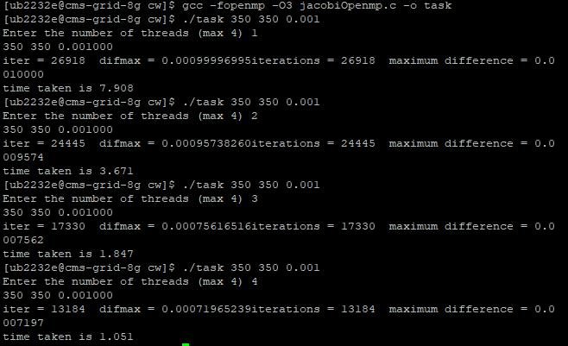

Figure 9 shows the results of Jacobi

Screenshots Gauss 2D
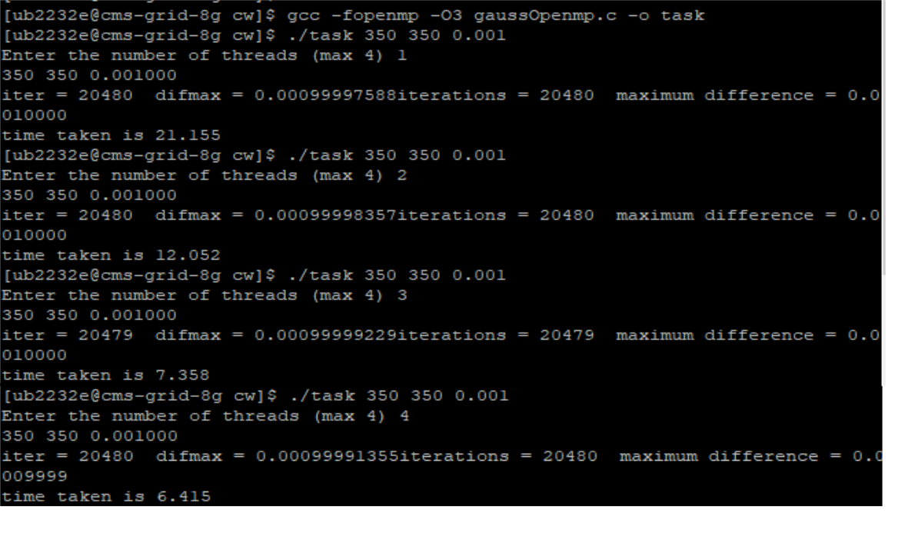

Figure 10 shows the results of Gauss | 20| P a g e
Jacobi 2D Test Cases

Compiler Optimisation: O3

 | Jacobi 2D | 500*500(s) | 600*600(s) | 700*700(s)
 | 2 |  | RESULTS
 | TEST NO. 1 | 10.041 | 14.207 | 18.878
 | TEST NO. 2 | 10.651 | 14.443 | 19.997
 | TEST NO. 3 | 10.222 | 14.332 | 18.926
 | TEST NO. 4 | 9.717 | 14.227 | 19.548
 | TEST NO. 5 | 10.332 | 14.697 | 19.541
 | AVERAGE: | 10.1926 | 14.3812 | 19.378
 | Jacobi 2D | 500*500(s) | 600*600(s) | 700*700(s)
 | 4 |  | RESULTS
 | TEST NO. 1 | 6.183 | 7.455 | 10.517
 | TEST NO. 2 | 5.930 | 8.054 | 10.460
 | TEST NO. 3 | 5.332 | 7.651 | 10.035
 | TEST NO. 4 | 5.285 | 7.411 | 11.016
 | TEST NO. 5 | 5.829 | 7.817 | 9.914
 | AVERAGE: | 5.7118 | 7.6776 | 10.3884
 | Jacobi 2D | 500*500(s) | 600*600(s) | 700*700(s)
 | 6 |  | RESULTS
 | TEST NO. 1 | 4.474 | 5.340 | 7.777
 | TEST NO. 2 | 4.348 | 5.561 | 7.465
 | TEST NO. 3 | 4.327 | 5.659 | 7.297
 | TEST NO. 4 | 4.201 | 4.632 | 7.737
 | TEST NO. 5 | 3.247 | 3.507 | 6.852
 | AVERAGE: | 4.1194 | 4.9398 | 7.4256
 | Jacobi 2D | 500*500(s) | 600*600(s) | 700*700(s)
 | 8 |  | RESULTS
 | TEST NO. 1 | 3.668 | 3.603 | 5.665
 | TEST NO. 2 | 2.529 | 4.502 | 5.852
 | TEST NO. 3 | 2.553 | 4.082 | 5.674
 | TEST NO. 4 | 3.206 | 4.994 | 5.521
 | TEST NO. 5 | 2.411 | 4.510 | 5.859
 | AVERAGE: | 2.8734 | 4.3382 | 5.7142
Table 9 shows the results of Jacobi

21 | P a g e
Gauss 2D Test Cases

Compiler Optimisation: O3

 | Gauss 2D | 500*500(s) | 600*600(s) | 700*700(s)
 | 2 |  | RESULTS
 | TEST NO. 1 | 28.798 | 45.044 | 66.627
 | TEST NO. 2 | 28.636 | 45.144 | 65.028
 | TEST NO. 3 | 28.843 | 46.044 | 65.448
 | TEST NO. 4 | 28.887 | 45.856 | 65.633
 | TEST NO. 5 | 29.257 | 45.993 | 66.147
 | AVERAGE: | 28.8842 | 45.6162 | 65.7766
 | Gauss 2D | 500*500(s) | 600*600(s) | 700*700(s)
 | 4 |  | RESULTS
 | TEST NO. 1 | 15.101 | 24.028 | 34.552
 | TEST NO. 2 | 15.485 | 23.311 | 34.038
 | TEST NO. 3 | 15.184 | 25.421 | 33.962
 | TEST NO. 4 | 15.137 | 23.575 | 34.323
 | TEST NO. 5 | 15.485 | 24.038 | 33.946
 | AVERAGE: | 15.2784 | 24.0746 | 34.1642
 | Gauss 2D | 500*500(s) | 600*600(s) | 700*700(s)
 | 6 |  | RESULTS
 | TEST NO. 1 | 11.068 | 16.066 | 24.566
 | TEST NO. 2 | 12.337 | 16.854 | 23.563
 | TEST NO. 3 | 10.574 | 16.550 | 23.568
 | TEST NO. 4 | 11.218 | 16.299 | 23.012
 | TEST NO. 5 | 10.502 | 16.705 | 23.353
 | AVERAGE: | 11.1398 | 16.4948 | 23.6124
 | Gauss 2D | 500*500(s) | 600*600(s) | 700*700(s)
 | 8 |  | RESULTS
 | TEST NO. 1 | 9.524 | 12.799 | 18.473
 | TEST NO. 2 | 8.156 | 12.506 | 17.207
 | TEST NO. 3 | 7.993 | 12.609 | 18.347
 | TEST NO. 4 | 8.625 | 13.647 | 17.415
 | TEST NO. 5 | 5.745 | 12.885 | 17.367
 | AVERAGE: | 8.0086 | 12.8892 | 17.7618
Table 10 shows the results of Gauss.

Referring to Table 9 and 10, both show the results of using O3 optimisation. As you can see, there is a huge difference in both results that you can see. A problem size of 500 using 2 threads can be ran in 10 seconds. However, Gauss with the same problem size is 28 seconds. Gauss makes more sense as the difference speedup from Task 2 shows the difference in size. By using 8 threads, the execution time for both makes sense. Jacob, on average, by using 8 threads compiles it 4 times as faster than using 2 threads. This is roughly the same for Gauss as 8 threads has a 4 times compiler rate than using 2 threads too. Therefore, there is not much difference in terms of comparing both results.

22| P a g e
Comparison Jacobi and Gauss Average

Please refer yourself to Figure 11 and Figure 12 where this is a graph representation of the results of the test cases that were completed using O3 optimisation. These are the average of each problem sizes that were used. This shows a great interpretation of each size is decreased as soon as more threads have been used. This shows that the more threads are used and worked together; it would enable the time to decrease. This is the same for both out comes.

Jacobi O3 Optimisation Average

Times (s)

25

19.378
20
14.3812
15
15 |  | 10.3884
10.1926 |  | 10.3884
10
10 |  | 7.6776 |  | 7.4256
 |  | 5.7118 | 4.9398 |  | 5.7142
 |  |  |  |  | 4.3382
5 |  |  | 4.1194 |  | 4.3382
5 |  |  |  |  | 2.8734
0
2 |  | 4 |  | 6 | 8
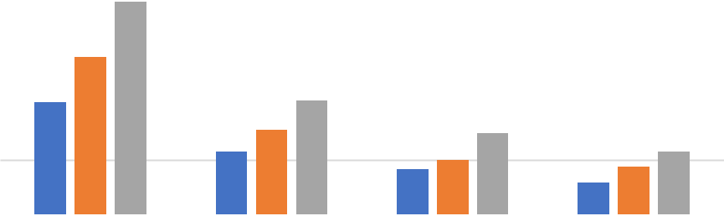

Threads

500 600 700

Figure 11 shows a graph of Jacobi using O3 optimisation

Gauss O3 Optimisation Average

Time (s)

- 65.7766
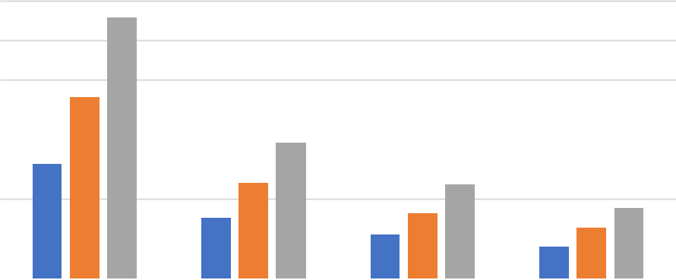

60

- 45.6162

40
40 |  | 34.1642
28.8842
30
30 |  | 24.0746 | 23.6124
20 |  | 15.2784 | 16.4948 | 17.7618
20 |  | 15.2784 | 11.1398 | 12.8892
 |  |  | 11.1398 | 8.0086
10 |  |  |  | 8.0086
0
2 |  | 4 | 6 | 8

Threads

500 600 700

Figure 12 shows a graph of Gauss using O3 optimisation

23| Page

Comparison of Task 1 and Task 3 Speedup

Referring to Figure 13 and Figure 14, this shows the results of the speed-up that of 500*500 problem size. This is due to the fact that 500 was used throughout each task. Therefore, it makes sense to provide a speedup result showing how much it has increased throughout each task. This was completed by getting Step 1 average of O3 which is 18.4404488. This was divided by each average of 500 shown in Table 9. By doing this, you can see the results of the speed-up of this in Figure 13. 45.692872 is the result of Step 1 for Gauss too. By dividing the average of 500 show in Table 10, you can see the results of the speed-up of this Figure 14,

Speed Up Jacobi 500*500

Speedup

7 |  |  |  | 6.417623721
6
5 |  |  | 4.476477157
4
4 |  | 3.228474386
3
3 | 1.809194906
2 | 1.809194906
1
0
0 | 2 | 4 | 6 | 8
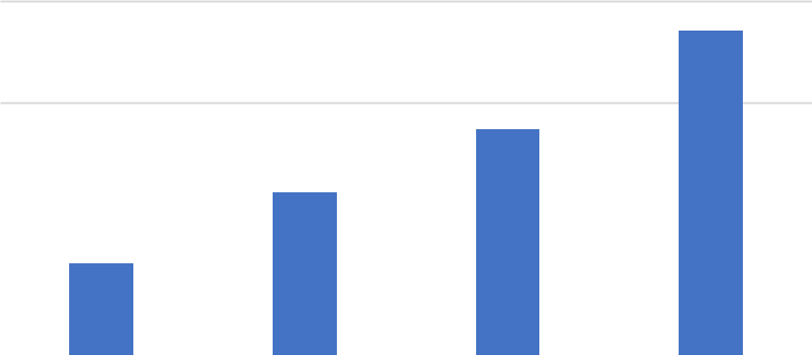

Threads

Figure 13 shows a graph of speed up in Jacobi

Speedup

Speed Up Gauss 500*500

6 | 5.705491597
5
5 | 4.101779206
4
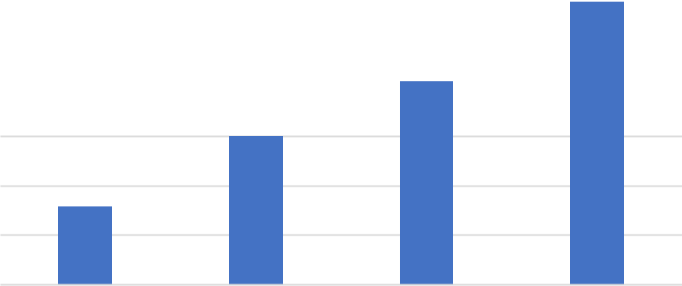

2.990692743
3

- 1.58193753

0

2 4 6 8

Threads

Figure 14 shows a graph of speed up in Gauss.

24 | P a g e

Task 4

In this task, further modifications were made to improve the parallel performance of this task. Please refer yourself to Figure 15 and Figure 16, these are the modifications of both codes. NOWAIT clause allows the thread to continue of execution by excluding the wait of other threads in the team to complete the region As this task was done on the last day, considering the performance issue, I could not alter these results for better and accurate results.

Improvements on Jacobi 2D

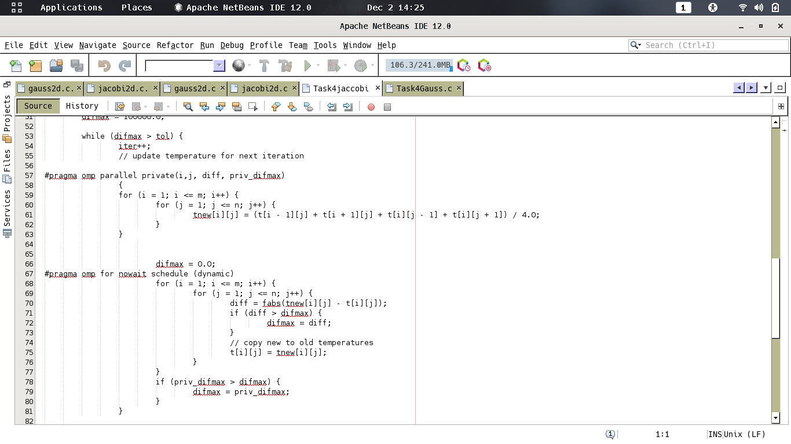

Improvements on Gauss 2D

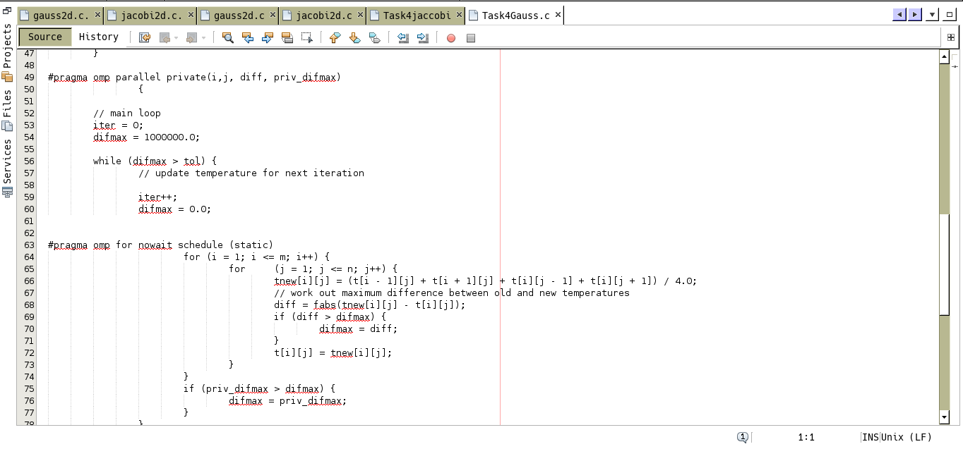

Figure 16 shows the modifications of what was made in Gauss. | 25 | Page

Screenshots Jacobi 2D Improvements

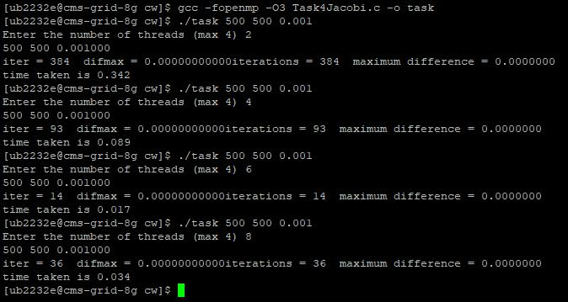

Figure 17 shows an example of improvement within Jacobi

Screenshots Gauss 2D Improvements
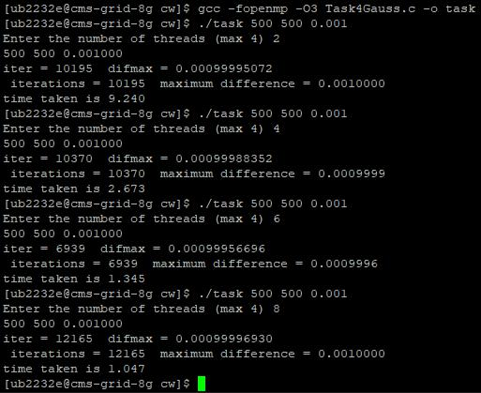

Figure 18 shows an example of improvement within Gauss.

26 | P a g e
Jacobi 2D Test Cases

 | Jacobi 2D | 500*500(s) | 600*600(s) | 700*700(s)
 | 2 |  | RESULTS
 | TEST NO. 1 | 1.606 | 3.584 | 5.067
 | TEST NO. 2 | 1.285 | 3.489 | 8.308
 | TEST NO. 3 | 1.736 | 1.642 | 4.226
 | TEST NO. 4 | 2.628 | 3.851 | 5.510
 | TEST NO. 5 | 1.030 | 2.443 | 5.034
 | AVERAGE: | 1.657 | 3.0018 | 5.629
 | Jacobi 2D | 500*500(s) | 600*600(s) | 700*700(s)
 | 4 |  | RESULTS
 | TEST NO. 1 | 0.767 | 1.078 | 1.552
 | TEST NO. 2 | 0.734 | 1.186 | 0.945
 | TEST NO. 3 | 0.404 | 0.678 | 0.886
 | TEST NO. 4 | 0.417 | 0.519 | 2.102
 | TEST NO. 5 | 0.168 | 1.003 | 0.765
 | AVERAGE: | 0.498 | 0.8928 | 1.25
 | Jacobi 2D | 500*500(s) | 600*600(s) | 700*700(s)
 | 6 |  | RESULTS
 | TEST NO. 1 | 0.107 | 0.110 | 0.117
 | TEST NO. 2 | 0.033 | 0.145 | 0.125
 | TEST NO. 3 | 0.033 | 0.083 | 0.218
 | TEST NO. 4 | 0.028 | 0.077 | 0.190
 | TEST NO. 5 | 0.038 | 0.176 | 0.053
 | AVERAGE: | 0.0478 | 0.1182 | 0.1406
 | Jacobi 2D | 500*500(s) | 600*600(s) | 700*700(s)
 | 8 |  | RESULTS
 | TEST NO. 1 | 0.033 | 0.016 | 0.035
 | TEST NO. 2 | 0.033 | 0.018 | 0.039
 | TEST NO. 3 | 0.024 | 0.013 | 0.027
 | TEST NO. 4 | 0.020 | 0.011 | 0.037
 | TEST NO. 5 | 0.005 | 0.023 | 0.045
 | AVERAGE: | 0.023 | 0.0162 | 0.0366
Table 11 shows the results of Jacobi

27 | P a g e
Gauss 2D Test Cases

 | Gauss 2D | 500*500(s) | 600*600(s) | 700*700(s)
 | 2 |  | RESULTS
 | TEST NO. 1 | 9.521 | 14.772 | 25.102
 | TEST NO. 2 | 9.128 | 15.426 | 23.047
 | TEST NO. 3 | 9.531 | 15.305 | 23.577
 | TEST NO. 4 | 9.118 | 15.398 | 23.204
 | TEST NO. 5 | 9.229 | 15.158 | 23.230
 | AVERAGE: | 9.3054 | 15.2118 | 23.632
 | Gauss 2D | 500*500(s) | 600*600(s) | 700*700(s)
 | 4 |  | RESULTS
 | TEST NO. 1 | 2.871 | 3.880 | 7.279
 | TEST NO. 2 | 2.820 | 4.992 | 6.572
 | TEST NO. 3 | 2.996 | 4.169 | 7.990
 | TEST NO. 4 | 3.135 | 3.855 | 7.297
 | TEST NO. 5 | 2.758 | 4.011 | 6.236
 | AVERAGE: | 2.916 | 4.1814 | 7.0748
 | Gauss 2D | 500*500(s) | 600*600(s) | 700*700(s)
 | 6 |  | RESULTS
 | TEST NO. 1 | 1.540 | 2.372 | 3.267
 | TEST NO. 2 | 1.402 | 2.402 | 4.693
 | TEST NO. 3 | 1.391 | 2.114 | 4.048
 | TEST NO. 4 | 1.651 | 2.413 | 3.633
 | TEST NO. 5 | 1.335 | 2.335 | 4.049
 | AVERAGE: | 1.4638 | 2.3272 | 3.938
 | Gauss 2D | 500*500(s) | 600*600(s) | 700*700(s)
 | 8 |  | RESULTS
 | TEST NO. 1 | 1.033 | 1.406 | 2.190
 | TEST NO. 2 | 0.853 | 1.656 | 2.174
 | TEST NO. 3 | 1.016 | 1.556 | 2.200
 | TEST NO. 4 | 0.921 | 1.408 | 2.401
 | TEST NO. 5 | 0.967 | 1.528 | 2.631
 | AVERAGE: | 0.958 | 1.5108 | 2.3192
Table 12 shows the results of Gauss.

Referring to Table 11 and 12, these show the results of Jacobi and Gauss. As you may know, Task 3 improvements were to adjust from on average of 10s to run 500, to 1s. However, for Jacobi, these results fluctuating. This may be the case of testing this on the last day, due to a performance issue as more than one person would be using 8G. These results are too quick. However, the improvement for Gauss has improved drastically.

28 | P a g e
Comparison Jacobi and Gauss Average

Please refer yourself to Figure 19 and Figure 20 where this is a graph representation of the results of the test cases that were completed using improvements of Task 3. These are the average of each problem sizes that were used. This shows a great interpretation of each size is decreased as soon as more threads have been used. This shows that the more threads are used and worked together; it would enable the time to decrease. This is the same for both out comes.
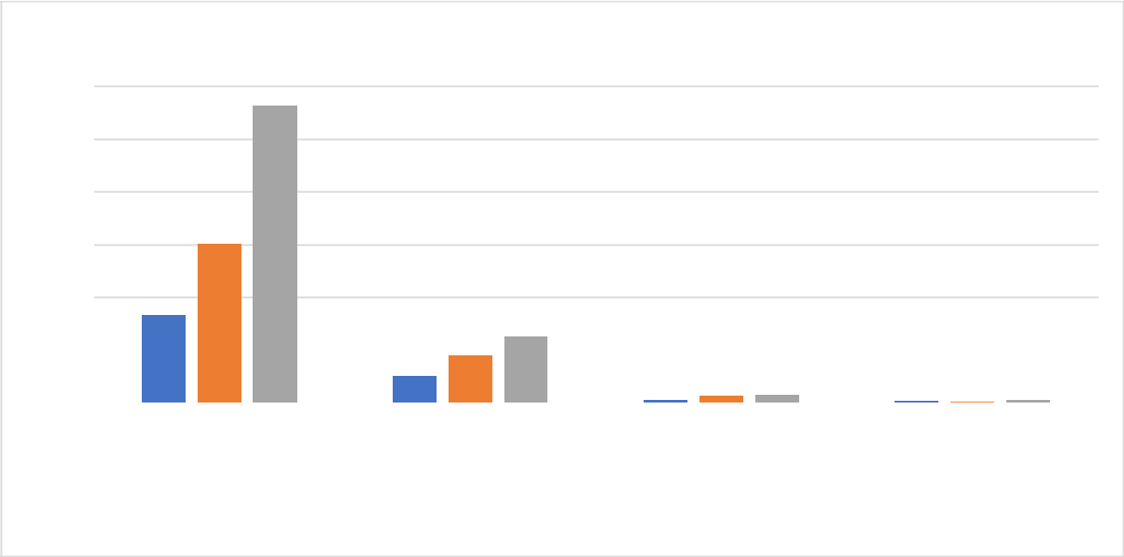

 | 6
 | 5
Times(s) | 4
Times(s) | 3

2

1

0

 | 25
 | 20
Time (s) | 15
Time (s) | 10

5

0

Jacobi Comparison Average

5.629

3.0018

1.657
1.25
0.8928

 | 0.498 |  |  |  |  | _{0.0478}0.11820.1406
 |  |  |  |  |  |  |  | 0.023 0.01620.0366
2 | 4 |  |  |  |  | 6 |  | 8
 |  |  |  |  | Threads
 |  |  | 500 |  | 600 |  | 700

Figure 19 shows the Jacobi average of Task 4
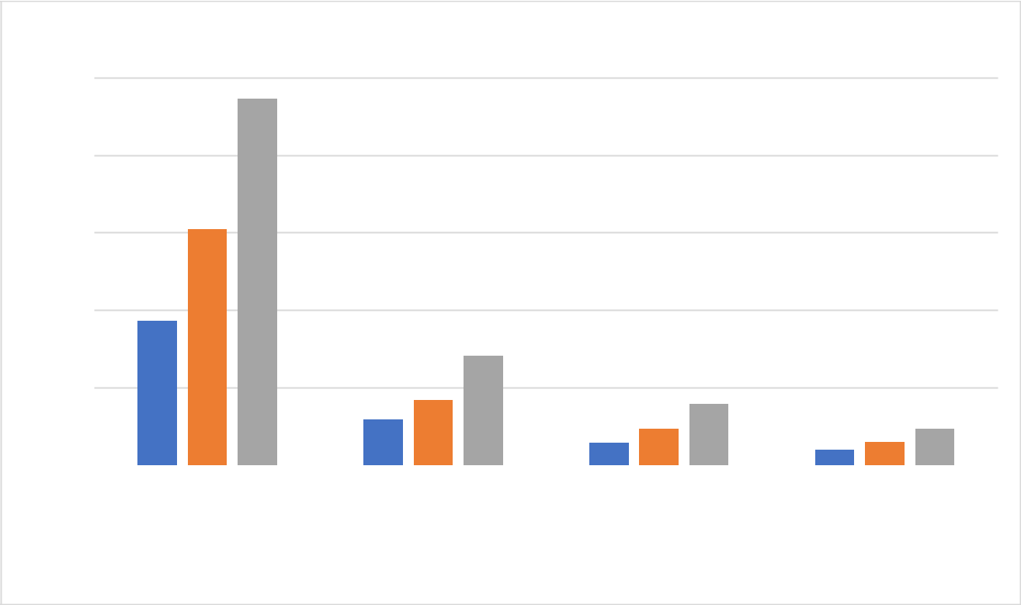

Gauss Comparison Average

23.632

15.2118

9.3054

7.0748

 | 4.1814 |  |  |  |  |  |  | 3.938
 | 2.916 |  |  |  |  | 1.4638^{2.3272} |  | 3.938
 | 2.916 |  |  |  |  |  |  | _{0.958} 1.5108^{2.3192}
2 | 4 |  |  |  |  | 6 |  | 8
 |  |  |  |  | Threads
 |  |  | 500 |  | 600 |  | 700

Figure 20 shows the Jacobi average of Task 4

29 | P a g e

Comparison of Task 3 and Task 4 Speedup

Figure 21 and Figure 22 show the speedup from Task 3. This has been done by simple calculation of subtracting each task from Task 3 average by Task 4. Here is the difference. As you can see, Figure 22 for Gauss has a bigger difference than Jacobi. This may be due to Jacobi was already having a quicker rate than Gauss. Therefore, when improvements were made; it had a smaller impact than Gauss.
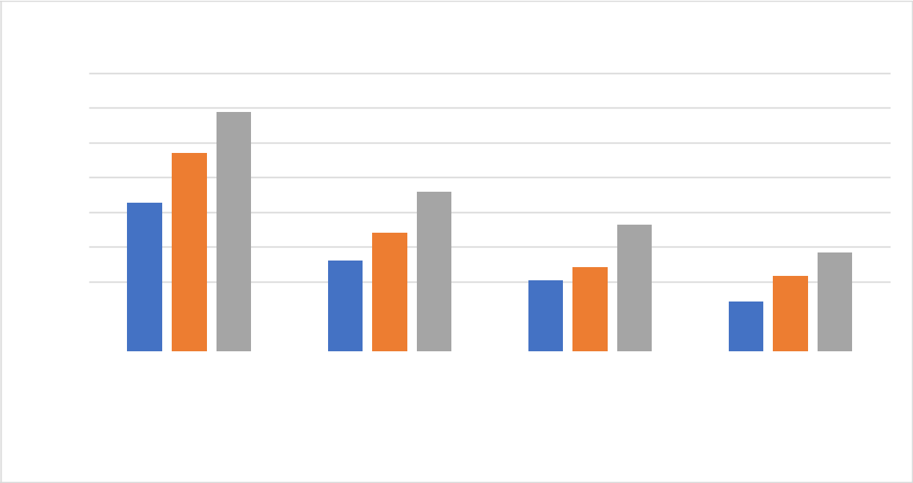

Speedup

Speedup

Jacobi Speedup from Task 3

16
13.749
14
- 11.3794

10 | 8.5356 | 9.1384
8 |  | 6.7848 |  | 7.285
8 |  | 6.7848 |  | 5.6776
6 |  | 5.2138 | 4.8216 | 5.6776
6 |  | 5.2138 | 4.8216 | 4.322
 |  |  | 4.0716 | 4.322
4 |  |  |  | 2.8504
2
0
0 | 2 | 4 | 6 | 8
Threads

 |  |  |  |  |  | 500 |  |  |  |  | 600 |  |  |  |  |  |  |  |  | 700
 |  | Figure 21 shows the speedup from Task 3 for Jacobi
 |  | Gauss Speedup from Task 3
45 |  | 42.1446
40
35
30.4044
30 |  | 27.0894
25
25 |  | 19.8932 |  |  |  |  |  |  |  |  |  |  |  |  |  | 19.6744
19.5788
20
20 |  |  |  |  |  |  |  |  |  |  |  |  |  |  |  | 14.1676 |  |  |  |  |  |  |  | 15.4426
15 |  | 12.3624
15 |  | 12.3624 |  |  |  |  |  |  |  |  |  |  |  |  |  | 9.676 |  |  |  |  |  |  |  | 11.3784
10
10 |  |  |  |  |  |  |  |  |  |  |  |  |  |  |  |  |  |  |  |  |  |  |  | 7.0506
5
0
2 |  | 4 |  |  |  |  |  |  |  |  |  |  |  |  |  | 6 |  |  |  |  |  |  |  | 8
 |  |  |  |  |  |  |  |  |  |  |  |  | Threads
 |  |  |  |  |  |  | 500 |  |  |  |  | 600 |  |  |  |  |  |  |  |  | 700
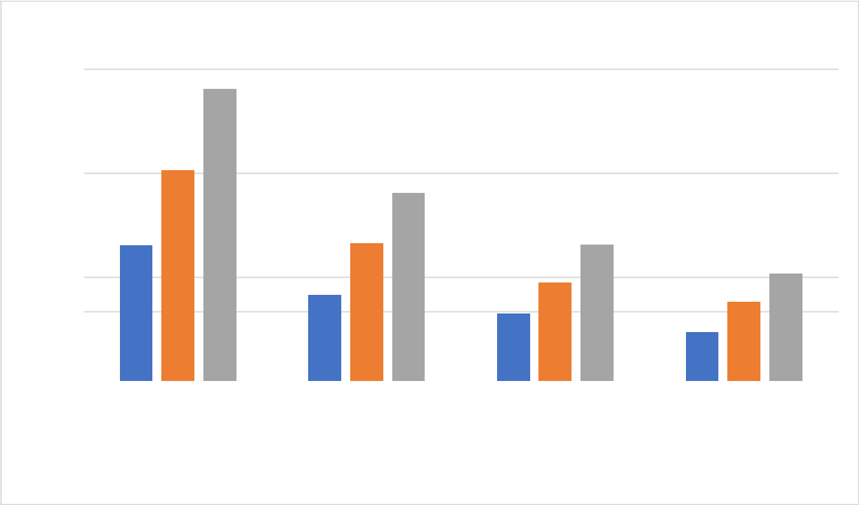

Figure 22 shows the speedup from Task 3 for Gauss

30 | P a g e

References

- Wiki Gentoo (2019). GCC Optimization. https://wiki.gentoo.org/wiki/GCC_optimization

- Wikipedia (2019). Optimizing compiler. [online] Available at: https://en.m.wikipedia.org/wiki/Optimizing_compiler
- Barney, B. (2008). Introduction to Parallel Computing. [online] Computing.llnl.gov. Available at: https://computing.llnl.gov/tutorials/parallel_comp/.

31 | P a g e

