WordPress Deployment on AWS ECS Fargate with RDS Documentation
Table of Contents
WordPress Deployment on AWS ECS Fargate with RDS Documentation 1
1. Prerequisites 1
2. Objective 2
3. Architecture Diagram General Workflow of the Infrastructure 3
4. Project Structure 4
5. Files, Purpose and Explanation 4
5.1 provider.tf 4
5.2 backend.tf 4
5.3 variables.tf 5
5.4 terraform.tfvars 5
5.5 outputs.tf 5
6. Module Explanations 5
6.1 VPC Module 5
6.2 Security Module 6
6.3 RDS Module 6
6.4 ECR Module 7
6.5 ECS Module 7
main.tf 8
7. Terraform Deployment Commands 8
Initialize providers and modules 8
Format code (optional but recommended) 8
Validate configuration 8
View changes before applying 8
Deploy infrastructure 8
8. Testing and Validation 9
8.1 Verify AWS Resources in Console 9
8.2 Push WordPress Image to Amazon ECR 10
8.3 Validate ECS Fargate Deployment 11
8.4 Accessing the WordPress Frontend 11
8.5 Connecting WordPress to RDS 12
8.6 Post-Deployment Verification 13
9. Troubleshooting 13
Issue 1 : ECS Task Starts but WordPress Cannot Reach Database 13
Issue 2 : ECS Task Fails to Pull Image 14
Issue 3 : RDS Setup Fails with Password Error 14
10. Cleanup 14
Conclusion 15

1. Prerequisites
Before starting, ensure the following requirements are satisfied:
- Terraform installed (v1.0+ recommended)
- AWS CLI configured with valid IAM credentials
- An S3 bucket created manually for Terraform remote backend
  - (Best practice for production to avoid storing state locally)
- Basic networking understanding (VPC, Subnets, Security Groups, IAM)
- Docker installed (only needed if pushing custom images to ECR)

2. Objective
Deploy a production-style WordPress application using Terraform, hosted on:
- ECS Fargate (fully serverless compute)
- Amazon RDS MySQL (managed database)
- VPC with two public subnets
- Security groups allowing communication between services
- Ubuntu-based WordPress container from Docker Hub
(wordpress:latest)
The deployment goal:
- ECS Fargate runs the WordPress container
- Application connects securely to the RDS MySQL instance
- Infrastructure follows modular Terraform design, similar to enterprise layouts

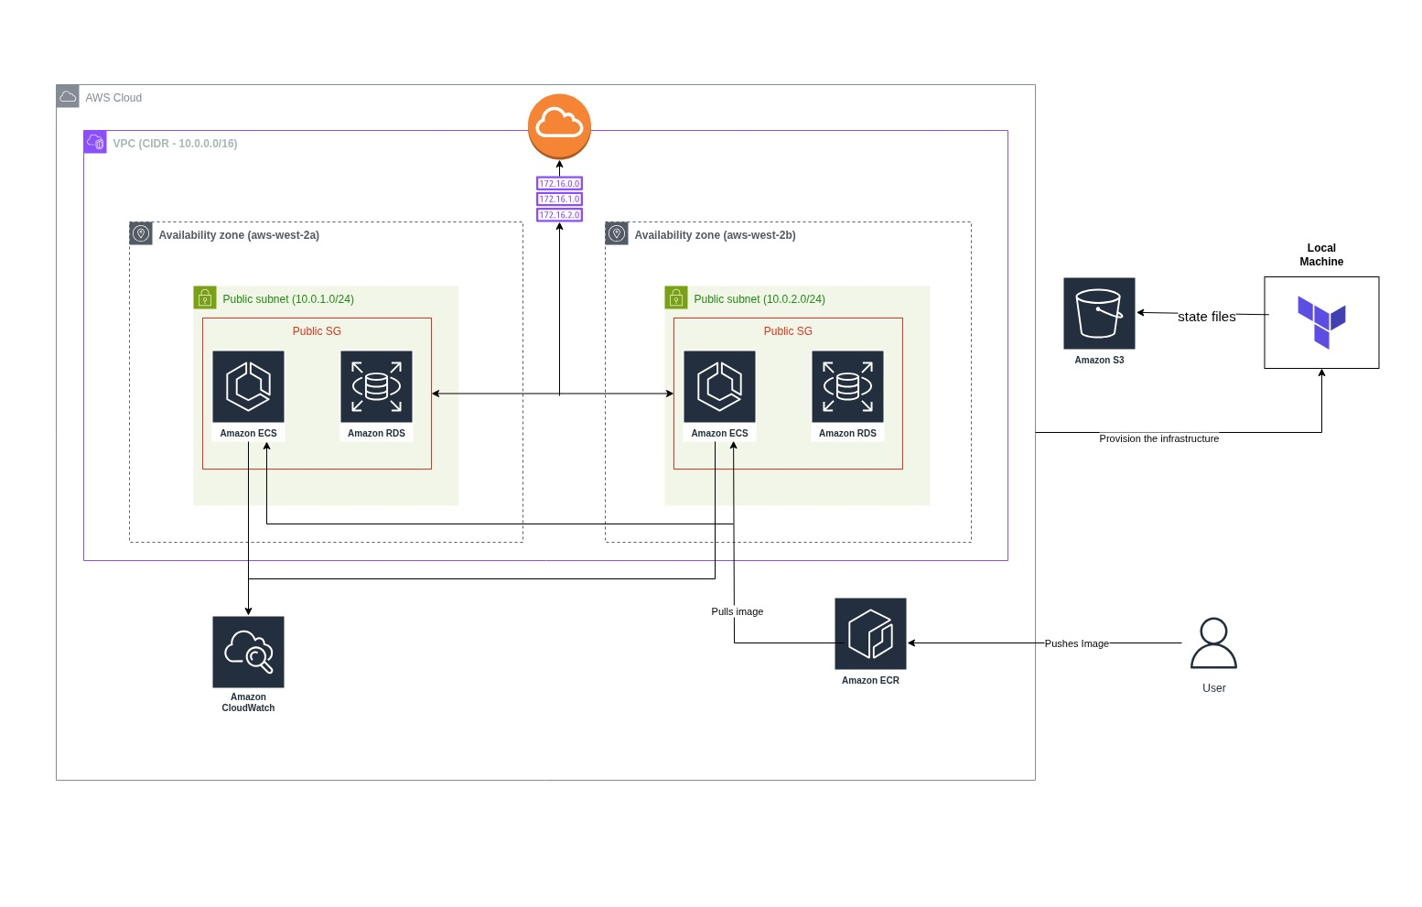
3. Architecture Diagram
General Workflow of the Infrastructure
You Push Image → ECR
↓
ECS Pulls Image → ECS Task Starts (WordPress Container)
↓
ECS Task Connects → RDS (Database)
↓
You Access ECS Task IP → WordPress Frontend Loads in Browser

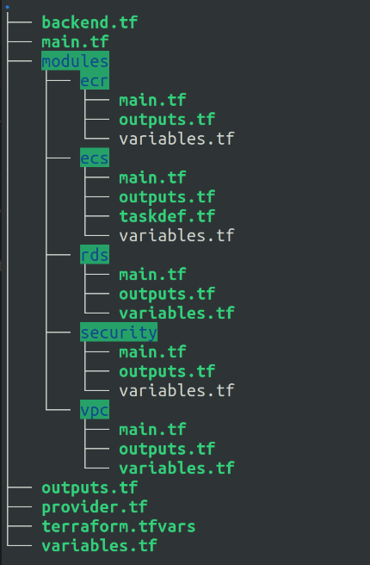
4. Project Structure

5. Files, Purpose and Explanation

5.1 provider.tf
- Configures the AWS provider pointing to us-west-2.
- Ensures Terraform knows which cloud provider and region to deploy to.

5.2 backend.tf
- Configures Terraform to store state remotely in S3.
- Enhances:
  - multi-user collaboration
  - state durability
- S3 bucket is created manually and referenced here.

5.3 variables.tf
- Central location for input variables:
  - VPC CIDRs
  - Subnet lists
  - RDS DB username/password
  - WordPress image name (wordpress:latest)
  - Instance types / ECS configuration

5.4 terraform.tfvars
Defines real deployment values, such as:
- AWS region
- VPC CIDR
- Subnets
- DB credentials
- Container image name
Terraform loads these automatically.

5.5 outputs.tf
Displays useful post-deployment information, such as:
- ECS Load Balancer or Service endpoint (if configured)
- RDS connection endpoint
- VPC ID and subnet IDs
- ECS cluster name

6. Module Explanations

6.1 VPC Module
Files:
modules/vpc/main.tf
modules/vpc/variables.tf
modules/vpc/outputs.tf
Function:
- Creates:
  - AWS VPC
  - Two public subnets (as per requirements)
  - Internet Gateway
  - Route tables associating subnets with the IGW
Reason:
- ECS tasks must reach the internet to pull Docker images.
- RDS deployed in public subnet for simplicity in this minimal setup.
Outputs usually include:
- vpc_id
- public_subnet_ids

6.2 Security Module
Files:
modules/security/main.tf
modules/security/variables.tf
modules/security/outputs.tf
Creates:
- Security group for WordPress ECS tasks:
  - Allows HTTP/HTTPS inbound
  - Allows outbound to RDS
- Security group for RDS:
  - Only accepts inbound MySQL (3306) from ECS SG
  - Everything else denied
This ensures controlled network access.

6.3 RDS Module
Files:
modules/rds/main.tf
modules/rds/variables.tf
modules/rds/outputs.tf
Responsible for:
- Deploying an Amazon RDS MySQL instance (db.t3.micro)
- Using credentials provided via variables
- Placed in a VPC subnet
- Security group applied
Outputs include:
- RDS endpoint
Used later by ECS task definition.

6.4 ECR Module
Files:
modules/ecr/main.tf
modules/ecr/variables.tf
modules/ecr/outputs.tf
Creates:
- An AWS Elastic Container Registry repository
- Allows pushing custom WordPress images if needed
If using Docker Hub image (wordpress:latest) – module still exists but may be unused.

6.5 ECS Module
Files:
modules/ecs/main.tf
modules/ecs/variables.tf
modules/ecs/outputs.tf
modules/ecs/taskdef.tf
Responsible for:
- Creating the ECS Cluster
- Defining an ECS Service running Fargate
- Creating an IAM Execution Role so the task can pull images and write logs
- Creating an ECS Task Definition (taskdef.tf) including:
  - WordPress container
  - Environment variables:
    - WORDPRESS_DB_HOST
    - WORDPRESS_DB_USER
    - WORDPRESS_DB_PASSWORD
    - WORDPRESS_DB_NAME
  - Log configuration
  - CPU / Memory sizing
This is the core of the application deployment.
The ECS service ensures:
- The container is continuously running
- If stopped, AWS restarts it automatically

main.tf
This file ties all modules together:
- Calls VPC module
- Calls security groups module
- Deploys RDS with the correct DB credentials
- Deploys ECS with the correct container configuration
- Passes outputs between modules (example: RDS endpoint → ECS task definition)
It is the central orchestration file.

7. Terraform Deployment Commands

Initialize providers and modules
terraform init

Format code (optional but recommended)
terraform fmt

Validate configuration
terraform validate

View changes before applying
terraform plan

Deploy infrastructure
terraform apply
Once complete, Terraform prints outputs, including:
- RDS endpoint
- ECS service details
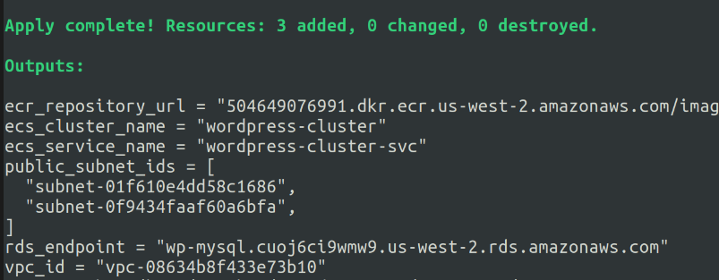

8. Testing and Validation
After deploying the Terraform configuration, the following steps were performed to verify that the infrastructure and WordPress deployment were working correctly.

8.1 Verify AWS Resources in Console
Once terraform apply completed successfully, the first step was to confirm that all major AWS resources were deployed as expected:
- VPC
- Public subnets
- Security groups
- RDS MySQL instance
- ECS Cluster
- ECS Service and running Task
- ECR Repository (if using ECR)
Validation Steps
- Log in to the AWS Console
- Open VPC Console → confirm VPC CIDR and subnets
- Check RDS Console → ensure DB instance is available
- Open ECS Console → Cluster → verify task is running
- Ensure ECS Service targets are healthy
- If using ECR: open ECR Console and verify the repository exists

8.2 Push WordPress Image to Amazon ECR
To make the WordPress container available to ECS, the image was pushed to ECR.
- Go to AWS Console for ECR, select your private registry and goto images.
- Click on View push commands on the right and paste them into the aws configured cli.
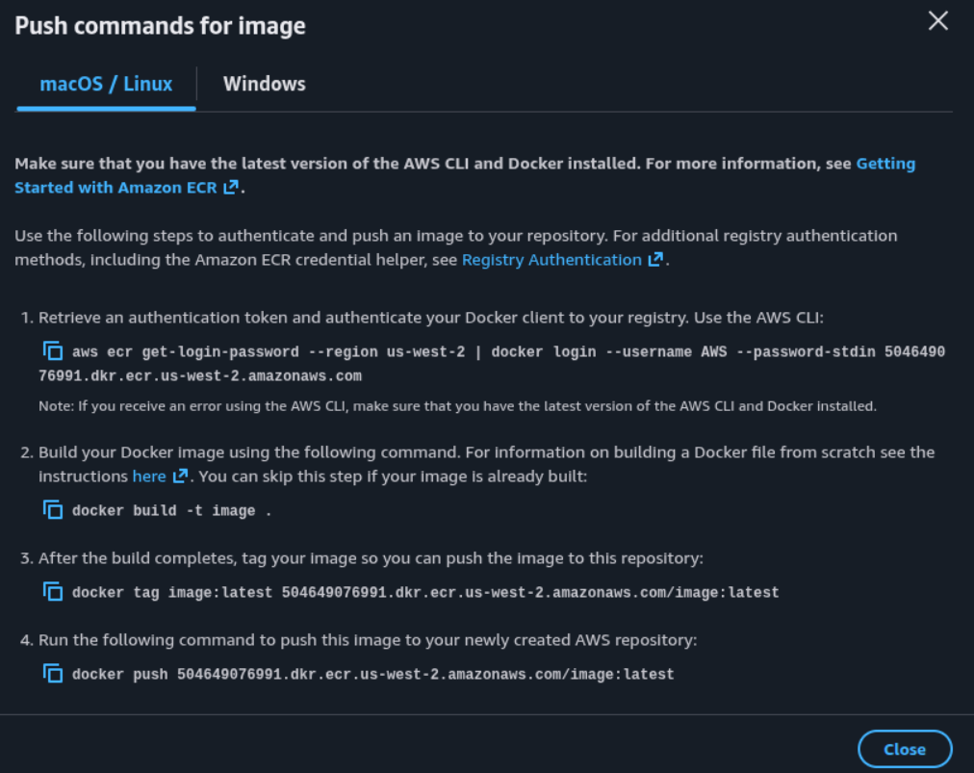
Then confirm the image has been pushed:

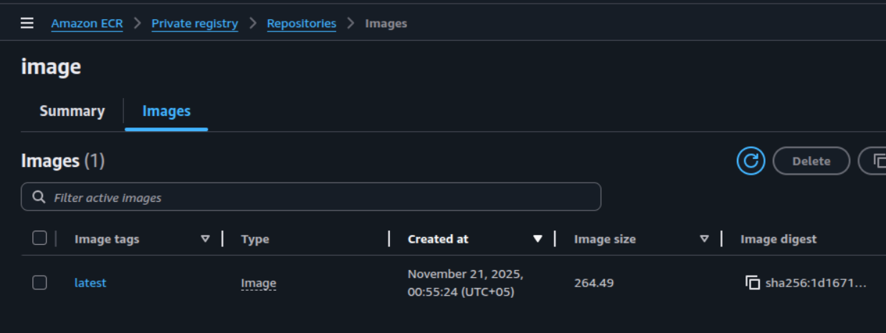

8.3 Validate ECS Fargate Deployment
Once the image was pushed, the ECS service automatically pulled the latest image and started a task in the cluster.
Validation Steps
- Navigate to:
ECS → Clusters → <cluster-name> → Tasks
- Confirm that:
  - Task status is RUNNING
  - Desired count equals running count
  - Task logs show no startup errors
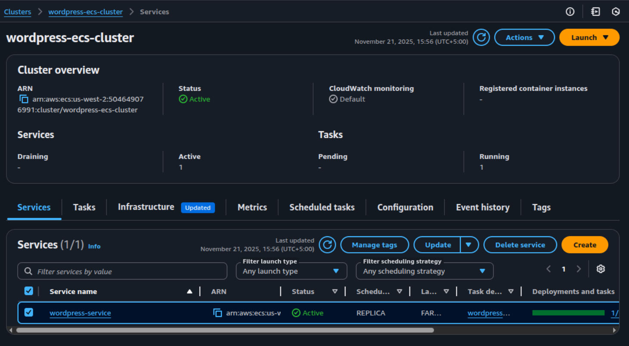

8.4 Accessing the WordPress Frontend
With the ECS task running successfully, the next step was to access WordPress from a browser.
- Go to EC2 Console and scroll down to Network Interfaces under Network and Security.
- Locate your ENI that belong to the public security group.
- Copy its IPv4 address and access it via browser. You will see the wordpress setup page.
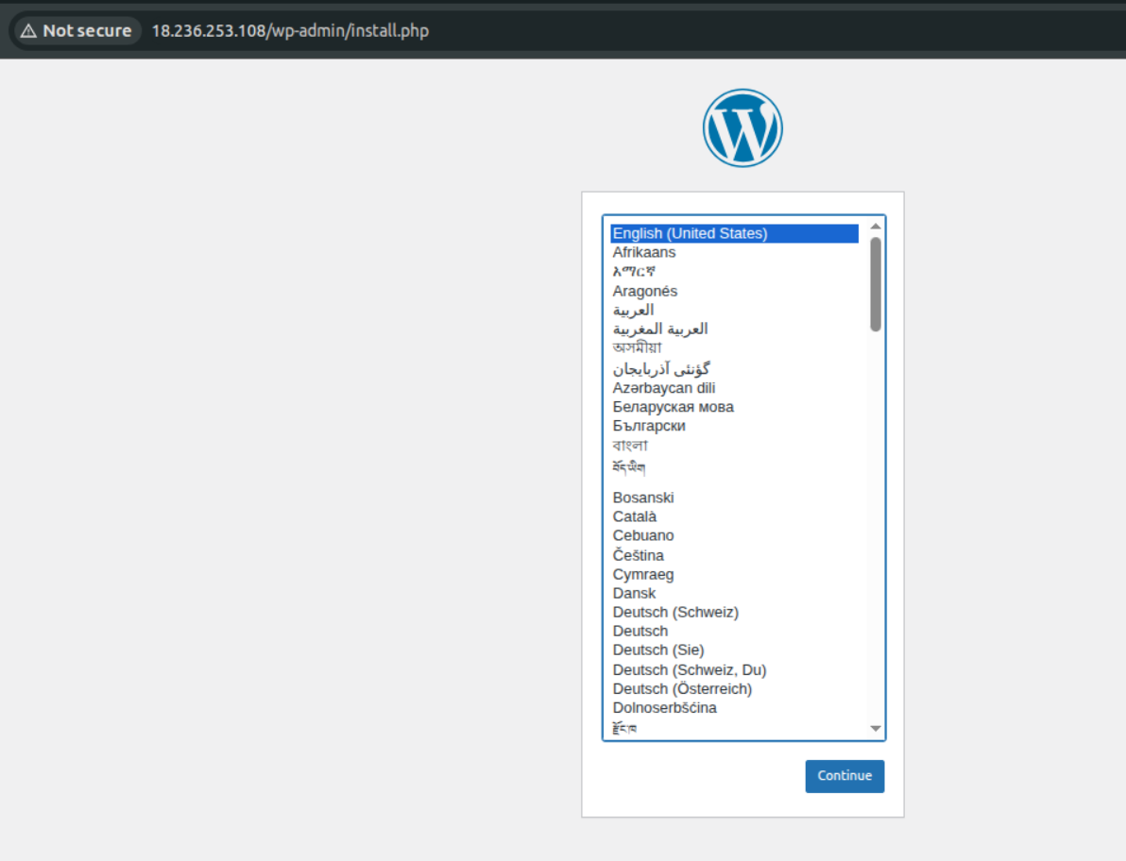
User can proceed with:
  - Site title
  - Admin user credentials
  - Database configuration

8.5 Connecting WordPress to RDS
During setup, the following values were entered:
Field | Value
Database Name | cloud
Username | wajahat
Password | (secure password used in tfvars)
Database Host | <rds-endpoint>
These values match the Terraform-provisioned RDS configuration.
If the configuration is correct:
- WordPress connects to RDS
- The installation completes successfully

8.6 Post-Deployment Verification
Final checks included:
- Confirming tables created in RDS:
SHOW DATABASES;
USE cloud;
SHOW TABLES;
- Confirming WordPress is reachable after a browser refresh
- Verifying logs in CloudWatch (if configured)

9. Troubleshooting
This section covers common errors encountered during deployment and how to resolve them.

Issue 1 : ECS Task Starts but WordPress Cannot Reach Database
Symptom:
WordPress setup page reports:
Error establishing a database connection
Cause:
The ECS Task Definition does not contain the required database environment variables, such as:
- WORDPRESS_DB_HOST
- WORDPRESS_DB_NAME
- WORDPRESS_DB_USER
- WORDPRESS_DB_PASSWORD
Without these, the container starts but cannot locate the RDS instance.
Resolution:
- Open modules/ecs/taskdef.tf
- Ensure the container definition includes:
environment = [
{ name = "WORDPRESS_DB_HOST", value = module.rds.db_endpoint },
{ name = "WORDPRESS_DB_NAME", value = var.db_name },
{ name = "WORDPRESS_DB_USER", value = var.db_username },
{ name = "WORDPRESS_DB_PASSWORD", value = var.db_password }
]
- Re-run:
terraform apply
- Wait for the ECS service to redeploy the task.

Issue 2 : ECS Task Fails to Pull Image
Symptom:
Task status in ECS → “Stopped” with reason:
CannotPullContainerError: pull access denied
Possible Causes & Fixes:
- Image not pushed to ECR
  - Push again using:
docker push <aws_account_id>.dkr.ecr.<region>.amazonaws.com/image:latest
- ECS Task IAM role missing ECR permissions
  - Ensure the task execution role includes:
    - AmazonECSTaskExecutionRolePolicy

Issue 3 : RDS Setup Fails with Password Error
Symptom:
InvalidParameterValue: MasterUserPassword is not valid
Cause:
RDS requires passwords with:
- Minimum length: 8 characters
- Must contain allowed character types
Resolution:
Update db_password in terraform.tfvars accordingly:
db_password = "StrongPass123"
Then re-run:
terraform apply

10. Cleanup
To remove all AWS resources created by Terraform:
- From the project root:
terraform destroy
- Confirm destruction when prompted.
- After destruction, manually delete the remote state bucket (if using S3) to avoid accidental future usage.
For security:
- Remove leftover ECR images (optional)
- Clear CloudWatch logs
- Ensure no orphan RDS snapshots remain

Conclusion
Testing confirmed that:
- Terraform successfully provisioned AWS networking, ECS, and RDS resources
- ECS pulled the WordPress image from ECR
- The application frontend loaded correctly
- WordPress successfully connected to RDS
- Installation completed through the browser interface

