================================================================
WRITING PLAN — ZKP-MCP for IoMT (Master's Thesis)
Numbers = the order you should WRITE each part in, not the final
thesis order. Sections stay in final thesis order below; just
follow the [priority] numbers when deciding what to work on next.
================================================================

FRONT MATTER
------------
[22] Dedications
[22] Acknowledgements
[21] Abstract (FR + EN, with keywords)
[22] Table of contents
[22] List of figures
[22] List of tables
[22] List of acronyms

[20] GENERAL INTRODUCTION
--------------------------

================================================================
CHAPTER 1 — BACKGROUND AND RELATED WORK
================================================================

[DONE] 1.1 Introduction

This chapter surveys the four pillars that form the theoretical and
technical foundation of this thesis. Section 1.3 examines the
evolution of multi-agent interoperability protocols -- with
particular focus on MCP, A2A, and their practical integration.
Section 1.4 reviews the application of MCP and combined MCP x A2A
architectures in clinical and IoMT settings, including real-world
healthcare deployments and federated learning systems. Section 1.5
covers the theoretical foundations and practical variants of
Zero-Knowledge Proofs. Section 1.6 discusses the emerging
intersection of ZKP and agent communication. Section 1.7 reviews
Retrieval-Augmented Generation (RAG) for medical question answering
and clinical decision support, including recent MCP-based
multi-agent RAG frameworks. Section 1.8 provides a comparative
synthesis of all reviewed works and positions the contribution of
this thesis.

1.2 Context and Problem Statement

The Internet of Medical Things (IoMT) refers to a network of interconnected medical devices, sensors, software applications, and healthcare systems that continuously collect, exchange, and process health-related data [30]. Managing multiple devices and multiple clinical cases at scale requires strong interoperability, which is why such systems are increasingly built as cooperating software agents rather than a single centralized program.

In this network, raw sensor data is particularly sensitive: if leaked or tampered with, it can directly harm the patient, either by violating their privacy or by leading to an incorrect clinical outcome. Protecting this data without compromising the system's ability to function is therefore a central concern.

In such a multi-agent system, no single agent has all the information needed to reach a final decision. Each agent depends on data from others to complete the pipeline — reading a sensor value, retrieving clinical guidelines, applying policy thresholds, and producing a decision. Because this data is sensitive, the interoperability connecting these agents cannot simply prioritize functionality; it must also preserve confidentiality.

This dependency is also where the risk lies: every exchange between two agents is a potential weak point. A leaked message compromises patient privacy, while a tampered or forged message can result in an incorrect clinical decision.

Several protocols currently enable this kind of agent-to-agent communication — MCP, A2A, ACP, and ANP — but they were designed primarily to solve coordination and interoperability, not confidentiality. This is the gap that motivates the present work, and it is examined in detail in the next section.

[DONE] 1.3 Multi-Agent Interoperability Protocols

1.3.1 From Classical Agent Languages to Modern Protocols

The challenge of enabling autonomous software agents to communicate
in heterogeneous environments has a long history. Early standards
such as KQML (Knowledge Query and Manipulation Language) and
FIPA-ACL, developed in the 1990s, established the foundational
vocabulary of performative-based agent communication [7]. These were
later complemented by service-oriented architectures and
retrieval-augmented generation (RAG) pipelines. However, none of
these approaches offered a unified, stateful, bidirectional interface
capable of bridging resource-constrained edge devices with
cloud-hosted LLMs. The period 2024-2025 marks a qualitative shift,
with four major protocol-oriented frameworks -- MCP, A2A, ACP, and
ANP -- emerging to address this need [7].

1.3.2 Model Context Protocol (MCP)

Introduced by Anthropic in November 2024, the Model Context Protocol
(MCP) is a context-exchange framework that redefines how LLM-centred
systems communicate [15,16,14]. Its architecture follows a
client-host-server model built on JSON-RPC 2.0. Three primitive
abstractions -- Tools, Resources, and Prompts -- allow MCP servers to
expose callable functionality, queryable data, and reusable
interaction templates to MCP clients. MCP supports two transport
modes: stdio for local subprocess communication and HTTP with
Server-Sent Events (SSE) for remote deployments. Sessions are
stateful and support dynamic capability negotiation, allowing clients
to discover available tools at runtime [14].

The rapid adoption of MCP across major AI labs (Anthropic, OpenAI,
Google DeepMind), developer tools (Cursor, JetBrains, Replit), and
cloud platforms (Cloudflare, Alibaba, Tencent) has been documented in
a comprehensive security analysis of the MCP ecosystem [19]. That
study, which catalogued over 100,000 MCP server listings across 26
community directories, found that MCP has become the de facto
standard for agent-to-tool integration. The analysis identified 16
distinct threat scenarios spanning four attacker archetypes:
malicious developers, external attackers, malicious users, and
systemic security flaws [19]. Key vulnerabilities include tool
poisoning, indirect prompt injection, credential theft, and session
hijacking -- all exploiting the absence of native cryptographic
security primitives in the current protocol design.

A complementary architectural survey [2] consolidates existing MCP
implementations across software development, healthcare, cloud
automation, and industrial control, identifying open problems in
latency, context tampering, and privilege escalation. It charts
research directions for cryptographic hardening, edge caching, and
QUIC-based transport optimisation as pathways toward a scalable and
secure deployment model.

1.3.3 Agent-to-Agent Protocol (A2A) and Complementary Protocols

Recognising that MCP addresses agent-to-tool communication but not
agent-to-agent collaboration, Google released the Agent-to-Agent
(A2A) protocol as an open-source project in April 2025 [13]. A2A is
explicitly designed to complement MCP: where MCP provides structured
I/O between an agent and external tools, A2A provides standardised
communication between autonomous agents across different frameworks
and vendors [9,13]. Its architecture is built on JSON-RPC 2.0 over
HTTP(S), using Agent Cards -- JSON-formatted capability descriptors
-- to enable dynamic discovery. Agents communicate via structured
Task objects and return standardised Artifacts. Security is enforced
through JSON Web Signatures (JWS) and OAuth 2.0.

A comparative survey of MCP, A2A, ACP (IBM's Agent Communication
Protocol), and ANP (Agent Network Protocol) [7] reveals that each
occupies a distinct niche in a complementary layered stack. MCP is
the most mature and widely adopted, but is limited to trusted,
client-server tool invocation. A2A extends collaboration to
agent-to-agent task delegation within enterprise environments using
capability-based discovery. ACP is the most flexible for multimodal,
REST-native messaging. ANP is the most architecturally ambitious,
using W3C DIDs and JSON-LD to enable open-internet, trustless agent
discovery. Critically, none of the four protocols currently provides
end-to-end formal security verification or standardised
cross-protocol interoperability bridges [7].

1.3.4 MCP x A2A Integration Frameworks

A key practical advance in the field is the integrated use of MCP and
A2A to build complete, interoperable multi-agent systems -- one that
is directly relevant to the IoMT scenario of this thesis. Jeong
[9,10] provides the most comprehensive technical analysis and
implementation of such an integrated framework. The study
demonstrates that MCP and A2A serve fundamentally complementary
roles: A2A governs the high-level "flow of conversation" between
autonomous agents, while MCP precisely manages the "information and
tool usage" required for each agent's interactions with external
systems. This principle of functional separation -- formulated as a
design principle in the integrated architecture -- avoids the
pitfall of a single protocol being stretched beyond its intended
scope.

The proposed MCP x A2A architecture is structured across five
layers: a User Interface Layer for multimodal content delivery, an
Agent Management Layer for lifecycle and capability negotiation, a
Core Protocol Layer implementing A2A message formats alongside MCP
content protocols, a Tool Integration Layer for external API
connectivity, and a Security and Authentication Layer enforcing OAuth
2.0, JWT tokens, and end-to-end encryption [10]. A key security
feature is the delegated authorization mechanism: when agents invoke
external tools via MCP, they leverage OAuth 2.0 scope restrictions to
obtain only the minimum permissions required -- a principle directly
applicable to the IoMT context where patient-data access must be
strictly bounded.

The framework was validated through a practical stock information
system implemented on LangGraph, where multiple specialized agents
communicate via A2A and access financial APIs via MCP. Importantly,
the study explicitly identifies medical data processing as a domain
where the long-term stability and security of these protocols
require further validation [10] -- a gap that this thesis directly
addresses by introducing ZKP-based security for MCP in an IoMT
clinical context.

1.3.5 Protocol Selection Guide: When to Use MCP Alone, MCP with
Sub-Agents, or MCP with A2A

The three deployment configurations -- MCP with a single agent, MCP
coordinating multiple sub-agents, and the combined MCP x A2A stack --
are not interchangeable. Each is optimised for a different degree of
agent autonomy, discovery requirement, and communication overhead.
Table 1.1 summarises the key distinctions across seven dimensions.

In the single-agent MCP configuration, one LLM client manages all
tool interactions directly. Communication is strictly through MCP
JSON-RPC request/response pairs over a stateful session channel;
there is no agent-to-agent negotiation. Context is local to the
session. This is the most lightweight configuration and is
well-suited to resource-constrained IoMT deployments where a single
orchestrator queries bedside sensors, retrieves EHR records, and
routes outputs to a clinician interface.

The multi-agent MCP configuration extends this by allowing an
orchestrator to coordinate specialised sub-agents -- each with its
own MCP server connections -- while the orchestrator retains overall
control. Sub-agents do not discover each other autonomously; the
orchestrator explicitly routes tool results and manages session
context across agents. While this partitions clinical reasoning
(e.g., a vitals agent vs. a medication-interaction agent), it
requires the orchestrator to authenticate to multiple MCP servers
simultaneously, widening the attack surface.

The MCP x A2A configuration introduces genuine peer-to-peer agent
autonomy. Rather than a fixed orchestrator, agents discover each
other via Agent Cards -- JSON descriptors published at a well-known
URL -- and negotiate tasks using structured A2A Task objects and
Artifacts. Agent identity is enforced by JSON Web Signatures (JWS) at
the A2A layer, while MCP continues to handle low-level tool access
within each agent. This layered design means A2A governs the 'flow of
conversation' between agents, while MCP governs 'information and tool
usage' [9,10]. The trade-off is additional overhead from Agent Card
resolution and JWS signing, making it less suitable for the most
constrained IoMT devices but appropriate when cross-vendor or
cross-institutional agent collaboration is required.

[TABLE 1.1 -- Comparison of MCP deployment configurations:
single-agent, multi-agent, and MCP x A2A. See original draft for the
full seven-row table: typical use case, who drives the conversation,
discovery mechanism, message unit, shared state/context, security
model, and suitability for IoMT.]

[DONE] 1.4 MCP and MCP x A2A in Clinical and IoMT Settings

1.4.1 IoMT Data Fragmentation and Clinical Integration Challenges

The Internet of Medical Things describes a network of connected
medical devices -- including pacemakers, insulin pumps, continuous
glucose monitors, and vital-sign sensors -- that continuously
collect, transmit, and act upon physiological data [1]. Clinical
information today is dispersed across heterogeneous systems: EHRs,
imaging archives, laboratory information systems, and communication
platforms [27]. This fragmentation increases clinician cognitive
load, creates transcription errors during patient handoffs, and
impedes the continuous, context-aware monitoring that IoMT devices
are theoretically capable of providing.

A critical characteristic of IoMT deployments is the severe resource
constraint of endpoint devices. Many implantable and wearable sensors
operate on small batteries, have limited CPU capacity, and
communicate over low-power wireless protocols. This constraint
fundamentally shapes the design space of any security solution:
cryptographic operations that are trivial on a server may be
prohibitively expensive on a pacemaker controller or insulin pump,
motivating the use of lightweight cryptographic constructions
specifically optimised for edge hardware.

1.4.2 Existing Clinical Deployments Using MCP-Compatible
Architectures

Before examining research-level frameworks, it is essential to
survey existing production systems in healthcare that already
operate on MCP-compatible or interoperability-first architectures, as
these define the deployment landscape into which ZKP-MCP must
integrate.

The electronic health record platform Epic Systems -- deployed
across more than 300 hospital systems and 305 million patient
records -- has emerged as a leading adopter of standardised AI
integration. Epic's App Orchard marketplace and its partnership with
AWS HealthLake provide FHIR R4-compliant APIs that are structurally
aligned with MCP's tool-invocation model: an AI agent can query
patient records, retrieve laboratory results, or access imaging
reports through standardised endpoints without system-specific logic
[1]. The Suki AI documentation assistant, integrated with Epic and
Cerner, exemplifies this pattern: voice-driven agents retrieve and
update EHR context in real time, reducing documentation time and
exhibiting semi-agentic behaviour under clinician oversight [1].

AWS HealthLake and Microsoft Azure Health Data Services provide
cloud-native FHIR servers that function as MCP-compatible data
sources -- structured clinical data stores accessible via
standardised API calls that an MCP client can invoke without
knowledge of the underlying data schema. These platforms increasingly
support LLM-powered query agents, moving toward the MCP model of
tool-augmented clinical reasoning. In the IoMT domain, AWS IoT
Greengrass enables local edge processing on medical devices,
supporting the off-device computation pattern that LiteZKP leverages
for lightweight proof generation [4].

A particularly relevant concrete implementation is LangCare [12], an
open-source clinical AI framework that implements MCP directly with
FHIR servers. LangCare provides an MCP server layer that exposes FHIR
resources -- patient demographics, observations, medication records,
and diagnostic reports -- as MCP tools callable by any compliant LLM
client. This allows an orchestrating agent to retrieve a patient's
complete clinical history through a single standardised MCP session,
without requiring custom API logic for each data source. LangCare's
architecture validates the technical feasibility of MCP as a
healthcare interoperability layer at the implementation level,
establishing the operational model that ZKP-MCP aims to secure.

These real-world deployments share a common limitation: none
implements cryptographic verification of agent identity or message
integrity. A compromised agent in any of these systems could access,
modify, or fabricate clinical data without detection. This absence of
native security primitives -- documented systematically in the MCP
threat taxonomy [19] -- is the core gap that ZKP-MCP addresses.

1.4.3 MCP-Integrated Agentic AI in Healthcare Research

The most comprehensive research-level perspective on MCP integration
in clinical medicine is provided by Choi and Yoo [1], who conducted a
targeted narrative review covering publications from January 2022 to
March 2025 to synthesise the convergence of MLLMs, agentic AI
architectures, and MCP as a unified interoperability framework.

The paper argues that MCP serves as the natural modular interface
enabling agentic AI systems to interact dynamically with
heterogeneous clinical data sources -- retrieving patient records,
invoking diagnostic tools, and routing clinical decisions to
responsible clinicians for final approval [1]. The proposed
operational workflow closely mirrors the scenario adopted in this
thesis: an MCP orchestration agent collects sensor data, invokes an
LLM for clinical reasoning, routes the output to a clinician, and
executes approved actions on actuator devices. State-of-the-art
models including GPT-4o, Med-PaLM 2, and Med-Gemini are capable of
interpreting text, medical images, audio, and structured clinical
data at or above human clinician performance [20,21]. A landmark
multicenter study by Mayo Clinic and UCSF demonstrated that
multimodal LLMs could detect diagnostic delays in systemic
mastocytosis from unstructured EHR notes with reviewer-level accuracy
[22].

Critically, the paper proposes a 25-item security and governance
checklist for MCP clinical deployments, covering mutual
authentication (OAuth 2.0, API tokens, mTLS), role-based access
control, session expiration and token rotation, TLS 1.2+ encryption
for all MCP communications, comprehensive audit logging, and
human-approval gates for any agent-triggered clinical action [1].
However, the paper does not implement or evaluate any of these
cryptographic mechanisms -- it acknowledges that MCP currently lacks
a unified framework for identity verification and secure
communication, making MCP-based systems vulnerable to unauthorized
tool access, privilege escalation, and data leakage [1]. This is the
precise gap that ZKP-MCP aims to close with a formally verifiable,
lightweight cryptographic layer.

The study's primary limitation is its nature as a perspective paper
without empirical evaluation. The authors identify data privacy,
secure authentication, and regulatory compliance as open challenges,
explicitly calling for research into cryptographic mechanisms within
MCP -- a call that this thesis directly answers.

1.4.4 Secure Multi-Modal Federated Learning via MCP in Healthcare

A complementary research direction demonstrates that MCP can serve as
an interoperability layer not only for individual clinical agents but
for entire federated learning (FL) ecosystems spanning multiple
healthcare institutions. Aueawatthanaphisut [11] proposes an
MCP-enabled Secure Multi-Modal Federated Fusion Framework that
unifies three pillars: multi-modal feature alignment for clinical
imaging, electronic medical records, and wearable IoT data; secure
aggregation with differential privacy to protect patient-sensitive
model updates; and energy-aware scheduling to mitigate dropouts in
mobile IoMT clients.

The framework employs MCP as a schema-driven interface -- formalised
as a schema mapping function T_MCP -- that aligns heterogeneous
encoders (imaging, EMR, IoMT) into a shared latent space. Privacy is
enforced through calibrated Gaussian noise injection under (epsilon,
delta)-differential privacy with moments accountant tracking, while
secure aggregation prevents server-side reconstruction of individual
client updates [11]. Energy-aware client scheduling selects
participating IoMT devices based on residual battery, communication
bandwidth, and update staleness, reducing dropout rates by more than
50% compared to standard FL baselines.

Experimental evaluation on benchmark healthcare datasets demonstrated
up to 9.8% improvement in diagnostic accuracy compared with unimodal
FL baselines, along with a 54% reduction in client dropout rates and
clinically acceptable privacy-utility trade-offs [11]. These results
directly validate two premises of this thesis: that MCP is
technically operable as a healthcare interoperability layer under
real privacy constraints, and that energy-aware design is essential
for IoMT deployments. The study's limitation is that it does not
address agent identity authentication or message integrity -- the
framework trusts that MCP communications are genuine, leaving it
vulnerable to the same tool poisoning and session hijacking attacks
documented in the MCP threat taxonomy [19]. ZKP-MCP complements this
framework by providing the missing identity and integrity guarantees.

[DONE] 1.5 Zero-Knowledge Proofs: Theory, Constructions, and Performance

1.5.1 Theoretical Foundations

A Zero-Knowledge Proof (ZKP) is a cryptographic protocol in which a
prover convinces a verifier that a given statement is true without
revealing any information beyond the validity of the statement itself
[24]. A valid ZKP must satisfy three properties: (1)
completeness -- an honest prover with a valid witness will always
convince the verifier; (2) soundness -- a cheating prover without a
valid witness cannot convince the verifier except with negligible
probability; and (3) zero-knowledge -- the verifier learns nothing
beyond the truth of the statement. These properties make ZKP uniquely
suited to scenarios where privacy and verifiability must coexist,
such as proving that a patient's vital signs are within a safe range
without disclosing the actual measurement.

Modern practical ZKP systems are built on three major construction
families: zk-SNARKs (Succinct Non-interactive Arguments of
Knowledge), zk-STARKs (Scalable Transparent Arguments of Knowledge),
and MPC-in-the-Head schemes, along with VOLE-based (Vector Oblivious
Linear Evaluation) zero-knowledge protocols. Each family offers a
different trade-off between proof size, prover time, verifier time,
and trust assumptions [8].

1.5.2 A Systematic Survey of ZKP Frameworks

The most comprehensive benchmarking study of ZKP frameworks to date
was conducted by Sheybani et al. [8], who evaluated 25 open-source
ZKP frameworks across all major construction families using a
three-axis methodology covering usability, accessibility, and
performance. Benchmarks were run on two canonical circuits -- 32x32
matrix multiplication and SHA-256 -- and results were averaged over
10 runs. Gnark (Groth16) and Arkworks are the fastest zk-SNARK
implementations, achieving proof sizes between 128 and 552 bytes,
well within the communication budget of resource-constrained IoT
devices. zk-STARK and VOLE-based systems produce proof sizes in the
order of hundreds of kilobytes, making them impractical for IoMT
applications with narrow bandwidth constraints. The survey provides a
decision flowchart mapping application requirements to the most
appropriate framework, directly informing the framework selection in
Chapter 3 of this thesis [8].

1.5.3 Microarchitectural Performance Analysis of ZKP

A microarchitecture-level performance analysis was conducted by
Samudrala et al. [5] using Circom and SnarkJS (Groth16) on an
exponentiation circuit scaled from 2^10 to 2^18 constraints across
three Intel CPU architectures. The results reveal that the trusted
setup phase accounts for 76.1% of total execution time, while the
proving phase accounts for 13.4%. The proving stage is the most
memory-bandwidth-intensive, consuming up to 25 GB/s of DRAM bandwidth
on BN128 curves. Big-integer arithmetic, memory allocation, and data
copying dominate CPU time during proof generation [5]. The proving
stage exhibits the highest parallelism potential (71.67% strong
scaling efficiency) and is the prime candidate for GPU acceleration,
while witness generation and verification stages saturate quickly.
These findings directly inform the off-chain delegation strategy
adopted in ZKP-MCP, where resource-constrained IoMT devices delegate
computationally intensive proof generation to a more capable edge
gateway.

1.5.4 LiteZKP: Lightweight ZKP for IoT and Edge Platforms

The most directly relevant optimisation framework for this thesis is
LiteZKP, proposed by Boo, Kim, and Ko [4]. LiteZKP addresses the
prohibitive cost of standard ZKP on resource-constrained devices
through three innovations: off-chain micropayment channel networks
that defer most ZKP computation to off-chain processing; mini-Merkle
tree structures that reduce constraint counts of membership proofs;
and proof-generation scheduling to batch and pipeline proof
operations. Together, these optimisations achieve reductions of over
55% in both proof-generation latency and energy consumption on
IoT/MEC hardware [4]. The off-chain computation model maps naturally
to the IoMT setting where a resource-constrained medical device
delegates proof generation to a more powerful edge gateway, while the
mini-Merkle structure can be repurposed to efficiently attest to the
integrity of structured sensor-data messages. The primary limitation
is that LiteZKP has not been evaluated in a healthcare or multi-agent
context and does not address the specific threat model of MCP-based
agent communication.

[DONE] 1.6 Zero-Knowledge Proofs for Agent Communication and
Privacy-Preserving Audit

The intersection of ZKP and multi-agent communication protocols is an
emerging research area with only one known prior work directly
combining these two domains. Jing and Qi [6] proposed zk-MCP, a
zk-SNARK-based audit framework for Internet of Agents (IoA)
communication built on the Model Context Protocol. The framework
compiles a Circom circuit (using SnarkJS/Groth16) that accepts the
transcript of an MCP communication session and generates a proof
that the message type distribution and token counts satisfy
specified constraints -- without revealing the content of any
individual message. The protocol operates asynchronously, decoupling
proof generation from message delivery.

Experimental evaluation on three production LLMs demonstrated that
ZKP overhead stays below 4.14% of total MCP communication time across
all tested configurations [6]. Verification time remains nearly
constant as circuit size grows -- a desirable property for real-time
clinical audit. The framework's security guarantees are formally
proven under data authenticity and communication privacy
definitions.

Despite these promising results, zk-MCP has three significant
limitations that prevent its direct application to the IoMT scenario
targeted in this thesis. First, the circuit is restricted to auditing
message type distributions and token counts; it does not verify the
identity of communicating agents, the integrity of tool invocations,
or the content of sensor readings. Second, the study was conducted
entirely on server-class hardware (AMD Ryzen 6850H, 32 GB RAM) with
no consideration of the resource constraints of embedded medical
devices. Third, no adversarial evaluation was conducted -- the
framework's robustness against the specific attack vectors of the MCP
threat taxonomy [19] is untested.

[DONE] 1.7 Retrieval-Augmented Generation in Clinical Decision Support

1.7.1 Foundations of Retrieval-Augmented Generation

Retrieval-Augmented Generation (RAG) augments a generative language
model with an explicit retrieval step, grounding its output in
evidence pulled from an external knowledge store rather than relying
solely on parametric memory [29]. By separating what the model knows
from what it retrieves, RAG reduces hallucination and lets the
underlying knowledge base be corrected or extended without
retraining the generator, two properties that make it attractive as
the evidence-grounding component of a clinical decision-support
pipeline. Early biomedical applications combined RAG with PubMed or
curated clinical corpora to improve factual accuracy on medical
question answering, but this line of work generally treats retrieval
and generation as a single-agent process inside one model call,
without the multi-agent coordination or interoperability concerns
discussed in sections 1.3 to 1.6 of this chapter.

1.7.2 RAG-MCP Multi-Agent Frameworks for Medical Question Answering

The most directly relevant recent work combining RAG with MCP-based
multi-agent coordination is Liu, Zhu, and Zhai [28], who propose a
multi-agent medical question-answering framework evaluated on the
MedMCQA and MedQA-USMLE benchmarks. An administrator agent routes
each question to five domain-specialized medical agents (physiology,
pathology, clinical medicine, treatment and pharmacology, and public
health) over an MCP client-server architecture; each agent answers
independently after retrieving supporting context from a shared RAG
knowledge pool, and the administrator aggregates the five answers
through a softmax-weighted consensus vote, so that agents whose
keyword-based domain-relevance score is higher for a given question
count for proportionally more of the final decision while every agent
retains some influence.

The paper's central finding is that the quality of the RAG knowledge
base outweighs its size. Using the entire knowledge split for
retrieval, the multi-agent framework improves accuracy by roughly
five points over a single-agent baseline (about 66-70% baseline
versus 71-75% multi-agent) on two base models (GPT-oss 21B and LLaMA
4-Scout 17B) without any fine-tuning. Filtering that same pool down
to only the 500 highest-scoring questions under a five-dimension
scoring rubric -- clinical reasoning complexity, medical knowledge
depth, explanation quality, option distractibility, and subject
relevance -- raises accuracy to nearly 80%, roughly ten points above
baseline from curation alone, with a companion scaling analysis
identifying 11-13% of the knowledge pool as the accuracy-maximizing
curated fraction. An ablation that replaces the five-agent ensemble
with a single agent under otherwise identical retrieval conditions
attributes a further 1.0-2.4 points to the multi-agent consensus
mechanism itself, isolating its effect from the retrieval curation. A
semantic-similarity analysis of the curated question sets, using
sentence-transformer embeddings, further shows that curation
increases reasoning depth and answer quality without simply
narrowing topical coverage, since the curated subsets remain as
semantically diverse as random samples from the full pool.

This work is relevant to the present thesis in two respects: it uses
an MCP client-server architecture as the coordination layer between
an administrator and specialized clinical agents, echoing the
multi-agent MCP configuration described in Table 1.1, and it treats
knowledge-base curation, rather than model fine-tuning, as the main
lever for accuracy in a RAG-based clinical question-answering system
-- a design choice directly relevant to the RAG pipeline built in
Chapter 3 of this thesis. However, its evaluation is confined to
offline multiple-choice question answering: agent communication is
assumed to be trustworthy, no mechanism verifies agent identity or
message integrity, and the framework is never tested under
IoMT-style resource constraints or in a real-time patient-monitoring
scenario. It therefore leaves untouched the security and
constrained-device dimensions that this thesis addresses, while
independently confirming that MCP-coordinated, RAG-grounded
multi-agent reasoning is an effective architecture for medical
decision support.

[DONE] 1.8 Comparative Analysis and Research Gap

The reviewed literature spans eight core works: Choi and Yoo [1]
provide the strongest clinical and architectural context for
MCP-integrated agentic AI in healthcare, but offer no cryptographic
mechanism. Aueawatthanaphisut [11] demonstrates that MCP can operate
as a real interoperability layer in federated healthcare systems with
differential privacy, but does not address agent identity or message
integrity. Jeong [9,10] provides the most complete implementation of
an integrated MCP x A2A framework, demonstrating its enterprise
viability and explicitly flagging medical data security as an
unresolved challenge. Hou et al. [19] deliver the most comprehensive
MCP security taxonomy with 16 empirically validated threat scenarios,
but propose only qualitative countermeasures. Sheybani et al. [8] and
Samudrala et al. [5] characterise the ZKP performance landscape at
both the framework selection and CPU bottleneck levels, but neither
targets IoT-class hardware or agent communication. Boo et al. [4]
demonstrate that lightweight ZKP is feasible on constrained hardware.
Jing and Qi [6] represent the closest prior work -- a real ZKP-MCP
integration -- but their circuit scope is narrow and their hardware
assumptions are unrealistic for IoMT.

On the retrieval side, Liu, Zhu, and Zhai [28] show that an
MCP-coordinated multi-agent architecture combined with a curated RAG
knowledge base substantially improves medical question-answering
accuracy, reinforcing the value of MCP as a coordination layer and of
curated retrieval as a grounding mechanism; however, their framework
assumes trustworthy agent communication and performs no cryptographic
verification of agent identity or message integrity, leaving open
exactly the security gap that ZKP-MCP is designed to close.

[TABLE 1.2 -- Comparison of directly related work against the core
dimensions of this thesis (Protocol, Multi-Agent, ZKP/Security, RAG,
IoMT-scale Evaluation), with ZKP-MCP shown for reference. See
original draft for the full table: Jeong [9,10]; Hou et al. [19]; Boo
et al. [4]; Jing and Qi [6]; Liu, Zhu, and Zhai [28]; this thesis --
ZKP-MCP.]

No prior work fills every column. Jing and Qi [6] and Boo et al. [4]
show that ZKP can be made both MCP-compatible and lightweight,
respectively, but neither in a multi-agent clinical setting; Jeong
[9,10] achieves multi-agent MCP x A2A coordination without any
cryptographic security; and Liu, Zhu, and Zhai [28] achieve
RAG-grounded multi-agent reasoning without any security guarantee.
ZKP-MCP is designed to be the first framework to check all four boxes
simultaneously.

Real-world deployments -- Epic/AWS FHIR servers, Suki AI clinical
agents, LangCare MCP-FHIR integration [12] -- confirm that MCP is
operationally viable in healthcare. However, none of these systems
implements cryptographic verification of agent identity or message
integrity at the protocol level.

The synthesis reveals a clear and well-defined research gap: no
existing work combines lightweight ZKP with MCP (with or without A2A)
in a context that simultaneously (a) targets the resource constraints
of embedded medical IoMT devices, (b) addresses the specific threat
categories of the MCP security taxonomy, and (c) provides empirical
evaluation in a clinical patient-monitoring scenario. The proposed
ZKP-MCP framework is designed to fill precisely that gap.

[DONE] 1.9 Conclusion

This chapter has surveyed the four pillars of this thesis. Section
1.3 established that MCP is the leading standard for LLM-agent tool
integration [15,16,14], that A2A complements it for agent-to-agent
collaboration [13], and that the MCP x A2A integration framework
provides a practical architecture for multi-agent systems [9,10] --
but that none of these protocols provides native cryptographic
security, with 16 documented exploitable threat vectors [19].
Section 1.4 showed that MCP-integrated clinical AI systems are
technically feasible and clinically valuable [1,11], that real-world
healthcare deployments already operate on MCP-compatible
architectures (Epic, LangCare) [12], and that privacy and
authentication remain open engineering problems at the protocol
level. Section 1.5 demonstrated that zk-SNARKs -- particularly
Groth16 variants -- offer compact proofs suitable for
bandwidth-constrained IoMT channels [8], that the proving stage
benefits from off-chain delegation [5], and that LiteZKP's
optimisations reduce IoT-class proof overhead by over 55% [4].
Section 1.6 confirmed that ZKP-MCP integration is achievable with
minimal latency overhead [6], but that existing systems do not
address agent identity, tool integrity, or constrained-device
deployment. Section 1.7 showed that MCP-coordinated, RAG-grounded
multi-agent reasoning improves medical question-answering accuracy
[28], but likewise assumes trustworthy communication.

Chapter 2 builds directly on this analysis by formalising the threat
model for the IoMT patient-monitoring scenario and deriving the
security requirements that the ZKP-MCP protocol must satisfy.

RUNNING REFERENCE TALLY (Chapter 1 sources) -- NOT a final section.
Keep this here only as a scratch list while drafting. These entries
belong in the single master BIBLIOGRAPHY at the very end of the
document (already copied there below) -- delete this block once the
thesis is assembled.
------------------------------
[1] J. Y. Choi and T. K. Yoo, "Transforming clinical medicine with
multimodal artificial intelligence, agentic systems, and the
model-context protocol: a perspective on future directions,"
Discover Health Systems, vol. 5, no. 6, 2026.
DOI: 10.1007/s44250-026-00343-w.
[2] P. P. Ray, "A Survey on Model Context Protocol: Architecture,
State-of-the-art, Challenges and Future Directions," IEEE, 2024.
[3] A. Singh, A. Ehtesham, M. Lambe, J. J. Grogan, A. Singh, S. Kumar,
and R. Raskar, "Evolution of AI Agent Registry Solutions:
Centralized, Enterprise, and Distributed Approaches," arXiv
preprint arXiv:2508.03095, 2025.
[4] E. Boo, J. Kim, and J. Ko, "LiteZKP: Lightening Zero-Knowledge
Proof-Based Blockchains for IoT and Edge Platforms," IEEE Systems
Journal, vol. 16, no. 1, pp. 112-123, 2022.
DOI: 10.1109/jsyst.2020.3048363.
[5] S. Samudrala, J. Wu, C. Chen, H. Shan, J. Ku, Y. Chen, and J.
Rajendran, "Performance Analysis of Zero-Knowledge Proofs," in
Proc. IEEE Int. Symp. Workload Characterization (IISWC), 2024,
pp. 144-155.
[6] G. Jing and H. Qi, "Zero-Knowledge Audit for Internet of Agents:
Privacy-Preserving Communication Verification with Model Context
Protocol," arXiv:2512.14737, Dec. 2025.
[7] A. Ehtesham, A. Singh, G. K. Gupta, and S. Kumar, "A survey of
agent interoperability protocols: Model Context Protocol (MCP),
Agent Communication Protocol (ACP), Agent-to-Agent Protocol
(A2A), and Agent Network Protocol (ANP)," arXiv:2505.02279, May
2025.
[8] E. Sheybani, A. Ahmed, M. Kinsy, and F. Koushanfar, "Zero-
Knowledge Proof Frameworks: A Systematic Survey,"
arXiv:2502.07063, Feb. 2025.
[9] C. Jeong, "A Study on the MCP x A2A Framework for Enhancing
Interoperability of LLM-based Autonomous Agents," Samsung SDS
Hyper Automation Team, 2025.
[10] C. Jeong, "A Practical MCPxA2A Integration Framework for
Interoperability in LLM-Based Autonomous Multi-Agent Systems,"
Journal of Intelligence and Information Systems, vol. 31, no. 3,
pp. 141-170, Sept. 2025. DOI: 10.13088/jiis.2025.31.3.141.
[11] A. Aueawatthanaphisut, "Secure Multi-Modal Data Fusion in
Federated Digital Health Systems via MCP," arXiv:2510.01780, Oct.
2025.
[12] LangCare, "LangCare MCP FHIR - Open-Source Clinical AI
Framework," GitHub Repository,
https://github.com/langcare/langcare-mcp-fhir, 2025.
Available: https://www.langcare.ai/
[13] Google Developers Blog, "Announcing the Agent2Agent Protocol
(A2A): A New Era of Agent Interoperability," April 2025.
Available:
https://developers.googleblog.com/en/a2a-a-new-era-of-agent-interoperability/
[14] Model Context Protocol, "Getting Started: Introduction,"
Official Documentation,
https://modelcontextprotocol.io/docs/getting-started/intro, 2025.
[19] [Hou et al. -- MCP security taxonomy / threat scenarios --
full citation to be added from project files
(Hou_et_al___2026__Model_Context_Protocol...pdf already in your
project).]
[20], [21], [22], [24], [27] [Cited in the draft but not included in
the reference list you pasted -- retrieve full citations before
submission.]
[28] T. Liu, M. Zhu, and S. Zhai, "Quality Outweighs Quantity:
Advancing Medical Question Answering with RAG-MCP Multi-Agent
LLM Framework and Curated Knowledge Databases," in Proc. 2026
IEEE 16th Annual Computing and Communication Workshop and
Conference (CCWC), 2026. DOI: 10.1109/CCWC67433.2026.11393764.
[29] P. Lewis et al., "Retrieval-Augmented Generation for
Knowledge-Intensive NLP Tasks," in Advances in Neural Information
Processing Systems, vol. 33, 2020, pp. 9459-9474.

NOTE: [15] and [16] are cited inline in 1.3.2 but were not present in
the reference list you pasted -- these are presumably the official
Anthropic MCP announcement/spec documents. Add them before
submission.

================================================================
CHAPTER 2 — SYSTEM MODELLING AND GLOBAL ARCHITECTURE
================================================================

[7] 2.1 Introduction

[3] 2.2 Threat model for the IoMT scenario
2.2 Threat Model for the IoMT Scenario

This threat model adopts the four attacker archetypes from the MCP threat taxonomy of Hou et al. [19] — malicious developers, external attackers, malicious users, and systemic security flaws — and instantiates them against the concrete pipeline described in Section 2.4. Where a threat corresponds to one of the 16 named vulnerabilities in that taxonomy, it is cited directly; where the IoMT scenario introduces a risk outside that taxonomy's scope, this is noted explicitly.

External attacker (network-level). Since inter-service communication in the current architecture occurs over plain HTTP, an attacker positioned on the network can eavesdrop on or tamper with messages exchanged between the LangGraph Coordinator and its services, or between Privacy MCP and the device.

External attacker (replay). The proof exchange between the device and Privacy MCP carries no nonce or timestamp, allowing a previously captured valid proof to be replayed as if current. This threat, specific to the freshness of a cryptographic proof exchange, falls outside the scope of Hou et al.'s taxonomy [19], which does not address wire-level replay of proof artifacts.

Malicious or compromised device. Nothing in the current design authenticates the device generating the proof, allowing a compromised or spoofed device to report a fabricated value as genuine. Like the replay threat above, this is a device-identity risk specific to the IoMT setting and is not covered by [19], which targets the MCP server/tool supply chain rather than physical device identity.

External attacker — Indirect Prompt Injection [19]. The Rule Engine feeds retrieved clinical guideline text directly into the LLM prompt to generate policy bounds. If the guideline source were tampered with, this constitutes an instance of Indirect Prompt Injection as defined by Hou et al. [19]: malicious instructions injected into the LLM workflow via an external resource, here causing policy bounds to be silently manipulated.

Malicious User — Unauthorized Access [19]. No endpoint in the current architecture authenticates its caller. Any client able to reach a service's port — Patient MCP, Knowledge MCP, or Privacy MCP — can invoke it directly, matching the Unauthorized Access category defined by Hou et al. [19], where session hijacking or impersonation results from absent access control at the session-management stage.

Out of scope. Physical compromise of the sensor hardware, and attacks on the underlying LLM's training data, are not addressed by this threat model.
[4] 2.3 Security objectives and design principles
2.3 Security Objectives and Design Principles

Building on the threat model presented in Section 2.2, this section defines the security properties the ZKP-MCP protocol is designed to provide. These are stated as objectives the architecture must satisfy, not as software requirements.

Confidentiality of the measurement value. The raw sensor value must never be exposed to any component beyond the device itself. This objective is already satisfied by the current architecture, as described in Section 2.4.3, and is preserved rather than introduced by ZKP-MCP.

Message integrity. Policies and proof results exchanged between services must not be alterable in transit without detection. This directly addresses the network-level tampering threat identified in Section 2.2.

Proof freshness. A proof must be verifiably tied to a specific, recent request, so that a previously valid proof cannot be replayed as if it were current. This responds to the replay threat identified in Section 2.2.

Device authenticity. The verifier must be able to confirm that a proof originates from a genuine, expected device, rather than an unverified or spoofed source. This addresses the compromised/spoofed device threat.

Guideline integrity. The clinical guideline content feeding into policy generation must be protected against tampering, since an altered guideline can silently produce an incorrect policy without any downstream component detecting the error. This responds to the prompt-injection threat identified in Section 2.2.

Access control. Only the intended orchestrated flow should be able to invoke each service; arbitrary direct calls to Patient MCP, Knowledge MCP, or Privacy MCP should not be possible. This addresses the unauthorized-access threat identified in Section 2.2.

Design principle: minimal disclosure. Beyond these individual objectives, the architecture follows a general principle of minimal disclosure — no component should receive more information than it needs to perform its specific task. This is what already motivates the current separation between raw sensor value (device-only) and proof status (shared across services), and is the principle ZKP-MCP extends to the remaining objectives above.

done[2] 2.4 Global architecture
2.4.1 Overview
This architecture centers on two components: the MCP-based services forming the orchestration layer, and the Zero-Knowledge Proof mechanism applied at the on-device monitoring layer. The following subsections describe each layer in detail and explain how ZKP is integrated into the agents' tasks.
2.4.2 Orchestration Layer
The LangGraph Coordinator acts as the orchestrator of the entire workflow. It queries the Patient MCP service to retrieve the patient's EMR, and the Knowledge MCP service to retrieve clinical guidelines via RAG. These guidelines are then passed to the Rule Engine, which generates the policy — the personalized range within which the patient's sensor readings should fall. The Privacy MCP subsequently sends this policy to the device and requests a proof verifying whether the sensor value satisfies it.
2.4.3 On-Device Monitoring Layer
The Privacy MCP forwards the policy bounds to the device's ZKP Client, which checks locally whether the sensor value falls within the range generated by the Rule Engine. The raw sensor value is never transmitted to the rest of the system — it is proved locally, and only the verified proof result is returned.
2.4.4 End-to-End Workflow
The doctor sends a query containing a patient ID to the LangGraph Coordinator, which retrieves the patient's EMR from Patient MCP and queries Knowledge MCP for relevant clinical guidelines. The Rule Engine uses these guidelines to generate a personalized policy, which is sent to the device through Privacy MCP. The device generates a proof locally, evaluating the sensor value against this policy; once the proof is verified, the Decision Engine produces a clinical decision — whether the patient's status is normal or requires medical attention — which is returned all the way back to the doctor.
2.4.5 Note on Terminology and Technology Choices
The components labeled "MCP" in this architecture communicate over HTTP REST rather than the JSON-RPC 2.0 transport of the official specification. This choice allowed the full focus of this thesis to remain on the design and validation of the ZKP-MCP security layer itself, independent of transport-level protocol compliance.
The rest of the technology stack was selected to match the two-layer architecture described above. HTTP/REST was chosen for the inter-service communication layer, as it allows each component to be exposed as a lightweight, independent service well suited to a research prototype composed of several cooperating microservices. LangGraph was used to implement the orchestration workflow as an explicit state graph rather than hardcoded control flow, making the sequence of steps easy to inspect and reason about. Bulletproofs were chosen for the ZKP engine because they are well suited to constrained devices: they produce relatively small proof sizes and can be generated locally without requiring a trusted setup. RAG was used to make the guideline-retrieval process faster and more reliable, reducing unsupported or invented recommendations, and allowing guideline documents to be updated without retraining the underlying language model. ChromaDB was used as the vector store for the RAG pipeline, offering a lightweight, local solution appropriate for the scale of the clinical guideline knowledge base used in this work. PostgreSQL was used to store structured patient records, providing a standard and reliable relational backend for the Patient MCP component. Finally, the LLM component runs locally through Ollama rather than relying on an external API, avoiding the transmission of sensitive clinical context to a third-party cloud service, which would itself introduce a privacy risk in this context.
Overall, these choices favor a lightweight, inspectable prototype suited to validating the ZKP-MCP protocol, rather than a production-grade deployment stack.

[5] 2.5 Design of the ZKP-MCP protocol
2.5 Design of the ZKP-MCP Protocol
This section formalizes ZKP-MCP as a security layer governing the proof exchange described in Section 2.4, addressing the objectives defined in Section 2.3.
2.5.1 Proof Type
ZKP-MCP defines one core proof type, a range proof: given a sensor reading value v and a policy interval [min, max] generated by the Rule Engine, the prover proves the statement v ∈ [min, max] without revealing v itself. This is implemented using Bulletproofs (Rust), invoked as a subprocess that takes {value, min, max} as input and returns a proof object together with a status field (NORMAL / OUT_OF_RANGE).
2.5.2 Protocol Messages
The current exchange defines one request/response pair:
- ProofRequest { bounds: {min, max} } — sent to the proof-generation component.
- ProofResponse { proof, status } — the resulting range proof and classification.
To satisfy the freshness objective from Section 2.3, this thesis proposes extending both messages with a request_id and timestamp, binding a given proof to a specific, non-replayable request. This extension is a designed addition, not part of the current implementation — Section 3.9 discusses this gap explicitly.
2.5.3 Architectural Note: Device Simulation in the Current Prototype
The architecture separates concerns between a Device Agent (which reads the physical sensor) and Privacy MCP (which requests and verifies proofs), as shown in Section 2.4. In the current implementation, however, Privacy MCP generates the proof itself, using a fixed simulated value rather than invoking the Device Agent's own /prove endpoint over the network. The two components are therefore not yet wired together as distinct network peers; Privacy MCP currently plays both roles. The protocol design in this section assumes the intended two-party form — Device Agent as prover, Privacy MCP as verifier — since that is the architecture Chapter 3 aims toward; the gap between this design and the current wiring is one of the points revisited in Section 3.9.
2.5.4 Protocol State Machine
Assuming the two-party form above, the exchange follows four states: Idle (no active request) → Requested (Privacy MCP has issued a ProofRequest) → Proved (the device has computed a ProofResponse; v is discarded from memory immediately after) → Verified (Privacy MCP validates the proof and forwards status to the Decision Engine). With the proposed request_id extension, a ProofResponse not matching an outstanding request_id is rejected — this is the mechanism that would enforce freshness once implemented.
2.5.5 Integration into the MCP Flow
This protocol occupies the "Proof Node" of the LangGraph workflow (Section 2.4.4): the coordinator sends bounds to Privacy MCP, which generates and returns {proof, status}. No other component in the pipeline is modified by this design.

[6] 2.6 Modelling (sequence / data-flow diagrams)

2.6 Modelling
To complement the global architecture presented in the previous section, this section models the dynamic behaviour of the proposed secure medical monitoring and clinical decision-support system. The objective is to illustrate how the different components interact during the processing of a clinical request and, more importantly, how sensitive IoMT sensor data are handled throughout the workflow.
The sequence diagram shown in Figure 2.X presents the complete interaction between the clinician, the MCP-based clinical services, and the Zero-Knowledge Proof (ZKP) components. For clarity, the workflow is divided into two main logical parts: MCP-based clinical coordination and ZKP-based privacy verification.

2.6.1 Sequence Diagram
The workflow starts when the doctor submits a patient identifier together with a clinical query to the LangGraph Coordinator. The coordinator acts as the central orchestration component and controls the interactions between the different services.
First, the coordinator contacts the Patient MCP to retrieve the corresponding patient profile from the patient dataset. The returned patient information is then forwarded to the Rule Engine, which is responsible for generating a patient-specific clinical policy.
To construct this policy, the Rule Engine requests relevant medical recommendations from the Knowledge MCP. The Knowledge MCP performs a semantic search over the medical knowledge base stored in ChromaDB and returns the most relevant guideline information. These retrieved guidelines, together with the patient context, are used by the Rule Engine and the Ollama LLM to generate personalized clinical thresholds. The resulting policy is represented by clinical bounds, such as a minimum and maximum acceptable sensor value.
Once the personalized bounds have been generated, the workflow enters the privacy-preserving verification stage. Only the required clinical bounds are transmitted to the Privacy MCP. The raw sensor measurement is not transmitted to the clinical backend.
The Privacy MCP initiates the proof-generation process on the local device. The Local Sensor/ZKP Client reads the sensor measurement locally and uses the Rust Bulletproof Engine to construct and verify a range proof against the received clinical bounds. Therefore, the sensitive sensor value remains within the local proof-generation environment.
After verification, only the resulting status is returned through the Privacy MCP to the LangGraph Coordinator. Depending on the verification outcome, this status may indicate that the measurement is within the accepted range, outside the accepted range, or that proof verification has failed.
Finally, the coordinator forwards the proof status to the Decision Engine. The Decision Engine evaluates the verified result and produces the corresponding clinical decision. The final recommendation or alert is then returned to the doctor.
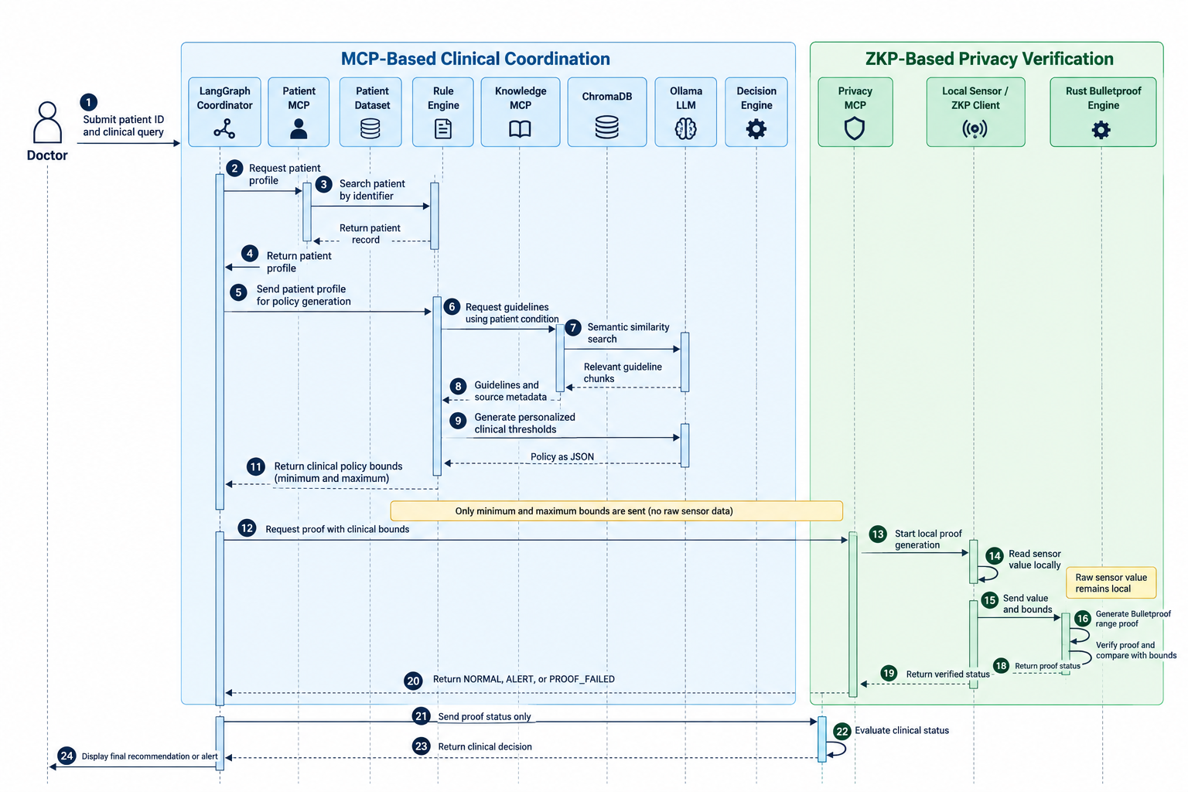Figure 2.X – Sequence diagram of the proposed MCP- and ZKP-based clinical decision-support workflow.

2.6.2 Data Flow and Privacy Boundary
The sequence diagram also highlights the main data flows of the proposed system. Three categories of information can be distinguished.
The first category consists of clinical and patient-context data. These data are exchanged between the Patient MCP, Rule Engine, Knowledge MCP, ChromaDB, and Ollama in order to construct the personalized clinical policy.
The second category consists of the clinical policy bounds generated from the patient context and medical knowledge. These bounds represent the information required by the ZKP mechanism to determine whether the sensor measurement satisfies the clinical policy.
The third category consists of the private IoMT sensor value. Unlike the other data, this value remains on the local device and is used only during the local proof-generation process. It is not directly transmitted to the LangGraph Coordinator, Patient MCP, Knowledge MCP, Decision Engine, or other backend clinical services.
Consequently, the main privacy boundary of the system is located between the local ZKP environment and the backend services. The backend receives only the verification result required for clinical decision-making rather than the underlying raw sensor measurement.
The simplified data flow can therefore be represented as:
Patient Context + Medical Knowledge → Personalized Clinical Bounds → Local ZKP Verification → Proof Status → Clinical Decision
This separation between clinical coordination and private sensor verification is a central design characteristic of the proposed architecture. It allows the system to use patient-specific clinical policies while limiting the exposure of raw IoMT sensor measurements to the backend infrastructure.

[8] 2.7 Conclusion
This chapter has presented the system model and global architecture that ground the remainder of this thesis. Section 2.2 derived a threat model for the IoMT scenario by instantiating the MCP threat taxonomy of Hou et al. [19] against the concrete pipeline introduced in Section 2.4, while also surfacing two threats -- replay and device spoofing -- that fall outside that taxonomy's scope because they concern the freshness and authenticity of a cryptographic proof exchange rather than the MCP transport layer itself. Section 2.3 translated these threats into six concrete security objectives -- confidentiality of the measurement value, message integrity, proof freshness, device authenticity, guideline integrity, and access control -- together with a minimal-disclosure design principle that governs how ZKP-MCP extends the existing architecture rather than replacing it.

Section 2.4 described the resulting two-layer architecture, in which a LangGraph-orchestrated set of MCP services retrieves patient records and clinical guidelines while an on-device Zero-Knowledge Proof client evaluates sensor readings against a policy without ever exposing the raw value. Section 2.5 formalized ZKP-MCP itself as the security layer governing this proof exchange, defining its range-proof statement, its two-message protocol, and the four-state machine that would enforce proof freshness once the proposed request_id extension is implemented; Section 2.5.3 was explicit that the current prototype has Privacy MCP simulate the device's role rather than communicating with a separate Device Agent, a simplification revisited in Section 3.9. Section 2.6 completed the model with sequence and data-flow diagrams that trace this exchange through the LangGraph workflow.

Together, these sections establish the target architecture and protocol design that Chapter 3 implements and evaluates: the threat model motivates the choice of range proofs over full data disclosure, the security objectives set the criteria against which the implementation is judged, and the architecture and protocol specification define what must actually be built. The gap between the two-party design assumed here and the single-process prototype described in Section 2.5.3, together with the request_id freshness extension that remains a proposal rather than an implementation, are the two design-to-implementation gaps that Chapter 3 addresses directly.

================================================================
CHAPTER 3 — IMPLEMENTATION AND EVALUATION
================================================================

[17] 3.1 Introduction

[9] 3.2 Environment and tools

[10] 3.3 Implementation of the ZKP-MCP protocol

[11] 3.4 Implementation of the RAG pipeline and multi-agent orchestration

[12] 3.5 Challenges encountered and solutions

[13] 3.6 Evaluation protocol

[14] 3.7 Performance results

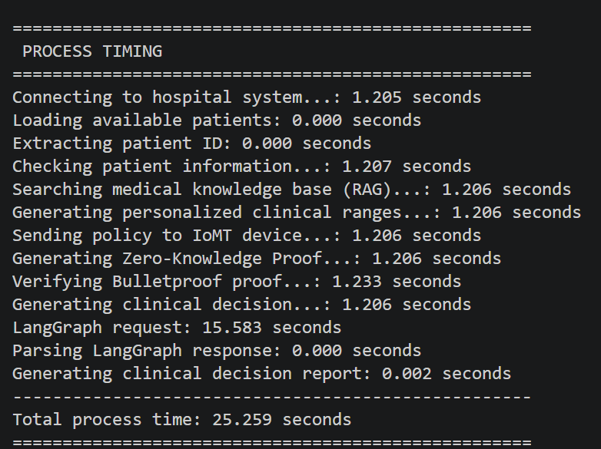
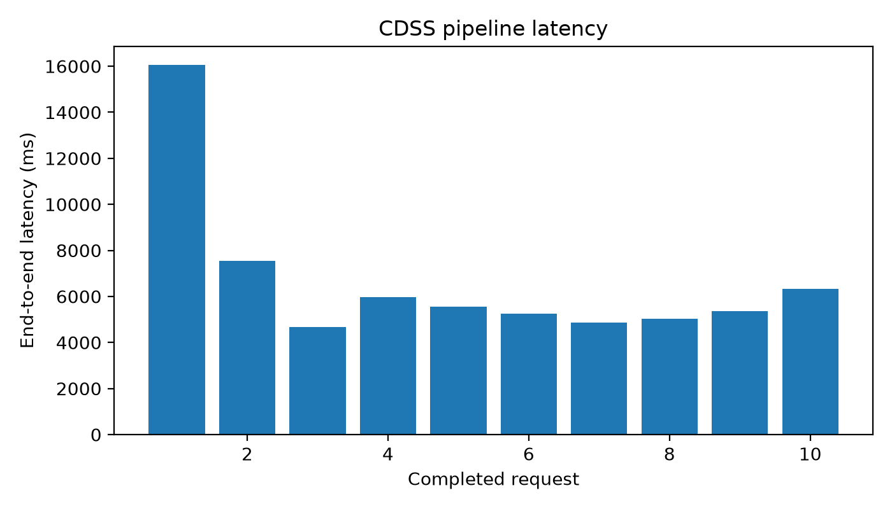
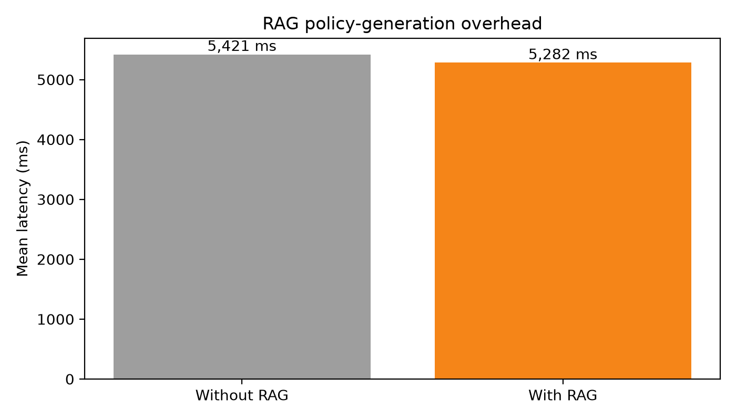

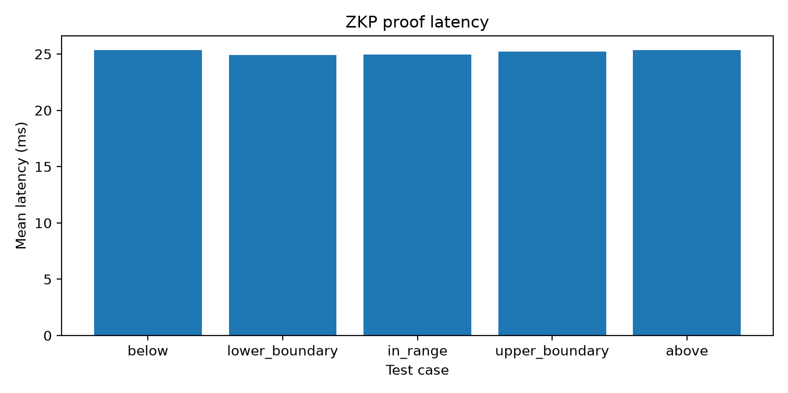

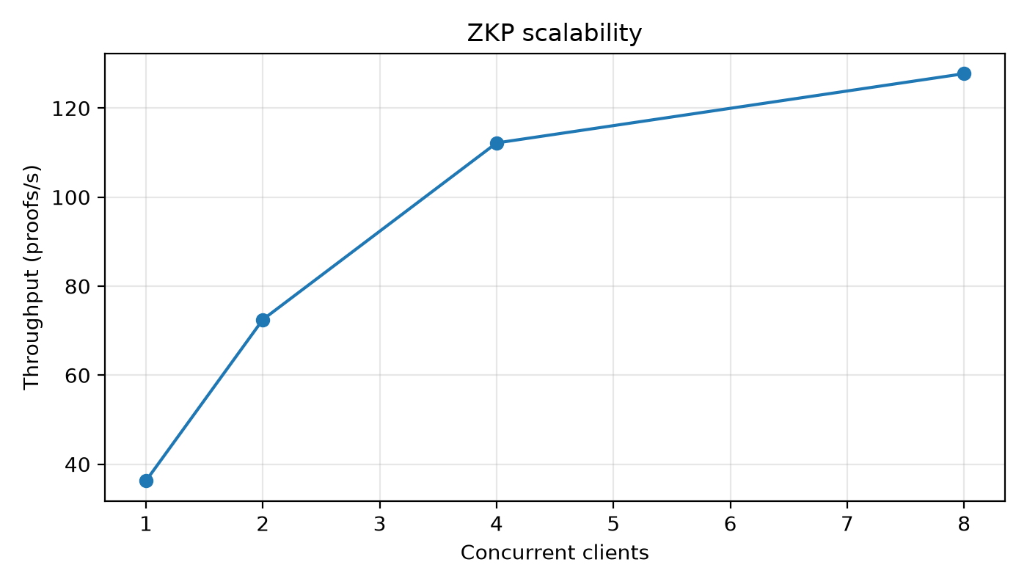

[15] 3.8 Comparison with related work (zk-MCP, LiteZKP)

[16] 3.9 Discussion and limitations

[18] 3.10 Conclusion

[19] GENERAL CONCLUSION AND PERSPECTIVES
------------------------------------------

[23] BIBLIOGRAPHY
------------------
(All references from every chapter converge here, typically in
citation order or alphabetical order depending on your program's
required style -- confirm with your supervisor. Chapter 1 references
below; add Chapter 2 and Chapter 3 references here as you write them,
do not create separate per-chapter lists.)

[30] B. Musumeci, R. Ramsey, S. Brennan, and H. Fraser, "Medical devices are vital, but vulnerable," IBM Institute for Business Value, Feb. 2020. Available: https://www.ibm.com/thought-leadership/institute-business-value/en-us/report/medical-device-security

[1] J. Y. Choi and T. K. Yoo, "Transforming clinical medicine with
multimodal artificial intelligence, agentic systems, and the
model-context protocol: a perspective on future directions,"
Discover Health Systems, vol. 5, no. 6, 2026.
DOI: 10.1007/s44250-026-00343-w.
[2] P. P. Ray, "A Survey on Model Context Protocol: Architecture,
State-of-the-art, Challenges and Future Directions," IEEE, 2024.
[3] A. Singh, A. Ehtesham, M. Lambe, J. J. Grogan, A. Singh, S. Kumar,
and R. Raskar, "Evolution of AI Agent Registry Solutions:
Centralized, Enterprise, and Distributed Approaches," arXiv
preprint arXiv:2508.03095, 2025.
[4] E. Boo, J. Kim, and J. Ko, "LiteZKP: Lightening Zero-Knowledge
Proof-Based Blockchains for IoT and Edge Platforms," IEEE Systems
Journal, vol. 16, no. 1, pp. 112-123, 2022.
DOI: 10.1109/jsyst.2020.3048363.
[5] S. Samudrala, J. Wu, C. Chen, H. Shan, J. Ku, Y. Chen, and J.
Rajendran, "Performance Analysis of Zero-Knowledge Proofs," in
Proc. IEEE Int. Symp. Workload Characterization (IISWC), 2024,
pp. 144-155.
[6] G. Jing and H. Qi, "Zero-Knowledge Audit for Internet of Agents:
Privacy-Preserving Communication Verification with Model Context
Protocol," arXiv:2512.14737, Dec. 2025.
[7] A. Ehtesham, A. Singh, G. K. Gupta, and S. Kumar, "A survey of
agent interoperability protocols: Model Context Protocol (MCP),
Agent Communication Protocol (ACP), Agent-to-Agent Protocol
(A2A), and Agent Network Protocol (ANP)," arXiv:2505.02279, May
2025.
[8] E. Sheybani, A. Ahmed, M. Kinsy, and F. Koushanfar, "Zero-
Knowledge Proof Frameworks: A Systematic Survey,"
arXiv:2502.07063, Feb. 2025.
[9] C. Jeong, "A Study on the MCP x A2A Framework for Enhancing
Interoperability of LLM-based Autonomous Agents," Samsung SDS
Hyper Automation Team, 2025.
[10] C. Jeong, "A Practical MCPxA2A Integration Framework for
Interoperability in LLM-Based Autonomous Multi-Agent Systems,"
Journal of Intelligence and Information Systems, vol. 31, no. 3,
pp. 141-170, Sept. 2025. DOI: 10.13088/jiis.2025.31.3.141.
[11] A. Aueawatthanaphisut, "Secure Multi-Modal Data Fusion in
Federated Digital Health Systems via MCP," arXiv:2510.01780, Oct.
2025.
[12] LangCare, "LangCare MCP FHIR - Open-Source Clinical AI
Framework," GitHub Repository,
https://github.com/langcare/langcare-mcp-fhir, 2025.
Available: https://www.langcare.ai/
[13] Google Developers Blog, "Announcing the Agent2Agent Protocol
(A2A): A New Era of Agent Interoperability," April 2025.
Available:
https://developers.googleblog.com/en/a2a-a-new-era-of-agent-interoperability/
[14] Model Context Protocol, "Getting Started: Introduction,"
Official Documentation,
https://modelcontextprotocol.io/docs/getting-started/intro, 2025.
[15], [16] [Official Anthropic MCP announcement/spec -- add full
citations, currently missing from your draft.]
[19] Hou et al., "Model Context Protocol (MCP): Landscape, Security Threats, and Future Research Directions," ACM Trans. Softw. Eng. Methodol., 2026
(Hou_et_al___2026__Model_Context_Protocol...pdf).]
[20], [21], [22], [24], [27] [Cited inline but missing from your
reference list -- retrieve full citations before submission.]
[28] T. Liu, M. Zhu, and S. Zhai, "Quality Outweighs Quantity:
Advancing Medical Question Answering with RAG-MCP Multi-Agent
LLM Framework and Curated Knowledge Databases," in Proc. 2026
IEEE 16th Annual Computing and Communication Workshop and
Conference (CCWC), 2026. DOI: 10.1109/CCWC67433.2026.11393764.
[29] P. Lewis et al., "Retrieval-Augmented Generation for
Knowledge-Intensive NLP Tasks," in Advances in Neural Information
Processing Systems, vol. 33, 2020, pp. 9459-9474.

-- Chapter 2 references: [none yet -- add as you write]
-- Chapter 3 references: [none yet -- add as you write]

