**Feature Planning Document of KSA**

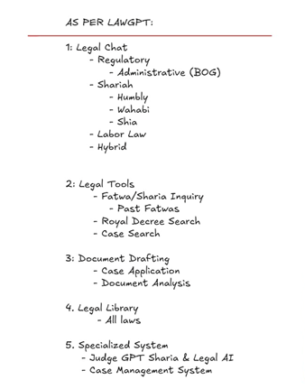

**✅ OVERVIEW OF CATEGORIES & SERVICES**

|  |  |
| --- | --- |
| Module | Main Service |
| 1. Legal Chat | AI-based legal assistance in Regulatory, Administrative (BOG), Shariah (Hanbali/Shia), Labor Law |
| 2. Legal Tools | Fatwa inquiries, past fatwa access, case searches, royal decree search |
| 3. Document Drafting | Auto-creation of legal docs: case applications, contracts, legal analysis |
| 4. Legal Library | Access to full laws & statutes |
| 5. Specialized Systems | JudgeGPT, Legal+Sharia AI, Smart Case Categorization, Case Management, Legal Form Generator |

**🗂️ 1. LEGAL CHAT MODULE**

**🔹 Services:**

* Real-time responses to questions on:
  + **Regulatory** laws
  + **BOG (Board of Grievances)** admin procedures
  + **Shariah** (Hanbali/Hybrid/Shia)
  + **Labor law**
  + **Hybrid cases (civil-criminal overlap)**

**📋 Data Required:**

* Frequently asked legal questions (FAQs) with answers
* Official fatwas and judicial opinions (Hanbali, Shia, etc.)
* Labor law policies and complaint workflows
* Board of Grievances court decisions
* Royal decrees related to labor, religion, and governance

**📑 Template:**

|  |  |
| --- | --- |
| Field | Example |
| Topic | Labor Law Termination |
| User Question | “Can I be fired without notice?” |
| Law Reference | Article 77, Saudi Labor Law |
| Sharia Position | Hanbali opinion on employee protection |
| AI Output (Chat) | “Under Article 77, termination is permitted with compensation...” |

**🧰 2. LEGAL TOOLS**

**🔹 Services:**

* **Fatwa inquiry tool**
* **Past fatwa repository**
* **Case Search Tool**
* **Royal Decree Search**

**📋 Data Required:**

* Fatwa database (authenticated: Permanent Committee, Grand Mufti, etc.)
* Categorized fatwas (family, business, finance)
* Full-text case judgments
* Index of Royal Decrees by ministry, topic, and year

**📑 Template:**

|  |  |
| --- | --- |
| Tool | Required Fields |
| Fatwa Inquiry | Question, Topic, Madhhab (e.g. Hanbali), Date, Issuing Authority |
| Case Search | Case Number, Type (criminal/civil), Year, Court Level, Outcome |
| Royal Decree | Decree Number, Date, Ministry, Law Area, Summary |

**📝 3. DOCUMENT DRAFTING**

**🔹 Services:**

* Auto-generate legal documents:
  + Case applications
  + Contract drafts
  + Legal opinions & analysis

**📋 Data Required:**

* Templates of legal forms used in KSA courts
* Standard case filing formats (Board of Grievances & General Courts)
* Contracts (employment, rental, agency, etc.)
* Sharia-compliant contract clauses (standardized or customizable provisions includes in contract to ensure they adhere to Islamic law (Sharia))

**📑 Template:**

|  |  |
| --- | --- |
| Document Type | Fields Required |
| Case Application | Plaintiff info, Defendant info, Case type, Incident details, Relief sought |
| Contract | Party A, Party B, Subject matter, Duration, Terms, Sharia clause |
| Legal Opinion | Query, Facts, Applicable Law, Sharia View, Conclusion |

**📚 4. LEGAL LIBRARY**

**🔹 Services:**

* Repository of **all Saudi laws**, Shariah rulings, administrative codes

**📋 Data Required:**

* Full text of Royal Orders, Ministerial Resolutions, Regulations
* English & Arabic versions (if available)
* Law categorization (Civil, Penal, Labor, Family, etc.)

**📑 Template:**

|  |  |  |  |  |  |
| --- | --- | --- | --- | --- | --- |
| Law Title | Law Number | Year | Summary | PDF / Full Text | Related Cases |
| Saudi Labor Law | 51 | 2005 | Regulates employer-worker rights | Download Link | 23 Related Judgments |

**🧠 5. SPECIALIZED SYSTEMS**

**A. Judge GPT – Legal & Sharia AI**

* Smart AI trained on case law, fatwas, contracts
* Role: give legal rulings, explain sharia impact

**B. Smart Case Categorization**

* AI classifies incoming cases based on:
  + Keywords
  + Legal domain
  + Jurisdiction

**📋 Data Required:**

* 1000+ labeled legal cases by type
* Keywords mapping to categories

|  |  |
| --- | --- |
| Input | Output Classification |
| "Unpaid salary" | Labor Law |
| "Marriage contract" | Family/Shariah |

**C. Case Management System**

* For lawyers/judges to track:
  + Case timelines
  + Deadlines
  + Related documents

**📋 Data:**

* Case ID, hearing dates, parties, judge notes

**D. Legal Form Generator**

* Auto-fill forms:
  + Power of attorney
  + Business license
  + Divorce petition

**📑 Form Template:**

|  |  |
| --- | --- |
| Form Name | Required Inputs |
| Power of Attorney | Name, CNIC, Purpose, Duration, Witnesses |
| Divorce Application | Husband info, Wife info, Reasons, Mahr |

**📌 GENERAL DATA SOURCES YOU NEED TO COLLECT**

|  |  |
| --- | --- |
| Type of Data | Source |
| Laws & Decrees | BoG, Royal Gazette, Ministry portals |
| Fatwas | Grand Mufti's site, Alifta, local Shariah boards |
| Case Judgments | Najiz.sa, BoG decisions, Ministry of Justice website |
| Legal Forms | Saudi courts, BoG templates, legal consultants |
| Labor Laws | Ministry of Human Resources (mlsd.gov.sa) |
| Shariah Interpretations | Islamic scholars’ archives, Fiqh books |
| Legal Users Needs (Chat FAQs) | Interviews, law forums, legal helplines |

**📦 6. Track My Case**

Includes: Najiz Case Status, Upload Court Info, Royal Decrees

🔹 Services:

* Check case progress via Najiz
* Upload missing case documents
* Search/view Royal Decrees

📋 Data Required:

* Najiz case tracking APIs
* Court document upload format
* Royal decree archive

📑 Template:

|  |  |
| --- | --- |
| Feature | Required Fields |
| Case Status Checker | Case Number, National ID, OTP |
| Court Info Upload | Case ID, Document Title, File Upload, Notes |
| Royal Decree Search | Decree Number, Ministry, Year |

**✅ 8. Compliance Checker**

Includes: Sharia Compliance, Regulatory Violations

🔹 Services:

* Scan contracts or business practices for compliance
* Flag shariah or regulatory violations

📋 Data Required:

* Shariah principles (Hanbali, Shia)
* Business regulations (licensing, labor, finance)

📑 Template:

|  |  |
| --- | --- |
| Checker Type | Required Fields |
| Sharia Compliance | Document Text, Contract Type |
| Regulatory Check | Entity Name, License Type, Document Upload |

**🧰 9. Business Legal Tools**

Includes: Contract Templates, Licensing Checklist, Labor Policy Validator, Nitaqat Analyzer

🔹 Services:

* Auto-generate business contracts
* Check labor policy compliance
* Validate Saudization level (Nitaqat)

📋 Data Required:

* Ministry of Commerce licensing checklist
* Pre-approved labor policy samples
* Nitaqat rules & industry thresholds

📑 Template:

|  |  |
| --- | --- |
| Tool | Required Fields |
| Contract Template | Company Name, Parties, Subject, Term |
| Licensing Checklist | Business Type, Industry, Location |
| Labor Policy Validator | HR Policy Text, Job Roles |
| Nitaqat Analyzer | Company Size, No. of Saudis, No. of Expats |

<https://lawgpt-ksa-uae.azurewebsites.net/auth>

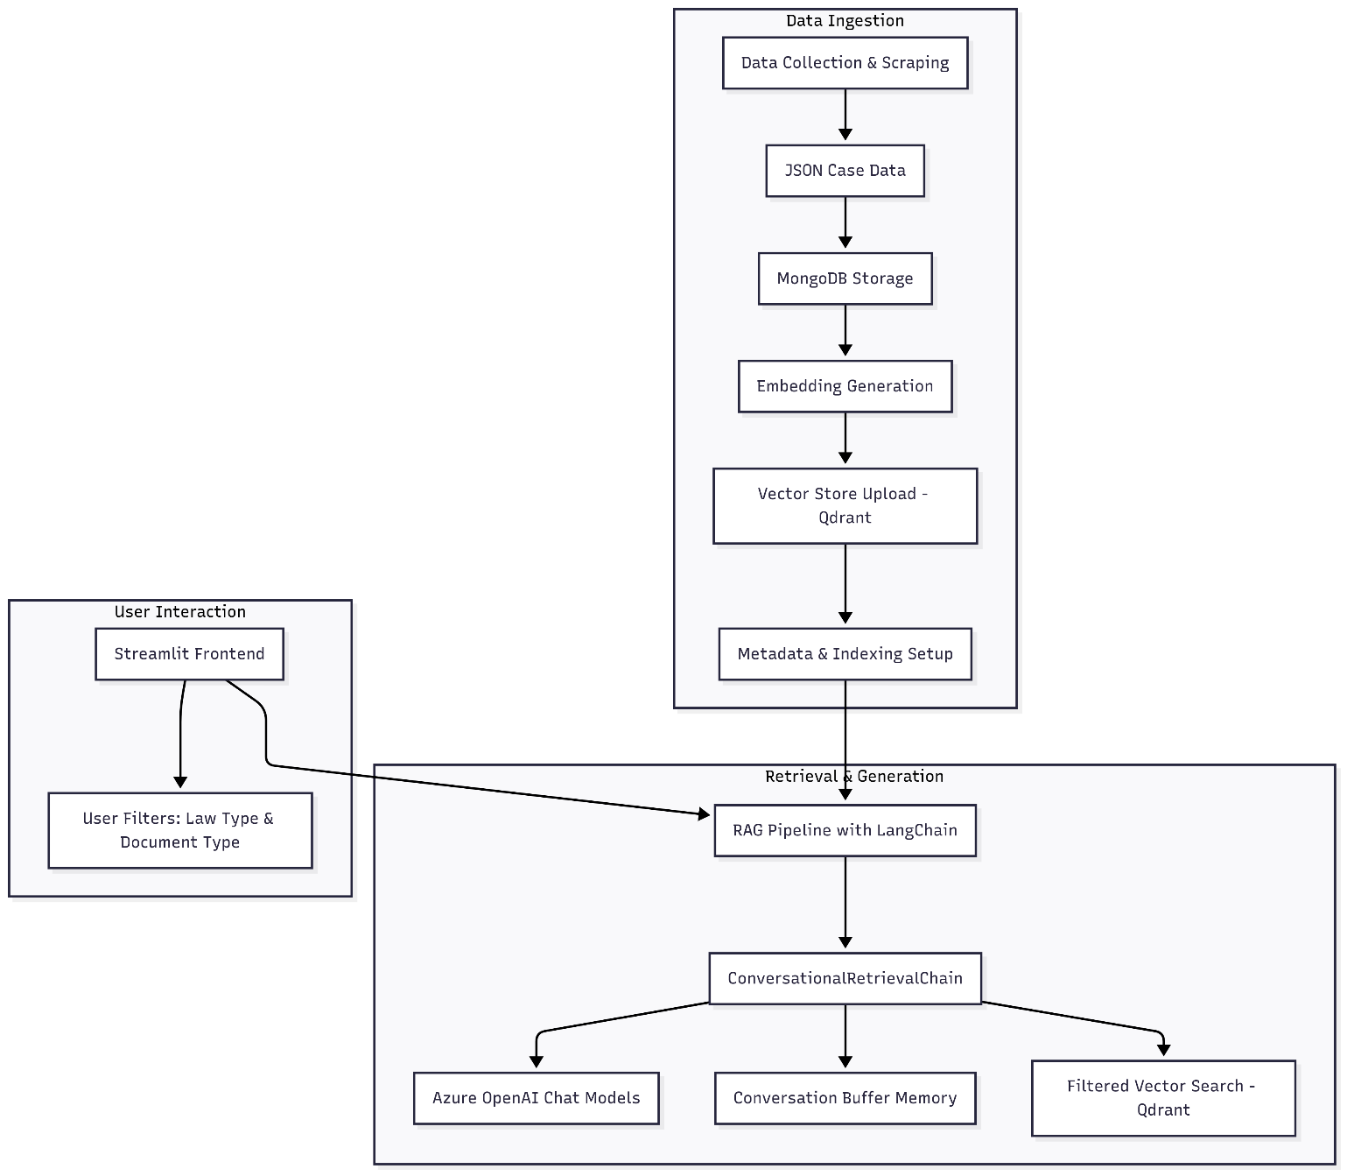

<https://chatgpt.com/share/6881cf66-2354-8006-82e8-56a060341cc9>