**SCOPING DOCUMENTATION OF LAWGPT FOR KSA:  
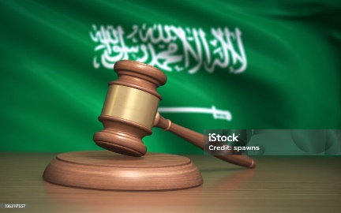**

**Table of Contents**

**1. Introduction**  
Scope and Sources  
Key References & Links

**2. 2010 Reforms**  
Available Reports and References

**3. Books and Official Portals**  
Ministry of Justice (MoJ) Portal – Media Center & Publications  
Bureau of Experts – Laws Library  
Supplementary References – Jurisprudence & Academic Sources

**4. Competitors – Saudi AI Legal Tools**  
Malakah (by Stixor) – Real-Time Legal Q&A, Automated Contract Drafting, Document Review & Analysis  
ChatGPT Assistant for Labour Law  
Mohamy.ai  
Arabic AI – Arabic-focused AI tools  
Leen (لين) – Legal assistant in Arabic  
Guide: How to use above platforms

**5. Court System of Saudi Arabia**  
Supreme Council of the Judiciary  
Sharia Courts (General & Summary Courts)  
Board of Grievances  
Specialized Courts (Commercial, Labor, Family)  
Appeal & Cassation Courts  
Shia Minority Courts

**6. Summary Table of Court Ranking**

**7. Judicial System Overview**  
Main and Special Courts  
Final Appeals Process  
Court Types and Jurisdiction

**8. Judges and Legal Training**  
Composition & Background  
Training Sources  
Criticism of the Judiciary

**9. Reforms (Post-2007)**  
Court Modernization  
Codification of Precedents  
Leadership Changes  
Public Access to Cases

**10. Law Enforcement**  
Regular Police, Secret Police, Religious Police (Mutawa)  
Mutawa Power Restrictions (2016)

**11. Criminal Law**  
Types of Crimes: Hudud, Qisas, Tazir  
Punishments and Evidence Rules  
Juvenile Justice Reforms (2020)

**12. Family Law**  
Marriage & Divorce Rules  
Custody & Inheritance Laws

**13. Commercial Law**  
Governing Sources  
Contract Law Principles  
Recent Reforms & IP Protection

**14. Labor and Land Law**  
Labor Rights & Exemptions  
Foreign Worker Restrictions  
Land Ownership Rules

**15. Energy Law**  
State Ownership of Resources  
Role of Saudi Aramco  
Privatization Trends

**16. Human Rights & Rule of Law**  
Criticism and International Concerns  
Role of NSHR  
Improvements in Codification

**17. Women’s Rights**  
Guardianship Reforms  
Driving, Work, and Travel Rights  
Remaining Legal Inequalities

**18. Political Freedom & Free Speech**  
No Political Parties or Elections  
Censorship and Protest Restrictions  
Notable Cases (e.g., Jamal Khashoggi)

**19. LGBT Rights in Saudi Arabia**

**20. Case Flowchart – Complaint to Enforcement Steps**

**21. How the Saudi Legal System Works**  
Uncodified Sharia & Judicial Discretion  
Trial Procedures  
Use of Najiz.sa

**22. Court Locations & Availability Table**

**23. Official Legal Websites**  
MoJ, Board of Grievances, Public Prosecution, Laws Portal, Human Rights Commission, Fatwa Portal

**24. Reference Summaries**  
Wikipedia Summary  
Document Accuracy Link  
Saudi vs. Pakistan Law Comparison

**25. Platforms Used in the Petition Flow**  
Najiz, Qiwa, Absher, Musaned, Board of Grievances

**26. Legal Hierarchy in Saudi Arabia**  
Shariah, Royal Decrees, Ministerial Regulations, Judicial Interpretations

**Introduction:**

This document outlines the scope and foundational resources for developing LawGPT tailored to the Kingdom of Saudi Arabia’s unique legal system. It integrates reforms, court structures, and existing AI legal tools to enhance accessibility and understanding of Saudi law. Leveraging local language nuances and jurisprudence, LawGPT aims to provide accurate, Sharia-compliant legal guidance. This scoping serves as a foundation for building an AI assistant aligned with Saudi Arabia’s judicial and regulatory framework.

**2010 Reforms:**

(only report available )  
<https://www.jstor.org/stable/48600023> country_report_2010_SAU

colab.research.google.com/drive/11qNXS1m5wyWp_vhiV2-dbWdZb-MhSxYl?authuser=0#scrollTo=b8aERzEyinzV

**BOOKS**

A. Ministry of Justice (MoJ) Portal : ( then go to >media center>publications)

<https://www.moj.gov.sa/ar/MediaCenter/Pages/Versions.aspx>

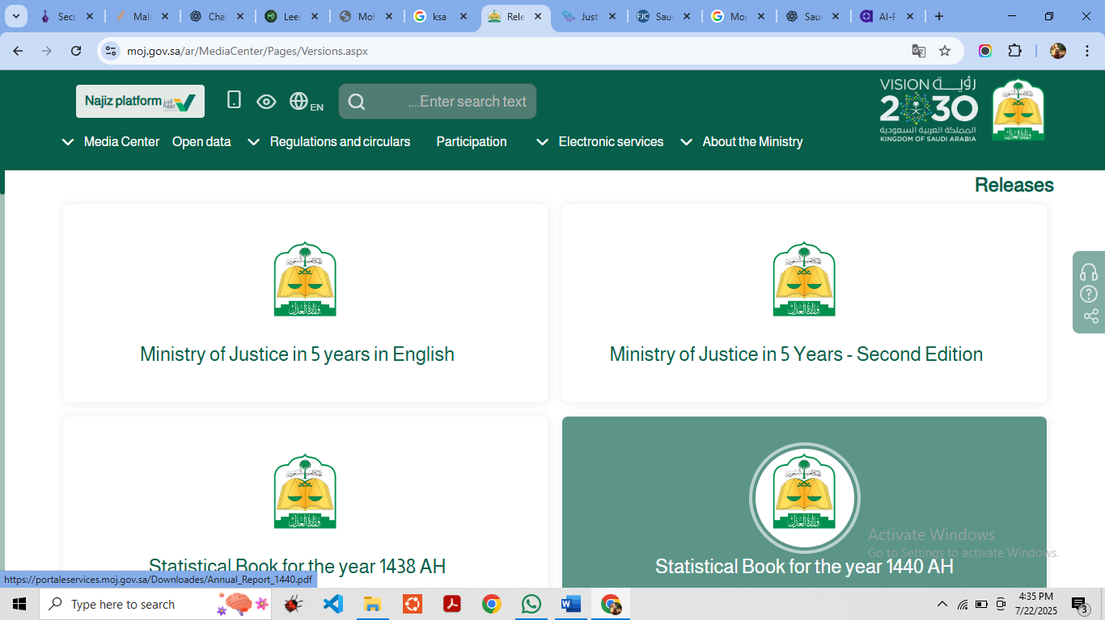

B. Bureau of Experts / Laws Library

<https://laws.boe.gov.sa/BoeLaws/Laws/Search>

C. Supplementary References

Legal analyses from academic and legal sites, such as *Kurdish Studies*, mention this 2018 sourcebook (notable mention of **2,323 principles + 8 volumes of jurisprudential sources**)

**COMPETITORS:**

**Notable Saudi AI Legal Tools**

**• Malakah (by Stixor)**

An AI chatbot offering **real-time Sharia-compliant legal guidance**. It answers queries based on Saudi law principles and provides instant, accessible insights. Malakah is a Saudi legal expert specializing in document analysis.

**Access Core Features**

**a. Real-Time Legal Q&A**

Ask legal questions—about employment law, VAT, business regulations, contracts, or lawsuits—and Malakah will respond instantly with answers aligned with Saudi law.

**b. Automated Contract Drafting**

Browse pre-approved contract templates (e.g., commercial agreements, founders’ agreements), choose the one you need, and let Malakah customize it based on your inputs.

**c. Document Review & Analysis**

Upload legal documents—contracts, compliance reports, HR policies—and Malakah’s AI will analyze them, point out risk areas, and suggest improvements.

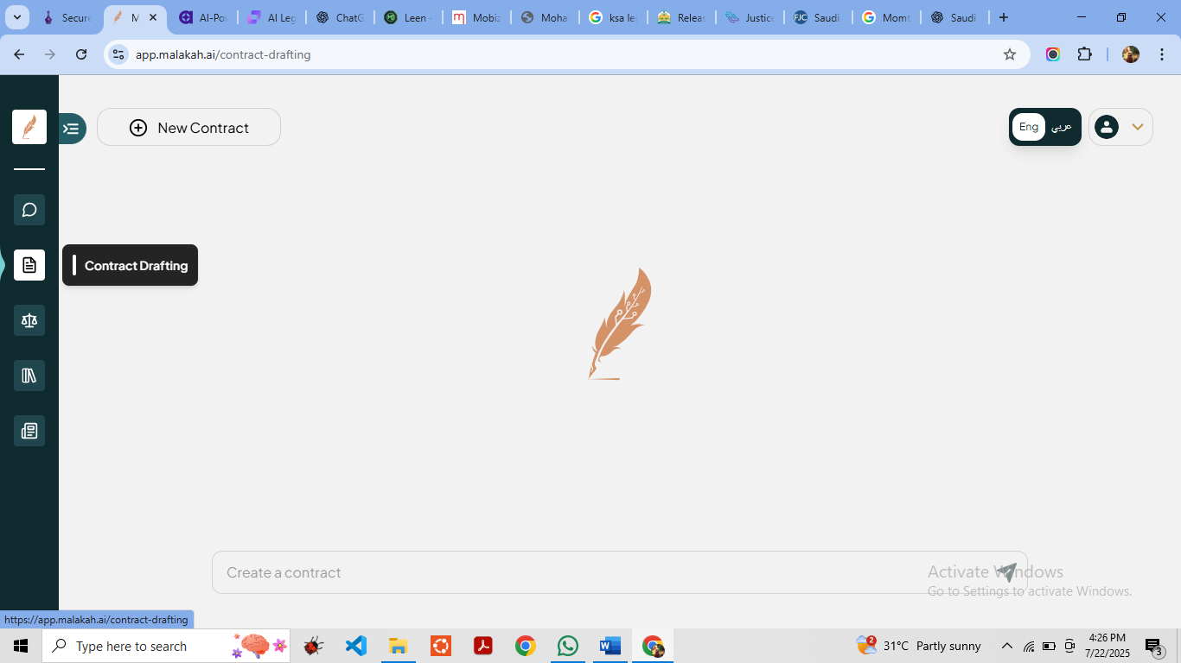

**• ChatGPT assistant for labour law:**

Recently launched in KSA, this tool provides **real-time answers on Saudi labour regulations** for both employers and employees

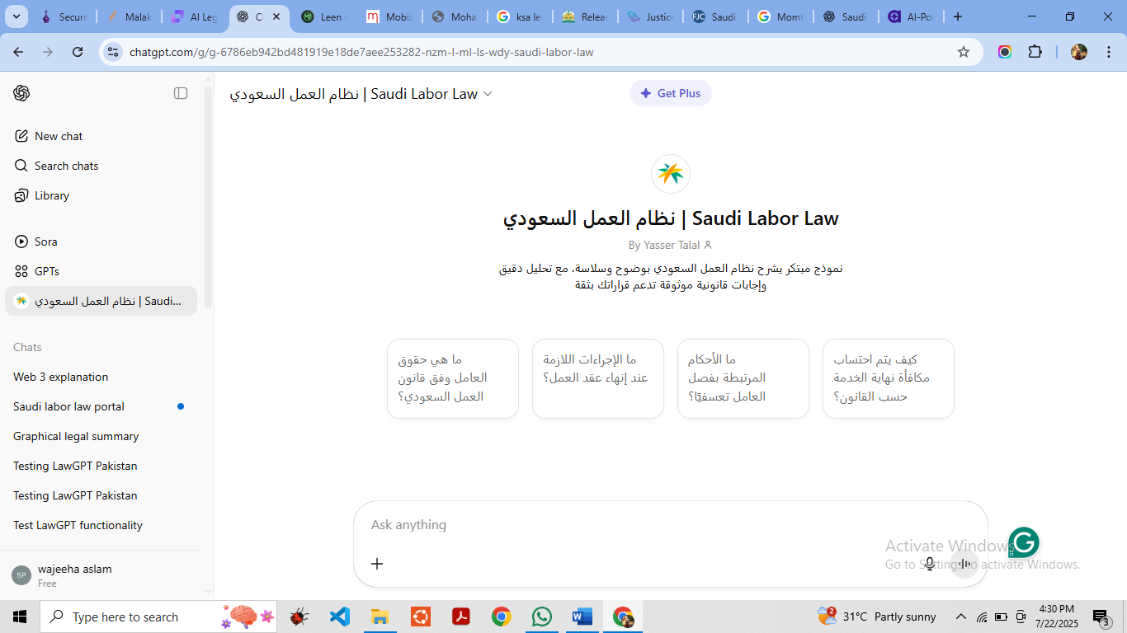

<https://chatgpt.com/share/68807b7c-4848-8007-8788-005ee3a1ac34>

**• Mohamy.ai**

An “AI Lawyer” tool covering UAE, KSA, Egypt, and broader Middle East laws—providing automated guidance on rights and procedures.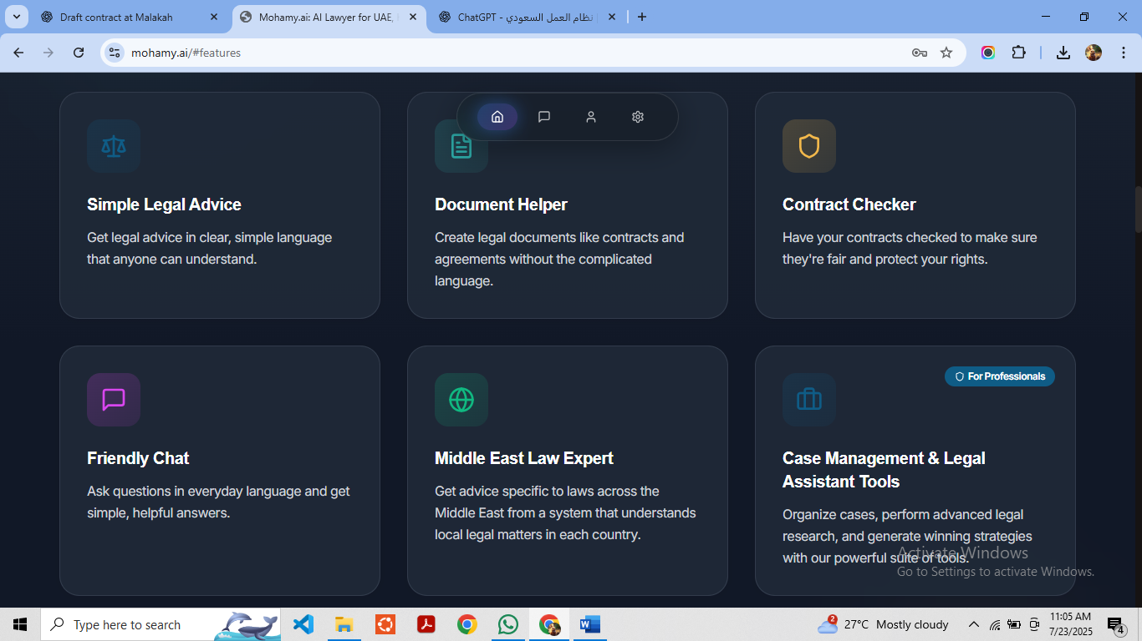

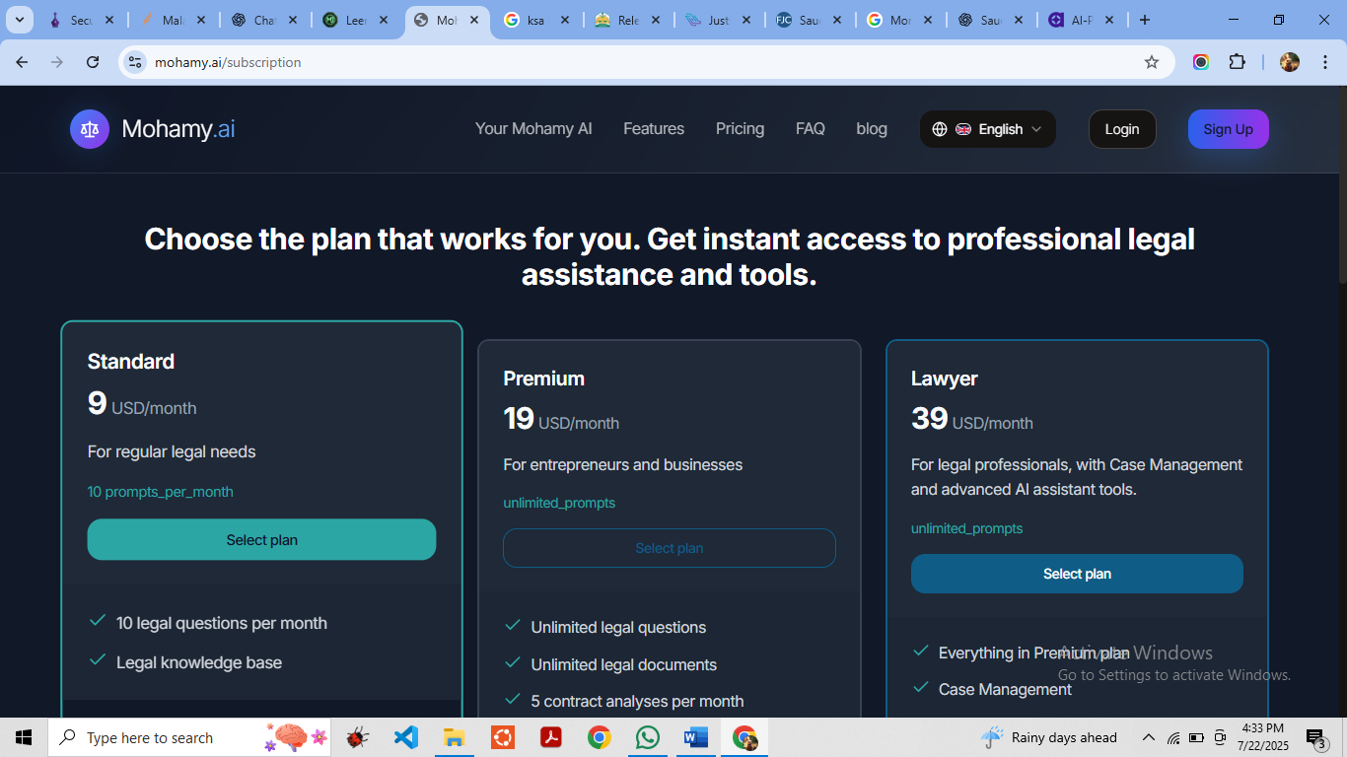

* **Arabic AI**

refers to artificial intelligence tools, models, platforms, or assistants that are designed to **understand, generate, or process the Arabic language**, culture, and legal systems. These systems are trained specifically to handle the **linguistic complexity** and **contextual nuances** of Arabic, which standard global AI models may not fully support.

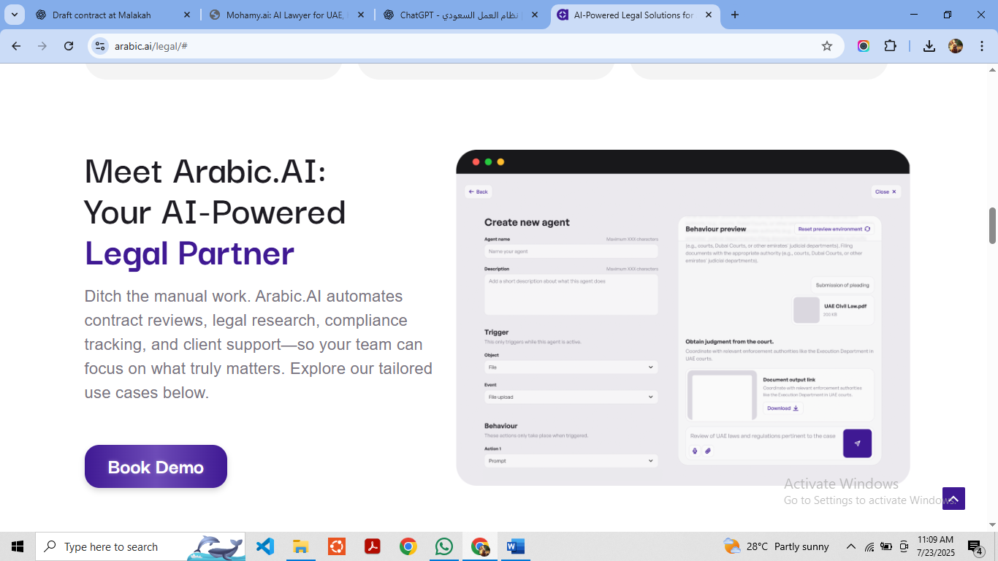

<https://www.youtube.com/watch?v=N2iYomxU8eQ>

* **Leen** (لين)

is a **Saudi AI-powered legal assistant** that helps users **create, review, and understand legal documents in Arabic**, especially aligned with **Saudi laws and regulations**.

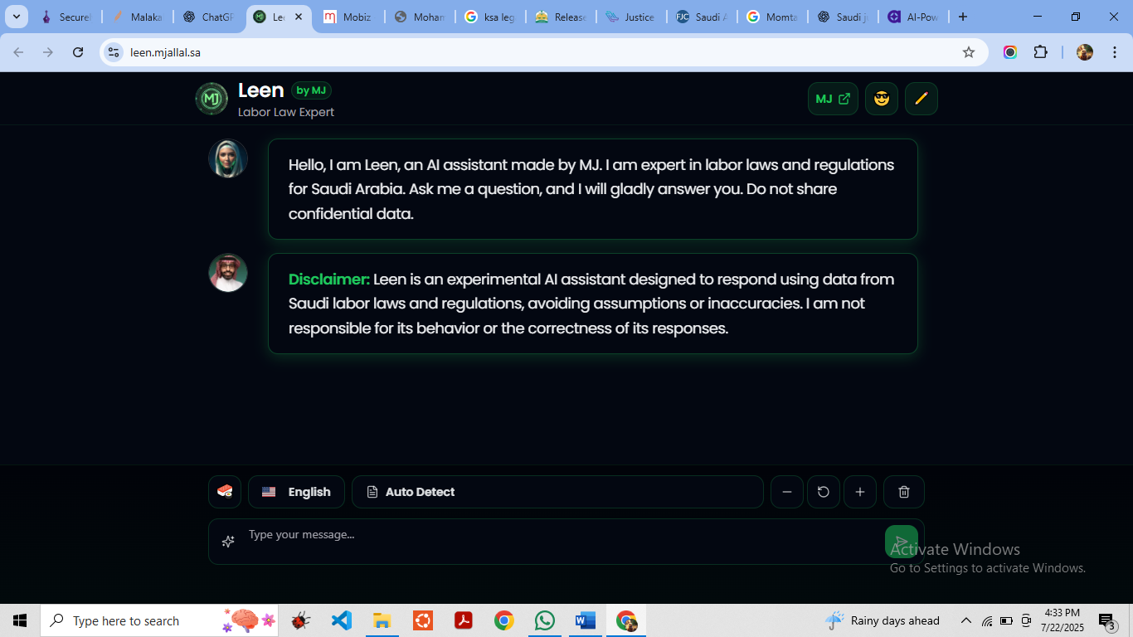

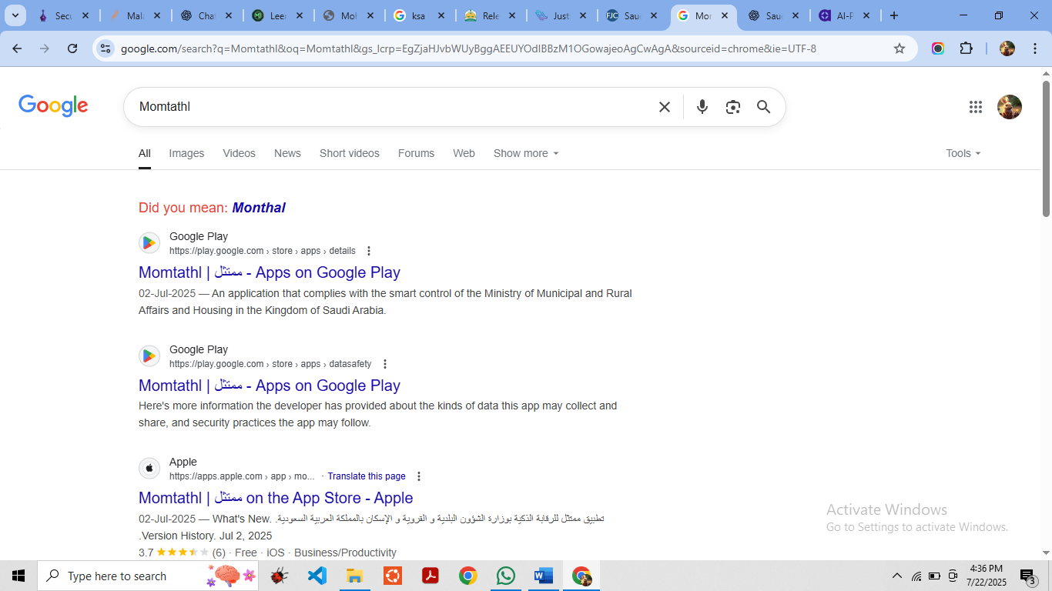

How to use all above webs : <https://chatgpt.com/share/68809763-ba34-8007-a3cf-9c223d30b98b>

**Court System of Saudi Arabia**

**Supreme Council of the Judiciary**

* + Oversees and supervises the judicial system.
  + Appointed by the King.

**Sharia Courts**

* + Based on Islamic law (Hanbali school).
  + Includes:
    - **General Courts** (civil & criminal cases)
    - **Summary Courts** (minor offenses)

**Board of Grievances**

* + Handles **administrative cases**, such as disputes involving government agencies.

**Specialized Courts**

* + Deal with:
    - **Commercial disputes**
    - **Labor issues**
    - **Personal status/family law**

**Appeal and Cassation Courts**

* + Review decisions from lower courts.
  + Final approval may rest with the King.

**Shia minority courts**

Two Shia courts for family matters and religious matters in the Eastern Province.

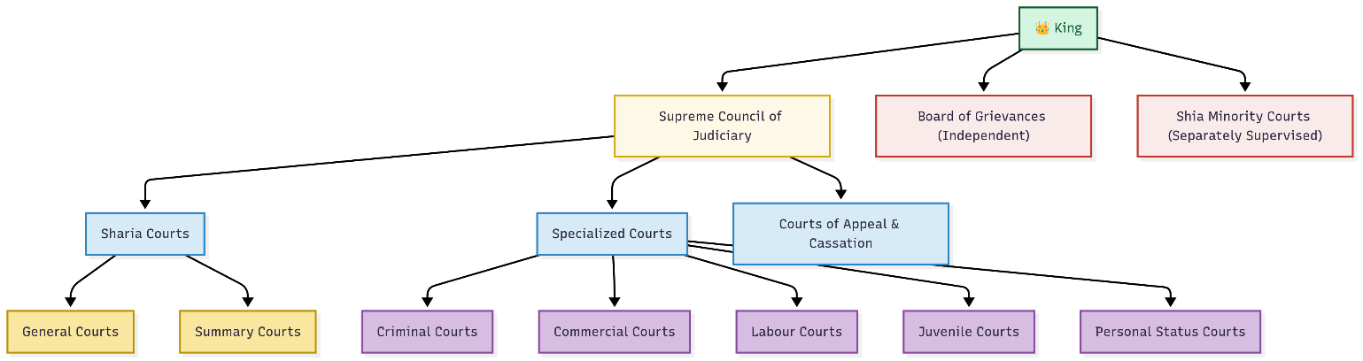

**Summary Table of Ranking:**

|  |  |  |  |
| --- | --- | --- | --- |
| Rank | Court Name | Jurisdiction Level | Sharia-Based? |
| 1 | Supreme Court (Cassation) | National (Highest) | ✅ Yes |
| 2 | Courts of Appeal | Regional | ✅ Yes |
| 3 | First-Degree & Specialized | Local | ✅ Yes (mostly) |
| 4 | Board of Grievances | Independent | ⚠️ Partially/No |

* **Judicial System Overview**
* **Main Courts:** Based on **Sharia law**, with judges (qadis) from the religious class (ulema).
* **Special Courts:** Include the **Board of Grievances** (commercial/government-related) and the **Specialized Criminal Court** (terrorism and activism).
* **Final Appeals:** Ultimately go to the King.
* **Court Types:** General, summary, appellate, and two Shia courts for family matters in the Eastern Province.
* **Judges and Legal Training**
* **Composition:** ~700 judges, mostly trained in Islamic (non-modern) law.
* **Training:** Based on the Quran and classical texts; few understand modern legal matters.
* **Criticism:** The Judiciary is viewed as outdated, insular, and conservative (mainly from Qasim province).
* **Reforms (post-2007)**
* **Modernization:** New courts established (criminal, personal status, commercial, labor).
* **Codification:** Legal precedents started being documented in 2018.
* **Leadership Change:** Younger judges and reformist appointments were made.
* **Publication:** Thousands of court cases made public in 2015.
* **Law Enforcement**
* **Forces:** Regular police, secret police (Mabahith), and religious police (Mutawa).
* **Mutawa:** Enforces moral codes, but their powers were restricted in 2016.
* **Criminal Law**

**Types of Crimes:**

* *Hudud* (Quranic, e.g. theft, adultery),
* *Qisas* (retaliatory, e.g. murder),
* *Tazir* (discretionary).
* **Punishments:** Public beheading, flogging, amputation, and stoning (rare).
* **Conviction Evidence:** Confession, male witnesses (female testimony restricted), or oath.
* **Juvenile Reform:** Minors exempt from capital punishment since 2020.
* **Family Law**
* **Marriage:** Polygamy allowed; no minimum marriage age until 2019.
* **Divorce:** Men can divorce unilaterally; women face obstacles.
* **Custody:** Fathers get sons (7+) and daughters (9+).
* **Inheritance:** Women receive half the share of men.
* **Commercial Law**
* **Governed by:** Sharia and royal decrees.
* **Contract Law:** No interest or speculative profits allowed; loss of opportunity is not compensable.
* **Recent Changes:** 2023 reforms for small businesses; improved IP law after WTO accession.
* **Labor and Land Law**
* **Labor Law:** Basic rights like leave and severance exist, but many groups (e.g. domestic workers) are excluded.
* **Foreign Workers:** Bound by strict contracts; vulnerable to abuse.
* **Land Ownership:** Mostly government-owned; foreigners restricted in Mecca/Medina.
* **Energy Law**
* **Ownership:** All natural resources belong to the state.
* **Saudi Aramco:** Dominates oil/gas; partial privatization underway.
* **Privatization:** Sectors like electricity moving toward privatization.
* **Human Rights & Rule of Law**
* **Criticism:** Arbitrary justice, royal family impunity, cruel punishments.
* **NSHR:** Government-linked human rights body with limited independence.
* **Codification & Precedent:** Historically lacking, now improving.
* **Women’s Rights**
* **Guardianship:** Abolished in 2019.
* **Driving:** Legal since 2018.
* **Work & Travel:** Women now need no male approval.
* **Court Bias:** Women’s testimony worth half a man’s; still face legal inequality.
* **Political Freedom & Free Speech**
* **No Parties/Elections:** Absolute monarchy.
* **Censorship:** Extremely tight; dissent not tolerated.
* **Protests Banned:** Since 2011.
* **Notable Case:** Murder of journalist Jamal Khashoggi by state agents in 2018.
* **LGBT Rights**

Homosexuality is illegal in Saudi Arabia and can be punishable by death; common penalties include flogging, imprisonment, and arrest for gender non-conforming behavior, such as men "behaving like women."

**Case Flowchart**

1️⃣ Complaint Filed

⬇

2️⃣ Investigation (Criminal) or Claim Review (Civil)

⬇

3️⃣ Court Hearings

⬇

4️⃣ Judgment Issued

⬇

5️⃣ Appeal (Optional)

⬇

6️⃣ Final Judgment

⬇

7️⃣ Enforcement (Najiz / Execution Court)

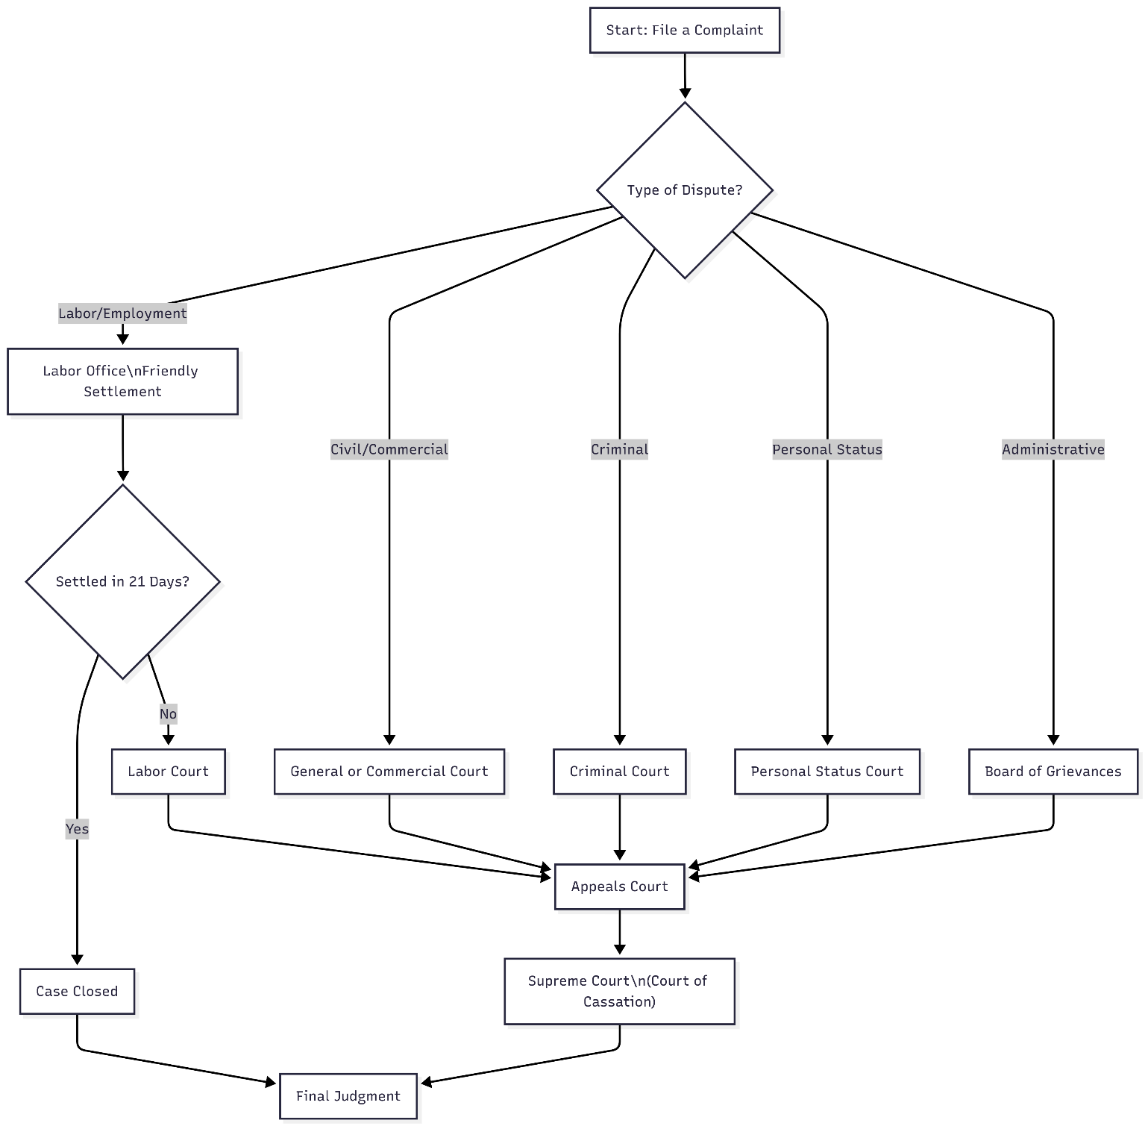

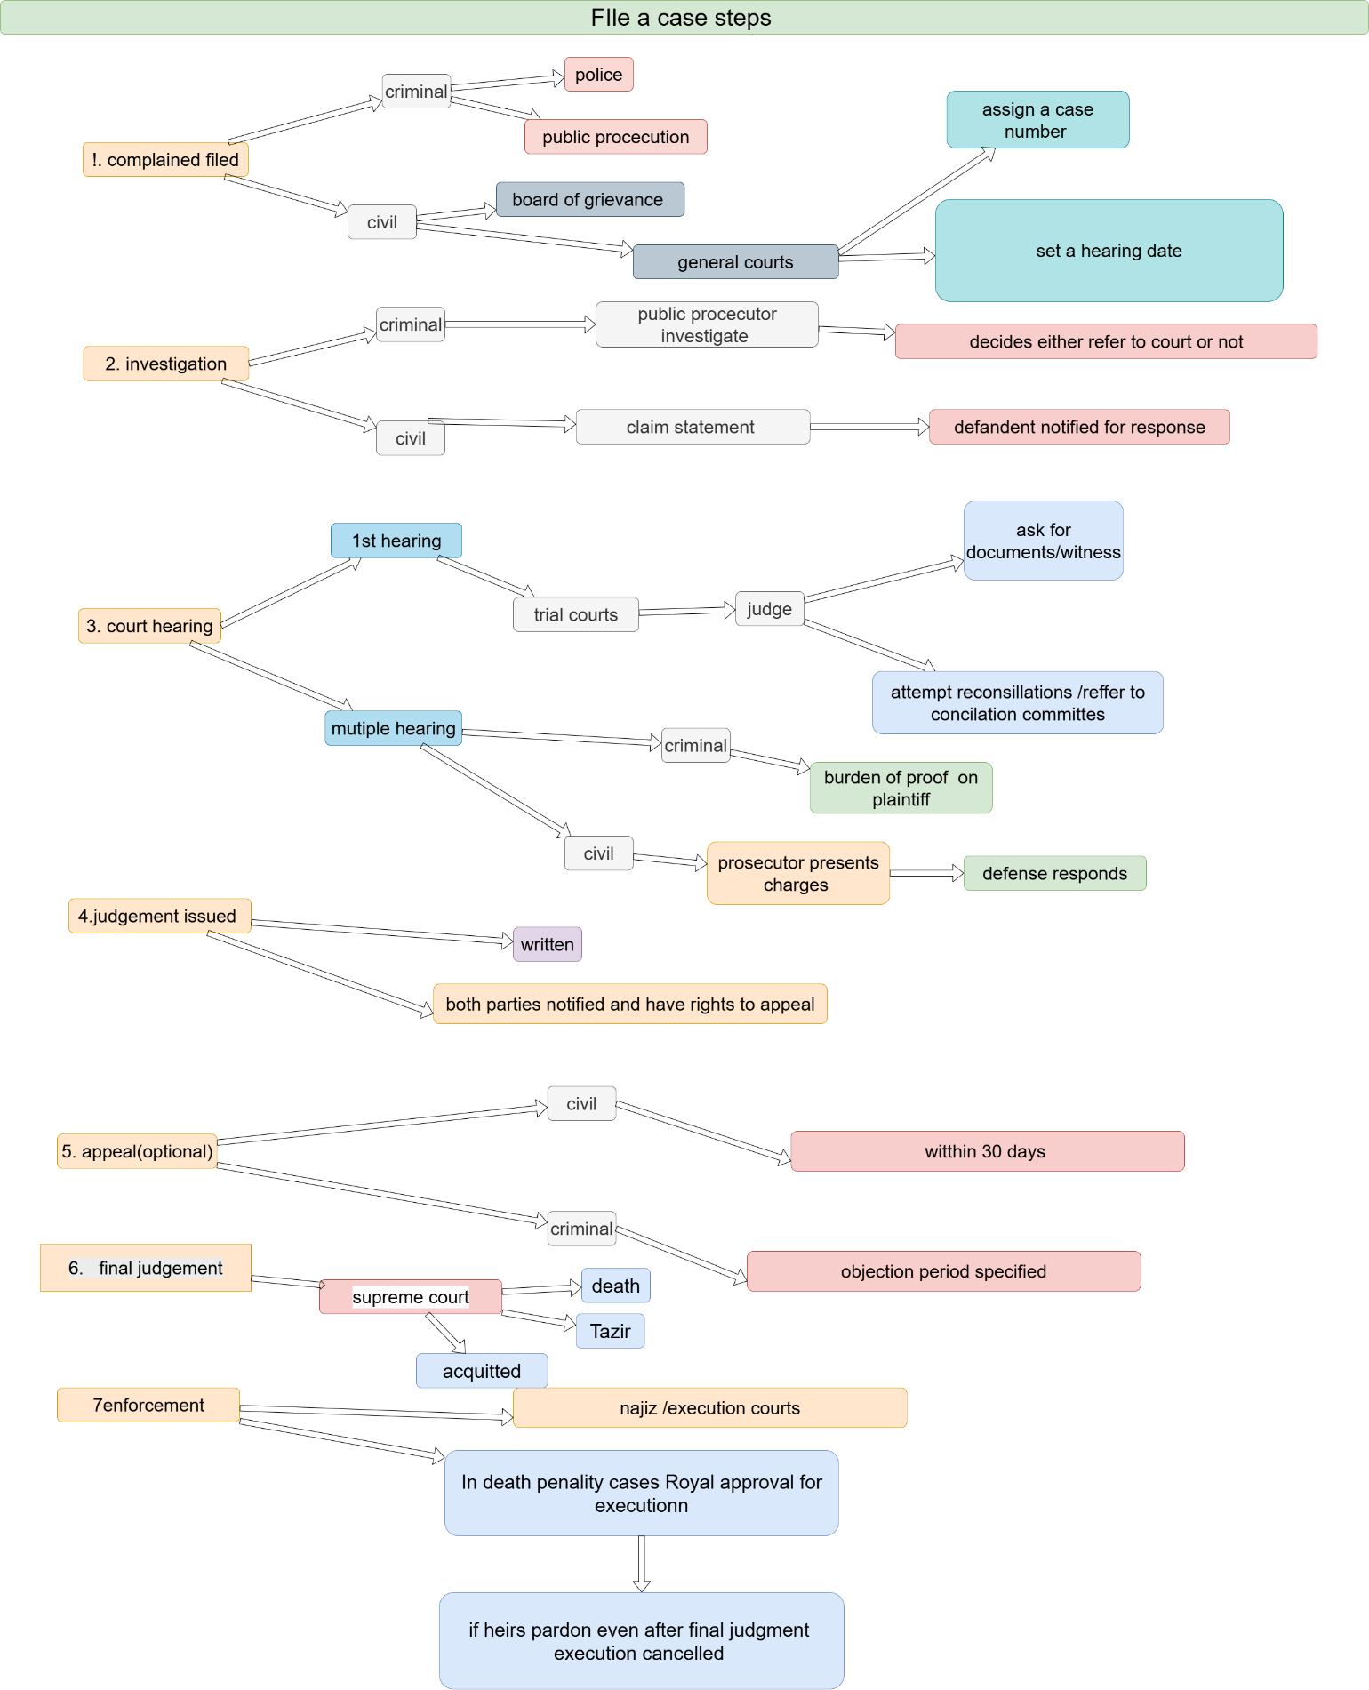

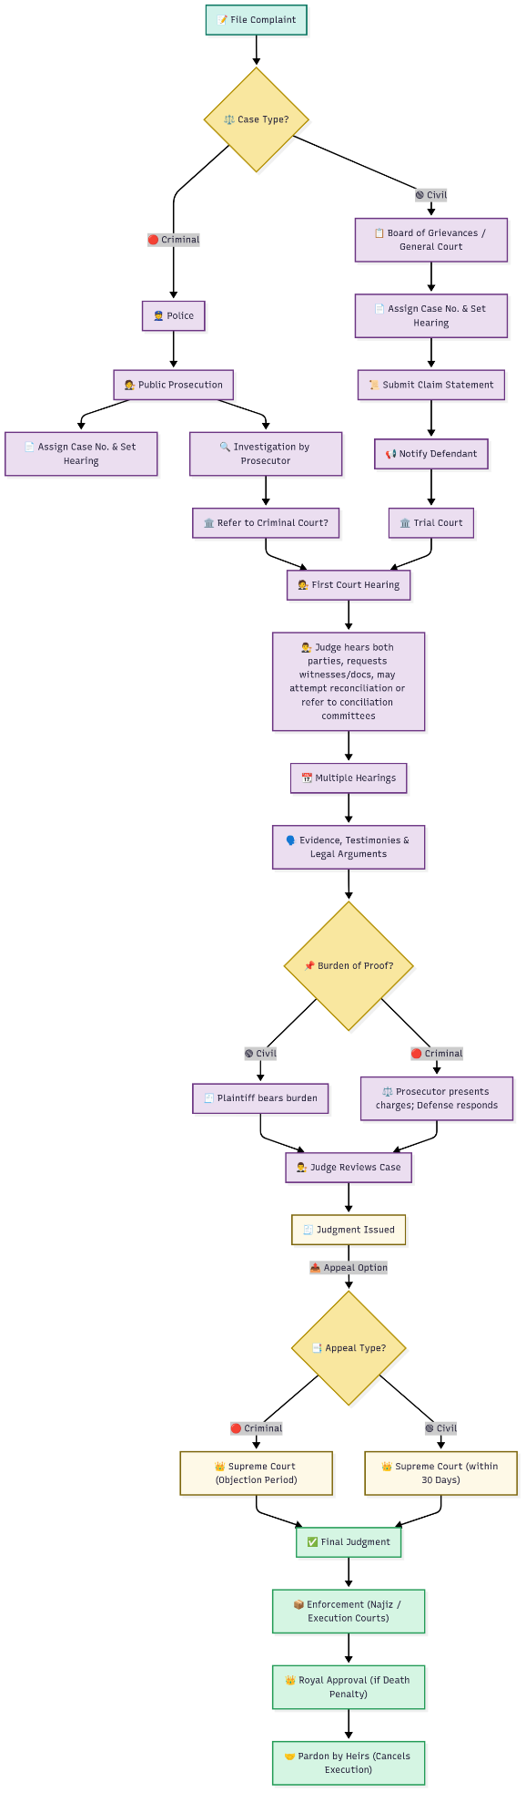

**How Saudi Legal System Works:**

* **Uncodified Sharia**: Judges use discretion in interpreting **Quran, Sunnah, Fiqh**.
* **No jury trials**.
* **Precedents are not binding**, but persuasive.
* **Public Prosecution is independent**, not part of judiciary.
* **Trials may be secret** in some sensitive matters.
* **Najiz.sa** is used for civil/labor/family cases, not for criminal trials.

|  |  |
| --- | --- |
| Court Type | Available In |
| Supreme Court | Riyadh |
| Administrative Supreme | Riyadh |
| Courts of Appeal | All 13 provinces (Riyadh, Jeddah, Dammam, etc.) |
| General & Summary Courts | **Every city/town** |
| Commercial Courts | Riyadh, Jeddah, Dammam, Makkah, Madinah |
| Labor Courts | Riyadh, Jeddah, Dammam, others |
| Personal Status Courts | All major cities |
| Board of Grievances | 13 main cities across KSA |
| Shia Courts | Qatif, Al-Ahsa (Eastern Province only) |

|  |  |  |
| --- | --- | --- |
| Website | Purpose | Link |
| Saudi Ministry of Justice | Court system, case tracking, legal documentation | [https://www.moj.gov.sa](https://www.moj.gov.sa/) |
| Board of Grievances (ديوان المظالم) | Administrative judiciary information and e-services | [https://www.bog.gov.sa](https://www.bog.gov.sa/) |
| Public Prosecution (النيابة العامة) | Criminal justice and prosecution system | [https://www.pp.gov.sa](https://www.pp.gov.sa/) |
| Saudi Laws Portal (Nafithah al-Nizamiyah) | Official database of Saudi laws in Arabic | [https://laws.boe.gov.sa](https://laws.boe.gov.sa/) |
| Human Rights Commission | Monitoring legal compliance with human rights | [https://www.hrc.gov.sa](https://www.hrc.gov.sa/) |
| FATWA | For fatwa’s | <https://alifta.gov.sa/home#projects> |

Summary of wiki:<https://chatgpt.com/share/687f337e-839c-8006-b90e-9a6c06764aec>

doc accuracy : <https://chatgpt.com/share/687fcc66-1568-8007-bceb-3d52559a80e9>

Saudi law vs Pakistan law : <https://chatgpt.com/share/68806f07-bfa4-8006-83cd-da9b87a9a849>

**Platforms Used in the Petition Flow:**

|  |  |  |
| --- | --- | --- |
| Platform | Official Website | One-Liner Purpose |
| Najiz (ناجز) | [https://www.najiz.sa](https://www.najiz.sa/) | Unified portal for filing, tracking, and managing court and legal services under the Ministry of Justice. |
| Qiwa | [https://www.qiwa.sa](https://www.qiwa.sa/) | Platform for managing employment contracts, labor compliance, and workforce services. |
| Absher (أبشر) | [https://www.absher.sa](https://www.absher.sa/) | Secure platform for personal legal status, ID, visas, and interior ministry services. |
| Musaned (مساند) | [https://www.musaned.com.sa](https://www.musaned.com.sa/) | Portal for hiring domestic workers, managing contracts, and resolving household labor disputes. |
| Bureau of Grievances (ديوان المظالم) | [https://www.bog.gov.sa](https://www.bog.gov.sa/) | Judicial platform for submitting complaints against government agencies and administrative decisions. |

**Legal Hierarchy in Saudi Arabia**

|  |  |
| --- | --- |
| Source | Precedence |
| 1. Shariah (Quran & Sunnah) | **Highest Authority** |
| 2. Royal Decrees & Regulations | Must **not contradict Shariah** |
| 3. Ministerial Regulations & Executive Orders | Enforce and clarify Shariah-compliant laws |
| 4. Judicial Interpretations (Ijtihad) | Applied by judges when no explicit law exists |

