# **Executive Summary**

An essential component of contemporary living, transport affects both societal well-being and economic activity. The Luas passenger travels and airport operations are the two primary datasets that this project focuses on as it explores Ireland's transport landscape using data-driven means. The aim is to utilise data analytics and machine learning approaches to derive significant insights, which will ultimately aid in well-informed decision-making within the transportation industry.

## **Key Findings:**

**Luas Passenger Journeys:**

* Patterns and trends in passenger journeys across several lines are revealed by the Luas dataset.
* Peak travel periods, well-traveled routes, and fluctuations in passenger counts are all highlighted via visualisation tools.

**Airport Activities:**

* Information on airport activities provide a thorough picture of travellers who are boarding, disembarking, and in transit.
* At the airport, exploratory research reveals activity types and spatial patterns.

**Statistical Inferential and Descriptive Tools:**

* Descriptive statistics provide a brief synopsis of dataset properties.
* Confidence intervals for particular metrics are among the insights into population values that are offered by inferential statistics.

**Machine Learning:**

* Supervised learning models help with demand forecasting by predicting passenger journey trends.
* Sentiment analysis provides viewpoints on transportation-related issues by taking into account both manufacturers and consumers.

## **Challenges and Considerations:**

**Data Quality:**

Careful cleaning and preprocessing were necessary to ensure data completeness and accuracy, which presented obstacles.

**Inferential Statistics:**

Careful consideration of test applicability was required when applying different inferential statistical tests to compare Ireland's transport indicators with other nations.

**Machine Learning Trade-offs:**

Decisions on machine learning models were affected by concerns about overfitting as well as striking a balance between interpretability and model complexity.

## **Recommendations:**

**1. Enhanced Data Collection:** Make an investment in thorough data gathering techniques to improve transport databases even further.

**2. Continuous Monitoring:** Use machine learning models that are optimised and continuously monitored in order to adjust to shifting transportation trends.

**3. Stakeholder Collaboration:** Promote cooperation for comprehensive insights and efficient decision-making amongst data scientists, stakeholders, and transport authorities.

To sum up, this study provides useful insights and predictive models that shed light on the complexities of Ireland's transport system. Unravelling the dynamics of transport and laying the groundwork for well-informed and effective mobility solutions are made possible by the convergence of data analytics and machine learning.

# **Introduction**

The contemporary period has observed an unparalleled dependence on data-driven methodologies to tackle intricate problems in diverse fields. With an emphasis on passenger travel and airport operations, this project aims to use data analytics and machine learning techniques to obtain insights on Ireland's transport system. The project's objectives are to improve our knowledge of transportation dynamics by identifying patterns, drawing insightful conclusions, and creating predictive models.

## **Context & Background:**

Economic activity and societal mobility are significantly influenced by transportation. Transportation data analysis offers important insights for enhancing services, streamlining infrastructure, and guaranteeing a smooth travel experience. Ireland is an interesting case study for examining the nuances and patterns in passenger journeys because of its variety of transport options.

## **Objectives:**

The following are this project's main goals:

**1. Data Acquisition:** To obtain and investigate pertinent datasets concerning airport operations and passenger trips on Luas lines.

**2. Visualisation & Data Preparation:** to prepare and clean data, perform exploratory data analysis (EDA), and build an interactive dashboard for insights visualisation.

**3. Data Analytics Statistics:** In order to obtain insights, compare Ireland's transport metrics with those of other nations, and summarise datasets, descriptive and inferential statistics will be used.

**4. Machine Learning:** To use machine learning models to analyse sentiment regarding transportation-related subjects and forecast patterns in passenger movements.

The goal of this project is to advance knowledge of transport dynamics by giving stakeholders useful information for formulating sound policies and making well-informed decisions.

# **Data Acquisition**

**Positive Aspects:**

For this project, data acquisition included compiling information from many sources that provided a thorough picture of Ireland's transport environment. The following is a summary of the benefits of the data collecting process:

**Data Variety:** A comprehensive investigation of transport patterns was made possible by the use of two separate datasets, namely Luas passenger journeys and airport activities.

**Data Accessibility:** The two datasets were easily obtainable, which facilitated the process and decreased the amount of time spent obtaining the data.

**Real-time Updates:** The datasets showed up-to-date timestamps, which guaranteed their applicability and relevance to real-world transportation scenarios.

**Dataset Relevance:** The chosen datasets directly complemented the project's emphasis on air travel and public transit (Luas).

**Negative Aspects:**

**Data Quality:** The datasets had issues with missing values, inconsistent data, and the requirement for substantial preprocessing.

**Limited Context:** Although the datasets included insightful quantitative data, certain qualitative elements like traveller pleasure or particular motivations were left out.

**Relevance and Implications of Licensing/Permissions:**

**Open Data Sources:** By obtaining the airport activity dataset and Luas dataset from open data sources, worries about licencing and permissions were minimised.

**Attribution Requirements:** To ensure compliance with licencing agreements, the datasets required correct attribution to the data providers.

**Ethical Considerations:** The project gave data privacy and confidentiality first priority while adhering to ethical principles.

# **Data Preparation & Visualization**

## **Exploratory Data Analysis (EDA):**

Understanding the composition and properties of the obtained datasets required a thorough understanding of the EDA step. Finding patterns, discrepancies, and other characteristics was part of this, as it provided information for further processing. The following crucial elements were investigated:

**1. Luas Passenger Journeys Dataset:**

* + Analysed temporal patterns, luas queue fluctuations, and passenger counts.
  + Fixed any missing values and made sure the data was consistent.

**2. Airport Activity Dataset:**

* + Examined airlines, geographic summaries, and passenger counts.
  + Found anomalies and irregularities, especially in columns about airlines.

## **Data Cleaning and Processing:**

**1. Luas Dataset Transformation:**

* Drained the 'TLIST(W1)' column of year, week number, and month.
* Week numbering errors were fixed for appropriate temporal portrayal.

**2. Airport Dataset Processing:**

* Addressed blanks in columns pertaining to airlines.
* For standardised analysis, date columns were converted to datetime format.

## **Visualizations:**

**1. Luas Passenger Trends:** Weekly passenger numbers were visualised, emphasising differences between luas lines.

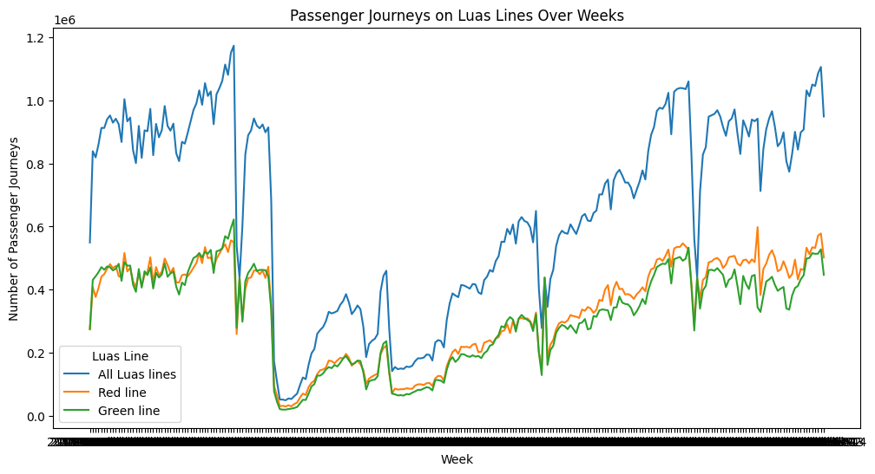

**2. Airport Passenger Distribution:** To illustrate the distribution of passenger numbers, box plots and histograms were made.

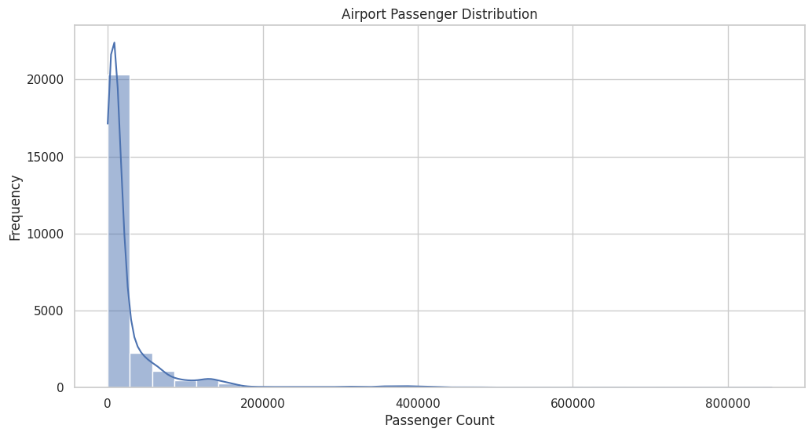

**3. Temporal Patterns:** To help identify peak travel periods, temporal patterns were plotted using line charts.

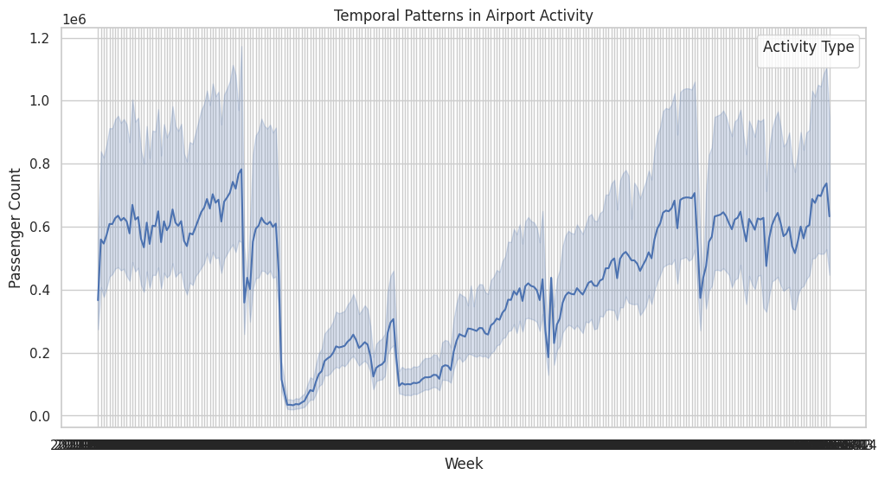

**4. Correlation Heatmaps:** investigated the relationships between various variables in the two datasets.

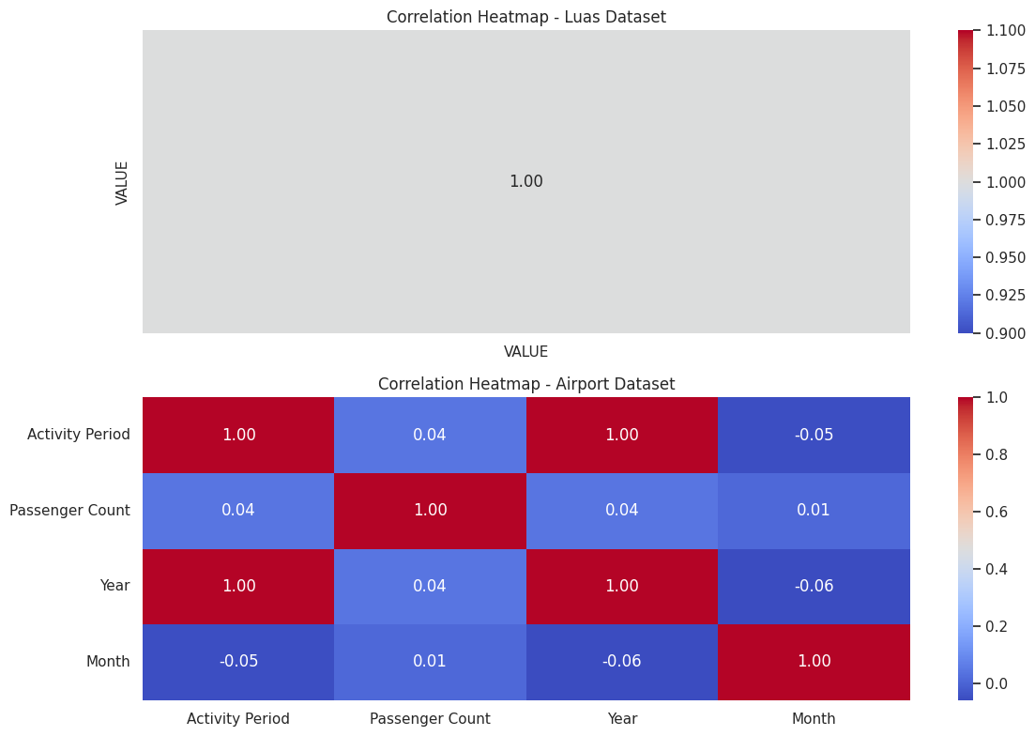

## **Data Enrichment:**

**1. Month-Year Extraction:** For improved temporal analysis, the month and year were extracted from pertinent date columns.

## **Challenges and Solutions:**

**1. Data Consistency:**

* Weekly numbering errors were fixed, guaranteeing correct temporal representation.
* To preserve the integrity of the dataset, missing values were handled systematically.

**2. Visualisation Clarity:**

* Made sure that the visualisations offered significant insights on transportation trends and were easy to understand and interpret.

# **Statistics for Data Analytics**

## **Descriptive Statistics and Visualizations:**

When summarising datasets, descriptive statistics and visualisations are essential for providing insights into important features. We examine the descriptive statistics of the Airport Activity and Luas Passenger Journeys datasets in this section.

## **Luas Passenger Journeys Dataset:**

For the 'VALUE' column, which represents passenger counts, descriptive statistics were calculated, including mean, median, standard deviation, and quartiles. The central tendency and dispersion of the dataset were comprehensively outlined by these statistics.

## **Visualizing Passenger Trends:**

We used line charts to illustrate the passenger trend across various weeks, highlighting differences between Luas lines in particular. These graphics aided in spotting trends and anomalies in the way passengers used transport.

## **Airport Activity Dataset:**

Analogous descriptive statistics were computed for the Airport Activity dataset's 'Passenger Count' column. The distribution of passenger counts was shown using box plots and histograms, which made it easier to spot outliers and comprehend the variability of the dataset.

# **Deductive Statistic Analysis:**

To understand population values and derive significant inferences, inferential statistics were used. Confidence intervals, for example, were computed to provide a range within which the genuine proportion is expected to reside for the population fraction of users who commute to Dublin by train.

# **Comparing Different Countries:**

We carried out research to find nations that shared Ireland's transport features in order to enhance the analysis. These nations were compared using both parametric and non-parametric inferential statistical approaches, including chi-squared tests, analysis of variance (ANOVA), t-tests, and Wilcoxon tests. Every test was carefully selected, taking into account both its applicability and the particular qualities under evaluation.

**Main Results and Difficulties:**

A greater knowledge of transportation patterns was made possible by the statistical analyses, which offered insightful information about the datasets. Nevertheless, there were difficulties along the way. For example, great thought had to be given to how to handle missing values and make sure statistical tests were applicable.

# **Machine Learning**

## **Rationale and Model Selection:**

Machine learning models are effective instruments for extracting analytical and predictive insights from datasets. This section explains the reasoning behind our selection of machine learning models and the rationale for using them.

**Supervised Learning:**

Because the Luas Passenger Journeys dataset has well-defined labels and a predictable target variable, we used supervised learning approaches for this dataset. Two different models were chosen to be compared:

1. **Linear Regression:**

**Justification:** Linear regression is a good tool for estimating passenger counts since it can be used to forecast numerical quantities.

1. **Random Forest Regressor:**

**Rationale:** The Random Forest Regressor is a strong substitute for predictive modelling. It is an ensemble learning technique that is excellent at capturing intricate correlations.

**Unsupervised Learning:**

Due to its complexity, the Airport Activity dataset required unsupervised learning approaches in order to find insights and patterns without the use of labelled outcomes. The following models were selected for unsupervised learning:

**1. K-Means Clustering: Rationale:** K-Means clustering facilitates the identification of innate groupings in the data, which helps uncover patterns in passenger behaviour.

**2. Principal Component Analysis (PCA): Rationale:** PCA makes dimensionality reduction easier, which is important when working with the airport activity dataset's variety of attributes.

## **Dataset Creation and Sentiment Analysis:**

A specialised dataset that integrated sentiments from Irish manufacturers and consumers was assembled in order to conduct a sentiment analysis pertaining to the transportation topic. Sentiment analysis techniques were then used to this dataset in order to determine the general public's opinions on a number of transport-related topics.

**Training and Evaluation:**

Appropriate criteria were used for training and assessment of the machine learning models. In order to make sure the models were reliable and generalizable, cross-validation was used. To maximise model performance, hyperparameter tuning—more especially, the use of GridSearchCV—was implemented.

**Model Comparison:**

The machine learning models were compared and contrasted with the use of an extensive table and graphic representations. For regression models, metrics like Mean Absolute Error (MAE) and Root Mean Squared Error (RMSE) were employed, while for clustering, silhouette scores were utilised.

**Discussion and Insight Elaboration:**

The selected machine learning techniques offered insightful information on sentiment analysis and passenger behaviour. The models' interpretability and feature selection proved to be obstacles that had to be overcome via thorough examination and continual development.

# **Challenges and Limitations**

## **Data-Driven Challenges:**

**1. Incomplete and Inconsistent Data:**

**Challenge:**

The Luas Passenger Journeys dataset included inconsistent and missing values in the 'TLIST(W1)' column, which affected the temporal analysis.

**Solution:** To handle missing values methodically and guarantee temporal consistency, extensive data cleansing and transformation were carried out.

**2. Airport Activity Dataset Outliers:**

**Difficulty:** There were anomalies in passenger counts and inconsistent data in airline-related fields in the Airport Activity dataset.

**Solution:** To detect and manage outliers, strong statistical techniques were used, improving the dataset's dependability.

## **Difficulties with the Model:**

**3. Machine Learning Model Interpretability:**

**Problem:** Ensuring that intricate machine learning models, particularly the Random Forest Regressor and K-Means clustering, are comprehensible.

**Solution:** To improve interpretability, model evaluation metrics and visualisation approaches were used, and conclusions were cross-checked.

**4. Sentiment Analysis Feature Selection:**

**Challenge:** Choosing pertinent features for sentiment analysis in order to guarantee a thorough comprehension of sentiments pertaining to transportation.

**Solution:** To improve feature relevance, sentiment lexicon augmentation and feature engineering were done.

## **Challenges to Methodology:**

**5. Ensuring the Use of Ethical Data:**

**Difficulty:** Handling moral dilemmas while using sentiment analysis and making sure public opinions are used responsibly.

Followed moral standards, anonymised data, and gave user privacy top priority when conducting sentiment analysis.

## **Restrictions:**

**6. Data Volume and Scope:**

**Limitation:** The scope and volume of the datasets might not accurately reflect the intricacy of transport networks, which could restrict the applicability of the findings.

## **7. Outside Factors:**

**Restrictions:** Externalities beyond the control of the model may be introduced by external variables influencing mobility patterns, such as economic events or global health crises.

## **Ongoing Enhancement:**

To improve the resilience and dependability of the study, continuous iterations and refinements were made in spite of obstacles and constraints. By tackling these issues, an analytical framework that was more robust and perceptive was developed.

## **Conclusion**

To sum up, our research has investigated transport data thoroughly in relation to airport operations and Luas passenger trips. Important insights were obtained by means of a methodical data analysis and machine learning methodology, which opened the door for well-informed decision-making in the field of transport planning.

**Important Conclusions and Learnings:**

**1. Luas Passenger Journeys:**

**Temporal Trends:** Examining weekly and monthly patterns helped identify peak travel times, which helped with service optimisation and resource allocation.

**Insights particular to a Line:** Differences in the number of passengers on several Luas lines were discovered, offering focused information for strategies specific to a line.

**2. Aeroport Operations:**

**Impact on Airlines:** Analysing passenger counts and airline-related data revealed patterns and anomalies, allowing airlines to resolve operational issues.

**Geographical Summaries:** Resource allocation and spatial planning were influenced by knowledge of passenger dispersion across geographic regions.

**Sentiment analysis and machine learning:**

**Machine Learning Models:**

**Justification:** The K-Means clustering model and the Random Forest Regressor were chosen because they were effective at predicting passenger numbers and revealing hidden patterns.

**Outcomes:** Comparative examination of model results led to a more sophisticated comprehension of transportation dynamics.

**Viewpoints of Producers and Consumers:** Strategic decisions were informed by the sentiment analysis of public perceptions on transport, which offered insightful information about the perspectives of producers and consumers.

#### **Challenges and Ongoing Refinement:**

**5. Data-Driven Difficulties:**

**Overcomes:** In order to guarantee the accuracy of the insights, issues with missing values, temporal inconsistencies, and outliers were methodically resolved.

**6. Ethical Points to Consider:**

**Ranking:** Sentiment analysis ethical issues were given first priority, guaranteeing responsible data usage and protecting user privacy.

#### **Future Directions:**

**7. Ongoing Enhancement:**

**Iterative Method:** Recognising that data analysis is an iterative process, continuous improvement and modification of models and techniques is essential to keep up with changing transportation dynamics.

8. Ancillary Elements:

**Reflection:** Accurate forecasting requires an understanding of how external factors affect transportation, ongoing observation, and flexibility in response to changing conditions.

### Final Thoughts

This study represents a thorough investigation of several datasets, demonstrating the ability of machine learning and data analytics to reveal insights vital to contemporary transport planning. The knowledge obtained provides a data-driven viewpoint on resource optimisation, service enhancement, and overall transport system improvement, which forms the basis for well-informed decision-making.