import numpy as np
import pandas as pd
from sklearn.model_selection import train_test_split
df = pd.read_csv("D:\\DESKTOP\\Pattern recognition\\Regression_on_Abalone_dataset\\Abalone dataset\\abalone.csv")
df.head()
Sex Length Diameter Height Whole weight Shucked weight Viscera weight \
0 M 0.455 0.365 0.095 0.5140 0.2245 0.1010
1 M 0.350 0.265 0.090 0.2255 0.0995 0.0485
2 F 0.530 0.420 0.135 0.6770 0.2565 0.1415
3 M 0.440 0.365 0.125 0.5160 0.2155 0.1140
4 I 0.330 0.255 0.080 0.2050 0.0895 0.0395
Shell weight Rings
0 0.150 15
1 0.070 7
2 0.210 9
3 0.155 10
4 0.055 7
#data Preprocessing
abalone_data = pd.get_dummies(df, columns=['Sex'])
abalone_data = abalone_data.apply(pd.to_numeric, errors='coerce')
abalone_data.dropna(inplace=True)
X = abalone_data.drop(columns=['Rings']).values
y = abalone_data['Rings'].values.reshape(-1, 1)
print(abalone_data.head())
Length Diameter Height Whole weight Shucked weight Viscera weight \
0 0.455 0.365 0.095 0.5140 0.2245 0.1010
1 0.350 0.265 0.090 0.2255 0.0995 0.0485
2 0.530 0.420 0.135 0.6770 0.2565 0.1415
3 0.440 0.365 0.125 0.5160 0.2155 0.1140
4 0.330 0.255 0.080 0.2050 0.0895 0.0395
Shell weight Rings Sex_F Sex_I Sex_M
0 0.150 15 False False True
1 0.070 7 False False True
2 0.210 9 True False False
3 0.155 10 False False True
4 0.055 7 False True False
X_train, X_test, y_train, y_test = train_test_split(X, y, test_size=0.2, random_state=0)
class LinearRegression:
def __init__(self):
self.coefficients = None
def fit(self, X, y):
X = np.array(X, dtype=float) # Convert to numpy array with float type
y = np.array(y, dtype=float)
X = np.c_[np.ones(X.shape[0]), X] # Adding intercept term
print("X dtype:", X.dtype)
print("y dtype:", y.dtype)
print("X shape:", X.shape)
print("y shape:", y.shape)
XTX = np.dot(X.T, X)
print("XTX shape:", XTX.shape)
XTX_inv = np.linalg.inv(XTX)
print("XTX_inv shape:", XTX_inv.shape)
XTy = np.dot(X.T, y)
print("XTy shape:", XTy.shape)
self.coefficients = np.dot(XTX_inv, XTy)
def predict(self, X):
X = np.c_[np.ones(X.shape[0]), X] # Adding intercept term
return np.dot(X, self.coefficients)
model = LinearRegression()
model.fit(X_train, y_train)
X dtype: float64
y dtype: float64
X shape: (3341, 11)
y shape: (3341, 1)
XTX shape: (11, 11)
XTX_inv shape: (11, 11)
XTy shape: (11, 1)
model = LinearRegression()
model.fit(X_train, y_train)
y_train_pred = model.predict(X_train)
y_test_pred = model.predict(X_test)
X dtype: float64
y dtype: float64
X shape: (3341, 11)
y shape: (3341, 1)
XTX shape: (11, 11)
XTX_inv shape: (11, 11)
XTy shape: (11, 1)
train_rmse = np.sqrt(np.mean((y_train_pred - y_train) ** 2))
test_rmse = np.sqrt(np.mean((y_test_pred - y_test) ** 2))
print("Linear Regression (Implemented from Scratch) Results:")
print(f"Training RMSE: {train_rmse}")
print(f"Testing RMSE: {test_rmse}")
Linear Regression (Implemented from Scratch) Results:
Training RMSE: 28.38604727410967
Testing RMSE: 27.447472962514897
#Ridge regression
from sklearn.linear_model import Ridge
import matplotlib.pyplot as plt
alphas = np.logspace(-3, 3, 10)
ridge_rmse = []
for alpha in alphas:
ridge_model = Ridge(alpha=alpha)
ridge_model.fit(X_train, y_train)
y_test_pred_ridge = ridge_model.predict(X_test)
ridge_rmse.append(np.sqrt(np.mean((y_test_pred_ridge - y_test) ** 2)))
plt.figure(figsize=(10, 6))
plt.plot(np.log10(alphas), ridge_rmse, marker='o')
plt.xlabel('log10(Alpha)')
plt.ylabel('RMSE')
plt.title('Ridge Regression: Effect of Alpha on Testing Data RMSE')
plt.grid(True)
plt.show()
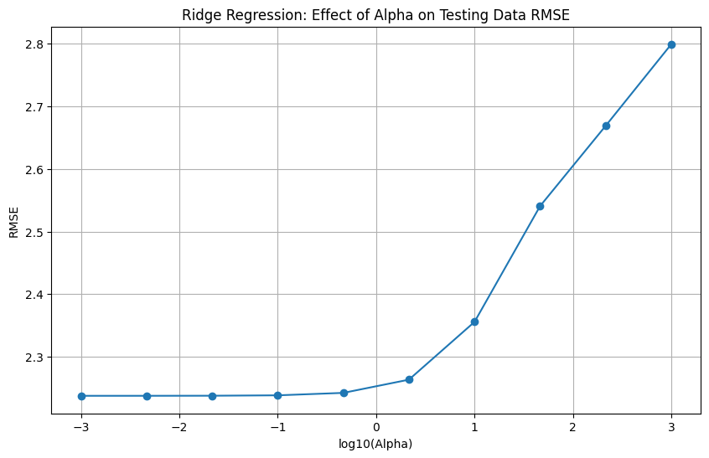
best_alpha_ridge = alphas[np.argmin(ridge_rmse)]
best_ridge_model = Ridge(alpha=best_alpha_ridge)
best_ridge_model.fit(X_train, y_train)
ridge_coefficients = best_ridge_model.coef_
print("Ridge Regression Results:")
print(f"Best Alpha: {best_alpha_ridge}")
print(f"Coefficients: {ridge_coefficients}")
Ridge Regression Results:
Best Alpha: 0.001
Coefficients: [[ -0.29688398 11.24671208 8.09620299 9.36998881 -20.16566223
-10.66723044 8.3432274 0.25167453 -0.57848757 0.32681305]]
#Lasso Regression
from sklearn.linear_model import LassoCV
lasso_cv = LassoCV(alphas=alphas, cv=5)
lasso_cv.fit(X_train, y_train)
best_alpha_lasso = lasso_cv.alpha_
c:\Users\wajid\AppData\Local\Programs\Python\Python312\Lib\site-packages\sklearn\linear_model\_coordinate_descent.py:1623: DataConversionWarning: A column-vector y was passed when a 1d array was expected. Please change the shape of y to (n_samples, ), for example using ravel().
y = column_or_1d(y, warn=True)
plt.figure(figsize=(10, 6))
plt.plot(np.log10(alphas), lasso_cv.mse_path_.mean(axis=1))
plt.xlabel('log10(Alpha)')
plt.ylabel('Mean RMSE')
plt.title('Lasso Regression: Effect of Alpha on Mean RMSE')
plt.grid(True)
plt.show()
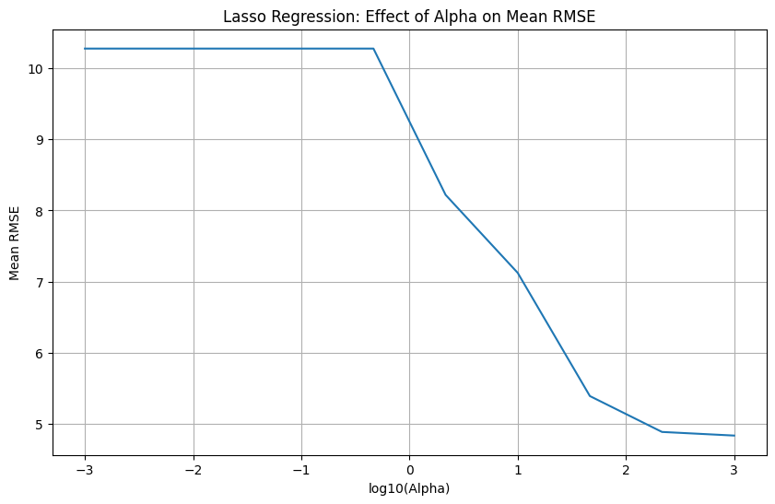
best_lasso_model = LassoCV()
best_lasso_model.fit(X_train, y_train)
lasso_coefficients = best_lasso_model.coef_
c:\Users\wajid\AppData\Local\Programs\Python\Python312\Lib\site-packages\sklearn\linear_model\_coordinate_descent.py:1623: DataConversionWarning: A column-vector y was passed when a 1d array was expected. Please change the shape of y to (n_samples, ), for example using ravel().
y = column_or_1d(y, warn=True)
print("Lasso Regression Results:")
print(f"Best Alpha: {best_alpha_lasso}")
print(f"Coefficients: {lasso_coefficients}")
Lasso Regression Results:
Best Alpha: 0.001
Coefficients: [ 0. 10.05126638 5.63502631 7.98672751 -18.7459969
-7.31354821 9.60391759 -0. -0.85798528 0.06185563]
from sklearn.model_selection import GridSearchCV
from sklearn.linear_model import Ridge, Lasso
ridge_params = {'alpha': np.logspace(-3, 3, 10)}
ridge_grid = GridSearchCV(Ridge(), ridge_params, cv=5, scoring='neg_mean_squared_error')
ridge_grid.fit(X_train, y_train)
best_alpha_ridge_grid = ridge_grid.best_params_['alpha']
best_ridge_model_grid = Ridge(alpha=best_alpha_ridge_grid)
best_ridge_model_grid.fit(X_train, y_train)
ridge_coefficients_grid = best_ridge_model_grid.coef_
print("Ridge Regression with GridSearchCV Results:")
print(f"Best Alpha: {best_alpha_ridge_grid}")
print(f"Coefficients: {ridge_coefficients_grid}")
Ridge Regression with GridSearchCV Results:
Best Alpha: 0.46415888336127775
Coefficients: [[ 1.95996929 8.07034739 6.86174188 8.01539628 -18.62875483
-8.45783363 9.62983073 0.26764849 -0.59896431 0.33131583]]
lasso_params = {'alpha': np.logspace(-3, 3, 10)}
lasso_grid = GridSearchCV(Lasso(), lasso_params, cv=5, scoring='neg_mean_squared_error')
lasso_grid.fit(X_train, y_train)
best_alpha_lasso_grid = lasso_grid.best_params_['alpha']
best_lasso_model_grid = Lasso(alpha=best_alpha_lasso_grid)
best_lasso_model_grid.fit(X_train, y_train)
lasso_coefficients_grid = best_lasso_model_grid.coef_
print("Lasso Regression with GridSearchCV Results:")
print(f"Best Alpha: {best_alpha_lasso_grid}")
print(f"Coefficients: {lasso_coefficients_grid}")
Lasso Regression with GridSearchCV Results:
Best Alpha: 0.001
Coefficients: [ 0. 10.44535663 6.74592122 8.61280194 -19.39301347
-8.83981434 9.03641293 -0. -0.84583421 0.06774797]
print("Comparing Coefficients\n")
print("Ridge Regression")
print(f"Best Alpha(Ridge): {best_alpha_ridge}")
print(f"Best Alpha(GridSearch): {best_alpha_ridge_grid}")
print("Coefficients from Ridge: ", ridge_coefficients)
print("Coefficients from GridSearchCV:", ridge_coefficients_grid)
print("\nLasso Regression")
print(f"Best Alpha(Lasso): {best_alpha_lasso}")
print(f"Best Alpha(GridSearch): {best_alpha_lasso_grid}")
print("Coefficients from Lasso: ", lasso_coefficients)
print("Coefficients from GridSearchCV:", lasso_coefficients_grid)
Comparing Coefficients
Ridge Regression
Best Alpha(Ridge): 0.001
Best Alpha(GridSearch): 0.46415888336127775
Coefficients from Ridge: [[ -0.29688398 11.24671208 8.09620299 9.36998881 -20.16566223
-10.66723044 8.3432274 0.25167453 -0.57848757 0.32681305]]
Coefficients from GridSearchCV: [[ 1.95996929 8.07034739 6.86174188 8.01539628 -18.62875483
-8.45783363 9.62983073 0.26764849 -0.59896431 0.33131583]]
Lasso Regression
Best Alpha(Lasso): 0.001
Best Alpha(GridSearch): 0.001
Coefficients from Lasso: [ 0. 10.05126638 5.63502631 7.98672751 -18.7459969
-7.31354821 9.60391759 -0. -0.85798528 0.06185563]
Coefficients from GridSearchCV: [ 0. 10.44535663 6.74592122 8.61280194 -19.39301347
-8.83981434 9.03641293 -0. -0.84583421 0.06774797]

