WAJID ALI HASHMI

500096923

B2(H)

EXPERIMENT 9

Q.1

public class thread1 extends Thread{

public void run() {

try {

Thread.*sleep*(5000);

System.***out***.println("Running");

}

catch(Exception e) {

System.***out***.println(e.getMessage());

}

}

public static void main(String[] args) {

thread1 t = new thread1();

t.start();

}

}

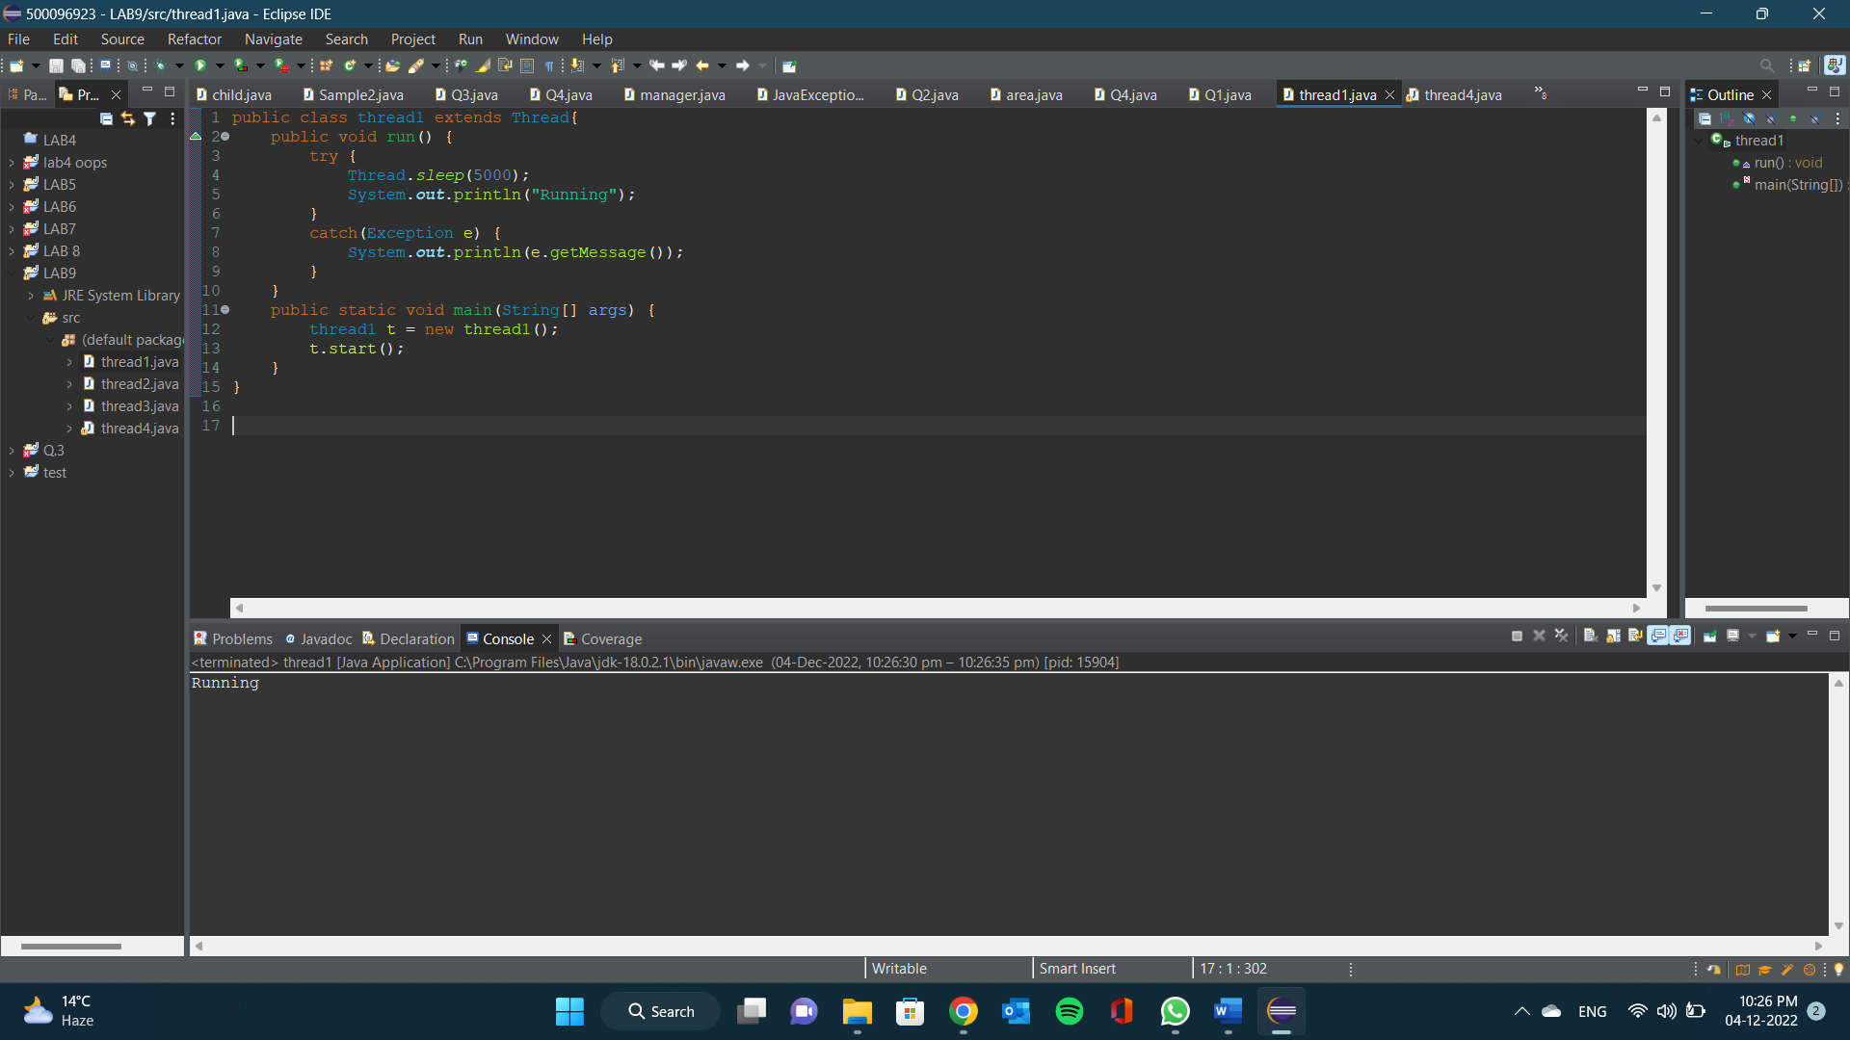

OUTPUT:

Q.2

class even extends Thread{

public void run() {

for(int i=0;i<10;i++) {

if(i%2==0) {

System.***out***.println(i+" : Even");

}

}

}

}

class odd extends Thread{

public void run() {

for(int i=0;i<10;i++) {

if(i%2!=0) {

System.***out***.println(i+" : Odd");

}

}

}

}

public class thread2{

public static void main (String[] args) {

even e = new even();

odd o = new odd();

e.start();

o.start();

}

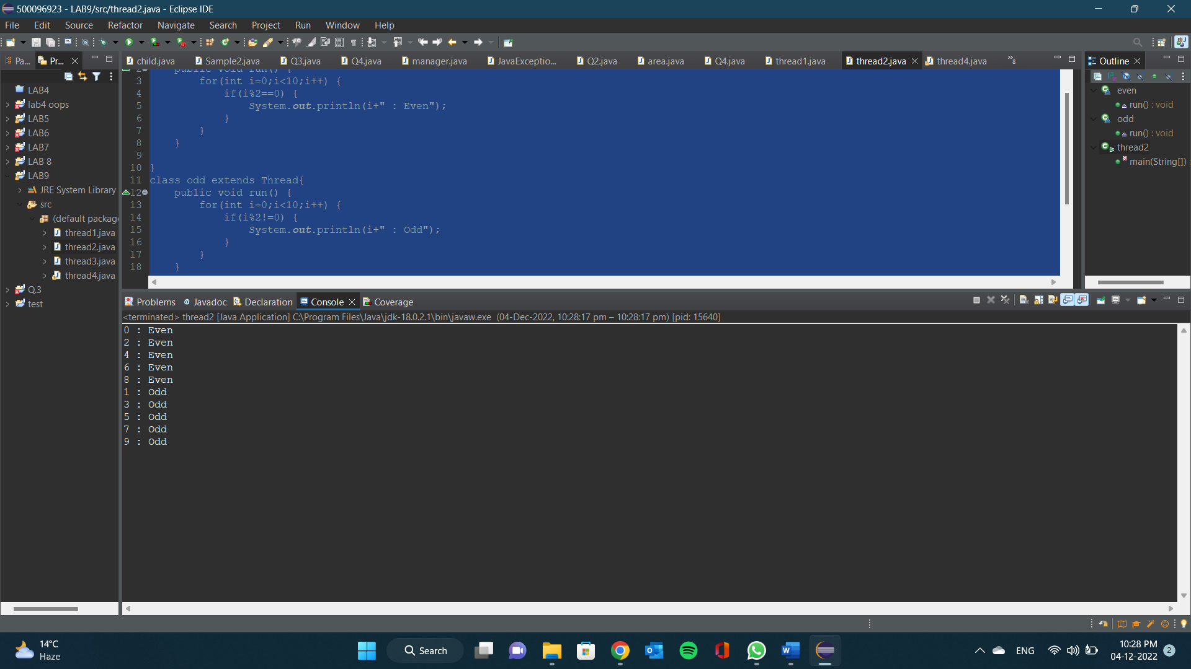}

OUTPUT:

Q.3

public class thread3 {

static Thread[] *thread3* = new Thread[10];

public static void main(String[] args) {

try {

data d = new data();

for(int i=0;i<10;i++) {

*thread3*[i] = new Thread(d);

*thread3*[i].start();

Thread.*sleep*(100);

}

}

catch(Exception e) {

System.***out***.println(e.getMessage());

}

}

}

class data implements Runnable{

int count = 0;

data d = this;

Thread t;

public void run() {

d=sys.*increment*(d);

System.***out***.println(d.count);

}

}

class sys{

synchronized static data increment(data i) {

i.count++;

return(i);

}

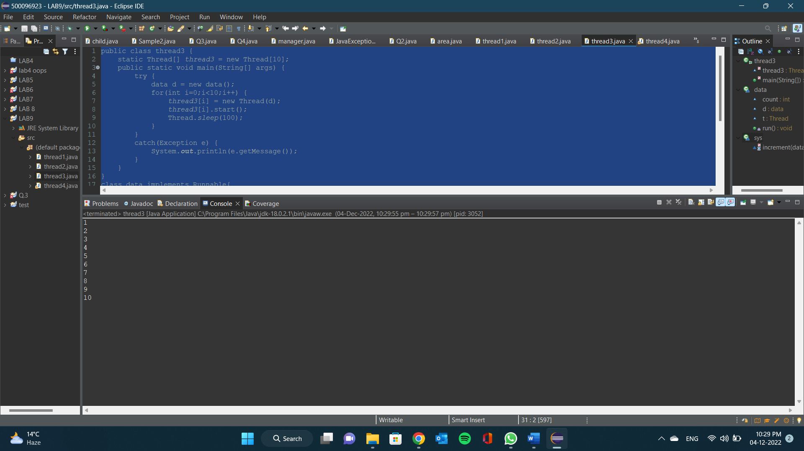}

OUTPUT:

Q.4

public class thread4 extends Thread {

public static void main(String[] args) throws InterruptedException{

Thread T1 = new Thread();

Thread T2 = new Thread();

Thread T3 = new Thread();

Thread T4 = new Thread();

Thread T5 = new Thread();

T1.setPriority(6);

T2.setPriority(1);

T3.setPriority(9);

T4.setPriority(10);

T5.setPriority(4);

T1.*sleep*(200);

if(T1.isAlive()) {

System.***out***.println("T1 is Alive");

}

else {

System.***out***.println("T1 is not Alive");

}

T2.start();

if(T2.isAlive()) {

System.***out***.println("T2 is Alive");

}

else {

System.***out***.println("T2 is not Alive");

}

T3.*sleep*(1500);

if(T3.isAlive()) {

System.***out***.println("T3 is Alive");

}

else {

System.***out***.println("T3 is not Alive");

}

T4.start();

if(T4.isAlive()) {

System.***out***.println("T4 is Alive");

}

else {

System.***out***.println("T4 is not Alive");

}

T5.start();

if(T5.isAlive()) {

System.***out***.println("T5 is Alive");

}

else {

System.***out***.println("T5 is not Alive");

}

}

}

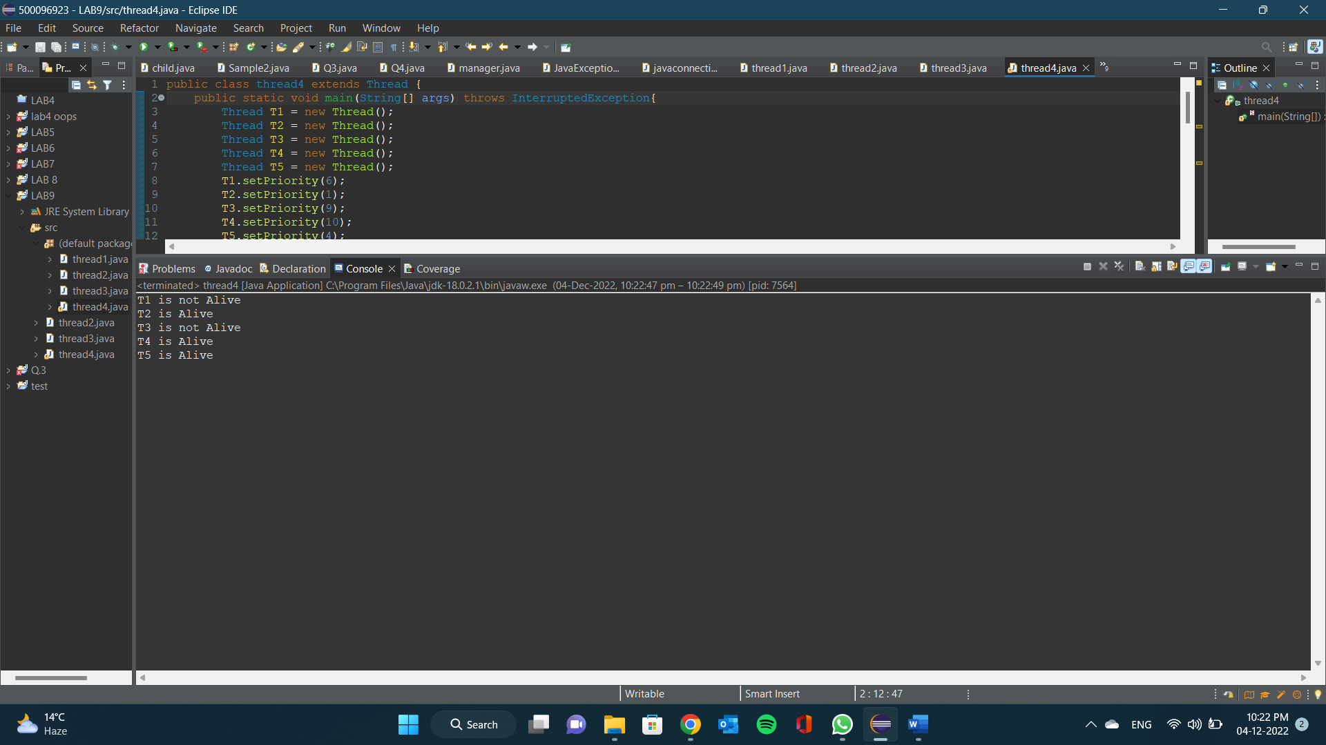OUTPUT: