**UC 01 Handling menu**

**Scope:**

A functional menu for the game.

**Level:**

Users

**Primary Actor:**

The user of the game.

**Stakeholders and interests:**

User: A functional menu, accessible and understandable game settings.

Highscore comparison between friends.

Company: A functional menu, accessible and understandable game settings, their company name in the bottom. Name of the game placed at the top of the menu.

**Preconditions:**

Menu opens.

**Success guarantee:**

Save/load function works.

High scores load.

Game closes successfully when exiting.

**Main Success Scenario:**

User can open menu.

After pressing start button game initializes.

**Extensions:**

Game crashes on purpose if the menu doesn’t load properly.

User Case diagram

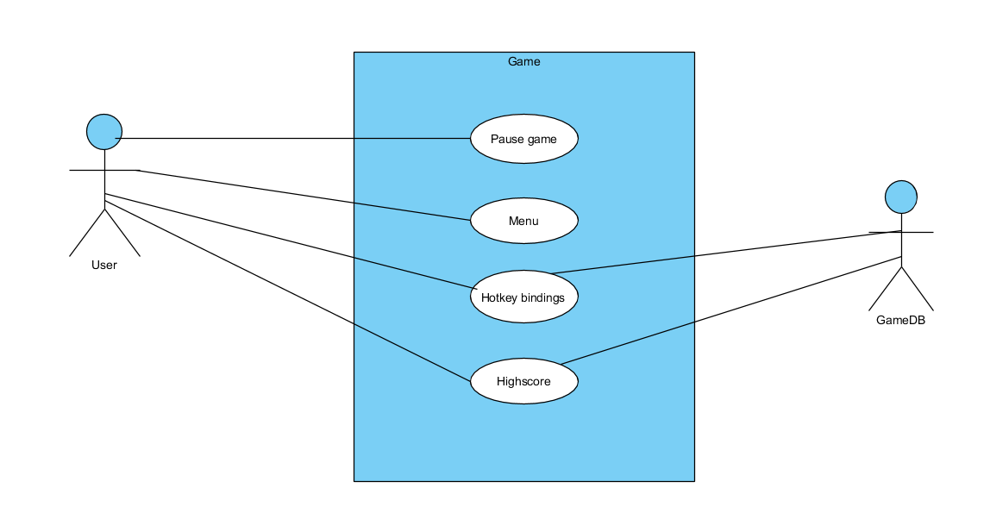

Domain Model

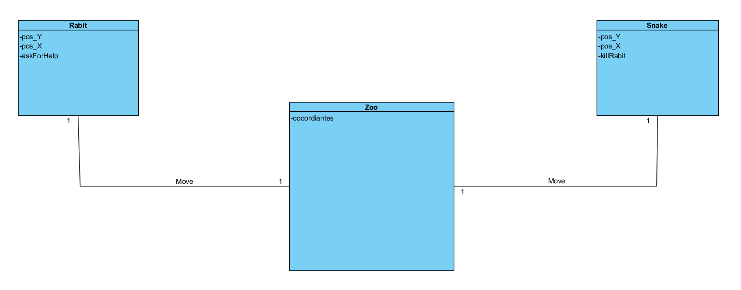

Class Diagram

