Phase 2: Data Collection, Understanding and Preparation
Project: Few-Shot Colorectal Histology Classification
Group ID: F26-04

1. Dataset Source and Description
The project uses the Colorectal Histology MNIST dataset (file hmnist2828L.csv), published on Kaggle. It is a down-sampled, grayscale version of the Kather et al. (2016) colorectal cancer texture dataset, Multi-class texture analysis in colorectal cancer histology_ (Scientific Reports, 6:27988). Each row is one tissue image stored as 784 pixel columns (a flattened 28 x 28 image) plus an integer class label.
The dataset has 5,000 images across 8 tissue classes with exactly 625 images per class. The original tiles are haematoxylin-and-eosin (H&E) stained human colorectal tissue patches. Labels in the CSV run from 1 to 8; following the original dataset's class order, they correspond to the tissue types below.
Label | Tissue class | Images
1 | Tumour epithelium | 625
2 | Simple stroma | 625
3 | Complex stroma | 625
4 | Immune cell conglomerates (lympho) | 625
5 | Debris and mucus | 625
6 | Normal mucosal glands | 625
7 | Adipose tissue | 625
8 | Background (empty) | 625
Table 1. Class labels and image counts (label-to-name mapping follows the original dataset order).

2. Data Collection Method
This is secondary data: no new images were collected by our group. The original images were produced by Kather et al. from anonymised H&E-stained colorectal cancer histology slides, which were digitised and cut into 150 x 150 pixel tiles and labelled by tissue type. We downloaded the pre-processed CSV version from Kaggle, where the images were converted to 28 x 28 grayscale and flattened into one row per image. Working at this resolution keeps the dataset small and fast to iterate on, which suits the many repeated episodes needed for few-shot experiments, at the cost of fine cellular detail.
The file was loaded with pandas (pd.readcsv) in the data exploration notebook (01dataexploration.ipynb_), which is part of the project repository linked above. The raw dataset is not stored in the repository; it is downloaded from Kaggle (kmader/colorectal-histology-mnist).

3. Preprocessing Steps
The following steps were applied and verified in the notebook:
- Loading and schema check. The CSV loads to shape (5000, 785): 784 pixel columns (pixel0000 to pixel0783) and one label column.
- Label verification. The unique labels are {1, ..., 8}, each appearing 625 times, so there are no stray or mislabelled classes.
- Missing-value check. The total count of missing values is 0, so no imputation or row removal was needed.
- Pixel-range validation. Pixel values span 0 to 255 (minimum 0, maximum 255), consistent with 8-bit grayscale.
- Feature/label separation. Pixel columns were selected by name prefix to form the feature matrix X; the label column forms the target vector y.
- Normalisation. Pixels were cast to float32 and divided by 255, rescaling values from [0, 255] to [0, 1] (verified: minimum 0.0, maximum 1.0).
- Reshaping for visualisation. Each 784-vector is reshaped to a 28 x 28 array when an image is needed (for plotting and for convolutional or transformer input).

4. Brief Exploratory Data Analysis
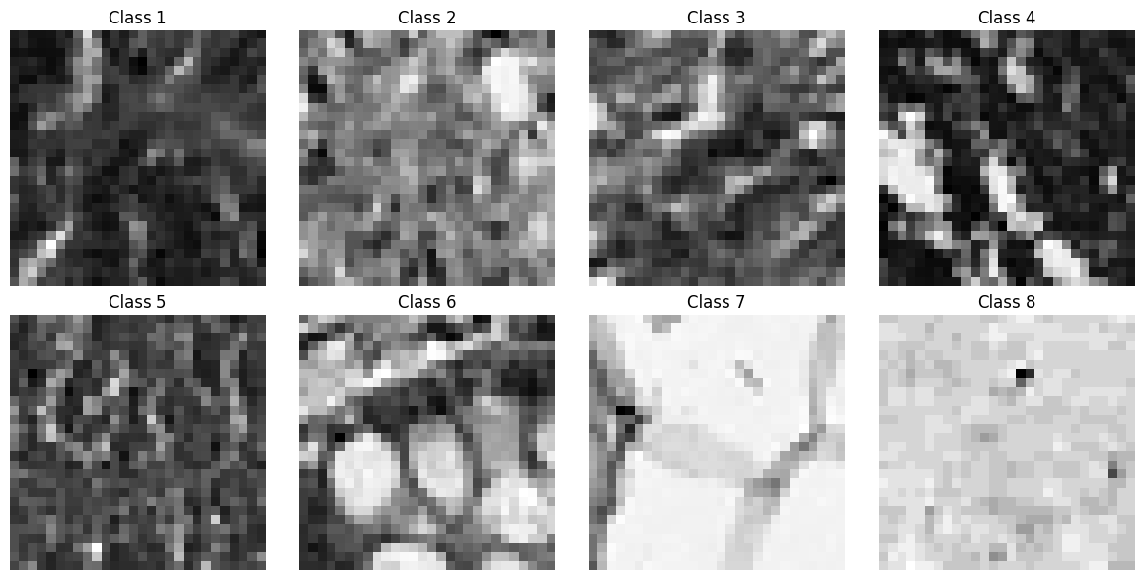
Figure 1. One example image per class (labels 1 to 8) from the 28 x 28 grayscale dataset.
Key insights from the exploration:
- Perfectly balanced classes. Every class has 625 images (12.5% each), so there is no class imbalance to correct. This is useful for few-shot work because any class can serve as a support or query class without sampling bias, and 625 images per class comfortably covers 1-, 5- and 10-shot support sets plus query images.
- Clean data. There are no missing values and the pixel range is valid, so the dataset is usable without cleaning.
- Visually distinct brightness and texture patterns. In the examples shown, classes 7 (adipose) and 8 (background) are bright with little texture, class 6 shows rounded gland-like structures, and class 4 shows high-contrast dark and bright regions. Classes 1, 3 and 5 appear darker and more fine-grained, so we expect these to be harder to separate than the bright classes. This is an observation from one image per class and should be confirmed with per-class pixel statistics.
- Low resolution. At 28 x 28 pixels, the fine nuclear and cellular detail visible in the original 150 x 150 tiles is lost, and only coarse tone and texture remain. This is a limitation to keep in mind when interpreting results.

5. Final Dataset Summary
Property | Value
Source | Colorectal Histology MNIST (Kaggle), derived from Kather et al. (2016)
File used | hmnist_28_28_L.csv
Number of images | 5,000
Image size / channels | 28 x 28, grayscale (784 features per image)
Number of classes | 8 (labels 1 to 8), 625 images each, perfectly balanced
Missing values | 0
Raw pixel range | 0 to 255
Processed feature matrix X | shape (5000, 784), float32, values in [0, 1]
Target vector y | shape (5000,), integer labels 1 to 8
Table 2. Final prepared dataset.
The dataset is clean, balanced and normalized, and is ready for the model implementation phase, including episodic sampling of 5-way 1-, 5- and 10-shot tasks.

GitHub Repo
https://github.com/Wajiha-144/Few-shot-colorectal-histology

